New – AWS Transfer for SFTP – Fully Managed SFTP Service for Amazon S3

SFTP Service for Amazon S3:-

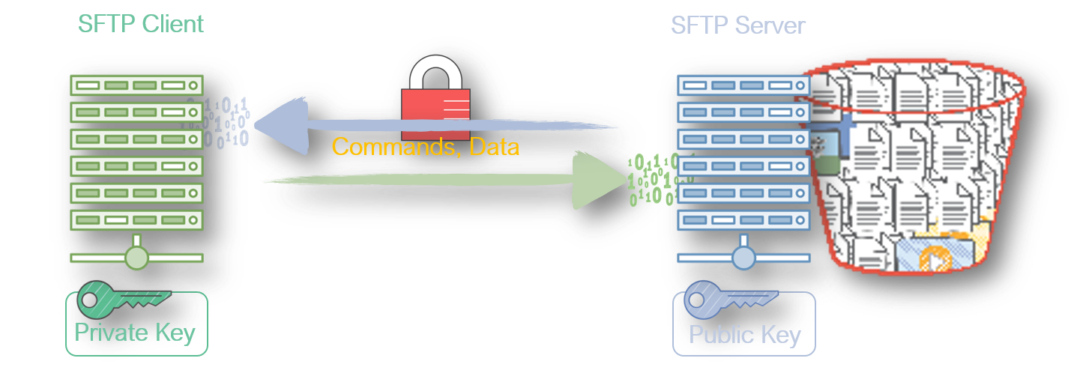

About:-

Earlier to connect S3 you need to install AWS CLI, pre-sighned URL’s ,IAM User,role.

Using user id and key securely connect to S3.

Ref: https://www.youtube.com/watch?v=zuRPbqcaRcI

https://aws.amazon.com/blogs/aws/new-aws-transfer-for-sftp-fully-managed-sftp-service-for-amazon-s3/

Pre-requisites:-

1.Create a S3 Bucket.

2. Lanuch one linux instance (By default linux have SFTP)
(If you are using Windows user WinSCP)

3. Generate SSH Keys .

4. IAM role for SFTP Users.
-Trust relationship

5. Create the SFTP Server.

STEP 1:- Create a S3 Bucket.

==>Goto AWS Console==> Select Services==> Select S3==> Select Create Bucket==>

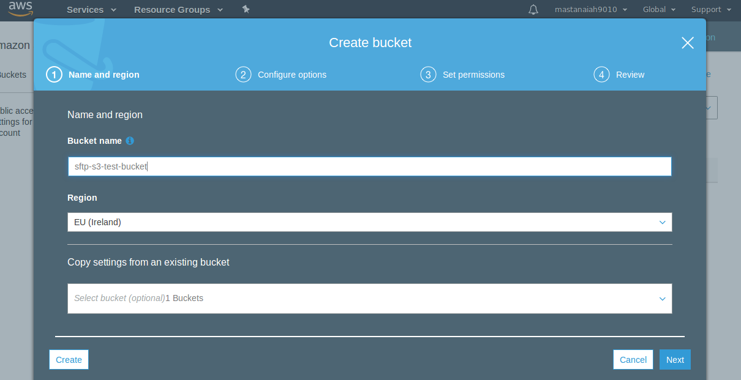

bucket name “sftp-s3-test-bucket” and then select Create.

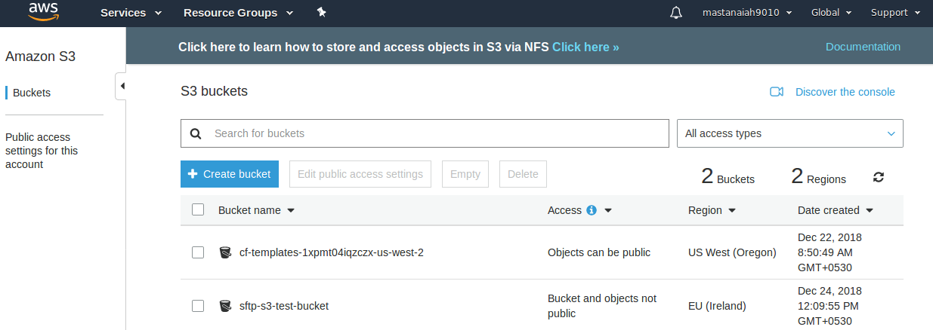

STEP 2:- Lanuch linux EC2-Instance.

==>Goto AWS Console==>Select Services==>Select EC2==> Select Launch Instance==>

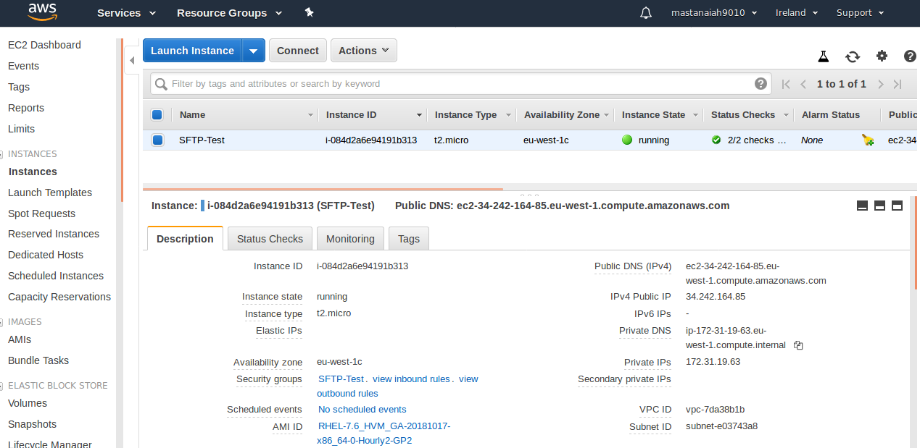

STEP 3:- Genrate SSH Key Pairs..

==> Connect to EC2-Instance.

Run below command to genrate keys:

ssh-keygen -P "" -f "sftp-test-key"

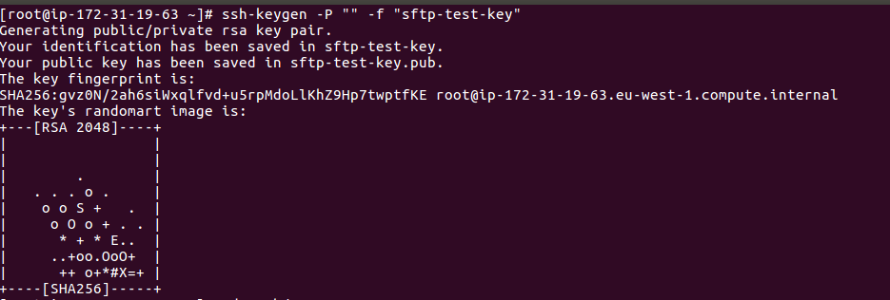

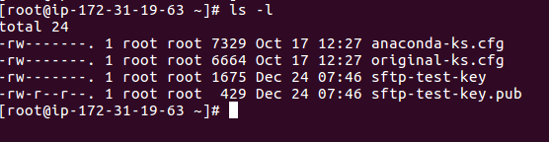
==> Open Public Key

Copy Public Key to notepad till highleted with white mark. And make it with one line(The public key should not be multiline (or) have any special characters like enter)

STEP 4:- IAM role for SFTP Users and edit Trust relationship.

(Create a IAM role for SFTP Users (Amazon S3 Full Access) and edit trust relationship with below

code))

{
"Version": "2012-10-17",
"Statement": [
{
"Effect": "Allow",
"Principal": {
"Service": "transfer.amazonaws.com"
},
"Action": "sts:AssumeRole",
"Condition": {}
}
]
}

==>Goto AWS Console login==>Select Services==>Select IAM==>left side panel Select

Roles==> Select Create role.

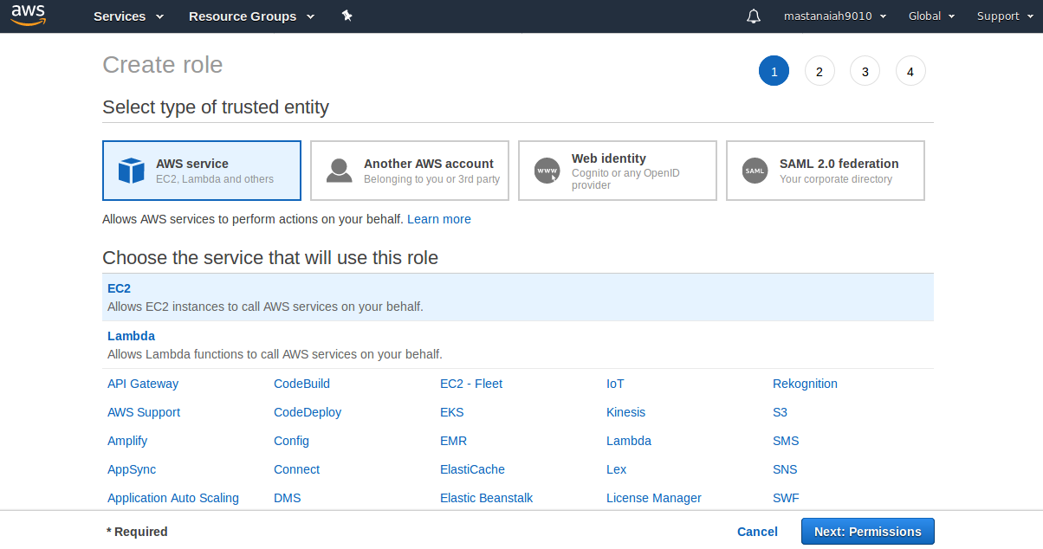
==> Select Permissions==> Give S3 full Access permissions==>

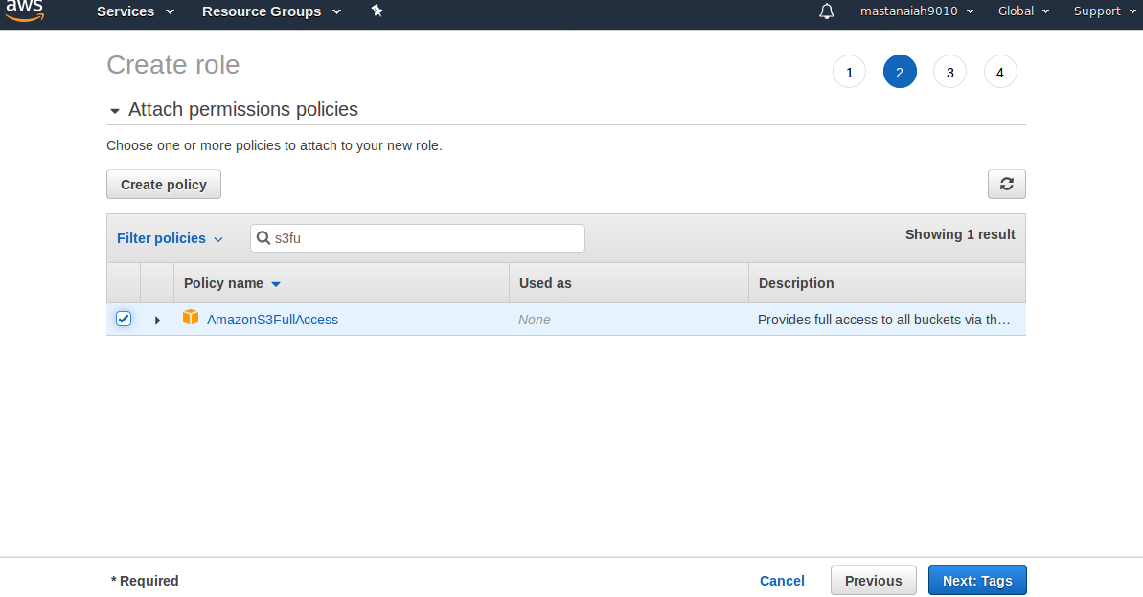

==>Next Select Tags. And next give role name like “sftp-role”

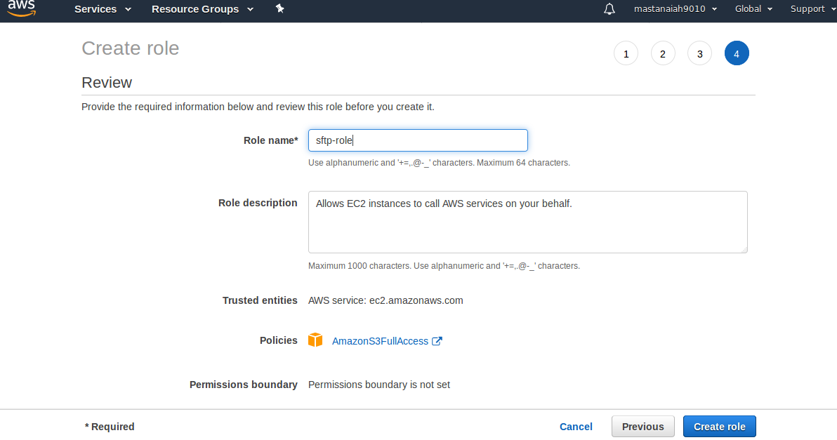
==> Select Create Role.
==> sftp-role create successfully.

==> Select sftp-role, goto trust relationships and edit trust relationships.

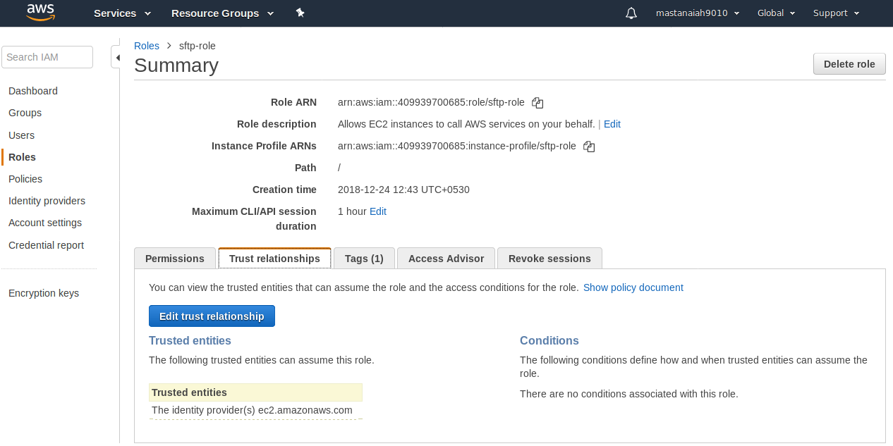
==> by default the below code is there and you can change with above code.

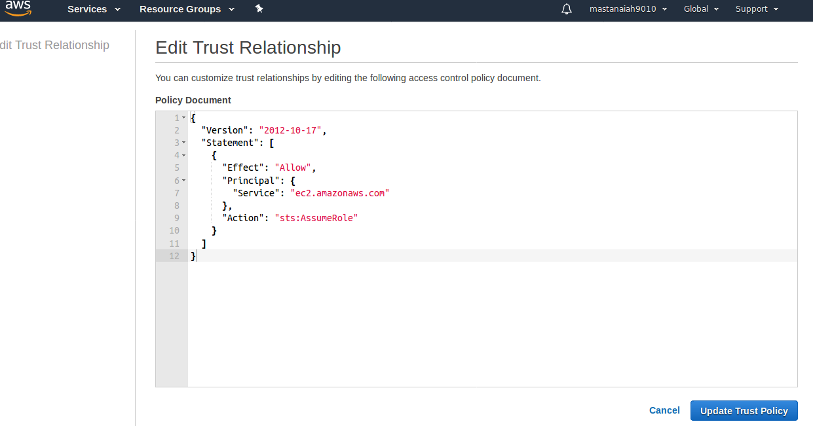

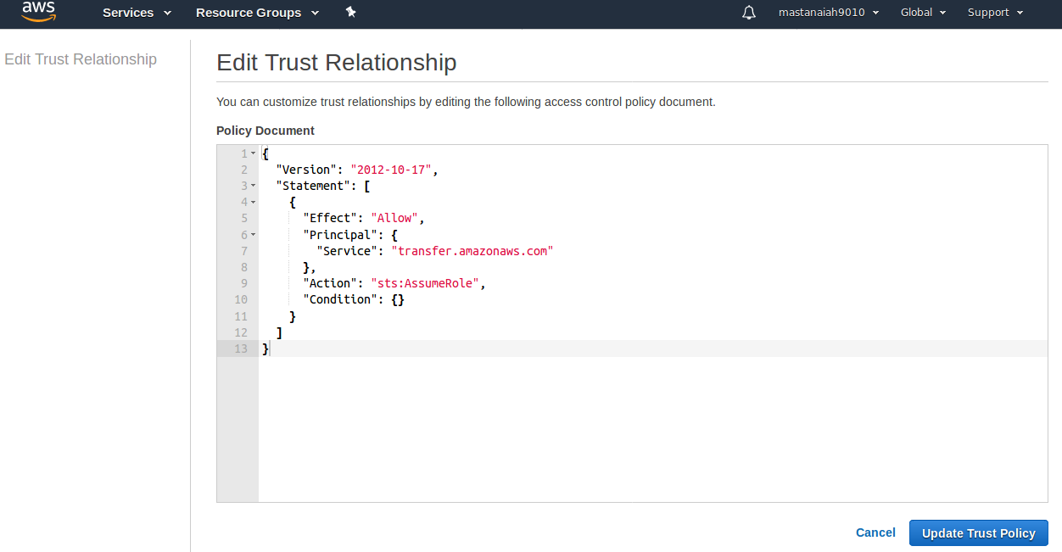
STEP 5:- Create a SFTP Server.

==>Goto AWS Console==> Select Servcies==>Select SFTP==> It will take you too Sftp Home

page.

==>Select Create Server==>

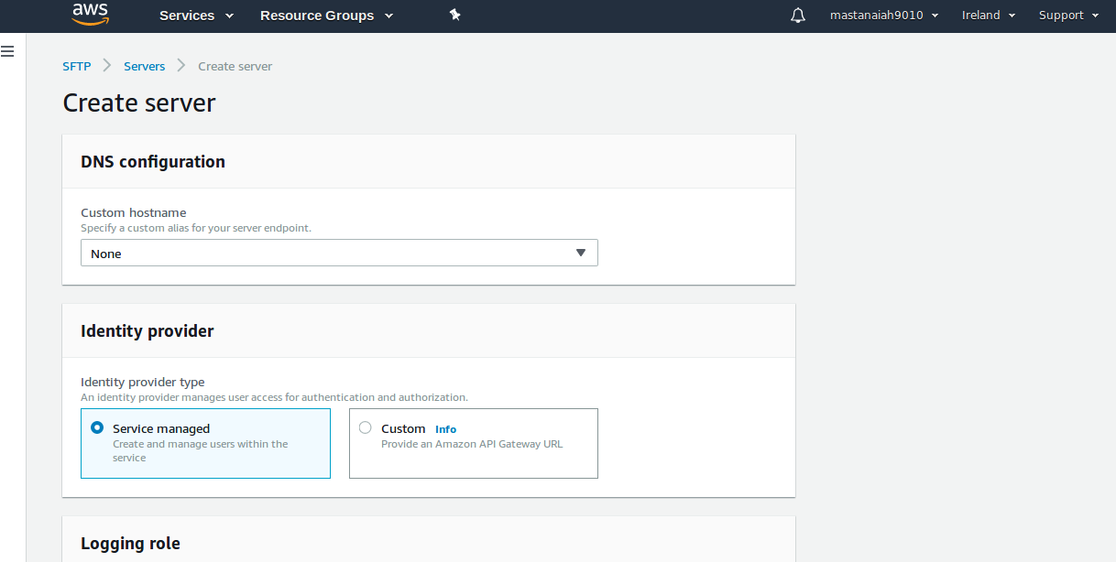
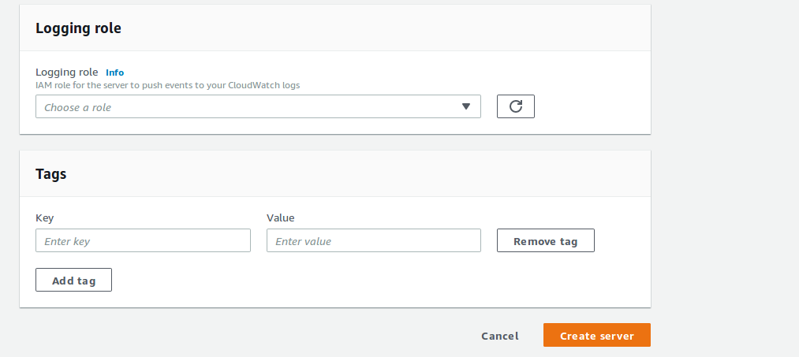

==> Select Create Server.

==> Sftp Server created like below,

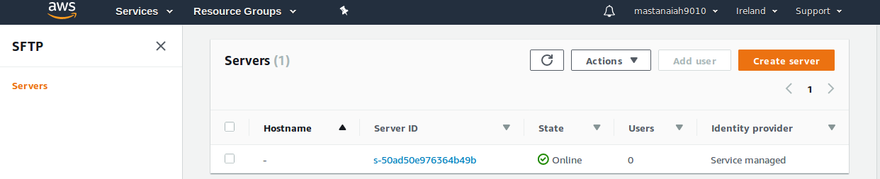
==> Click Servcer ID it will show all configuration details and create creating Sftp users.

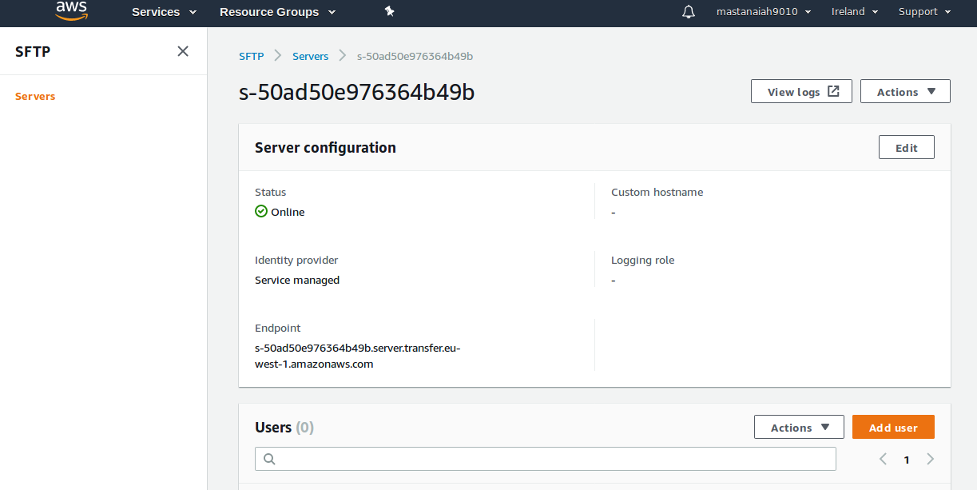
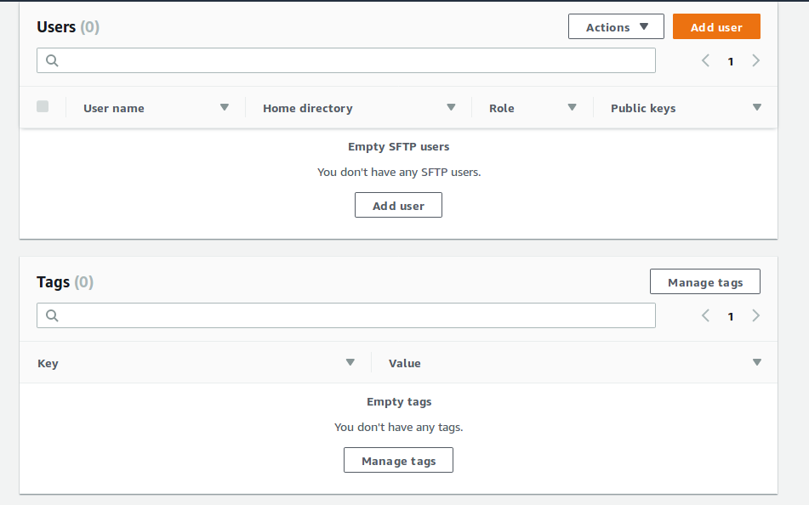
==> Select Add User==> give username=”sftptestuser” role=sftp-role ,bucketname=sftp-s3-test-bucket , user SSH public key.

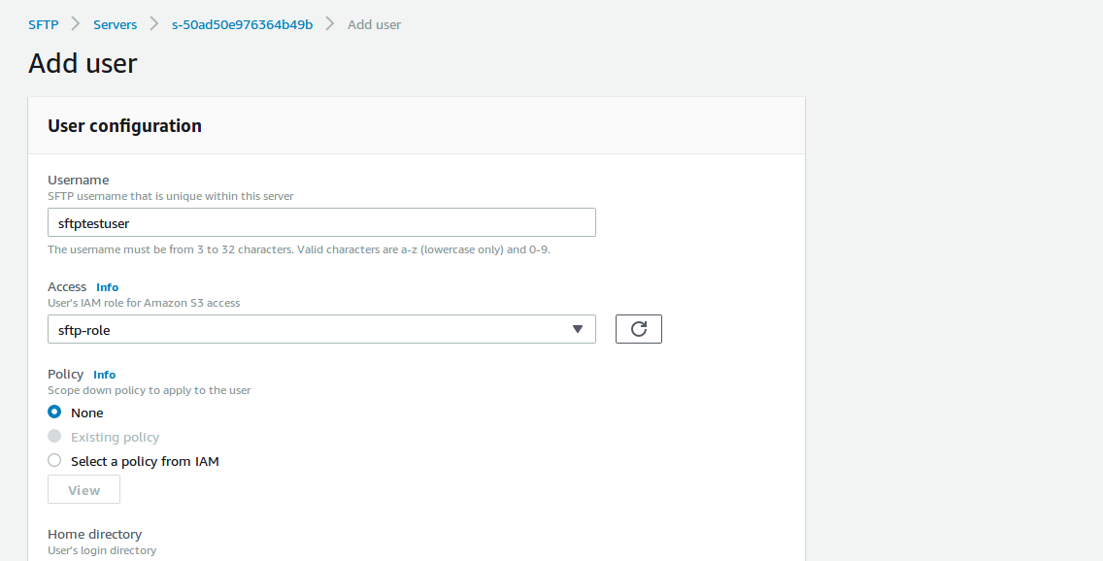

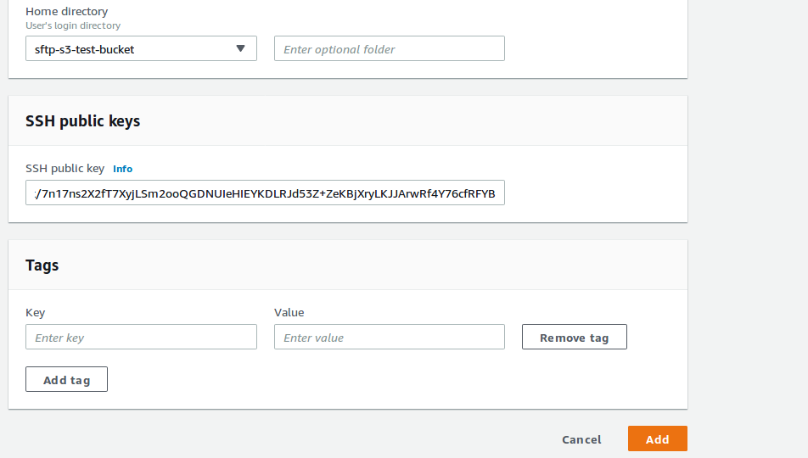
==> Select Add.

==>Successfully created user sftptestuser.

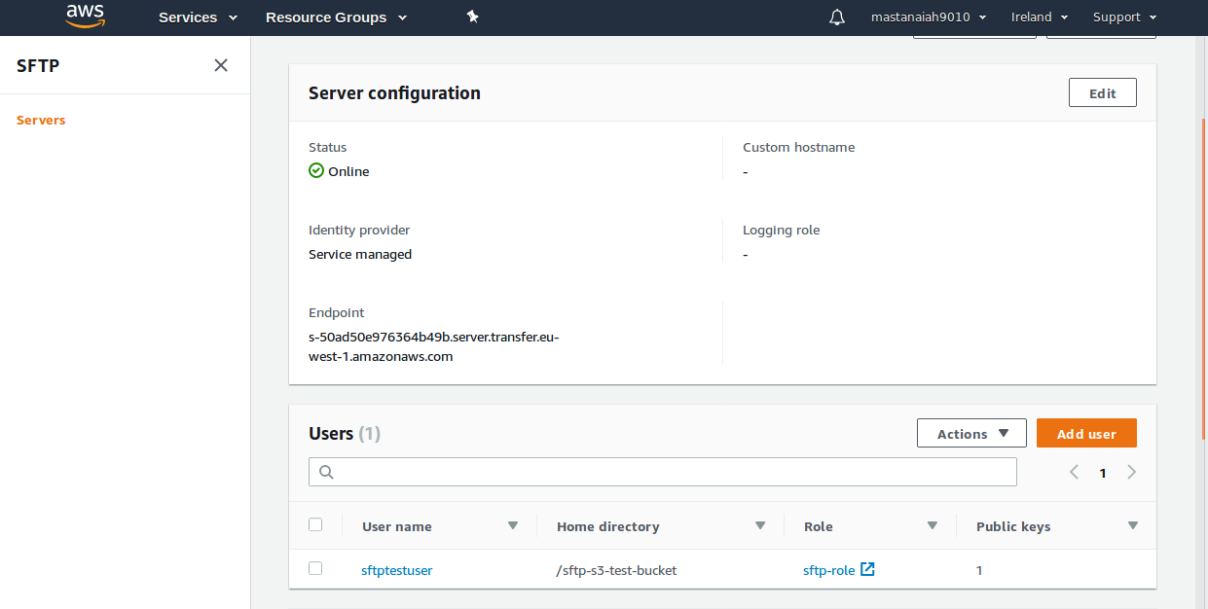

Take endpoint to connect SFTP server:

s-50ad50e976364b49b.server.transfer.eu-west-1.amazonaws.com

STEP 6:-Connect to EC2 Machine.

==> First Connect to Linux EC2-Instance and run the below command to connect Sftp server.

sftp -i sftp-test-key testuser@YOUR-SFTP-END-POINT

Ssh -i sftp-test-key sftptestuser@s-50ad50e976364b49b.server.transfer.eu-west-1.amazonaws.com

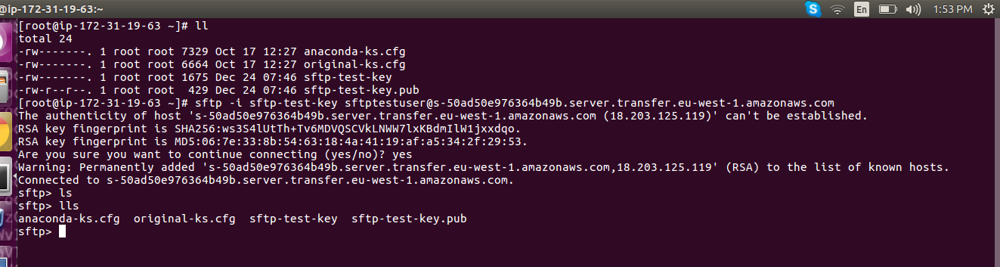
mput sftp-test-key.pub (copying sftp-test-key.pub to s3)

