Setup VPC Flow logs to CloudWatch Log Group.

Setup VPC Flow Logs To CloudWatch Log Group | Investigate or troubleshoot network issues in my VPC?

------------------------------------------------------------------------------------------------->

Pre-requisites:-

Create a CloudWatch Group.

Create a IAM role attacha custom policy.

First Create a VPC.

https://www.youtube.com/watch?v=aczp7gCZZlQ

https://docs.aws.amazon.com/vpc/latest/userguide/flow-logs-cwl.html

https://docs.aws.amazon.com/vpc/latest/userguide/flow-logs-cwl.html

STEP 1:- First Create a CloudWatch Group.

-> Goto AWS Console->Select Services-> Select CloudWatch->Choos CloudWatch.

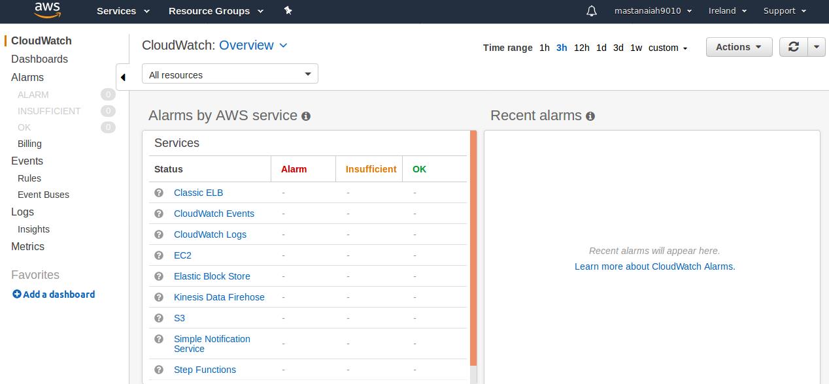

-> From the left side panel select Logs--> Select Create Log group.

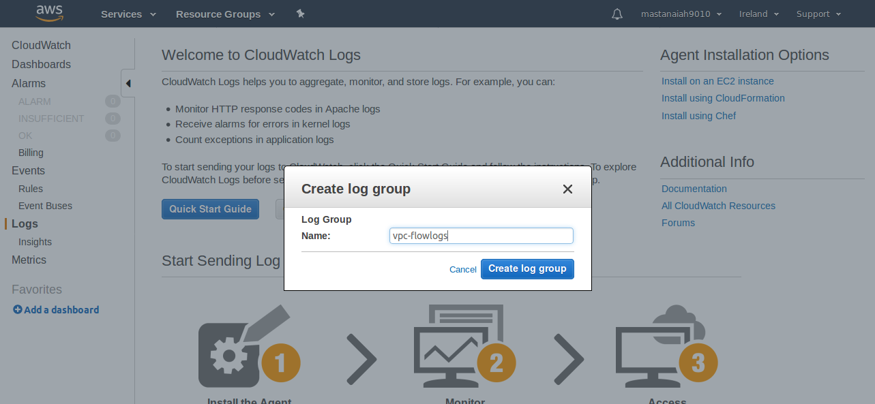
->Select Create log group.

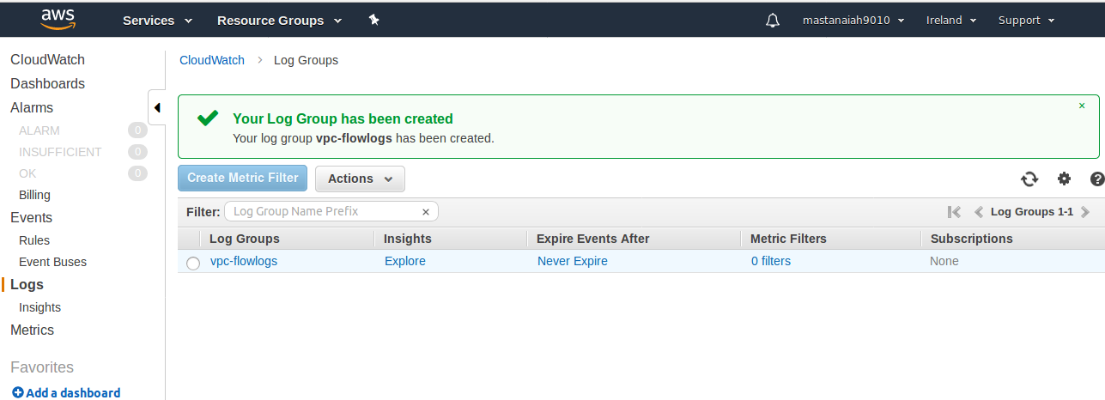
STEP 2:- Create a IAM Role:-

->> Goto AWS Console->Select Services-> Select IAM->From left side panel Select role->

-->Select Create role.

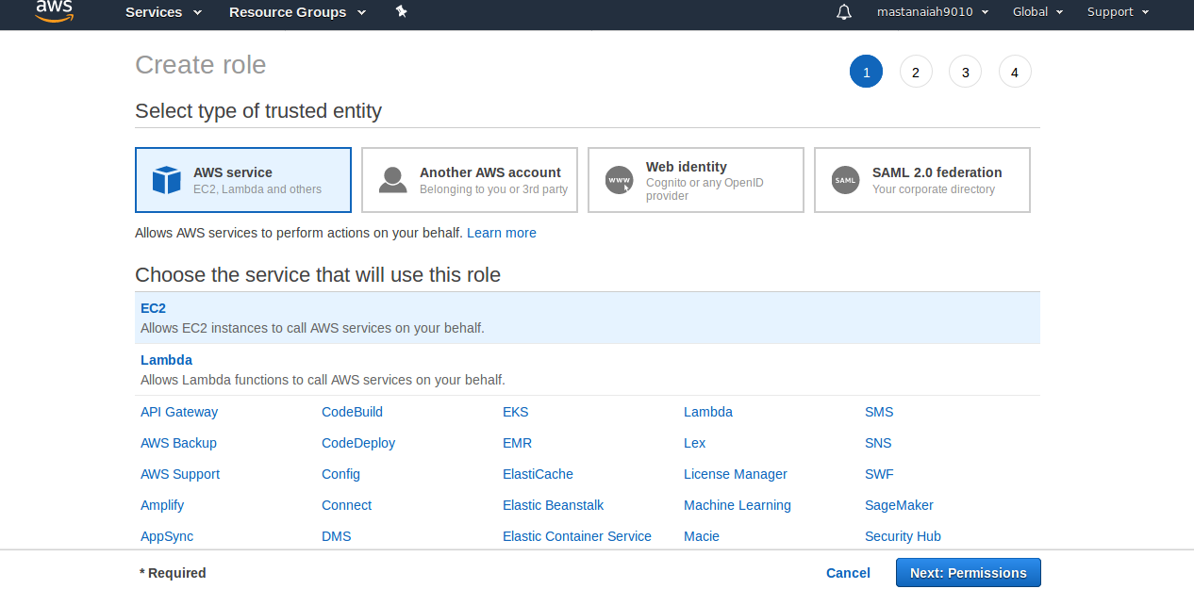

--> Select Permissions.

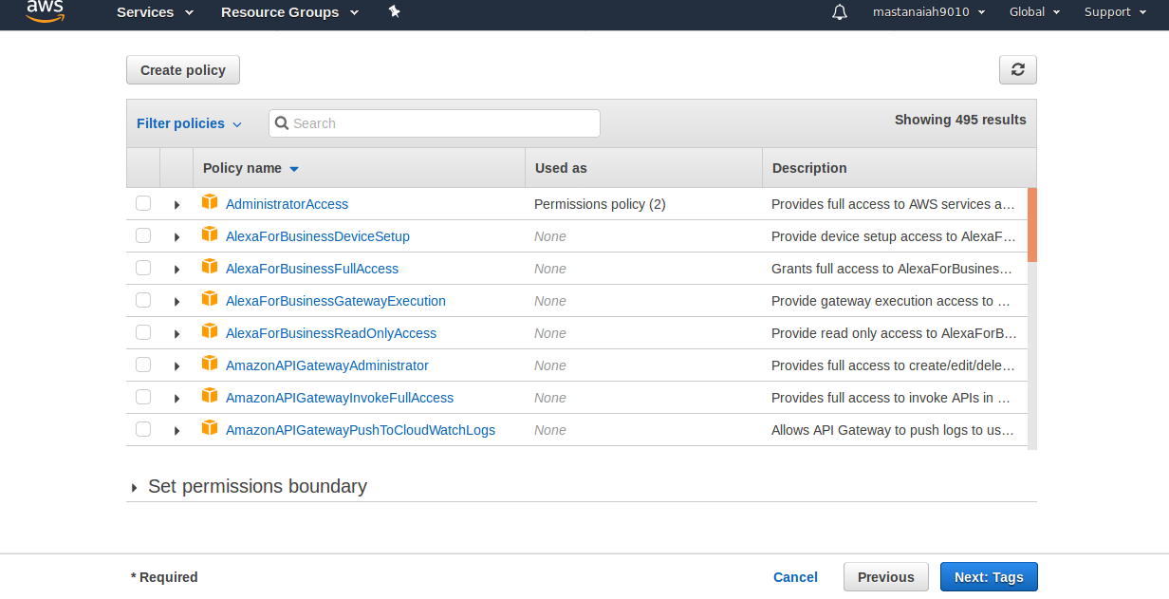
-> Select Tags.--> Select review.

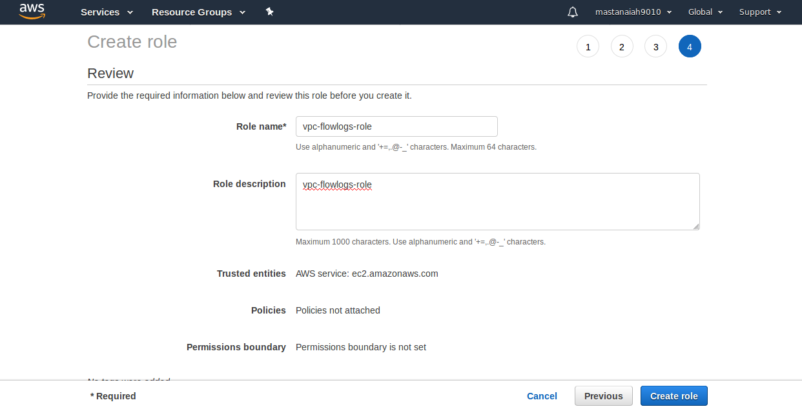
-> Select Create role.

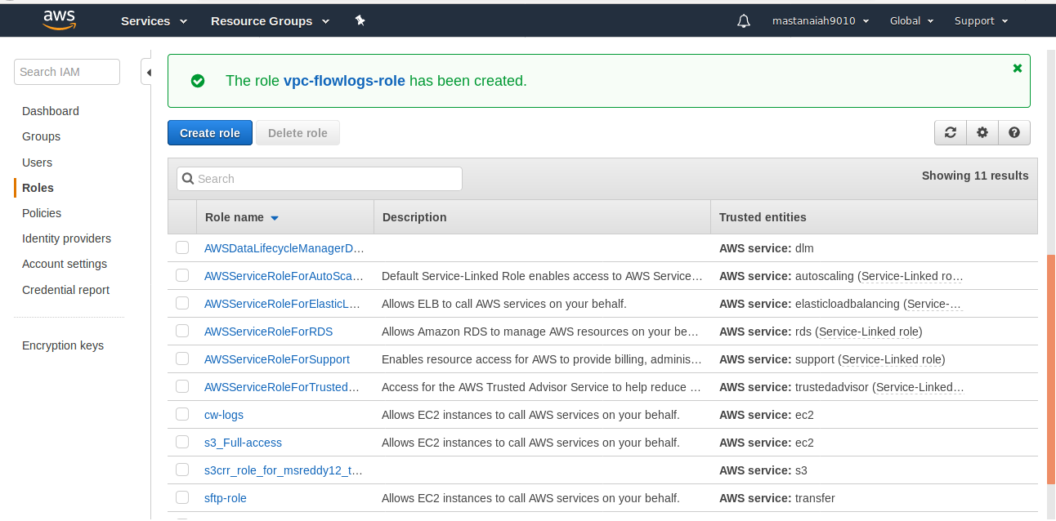

Select vpc-flowlogs-role.

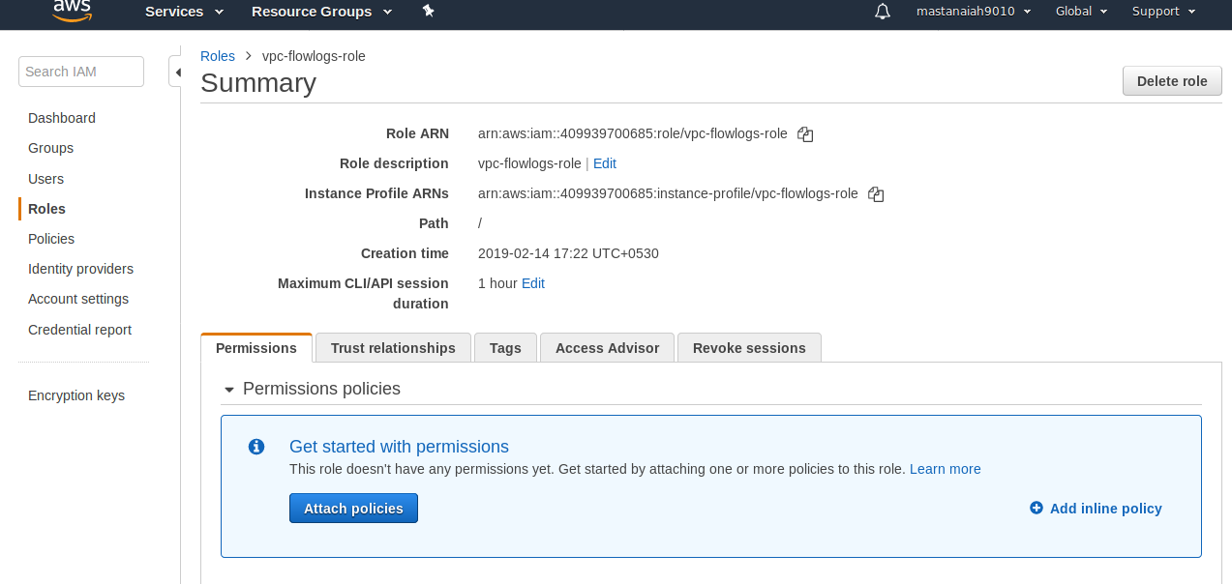

Select Add Inline policy.

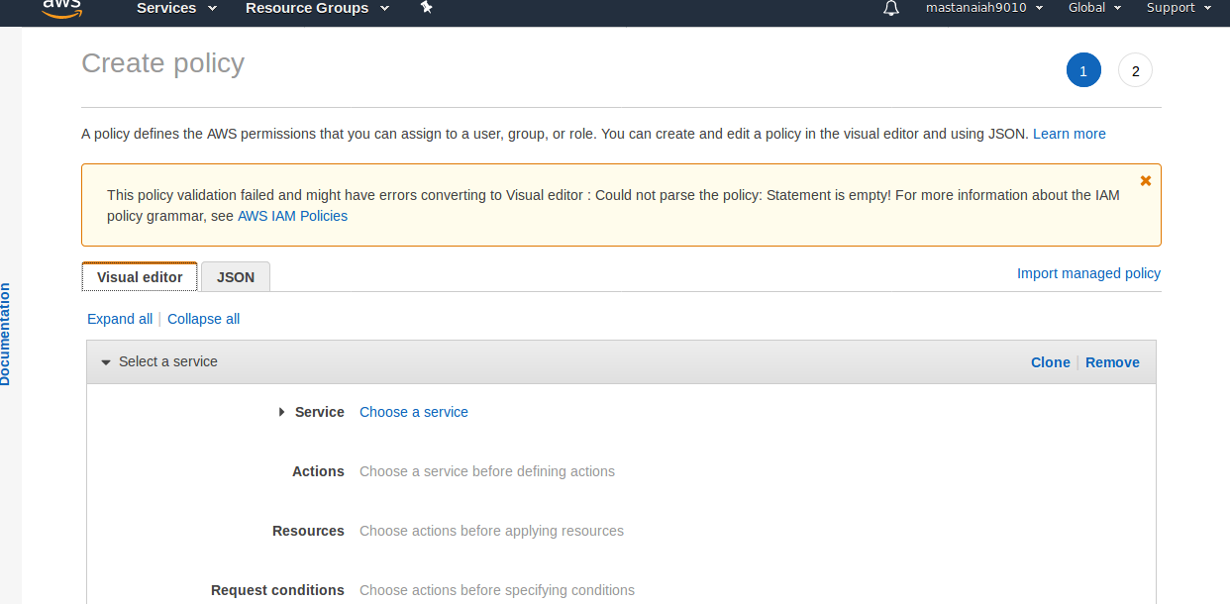

->Select JSON.

->Replace with the below Code.

{ "Version": "2012-10-17", "Statement": [ { "Action": [ "logs:CreateLogGroup", "logs:CreateLogStream", "logs:PutLogEvents", "logs:DescribeLogGroups", "logs:DescribeLogStreams" ], "Effect": "Allow", "Resource": "*" } ] }

Ref Link:

https://docs.aws.amazon.com/vpc/latest/userguide/flow-logs-cwl.html

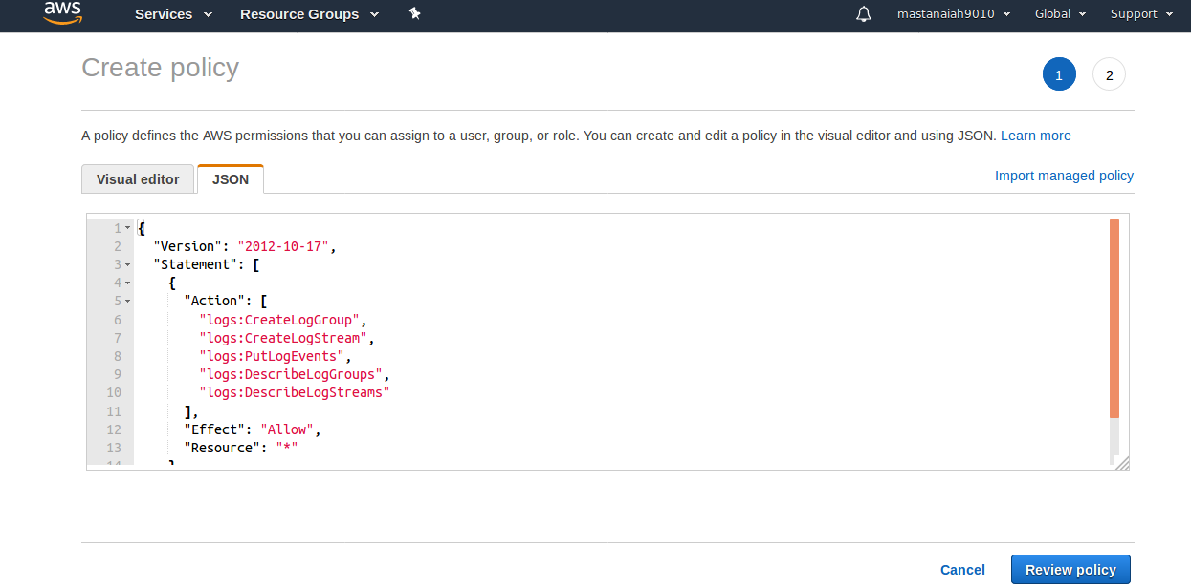
->Select Review policy.

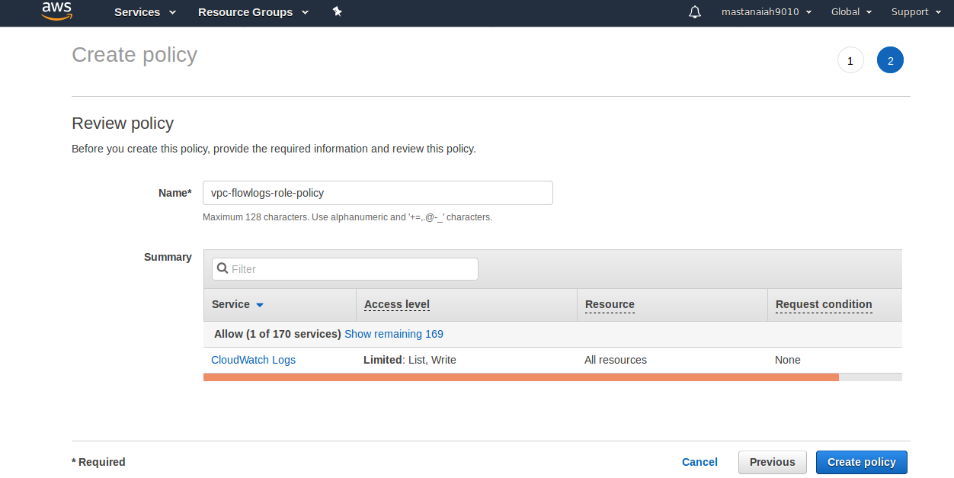

->Select Create policy.

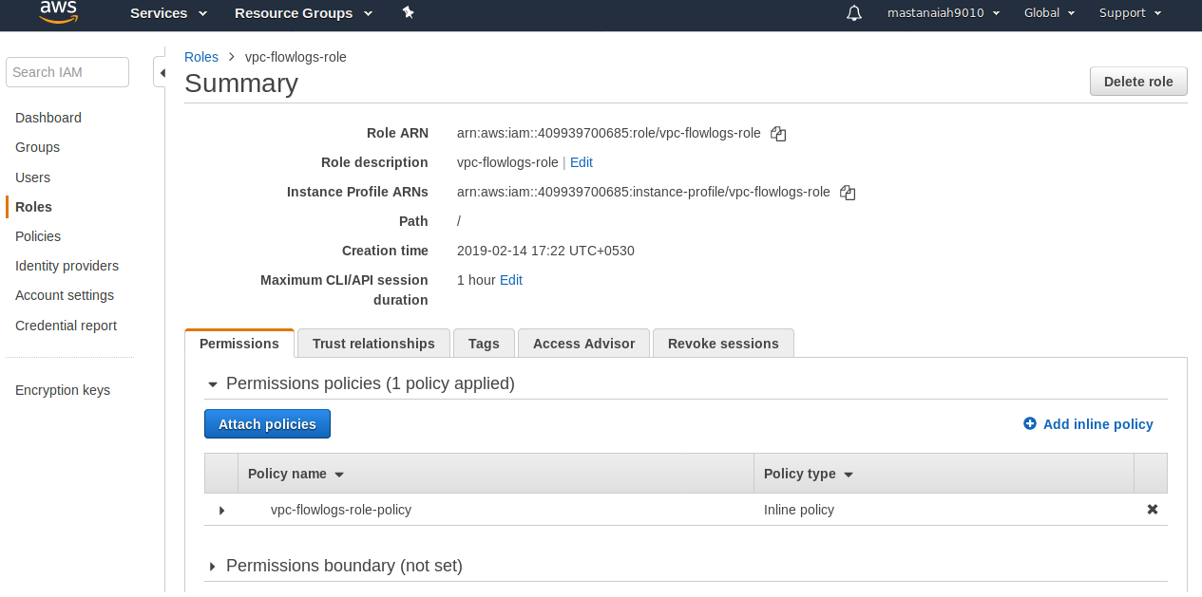

->Select Trust Relationships --> Select Edit trust relations ship.

->Copy the below code into Edit trust relations ship.

{ "Version": "2012-10-17", "Statement": [ { "Sid": "", "Effect": "Allow", "Principal": { "Service": "vpc-flow-logs.amazonaws.com" }, "Action": "sts:AssumeRole" } ] }

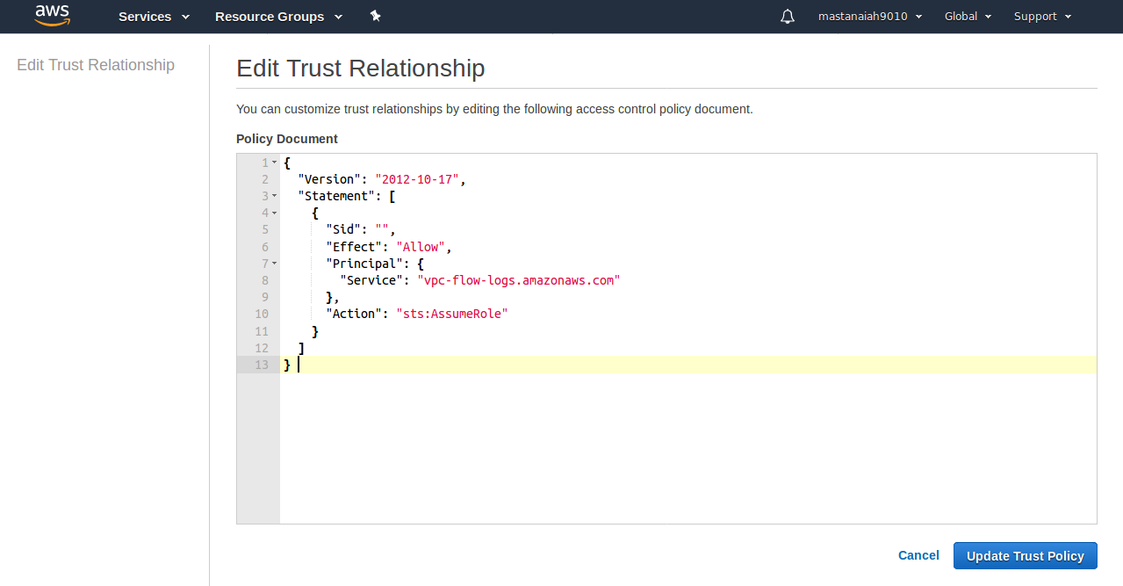

->Select Update trust Policy.

STEP 3:- Create a VPC.

STEP 4:- Goto VPC Dash board.

-> Goto AWS Console->Select Services-> Select VPC->Choose your VPC.

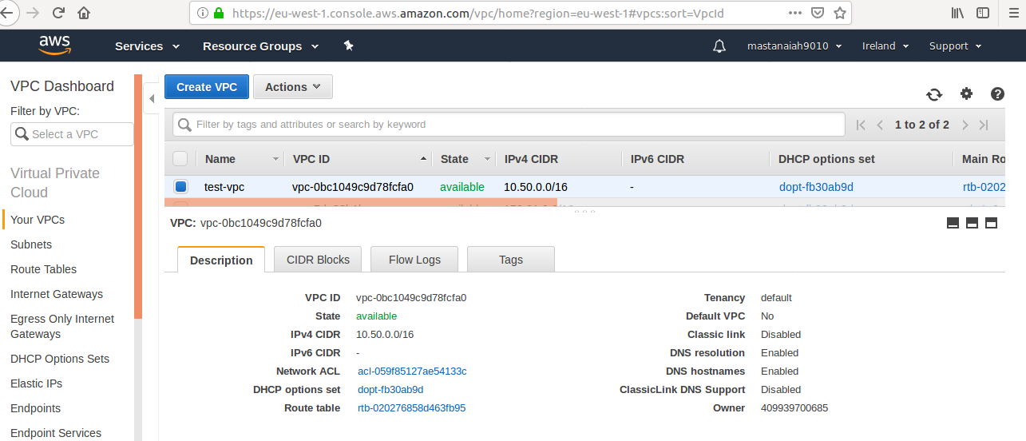

--> Select Flow Logs.

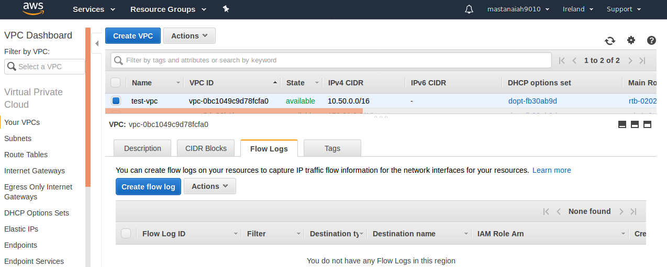

Select Create Flow log-->

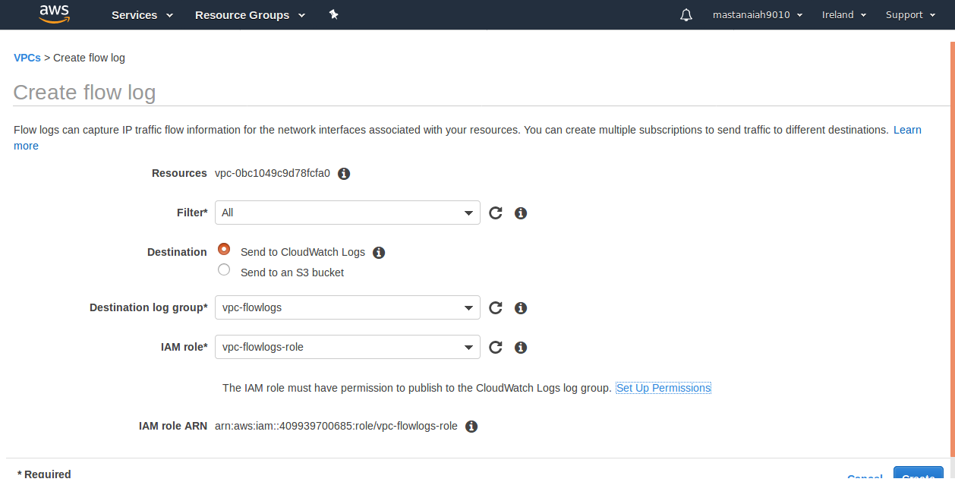
From VPC Dash Board.

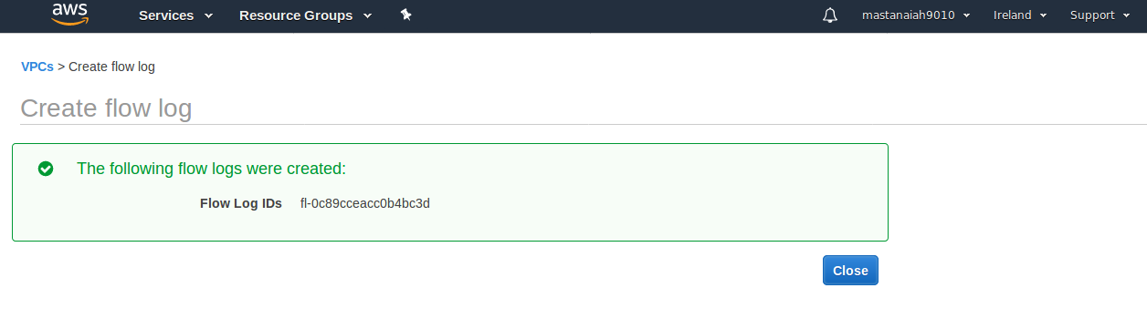
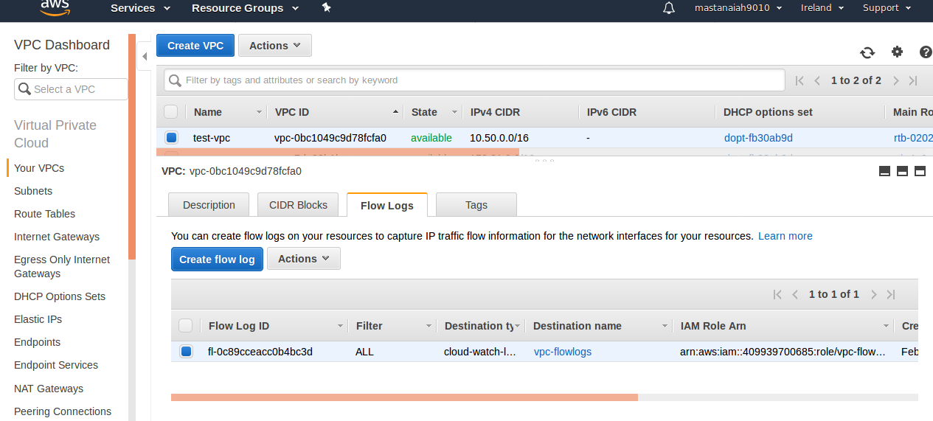
Next goto CloudWatch Dashboard.

-> From Left side panel Select Logs->

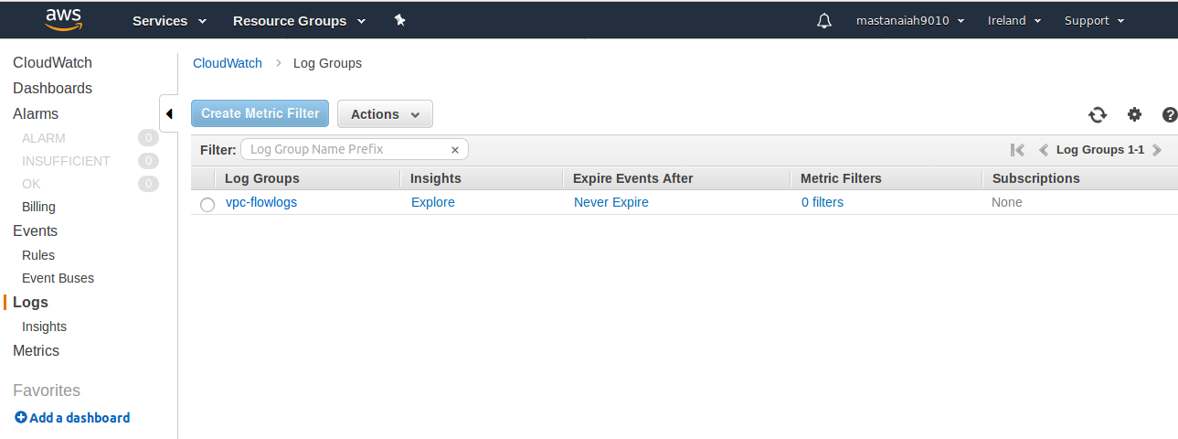
Select vpc-flowlogs.

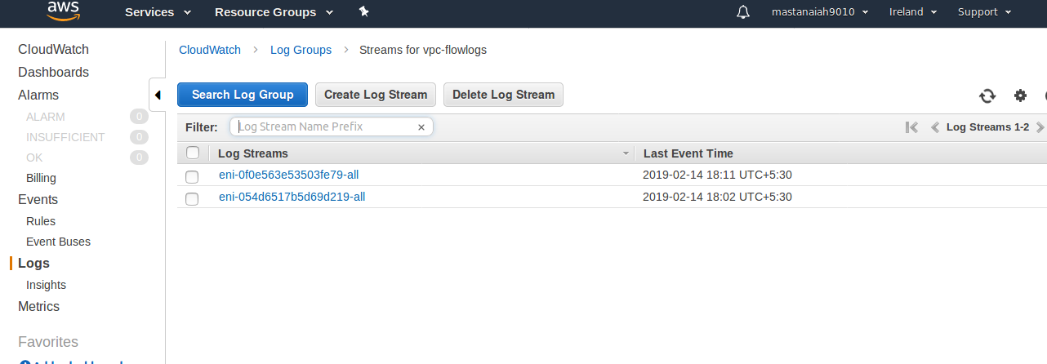
Select any of the above shows like below logs.

