Topic:-

SonarQube Installation

SonarQube Integration with Jenkins

Pre-Requisites for SonarQube Installation:-
Lanuch 1 EC2-Instance and 1 RDS Instance.
Download stable SonarQube version from below website and place it in EC2-Instance.
Ref:-
https://www.youtube.com/watch?v=zRQrcAi9UdU
STEP 1:- Lanuch one EC2-Instance and One RDS Instance.
=>First Launch EC2-Instance.
==>Goto AWS Console=>Select Services=>Select EC2=>Select SecuiryGroups=>Create Security Group=>
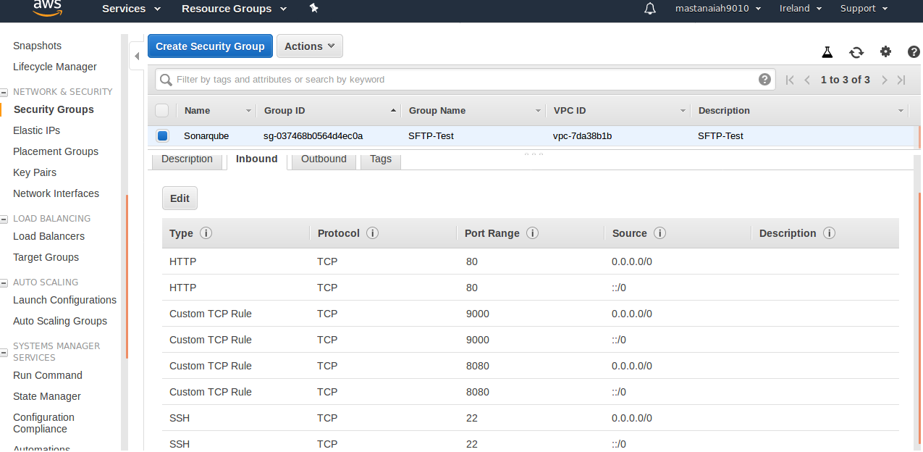

==>Goto AWS Console=>Select Services=>Select EC2=>Select Launch Instance=>Choose AMI and launch=>
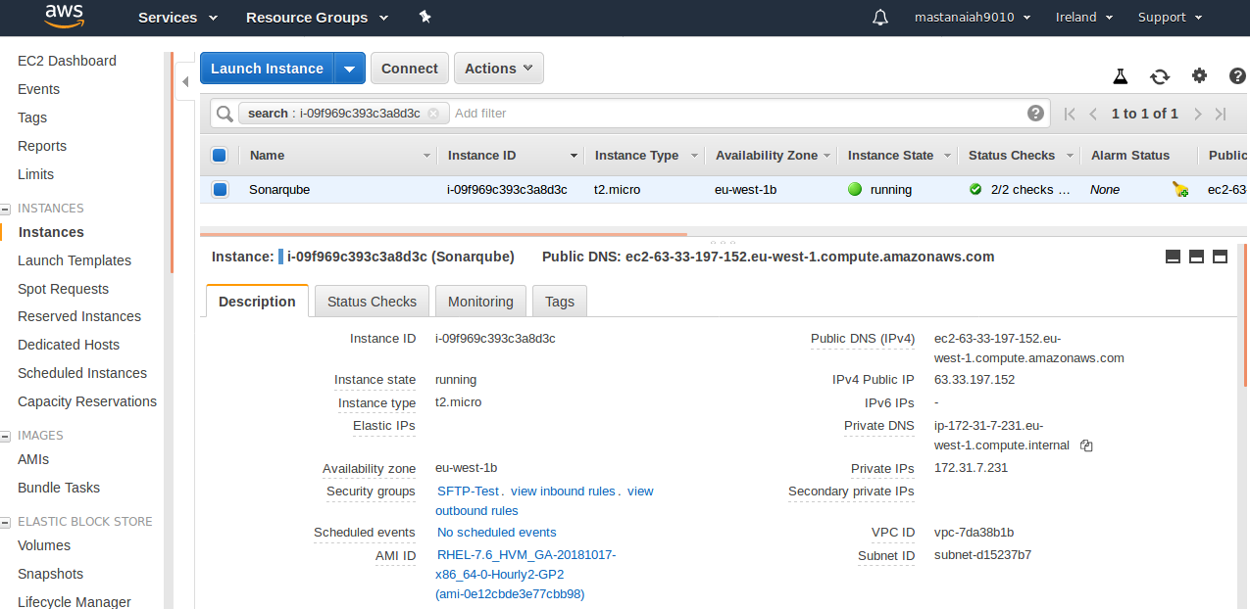
=> Connect to EC2-Instance.
=> Instanall java
# yum install java* -y
=>Check Java Version
# java -version
=> Install MYSQL Client version to connect RDS server.
# yum install mysql* -y
# yum install mysql
=> Install wget & unzip
# yum install wget unzip -y
=>Download Stable SonarQube version from below website.
https://www.sonarqube.org/downloads/
=>Download & Unzip SonarQube 6.0
# cd /opt
# wget https://binaries.sonarsource.com/Distribution/sonarqube/sonarqube-6.0.zip
# unzip sonarqube-6.0.zip
# mv sonarqube-6.0 sonar
STEP 2:- Create a RDS Instance (MYSQL)
=> Create a Security Group for RDS Instance.
==>Goto AWS Console=>Select Services=>Select EC2=>Select SecuiryGroups=>Create Security Group=>

Allow RDS instance security group to access SonarQube server
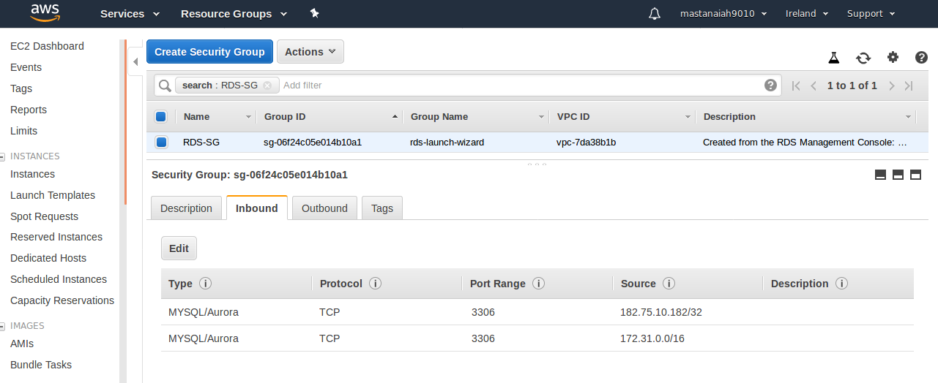
==>Goto AWS Console=>Select Services=>Select RDS=>Select Create database=>Select MySql=> Select Next=> Here give all configuration details like,
DB Instance Identifier : sonarqubedb
Master Username and Password: sonarqube
Database Name : sonarqube
==>finally Select Create Database.
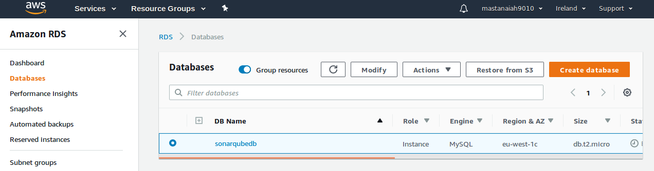
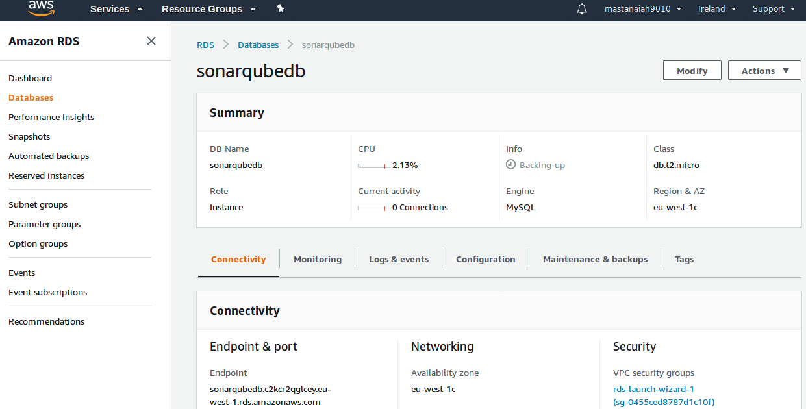

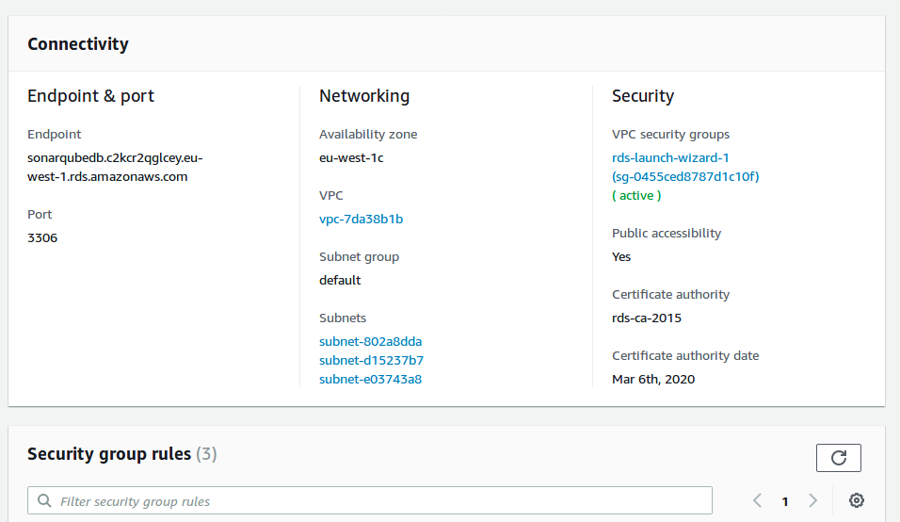
STEP 3:- Connect RDS Instance with Database Credentials from EC2-Instance.
# mysql -h <RDS_Instance_endpoint> -u <DB_USER_NAME> -p <DB_PASSWORD>
# mysql -h sonarqubedb.c2kcr2qglcey.eu-west-1.rds.amazonaws.com -u sonarqube -p
(here prompts passwd for sonarqube)
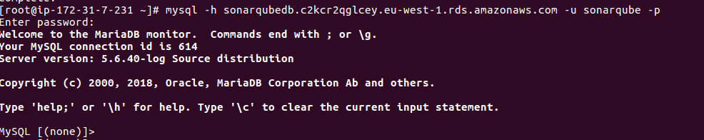
STEP 4:- Create a new Sonar database.
# CREATE DATABASE sonar CHARACTER SET utf8 COLLATE utf8_general_ci;

STEP 5:- Create a local and a remote user:

# CREATE USER sonar@localhost IDENTIFIED BY 'sonar';

# CREATE USER sonar@'%' IDENTIFIED BY 'sonar';

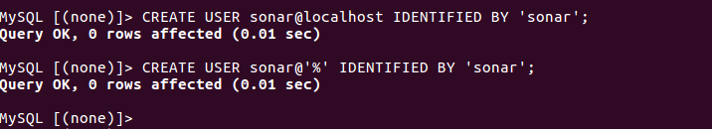

STEP 6:- Grant database access permissions to users.
# GRANT ALL ON sonar.* TO sonar@localhost;

# GRANT ALL ON sonar.* TO sonar@'%';

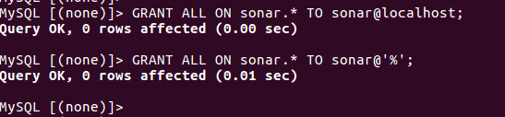

STEP 7:- Check users and databases (Excute all below commands)
# use mysql;

# show databases;
# SELECT User FROM mysql.user;
# FLUSH PRIVILEGES;
# QUIT
STEP 8:- Let’s Jump back to your EC2 instance and enable SonarQube properties file to connect RDS Database.
=> Goto /opt/sonar/conf/sonar.properties file .
Edit sonar.properties file to uncomment and provide required information for below properties.
sonar.jdbc.username=sonar
- sonar.jdbc.password=sonar
- sonar.jdbc.url=jdbc:mysql://<RDS_DATABAE_ENDPOINT>:3306/sonar?useUnicode=true&characterEncoding=utf8&rewriteBatchedStatements=true&useConfigs=maxPerformance&useSSL=false
- sonar.web.host=0.0.0.0
- sonar.web.context=/sonar

sonar.jdbc.username=sonar
sonar.jdbc.password=sonar
sonar.jdbc.url=jdbc:mysql://sonarqubedb.c2kcr2qglcey.eu-west-1.rds.amazonaws.com:3306/sonar?useUnicode=true&characterEncoding=utf8&rewriteBatchedStatements=true&useConfigs=maxPerformance
sonar.web.host=0.0.0.0
sonar.web.context=/sonar

STEP 9:- Start SonarQube service.

# cd /opt/sonar/bin/linux-x86-64/
# ./sonar.sh start
# ./sonar.sh status

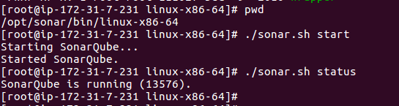
STEP 10:- SonarQube application uses port 9000. access SonarQube from browser

# http://<EC2_PUBLIC_IP>:9000/sonar
# http://63.33.197.152:9000/sonar/

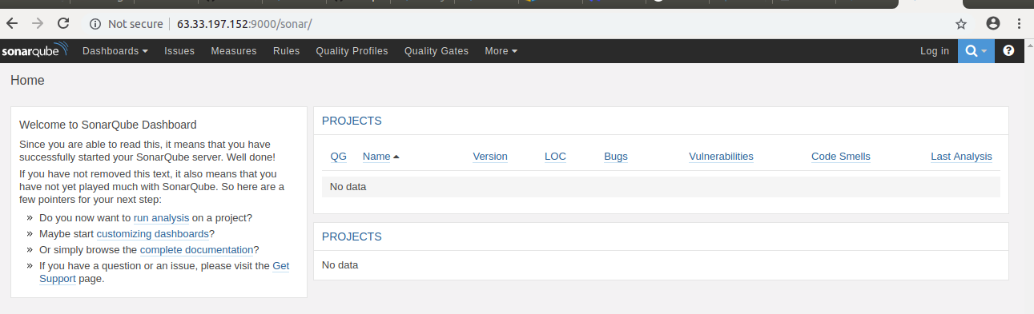
STEP 11:-If you want to login (Default user name & Password: admin)
=> After login with default user name & Passwd page will come like below,
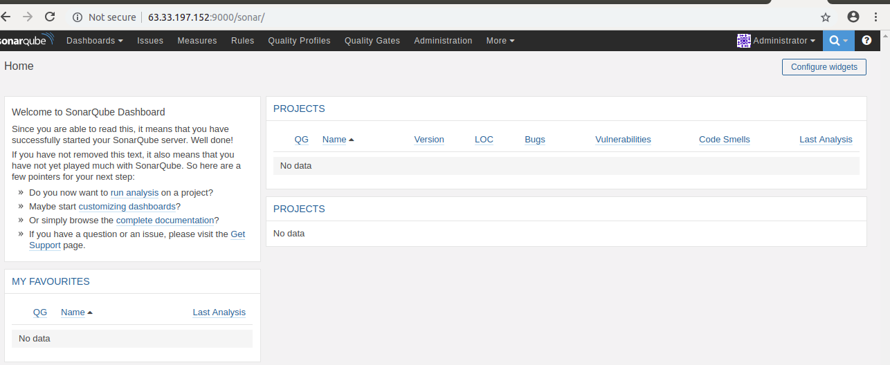
STEP 12:-Run SonarQube as a default service
Implement SonarQube server as a service

Ref:
https://www.oreilly.com/library/view/sonar-code-quality/9781849517867/ch02s05.html
=>Create the file /etc/init.d/sonar with the Vim or Nano editor:
# /etc/init.d

#Append the following lines and save it in sonar file
#! /bin/sh
/usr/bin/sonar $*

# vi sonar
#! /bin/sh
/usr/bin/sonar $*
:wq!
=>sudo ln -s /home/user/development/servers/sonar-2.11/bin/linux-x86-32/sonar.sh /usr/bin/sonar
sudo chmod 755 /etc/init.d/sonar
cd /etc /init.d
sonar defaults
/bin/sonar start
/bin/sonar status

SonarQube Installation Completed.........!!!

SonarQube Integration with Jenkins:-
Pre-requisites for SonarQube Integration with Jenkins:
=> Lanuch One EC2-Instance and Install Jenkins and SonarQube Scanner.

STEP 1:- Launch One EC2-Instance.
=> Launch One EC2-Instance and Install Java,Jenkins and SonarQube Scanner.
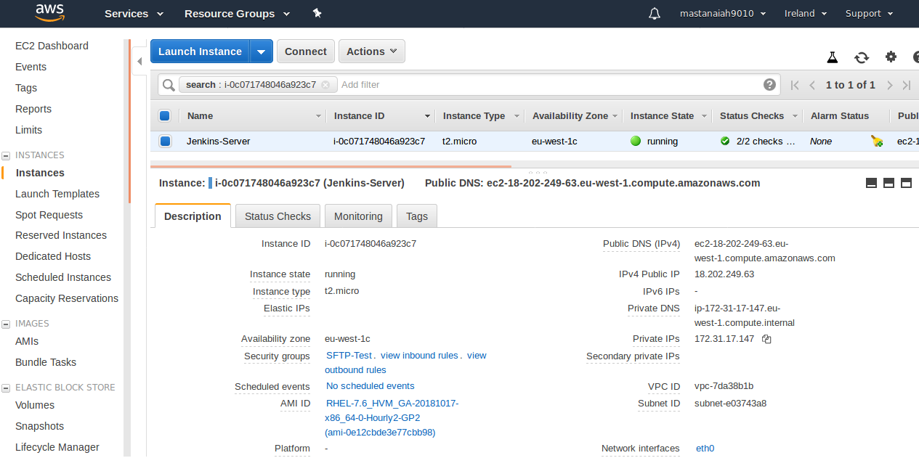
STEP 2:- Connect To EC2-Instance and Install Java, git and wget unzip packages.
# yum install wget unzip -y
# yum install git -y
# yum install java* -y
STEP 3:- Install Jenknis. (Ref below link to Install Jenkins on Redhat 7)
https://wiki.jenkins.io/display/JENKINS/Installing+Jenkins+on+Red+Hat+distributions
# sudo wget -O /etc/yum.repos.d/jenkins.repo http://pkg.jenkins-ci.org/redhat/jenkins.repo
# sudo rpm --import https://jenkins-ci.org/redhat/jenkins-ci.org.key
# sudo yum install jenkins -y
# sudo service jenkins start
# service jenkins status
# chkconfig jenkins on
==> Jenkins run on Port 8080. (http://18.202.249.63:8080/)
==> Jenkins is up and running now.

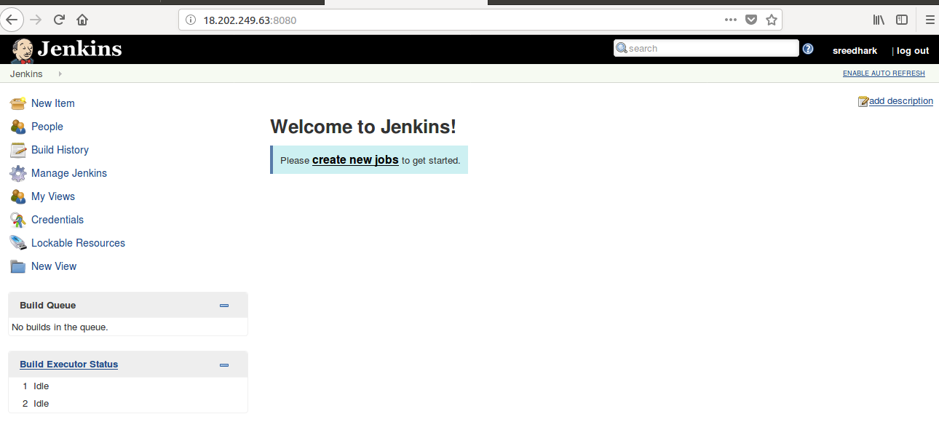
STEP 4:- Install SonarQube Scanner.
=> SonarQube Scanner URL:
https://docs.sonarqube.org/display/SCAN/Analyzing+with+SonarQube+Scanner

# cd /opt
# wget https://binaries.sonarsource.com/Distribution/sonar-scanner-cli/sonar-scanner-cli-3.2.0.1227-linux.zip
# unzip sonar-scanner-cli-3.2.0.1227-linux.zip
# mv sonar-scanner-3.2.0.1227-linux sonar_scanner

STEP 5:- Set SonarQube Server details in Sonar-Scanner .Properties file.

# cd /opt/sonar_scanner/conf
# vi sonar-scanner.properties
#sonar.host.url=http://localhost:9000 ( by default like this change to like below)
sonar.host.url=http://54.229.10.226:9000 (54.229.10.226 this is SonarQube Server IP)

STEP 6:- Login to Jenkins GUI console and install " SonarQube scanner" plugin.

=> Loign to Jenkins GUI Console=>Manage Jenkins->Manage Plugins->Availabe->SonarQube Scanner.

STEP 7:-Configure SonarQube server name and authentication token in Jenkins GUI
Console.

Manage Jenknis->Configure System->SonarQube Servers->add sonarQube->

Name:SonarQube-server
Server URL: http://54.229.10.226:9000/sonar (This is Sonarqube server Url)
Server Authentication Token: 92c684a27c1cef0d143ef537022d9c91cc052245
(To generate Server Authentication Token login into Sonarqube Server http://54.229.10.226:9000/sonar with default user name and passwd: admin, Once login Select Administrator--> Select MyAccount-->Select Security->Generate Tokens “jenkins_user” click generate.
Ex: 92c684a27c1cef0d143ef537022d9c91cc052245 )
the below is Sonarqube configuration in Jenkins.

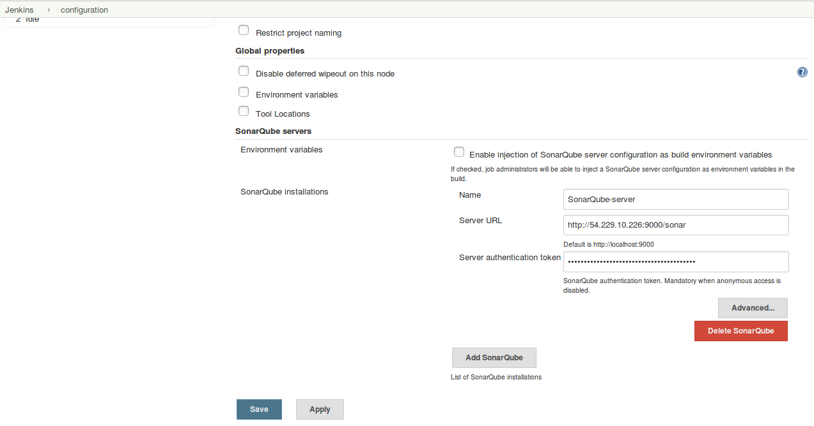
=> Next Select Apply and Save.

STEP 8:- Configure SonarQube scanner home path.

=>Manage Jenkins->Global Tool Configuration->SonarQube Scanner->Add SonarQube Scanner->
Name:Sonar_Scanner
SONNAR_RUNNER_HOME:/opt/sonar_scanner

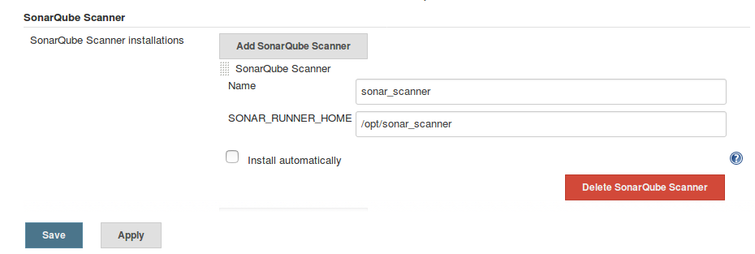
=>Next Select Apply and Save.

STEP 9:- Create a job to test SonarQube. Provide below sonar properties details in the job under build
=>Login to Jenkins Console->Create a Sample Job.
-> Select New Item-> Enter Item Name:”Sonarqube_sample job”-> Select FreeStyle Project->
-> Select Ok.-> Source Code Management-> Select Git and give github url.

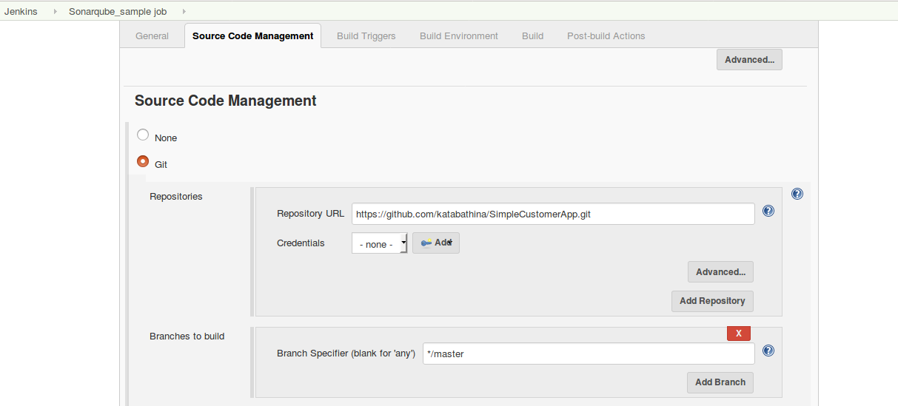
-->Next Build Section:
-> Select Execute SonarQube Scanner.
-> here Analysis Properties (it is mandatary) to fill with below details.
sonar.projectKey=Valaxy
sonar.projectName=ValaxyDemo
sonar.projectVersion=1.0
sonar.sources=/var/lib/jenkins/workspace/$JOB_NAME/<PROJECT_NAME>/src
Ex:- sonar.sources=/var/lib/jenkins/workspace/$JOB_NAME/SimpleCustomerApp/src

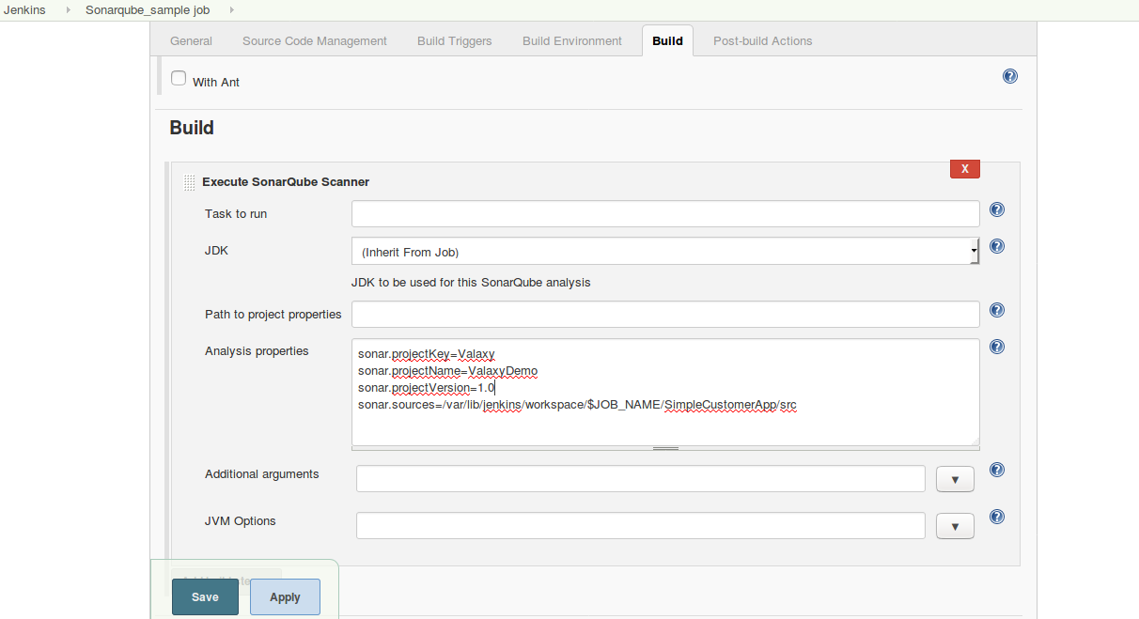
=> Next Select Apply and Save.
==> Next Build Job “Sonarqube_sample job”.
STEP 10 :- Build Success-->Goto Console Output.
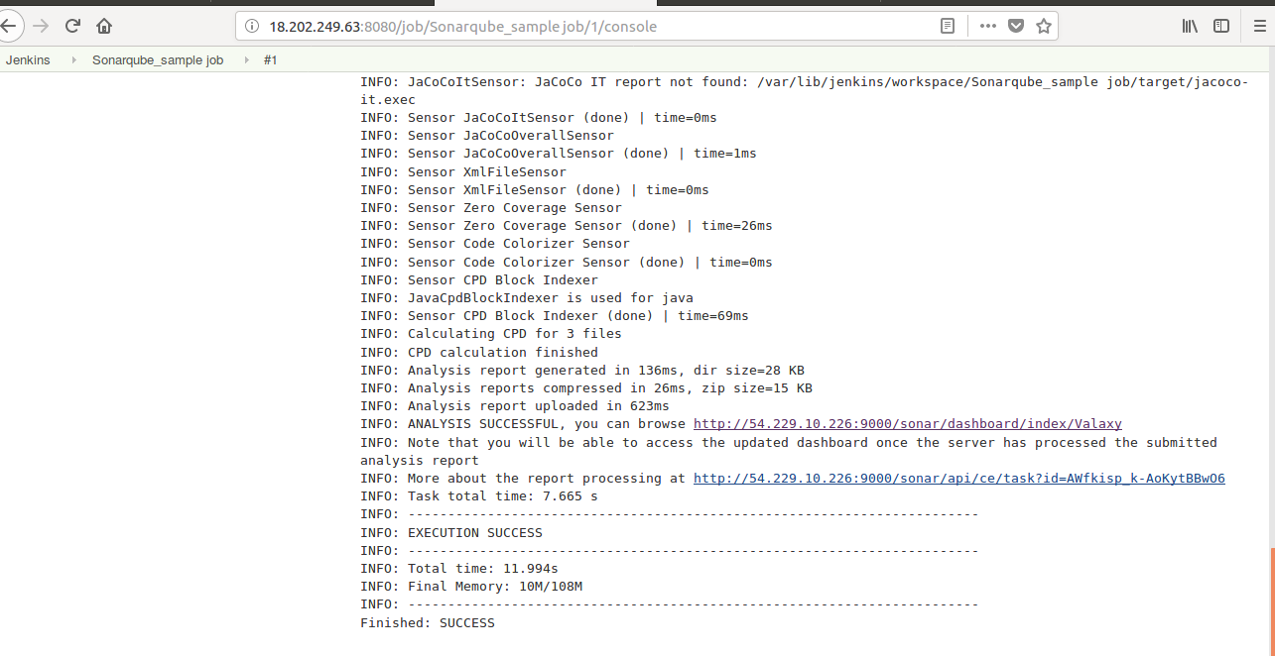

STEP 11:-If Click below link from Console Output, it will take you too Sonarqube Console page.
INFO: ANALYSIS SUCCESSFUL, you can browse http://54.229.10.226:9000/sonar/dashboard/index/Valaxy

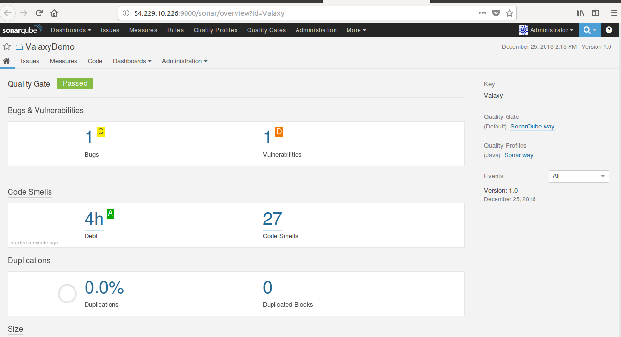
STEP 12:- If you want Customize Report:-
SonarQube Console-> Under Dashboards Select Custom, it will give Custom dash board Analysis.

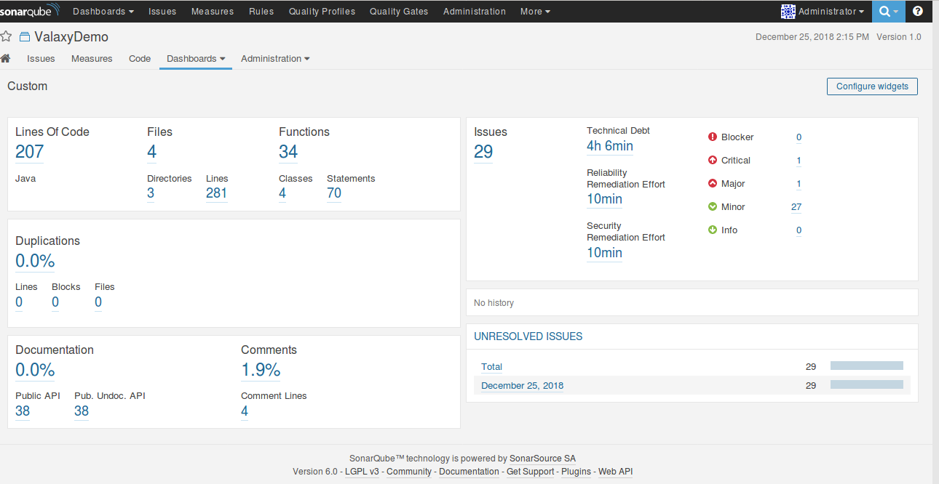

Ref Links:-
https://www.youtube.com/watch?v=k-3krTRuAFA
https://www.youtube.com/watch?v=zRQrcAi9UdU

SonarQube Integration with Jenkins Completed.....!!!!

