=>What is .htaccess file?

.htaccess Stands for hypertext access. This is the default name of the apache directory-level configuration file. This file can be used to create security restictions for particular directories.
One of the most common uses is to require user authentication in order to server certain web pages.

==>You should use the httpd.conf file to place restrictions on your server. Only then you use .htaccess, to furthur restrict the already allowed users.

==>Do not ever use .htaccess to handle secure or priviliged content, like user data.

==>.htaccess file is loaded every time a webpage is requested, incurring a performance loss.

=>I have already Sample web page in Apache.

(the default page file location is /var /www/html/index.html>

cat index.html
</h1>This is sample web page</h1>

=> Check in the browser with IP default page will come like below.

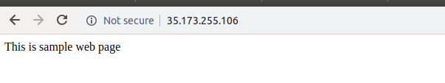
=> Create a directory in “/var/www/html” location.

=> mkdir documents
=> cd documents
=> here create a some sample files and directories.

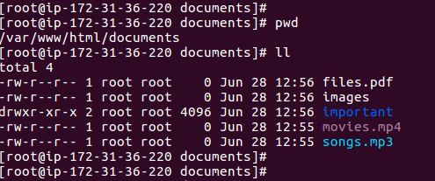

=> Go and check in the browser you can able to access all files and directory under documents directory.

(Ip/documents)

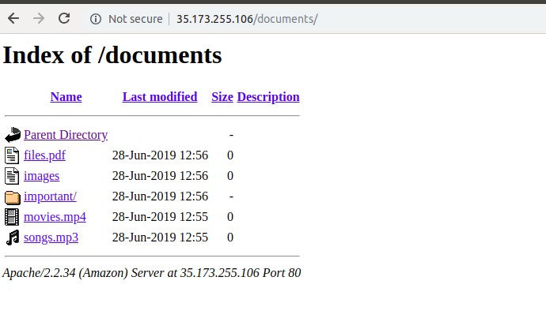
=> If you want to restict accessing documents directories you can create .htaccess file under documetns directory means (/var/www/html/documents)

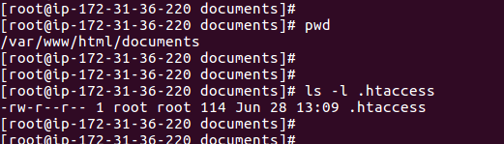

=> Inside .htaccess file have to put some entries.

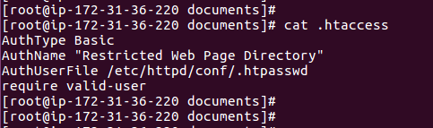

Note: “AuthUserFile /etc/httpd/conf/.htpasswd” this means we are storing users and passwd in .htpasswd location.

=>Crate a user and password for .htpasswd file.

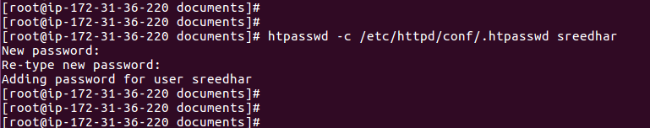
=>here User and Encrypted passwd showing like this.

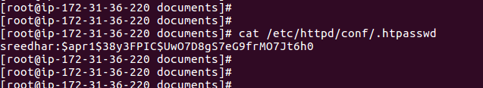
=>Goto “Apache Configuration file” and Create a “directory tab” last

vi /etc/httpd/conf/httpd.conf

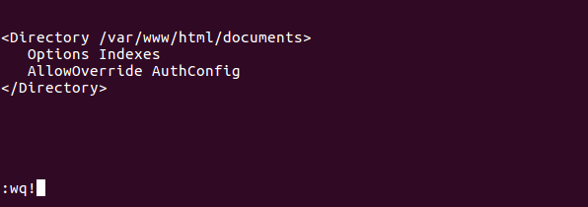
=>Restart the Apache service.

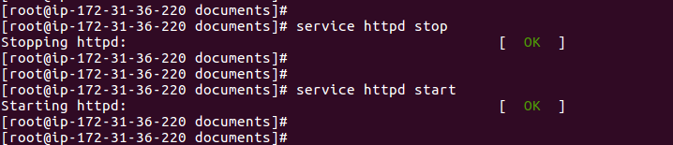

=> Now go and check in browser <http://35.173.255.106/documents> it will ask user and name.

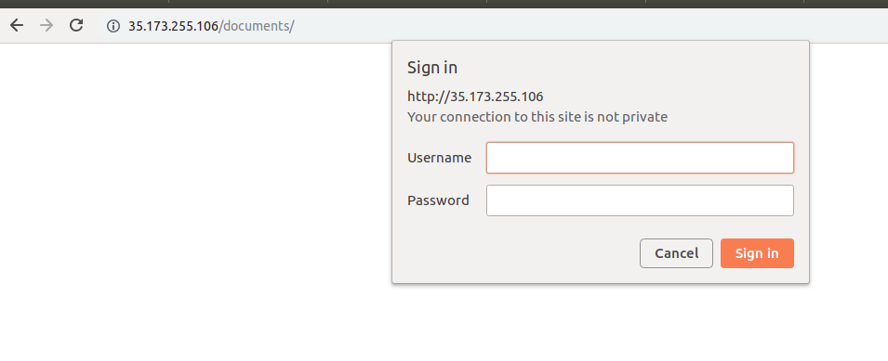
=>Now if you give Username and passwd then it will give access.

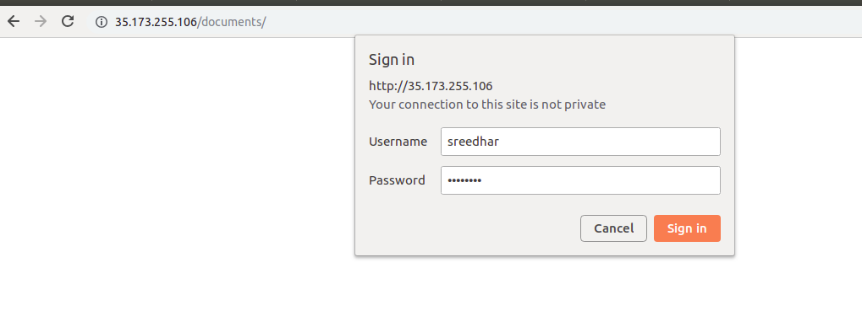

=> click Sign in.

