Jenkins:-

!. Jenkins Introduction:-

- Java Application
- used for continuous integration and continuous delivery

STEP 1:- Download Jenkins

STEP 2:- Place the war file into any location on your system.

STEP 3:- Goto command prompt (windows) || terminal (mac/linux)
- goto folder where jenkins.war is
- java -jar jenkins.war

(admin key will get)

STEP 4:- Goto browser – http://localhost:8080

STEP 5:- Install required plugins.

STEP 6:- Get started with jenkins home window.

How to Setup jenkins on Tomcat:-

Why?

Running Jenkins Standalone (jetty/winstone) Vs Running jenkins on tomcat.

****Tomcat5 or Above******
***java (7 or above) should be available.

JAVA Environment Variable Setup in Windows

This PC==>(R Click) Properties ==>Advanced System Settings ==> Environment Variables ==>

(Click) System Variables ==>

Variable Name :JAVA_HOME
Variable Value :C:\Program Files\java\jdk1.8.0_7.1
and save.

Next Select PATH

Variable name : PATH
Variable Value : C:\Program Files\java\jdk1.8.0_7.1\bin

next restart is required.
Goto commmand promt

java -version

https://www.youtube.com/watch?v=BN7LZ3ygn_0 jenkins installation in windows(polarpu prasad)

STEP 1:- Download Tomcat

STEP 2:- Unzip and place tomcat folder folder at any location.

STEP 3:- Copy/Place the jenkins.war file inside Tomcat/webapps folder.

STEP 4:- Goto Commandprompt (cmd) -window || Terminal (Mac/Linux)
goto tomcat/bin directory.

Make all the files executables :chmod +X *.sh

STEP 5:- Start Tomcat: ./Startup.sh
(To shutdown tomcat: ./shutdown.sh)

STEP 6:- Verify if tomcat started : browser – http://localhost:8080

STEP 7:- Verify if jenkins is running on tomcat – http://localhost:8080/jenkins

Standalone Jenkins running with different port number:-

*** To start jenkins (standalone) on differnt port ***

Java -jar jenkins.war - - httpPort=9090

How to change Home Directory

Jenkins Home Directory Contains:

1. All configurations
2. Pluggins
3. Job details
4. Logs

Why?

To move jenkins home directory to a location that has enough disk space.
Project requirement.

STEP 1: - check your current home directory.

Jenkins => manage jenkins => configure system =>

here you will see your current home directory.

STEP 2:- Create a new folder (Which will be new home directory)

STEP 3:- Copy all data from old directory to new directory.

STEP 4:- change environment variable JENKINS_HOME and set it to new directory.

Windows = change environment variable
Mac/ Linux = Goto terminal

export JENKINS_HOME=/Users/raghav/Desktop/Tools/Jenkins/JenkinsHome/

Perminent Environment Variable in MAC/Linux

under .bash_profile
export JENKINS_HOME=/Users/raghav/Desktop/Tools/Jenkins/JenkinsHome/
:wq!

STEP 5:- restart Jenkins

How to Use CLI (Command Line Interface)

STEP 1:- Start Jenkins

STEP 2:- Goto Manage Jenkins => Configure global security => enable security.

STEP 3:- goto http://localhost:8080/cli

STEP 4:- downlaod jenkins-cli jar. Place at any location.

STEP 5:- test the jenkins command line is working.

!!. How to Create Users + Manage + Assign Roles:-

How to create new users

How to configure new users

How to Create new roles

How to assign users to roles

How to control user access on projects

STEP 1:- How to Create New Users

Goto Jenkins Console --> Click on Manage Jenkins --> Select Manage Users -->

click on Create User.

here
Username : User1
Password:*****
Confirm Password:*****
Full Name: User one

STEP 2:- Configure Users.

Whenever login to the Jenkins top right corner username (User One) will be there.

Click User One besides drop down==>click Configure.==> here you will see the configure
window of perticular user(User One).

STEP 3:- Create and Manage Users Roles.

Create and Manage Users role to do that Roles Strategy Plugin is required.

Multiple ways we can do this Roles Strategy Plugin

==> 1.Goto browser --> Roles strategy plugin

https://wiki.jenkins.io/display/JENKINS/Role+Strategy+Plugin

download the role strategy plugin and put it in==> jenkins home directory--> plugins-->

after that restart jenkins.

OR

==> 2. Goto Jenkins Console-->Manage Jenkins--> click on Manage Plugins-->

here updates available installed advanced-----> select available and search Role strategy plugin.

-->After installed jenkins restart is required.

(Role Based Authorization Strategy)

OR

==> 3 .if already downloaded the hpi plugin

Goto Jenkins Console-->Manage Jenkins--> click on Manage Plugins-->

here updates available installed advanced-----> select advanced

choose the pluging and upload.

-->After installed jenkins restart is required

====>

STEP 4:-

Goto Jenkins Console==>Manage Jenkins==> configure global Security=>

make sure enable security enabled

inside authorization section ==> find and select role-based strategy.(this option will come only after plugin installed and jenkins is restarted)

next apply and save.

===>Goto Jenkins--> Manage Jenkins-->Manage and Assign role(you will get this only after select role based strategy)--> here is below

Manage Roles,
Assign Roles,
Role Strategy Macros.

--> First select Manage Roles-->Here is below

Global Roles,
Project Roles

Next Select on Assign Roles-->here is below

Global Roles,
Project Roles

Basic Configurations:-

STEP 1 :- Manage Jenkins --> Configure Systems

STEP 2:- Get understanding of common/basic Configurations

Home Directory :- This is the jenkins home directory path, If you want you can change the

jenkins home directory path.

If click advanced

Workspace Root Directory
Buildrecord Root Directory

Sysem Message:- this basic sysem message if you want you change.

# of Executors:- jenkins executes parllel jobes based count on number (ex:2 means two jobs runs parllelly)

Lables:-

Usage:-

Quiet Period:-

SCM Checkout retry count:-

Restrict Project Naming:-

Default
Pattern
Role based Strategy

Global Properties:-

Jenkins Location:-

SSH Server:-

Shell:-

!!!. Getting Started with JOBS:-

1. How to Create a basic JOB in Jenkins

2. Basic Job Configurations

3. How to run the JOB remotely

4. How to chain job Execution.

STEP 1:- Goto Jenkins console -->New Item--> add details.

New Item--> Add details-->Select free style project--> click ok-->

General
Source Code Management
Build Triggers
Build
Post-build Actions

the above are the main component build job.

STEP 2 : How to trigger the Job remotly.

Goto any existing job -->Configure--> goto Build triggers--> Select Trigger builds remotely.

Under Build Triggers (Athentication token what ever you want you can give) apply and save.

Goto browser-->

localhost:8080/job/test1/build?tocken=1234
here ip:8080/job/test1/build?tocken=1234

STEP 3: How to chain Job executions:-

for this scenario Create two sample projects Test1, Test2, Test3):-

Goto Jenkins Console--> New Item--> Enter details--> select free style project--> click OK-->

goto build select execute shell (give command exp: pwd) and apply and save.

Goto Jenkins Console --> New Item --> Enter Details --> Select Free Style Project--> Click Ok-->

goto build select execute shell ( give commnad exp pwd)

Goto any of the project and configure ---> Build Triggers choose build after other projects are built.

Projects to watch (Test1)

along with that we can give below of any

Trigger only if build is stable (choose this for now)

Trigger even if the build is unstable

Trigger even if the build fails.

Next Other Session

Post Build Actions---> choose build other Projects--> Projects to build (Test3)--> Trigger Only if

the build is stable.

Next apply and save.

!V. Jenkins Integration with GIT (SCM)

1. Create a Java Program and run it through command line.
2. Create a Jenkins job to run the java program
3. Add this project/program to GIT.
4. Jenkins – add git plugin
5. Configure Jenkins Job to trigger the execution when a change is pushed to Github.

STEP 1:- Create a JAVA Program.

First take a note pad and create a simple java program.

file name will be .java extention(ex: hello.java)

public class hello{

public static void main(String[] args){

for(int i=1;i<=10;i++){

system.out.println(“Hello World ... “+i);
}
}

}

STEP 2:- Create Jenkins job to run the program

Goto Jenkins Dashboard--> New Item-->add details (helloworld)--> free style project--> OK-->

directly goto Build( cd /users/raghava/Desktop/javaProject1
javac Hello.java
java Hello)

STEP 3:- Add project to Git and Github.

Git init
git status
git add .
Git commit -m “added helloworld”

push to remote repository (github)

git remote add origin https://github/com/sreedhar/helloworld/git

git push -u origin master

STEP 4: here

Source Code Management add git and select build triggers pole scm.

first check plugins installed or not for Git (Manage jenkins--> manage nodes--> installed)

V. PIPELINES | DEPLOYMENTS | INTEGRATIONS | PLUGINS

What is Automated Deployments?

Build----> Deploy---> Test---->Release.

Automated Deployment is the process of automating the deployment process in a Continuous Delivery Sysem.

Build>Delivery>Test> Release.

How to do Automated Deployments (Step by Step)

ST EP 1:- Start Jenkins

STEP 2:- Install Plugin (Deploy Plugin)

STEP 3:- Create a bulid job in Jenkins

Goto Jenkins console --> Net Item--> enter details(AutomatedDeploymentTest)-->FreeStyle Project-->Ok.

Here download sample war/ear file for deployment purpose

STEP 4:- Add Post-build Action Deploy war/ear to Container (add values to the fields)

Build (Excute Shell Ex: date)

Post Build-action (Will get applaction Deploy war/ear to container) this option will come after install the plugin

Under Post-Build Actions:-

Deploy war/ear to container

WAR/EAR files ***/.war

Context Path sample.war

Containers :- tomcat 7.x

manager user name
manager password
tomcat url

STEP 5:- in tomcat-user.xml add user for Deployment.

STEP 6:- Run and Validate.

Tips:-

if jenkins and tomcat running on the same system, ensure use different ports.

If you get error like this

caused by : java.net.ConnectionException: Connection refused (Connection refused)

Make sure tomcat server running and accessible from jenkins.

Notifications – How to send Email from Jenkins

Goto Jenkins console---> manage jenkins--> configure system--> go down (E-mail Notifications)

Smtp server :- smtp.gmail.com (incase its gmail)

next click on Advanced

Select Use SMTP Authentication

User Name (sreedhar.katabathina@gmail.com) –which will send mail from

passwd: XXXXXX

Use SSL (enable this check box)

SMTP Port : 465

Test configuration by sending test e-mail (enable this option)

Test Email recipient (sreXXXX@gmail.com)

next hit the “test configuration”

if get any error goto your gmail accout(which sender account ) login-->my account--> click singing to google-->goto down Allow less secure app: ON (we have to make it on)

and agin click “test configuration”

goto any job and goto post build action select sent email ang give recipient mail id’s.

What is pipeline in jenkins?

Pipeline-is a workflow with group of events or jobs that are chained and integrated with each other in sequence.

Every job in a pipe line has some dependency on one or more other jobs.

How to setup Delivery Pipeline in Jenkins(Step by Step):-

STEP 1:- Chain required jobs in sequence

(Add upstream/downstream jobs)

Goto Jenkins console--> New Item--> enter details( Sample Build job)--> freestyle project-->Ok-->

Build triggers (Execute shell date echh “build job completed successfully)

create one more job

goto jenkins console --> New Item--> enter details(sample deploy job)-> freestyle project-->OK

build triggers-->execute shell “date echo”deploy job completed successfully”)

create one more job

goto jenkins console --> New Item--> enter details(sample Test job)reestyle project-->OK

build triggers-->execute shell “date echo”job completed successfully)

Now we have 3 jobs

1 sample build job
11. sample deploy job
111. sample test job

goto sample deploy job firs--->

select build job--> configure--> Build triggers -->

Build after other projects are build.

projects to watch : sample build job

(trigger only if the build is stable)

apply and save.

goto sample test --->

select build job--> configure--> Build triggers -->

Build after other projects are build.

projects to watch : sample deploy job

(trigger only if the build is stable)

apply and save.

If run first job sample build job other jobs will run.

Step 2:- Install Delivery pipe line plugin

goto to jenkins console---> manager jenkins-->manage plugins--> available (search delivery pipeline pluggin)

STEP 3:- Add Delivery Pipeline View (configure the view)

goto jenkins console ---> select + symbol top right side--> select Delivey pipeline view-->

View name(Test Delivery Pipeline)-->Ok-->

we will keep all the values as usual and go down -->Pipelines-->

add components-->

here we have to our initial job name( sample build job)--> apply and save.

STEP 4:- Run and Validate.

Tips:-

Update the options in Delivery Pipeline view as per your need.

How to Setup Build Pipeline in Jenkins?

STEP 1:- Chain required jobs in sequence

( Add upstream/downstream jobs)

STEP 2:- Build Pipeline Plugin

Goto Jenkins console--> manage jenkins--> manage plugins-->

available (search build pipeline)

STEP 3: Build Pipeline View

(Configure the view)

Goto Jenkins console---> click on + Symbol ---->view name( build pipeline Test) --> select option

build pipeline view(this option will get only after install the plugin)-->Ok--->

after that you will get configuration window for

upstream/downstream config---> Select “Our sample build job” --> apply and SAVE.

!. How to Parameterized job in jenkins.
1. Start Jenkins.
2. Create a new freestyle job.
3. Parameterized Job.
4. Run and Validate.

Syntax:
Windows - %parametername%
linux/Mac - $parametername
- ${parametername}
- “{parametername}”

!!. How to run job from the command line.
1.How to run a job from command line.
11. How to run a job from command line with user Athentication (with username and password)
111. How to show a progress/results on command line.

!!!. How to run Parameterized job from command line.
1.How to run job with parameters from command line.
11. How to show result on command line.

!v. How to create Parameters-CHECK BOX,DROP DOWN, RADIO BUTTON.

V. How to Pass Parameters to to downstream job
1.Start Jenkins
2. Manage Jenkins->Manage plugins-> install Parameterized trigger plugin.
3. Create a parameterised job
4. Create a new upstream job.
5. In post build actions-pass the parameters.

V!. How to create Build Monitor View in Jenkins.
===========================================>
1.What is Build Monitor view plugin
2. How to add in jenkins.

Tutorial 2 for jenkins(udemy)

------>

what is jenkins is?

Installing and getting started with jenkins.

Understanding and configuring jenkins tools

Creating and working with users for jenkins

Creating our first freestyle project.

Checking out code with GIT

working with maven project of java to build + compile

working with maven project of java to build + compile + test

working with maven project of java to build + compile + test + report generation.

Working with Pipeline Project (Two Parts)

Working with Maven Project of JAVA to build + Compile + Test + Report Generation with Pipeline.

Working with .Net Project using freestyle jenkins

Working with .Net Project using Pipeline jenkins

Working with Agents/Nodes

Cross browser testing

Parllel Testing

Working with Dockers and much more...

=========================================================>

Administrator

Ao-fSXXIdUXJfqrh%K?muVcrI2c9A9Dm

jenkins Admin Passwd

b411acdbe2994ad8b364338c00de07d1

JENKINS_URL/job/testjob/build?token=TOKEN_NAME

34.249.158.141:8080/job/testjob/build?token=1234

=============================================================>

Jenkins Master Slave Configuration:-

First lanuch jenkins Master--> jenkins is up and running.

=> lauch new server which is slave server.

=> Create a one directory in jenkins slave for (all jenkins related configurations)

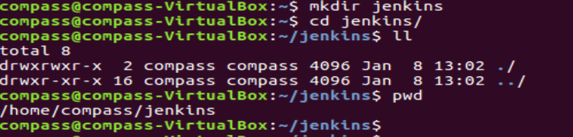

=> Install java On Jenkins Slave node.

=> Create a user and passwd for jenkins slave.( to communicate ssh from master to slave)

I have Created user and passwd for Jenkins Slave Server.(compass&compass)

=> Goto Jenkins Master Server Console.

Manage Jenkins=>Manage Nodes=>

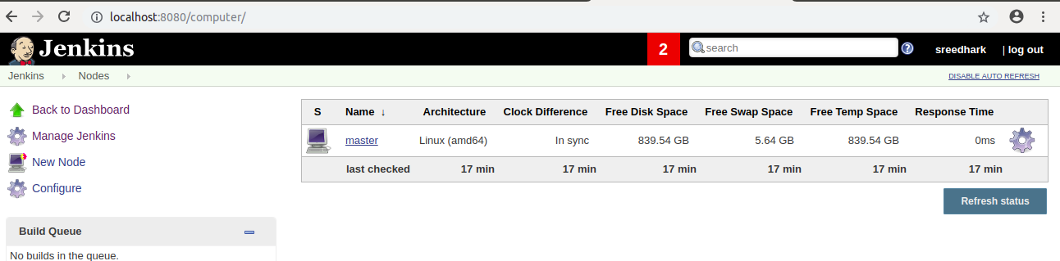
=> here Select New Node=>

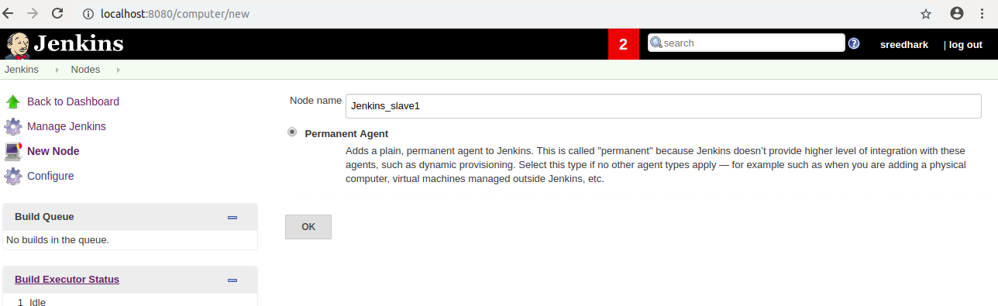
Next it will take you too below,

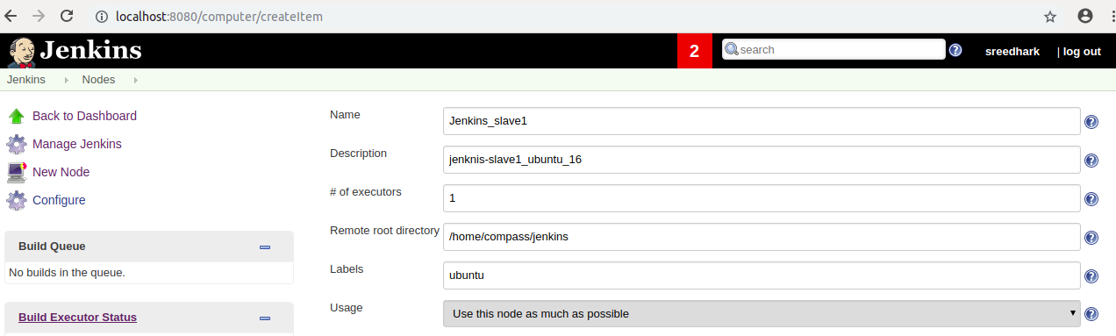
Here next it will ask credentials first select add-> Click jenkins->

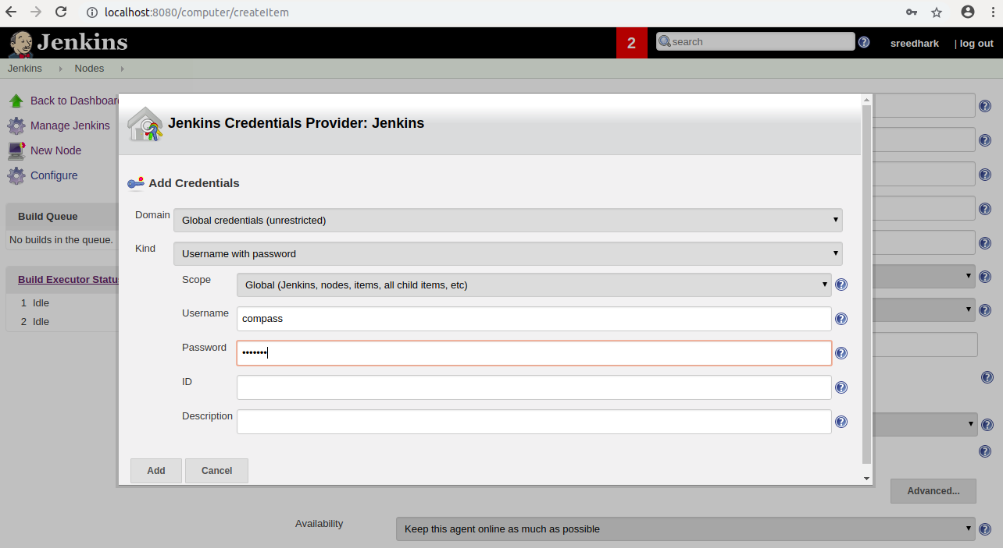
Next Add.

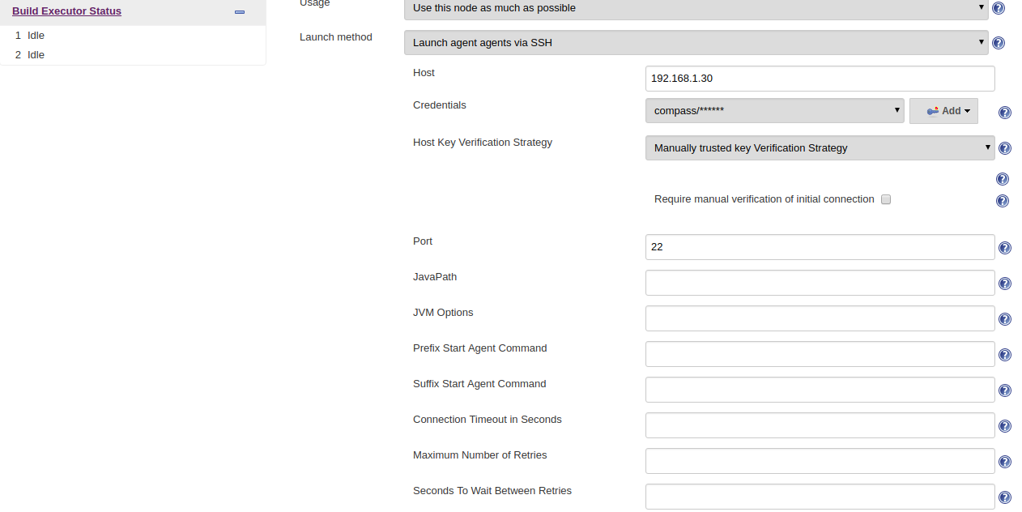


Next Select Save.

Here it will show like this.

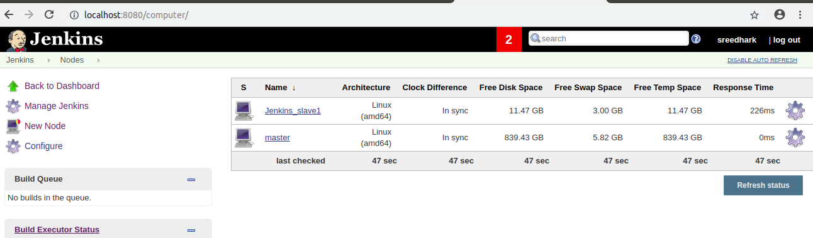
Jenkins_Slave1 is online now.

=> Goto Jenkins Slave home direcroty.

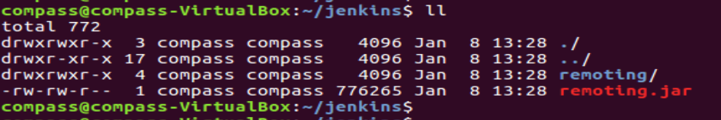

==> Now to Create a Sample job in Master Jenkins to run on Jenkins Slave.

==> Goto Master Jenkins Console-> Select New Item--> Item name: TestSlave1Demo-->

Select FreestyleProject-> Select OK.

Next It Will come below options -> Select Restrict Where this project can be run.

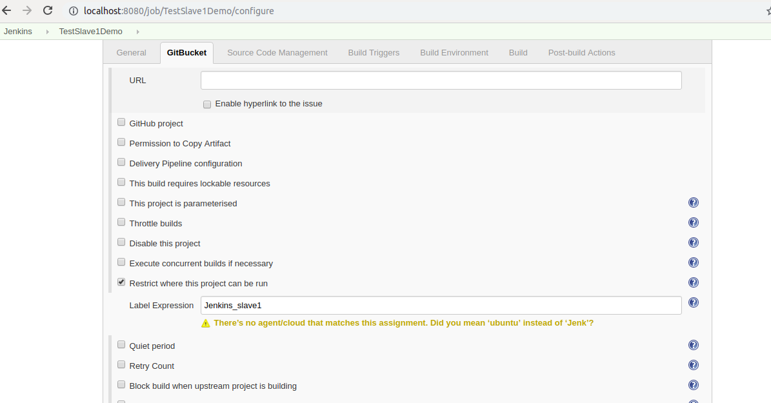
Next Goto build section-> Select execute Shell->

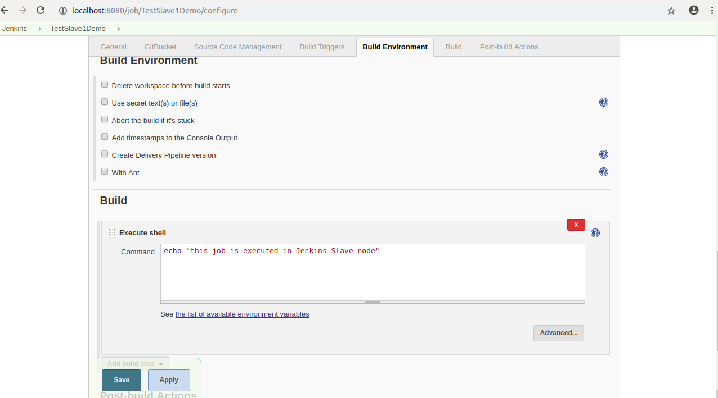
--> Next Select Apply and Save.

--> Now build the job. And see the console output.

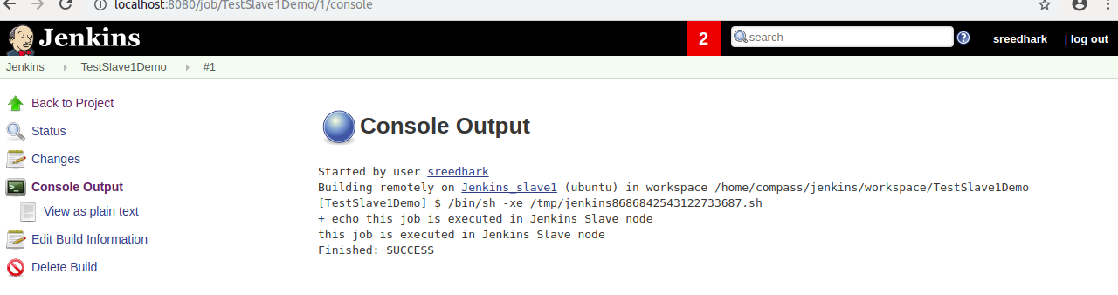
=> Next Goto Jenkins Slave home directory.
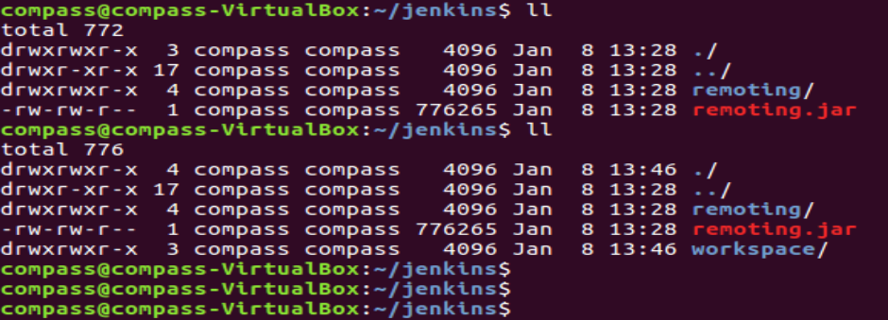

If you goto inside workspache direcory. You will see the job name.

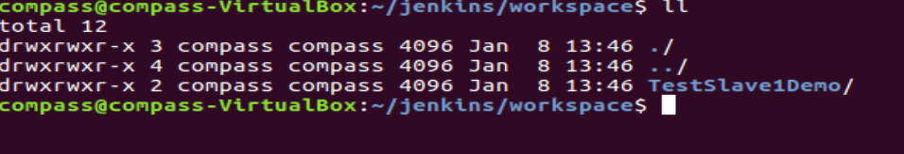

==========================>

------------>
webapp/target/*.war

Jenkins war file build location will give in jenkins below path.

/var/lib/jenkins/workspace/test111/webapp/target/webapp.war

ansible-playbook /opt/play-books/copyfile.yml
---------------->

Ansible Integration with Jenkins:-

Pre-requisites:-

Install jenkns and make it jenkins user as a sudo user.
Install Ansible and create Ansible user and make it as a sudo user and password less authentication setup.
Install Publish over ssh plugin (jenkins and ansible integration)
Configure Pubilish over ssh in Jenkins Configure system(Estabilsh Communication jenkins to ansible)
Create a sample playbook.
Create a jenkins job.

STEP 1: First lanuch 2 Servers.

=>First Server for Ansible and Jenkins and Second Server for Tomcat.

=>Login to first Server , Install java and install jenkins.

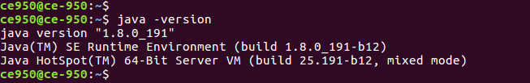
=>Next Install jenkins.

=>Confirm Jenkins is running or not?

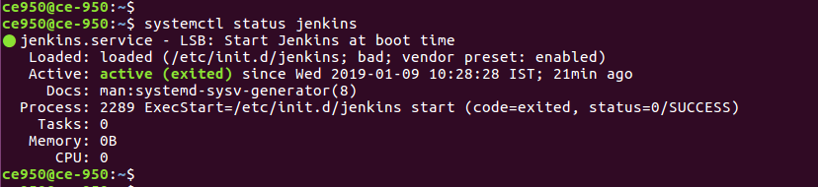
=>Jenkins is up and running and open jenkins console.

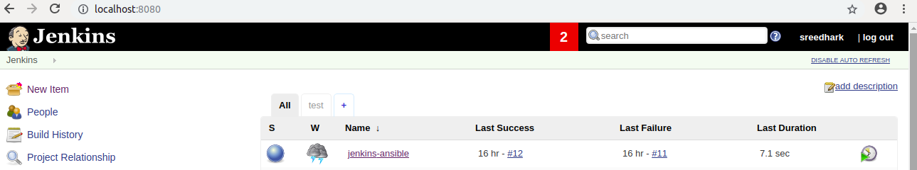
=>Jenkins User make it as Sudo User.

STEP 2:- Install Ansible.

=>Verify Ansible version.

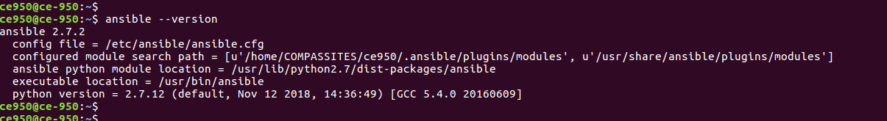
=> Create a Ansible User and make it as Sudo User.

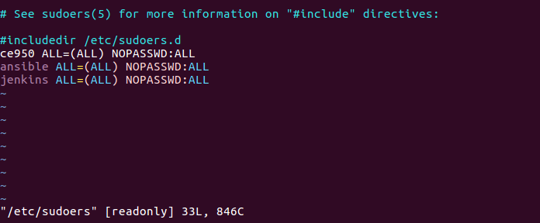
=> Next Generate Public and Private key for Ansible User.

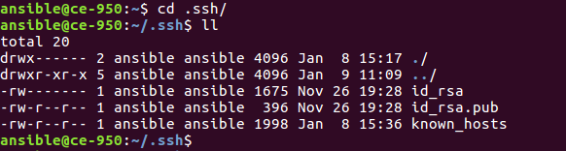
STEP 3:- Login To Second Server.

=>Install Java

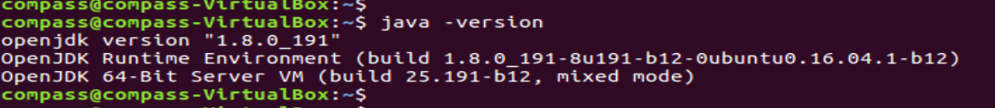
=>Install Tomcat.

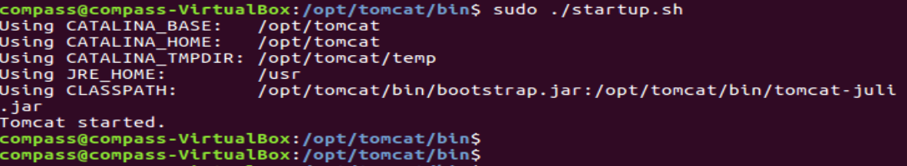
=>Tomcat Started.

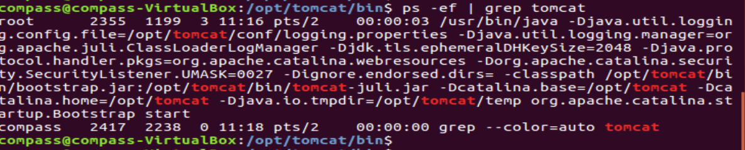
=>Tomcat up and running.

STEP 4 :- Create a ansible User and make it as a Sudo User.

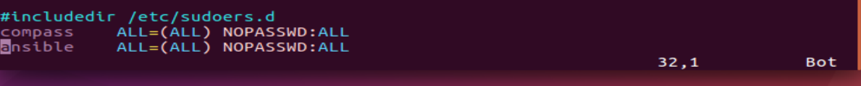
STEP 5:- Connect to First Server.

=>Swith to Ansible User and goto .ssh Foler copy public key to Second server Ansible User.

Ssh-copy-id <ServerIP>

ssh-copy-id 192.168.1.30

=>After that check to verify Passwordless authentication is working or not.

Ssh 192.168.1.30

=>Next add Sercond Server IP In Ansbile Host file.

vi /etc/ansible/hosts
Ex:
[Webserver]
192.168.1.30
:wq!

STEP 6:- Check with Ansible Master Communication host or not?

ansible all -m ping

STEP 7:- Installe the Publish Over SSH Plugin and after that restart jenkins.

=>Ansible integration with Jenkins need “Publish Over SSH” Plugin is mandatory.

=>Install “Publish Over SSH “

Manage Jenkins=>Manage Plugins=>Available=>Publish Over SSH=>

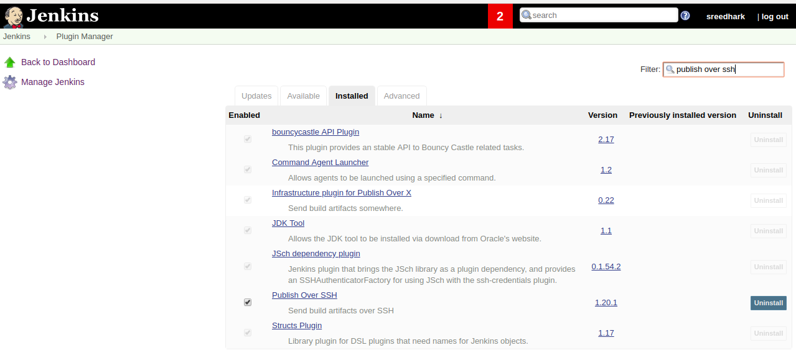

STEP 8:- Enable Connection between Ansible and Jenkins.

=>Manage Jenkins=>Configure System=>Publish Over SSH=> SSH Servers=>

SSH Servers:

->Host Name:<here will ansible server IP>
->User Name:<ansible user name>
->Password: <ansible user passwd>

Test the Connection “Test Connection” <to verify test connection is success or fail>

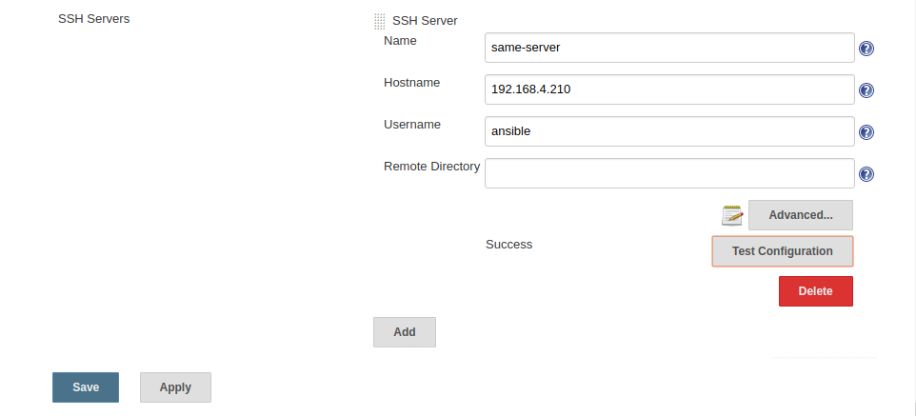

Click Advanced there you will get multiple Options (here you will give ansible user Password)

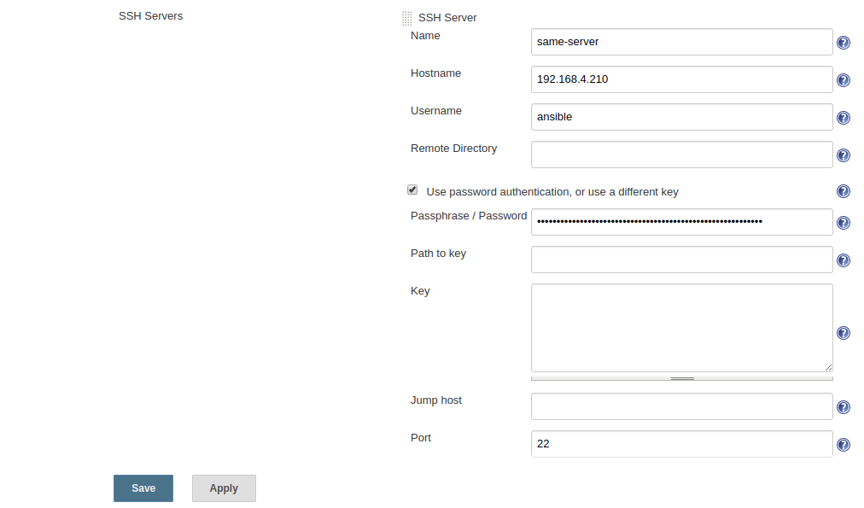
==> Next Select Apply and Save.

STEP 9:- Create a Playbook.

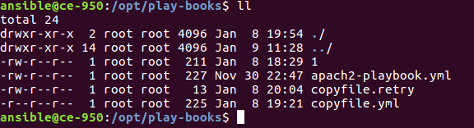
=>Here created a Copyfile.yml playbook.

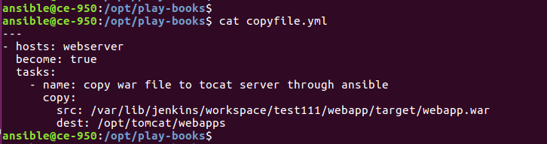
=>Here src is a Jenkins build a war file location, and dest is tomcat server webapps path.

STEP 10:- Create job in Jenkins.

=>Goto Jenkins Console=> Select New Item=>Enter name=test111=>Select Maven

Project=>

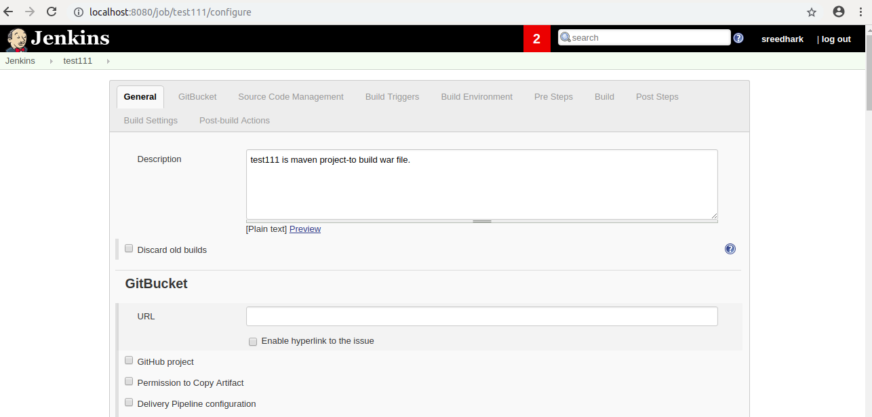

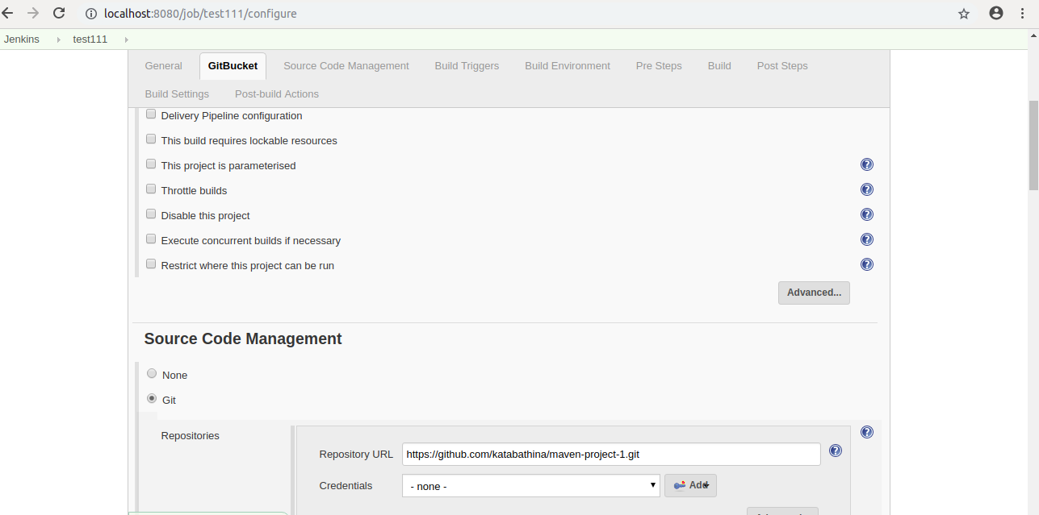
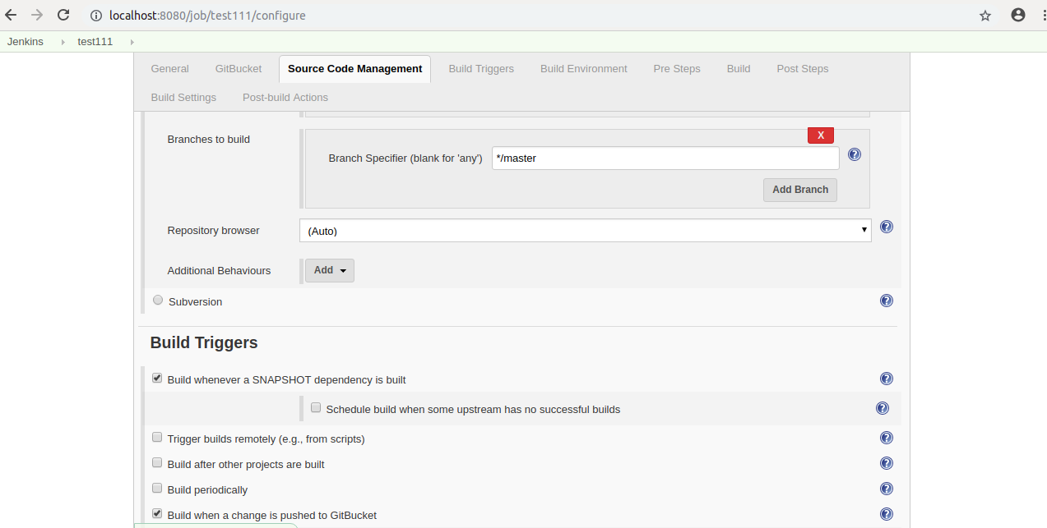
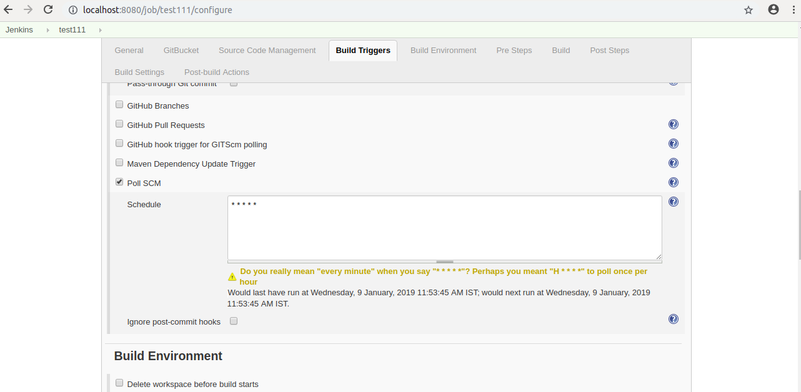

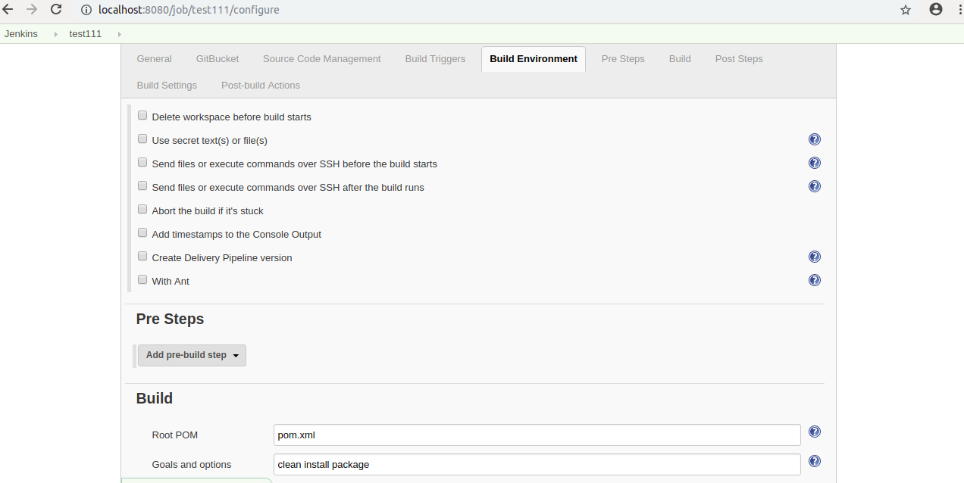

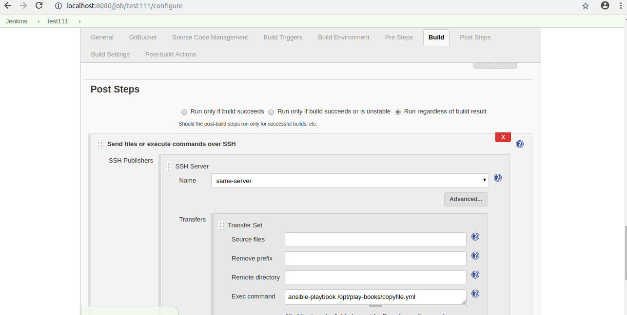

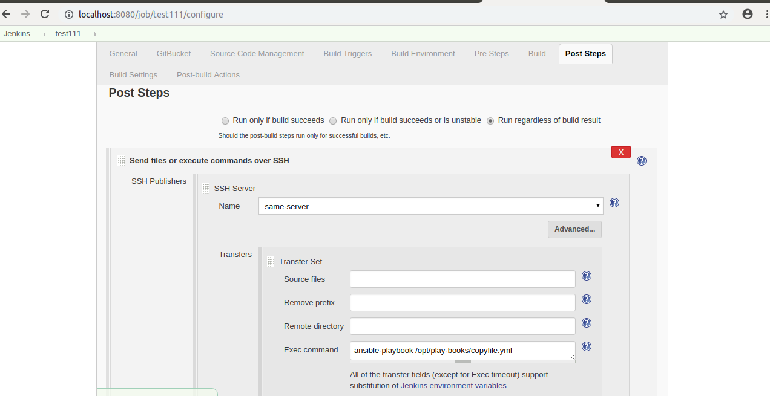
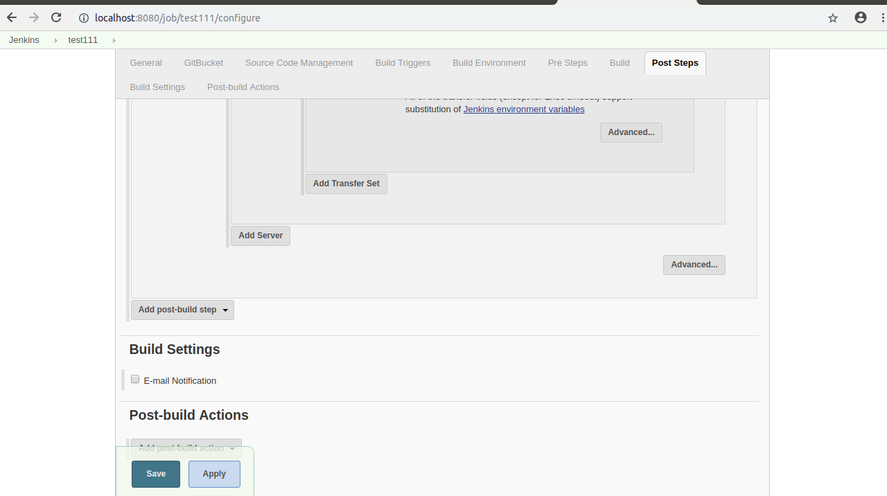
==> Next Select Apply and Save.

STEP 11:- Now build the Job.

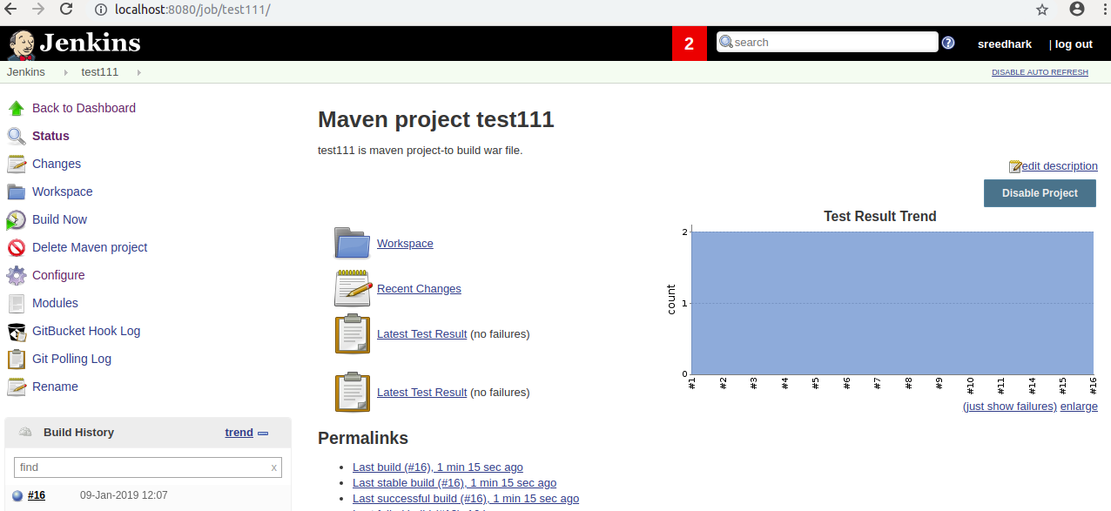
=>Build Success and now see the console output.

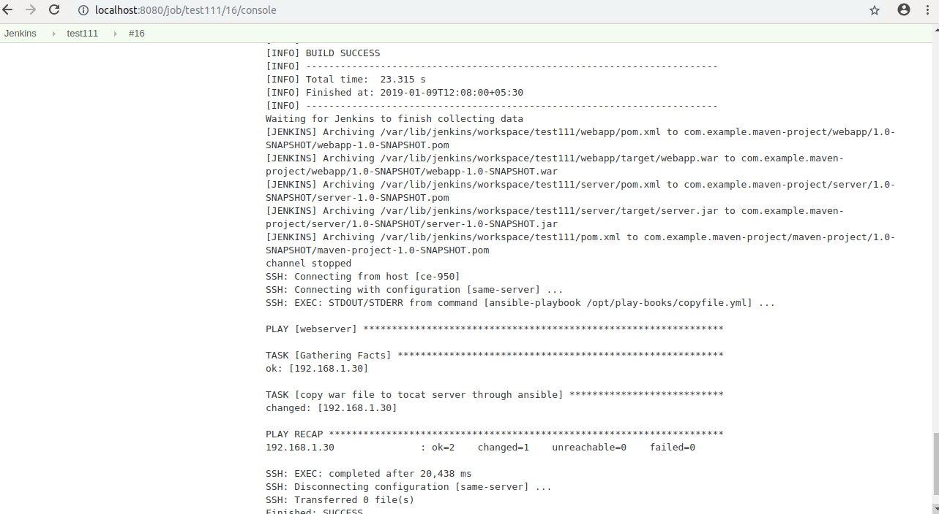
=>Goto Tomcat Server webapps path and broweser output.

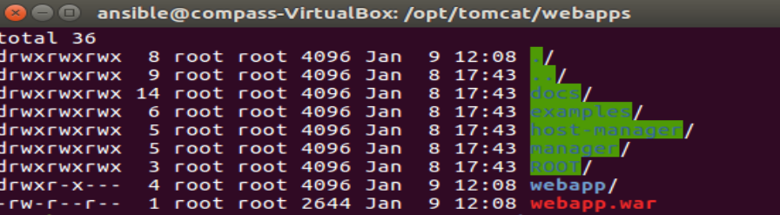

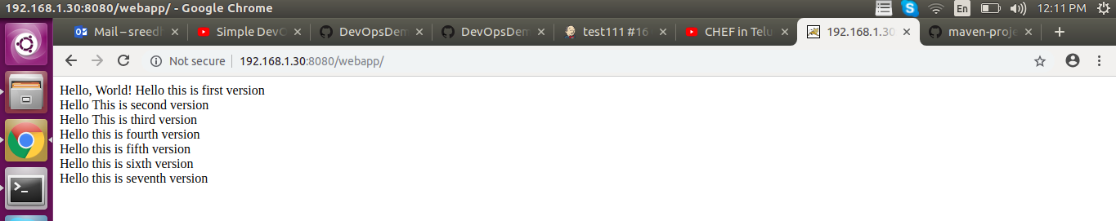

=====>

Ref Links:-Velaxy Technology(Devops 2 link)

https://www.youtube.com/watch?v=nE4b9mW2ym0

https://github.com/ValaxyTech/DevOpsDemos/blob/master/Jenkins/Ansible_integration.MD

https://github.com/ValaxyTech/DevOpsDemos/blob/master/SimpeDevOpsProjects/Project-02.MD

