=> LifeCycle Manager:-

Taking Automatic backups of Volumes and Instances Using Lifecycle Mangaer.

Ref link:-

https://aws.amazon.com/blogs/aws/new-lifecycle-management-for-amazon-ebs-snapshots/

=> Launch EC2-Instance with tags like below,

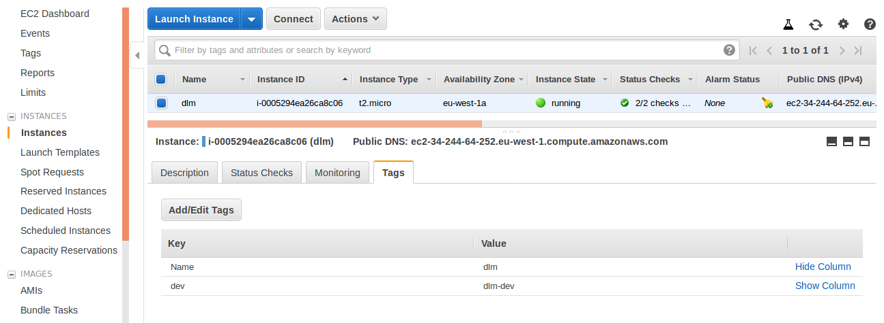
=> From left side panel select Lifecycle Manager. (here taking Instance backup)
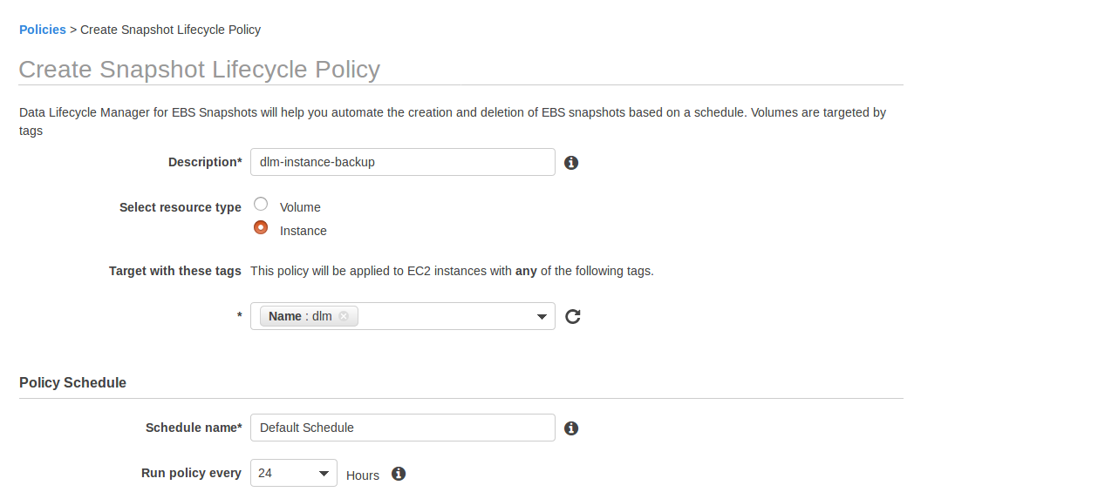
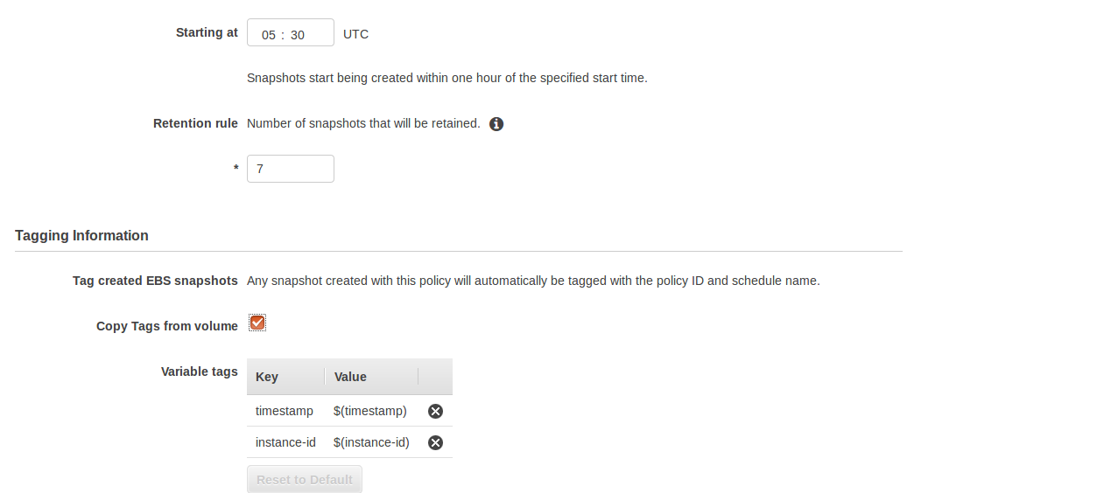

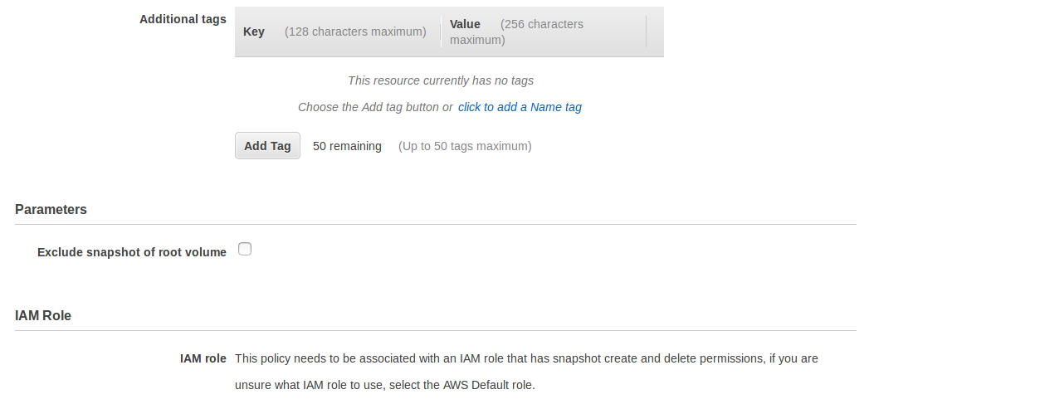

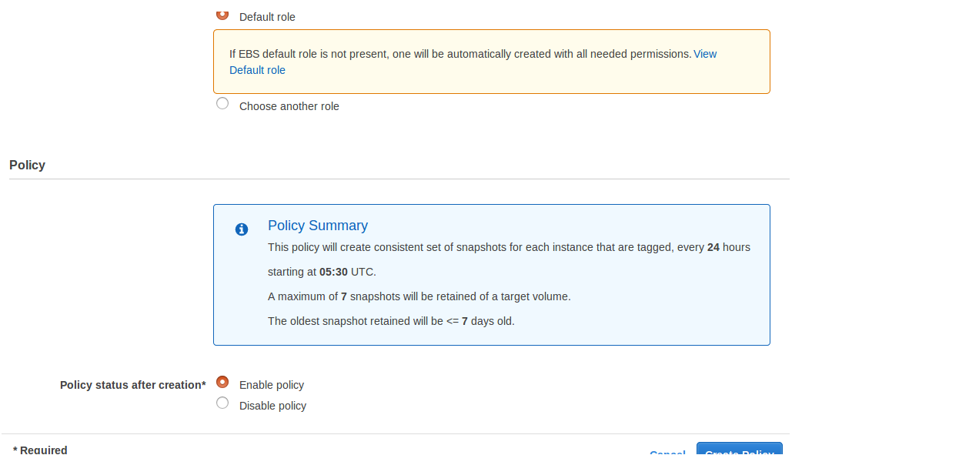
=> Select Create Policy.

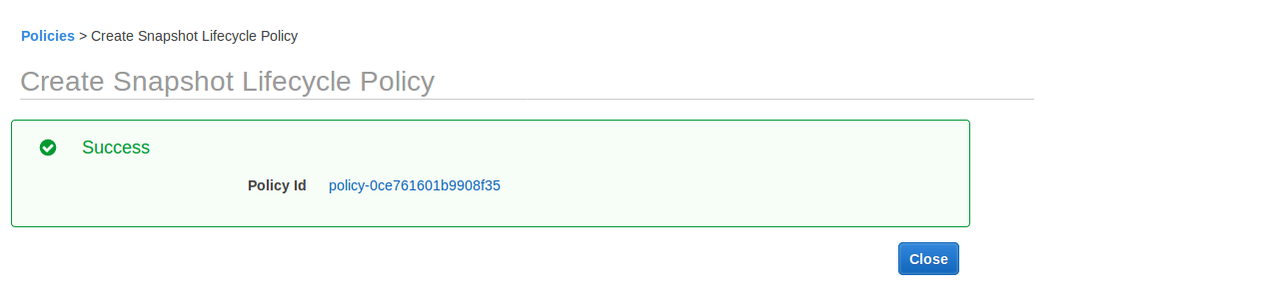
=> Select Policy Id it will take you into Lifecycle Manager Console,

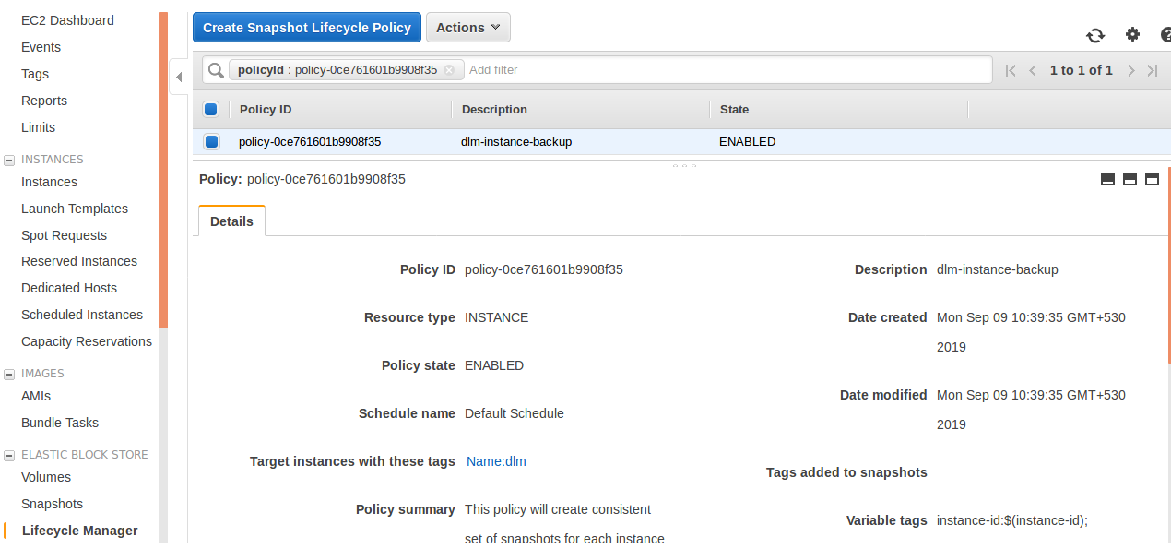

=> Go and Check in Snapshot section,

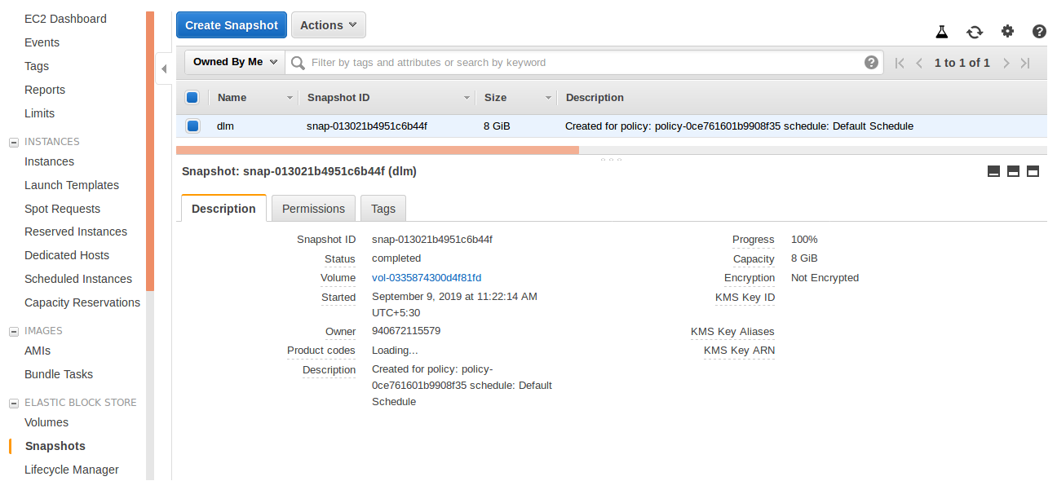

=>(Here Taking Volume backup)

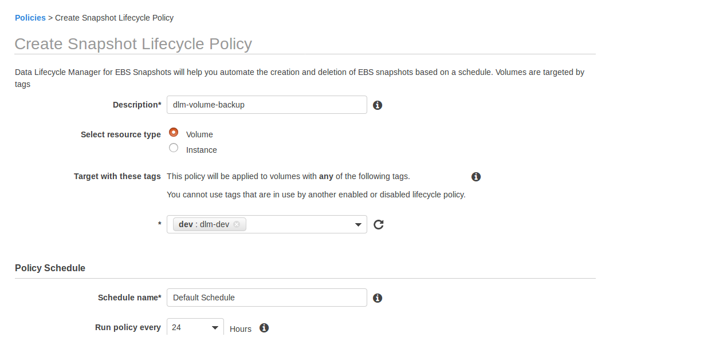

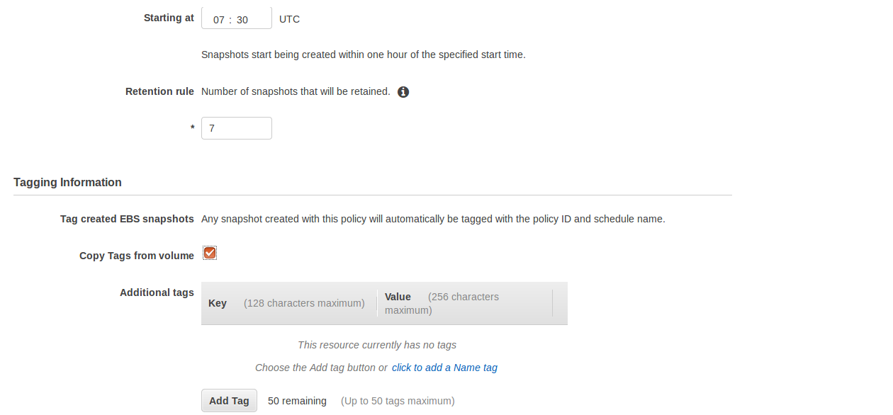

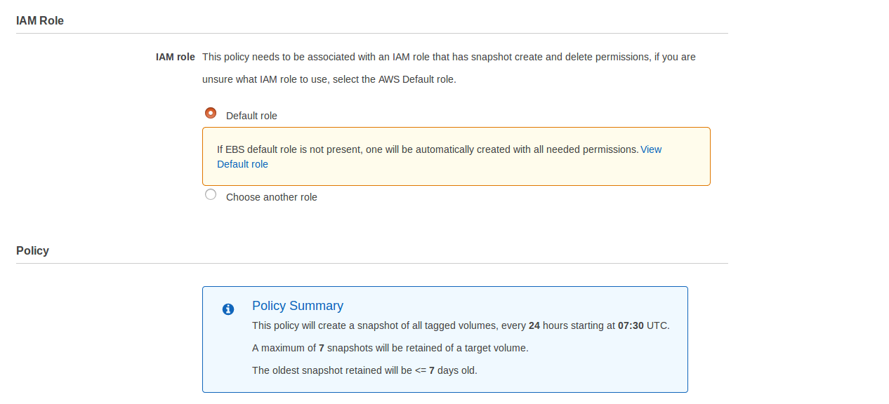


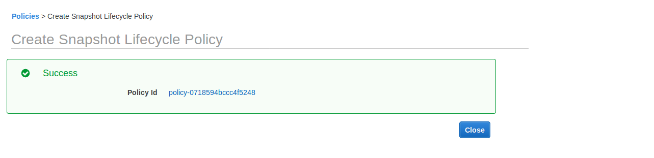
=> Select Policy Id it will take you into Lifecycle Manager Console,

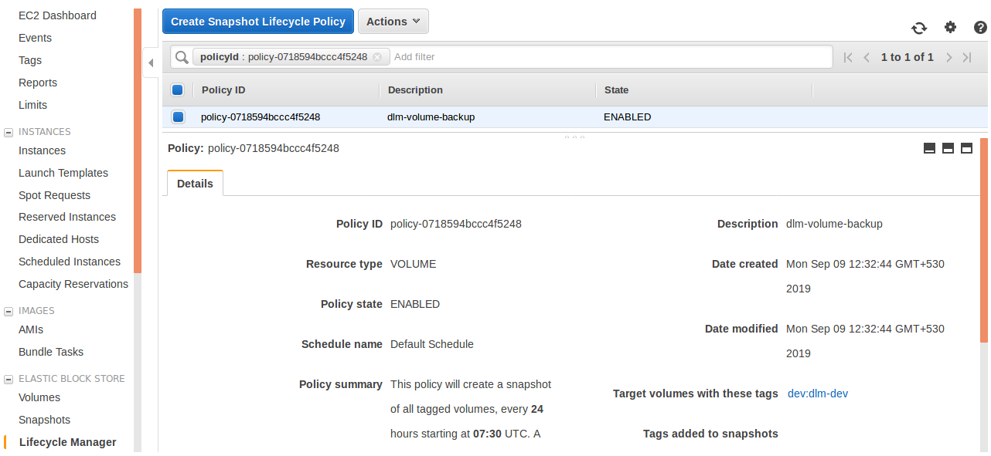
=> Go and Check in Snapshot section,

