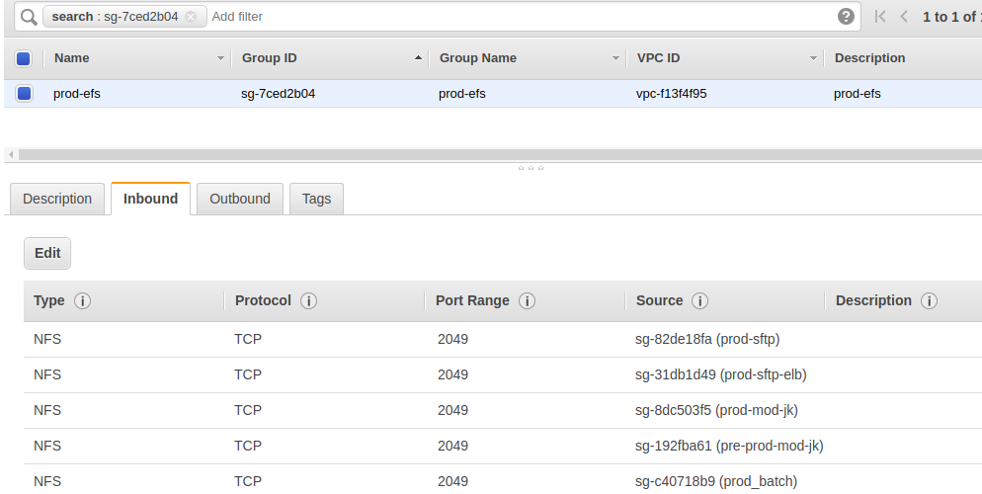

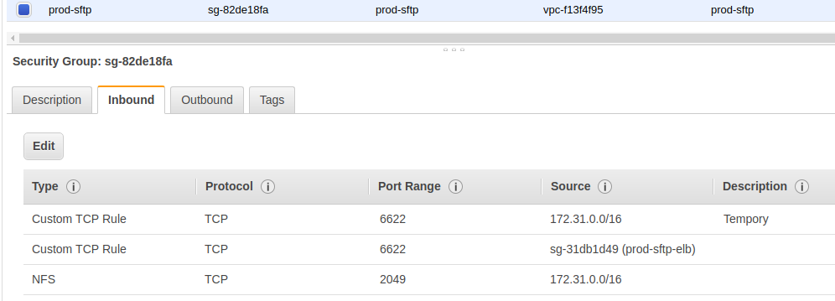

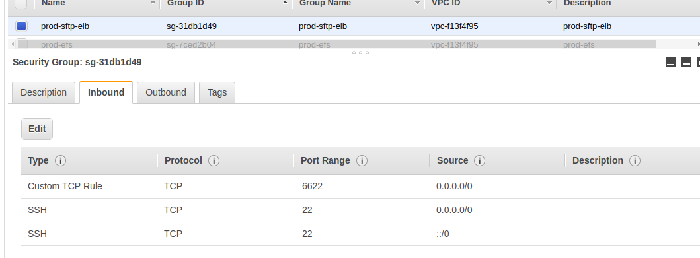

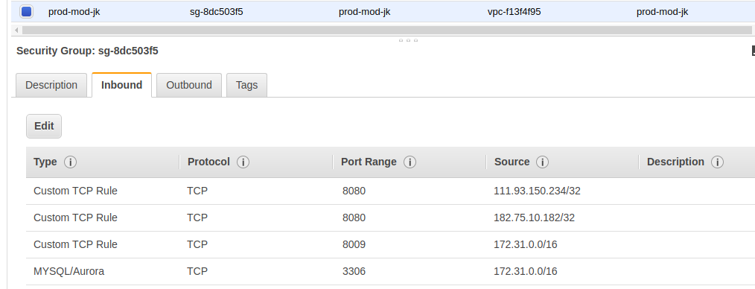

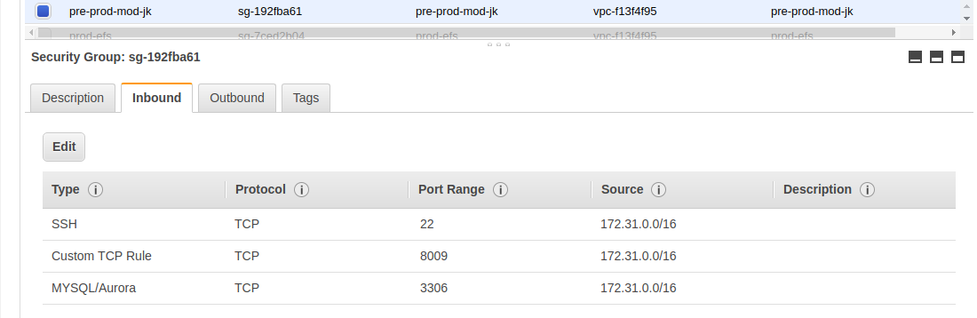

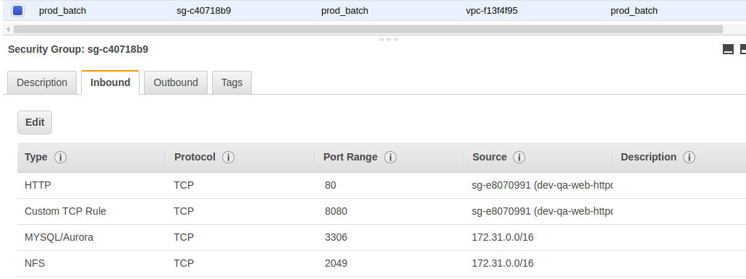

Qa-Sftp

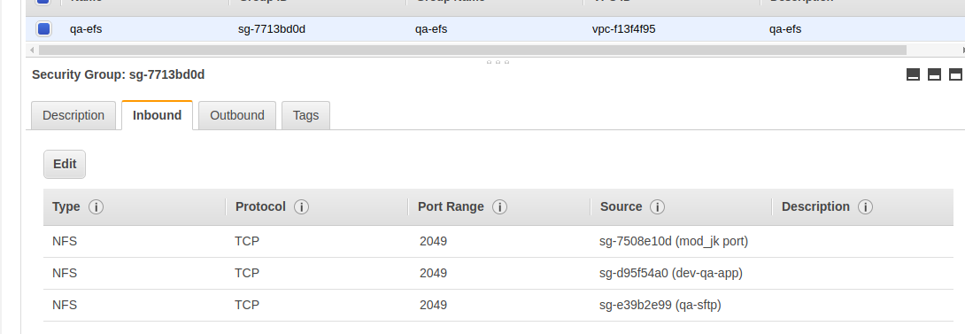

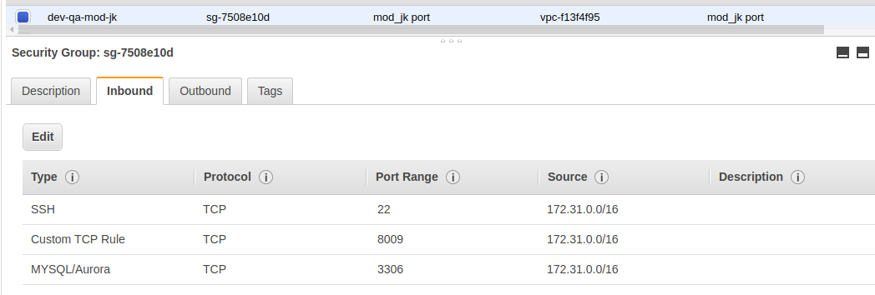

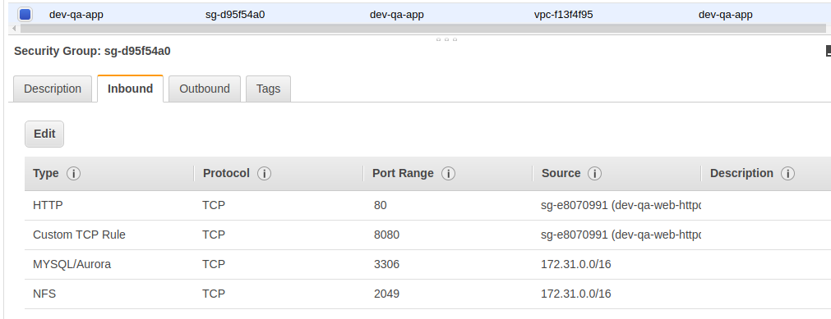

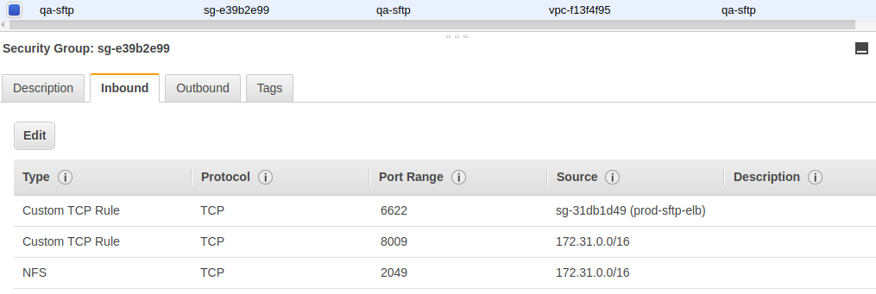

[compassitesro@eu_lyweb_qa_lnx_sftp01 ~]$ df -h
Filesystem Size Used Avail Use% Mounted on
devtmpfs 488M 60K 488M 1% /dev
tmpfs 497M 0 497M 0% /dev/shm
/dev/xvda1 30G 1.4G 28G 5% /
fs-4f58d986.efs.eu-west-1.amazonaws.com:/ 8.0E 5.8G 8.0E 1% /sftp-qa

sftp -a

[compassitesro@ip-172-31-46-137 ~]$ df -h
Filesystem Size Used Avail Use% Mounted on
devtmpfs 3.8G 48K 3.8G 1% /dev
tmpfs 3.8G 0 3.8G 0% /dev/shm
/dev/nvme0n1p1 30G 1.9G 28G 7% /
fs-489f4a81.efs.eu-west-1.amazonaws.com:/ 8.0E 8.5G 8.0E 1% /sftp-data
fs-489f4a81.efs.eu-west-1.amazonaws.com:/sftp_home/data_custom1 8.0E 8.5G 8.0E 1% /sftp-data/custom/custom1/data_custom1
fs-489f4a81.efs.eu-west-1.amazonaws.com:/sftp_home/data_custom2 8.0E 8.5G 8.0E 1% /sftp-data/custom/custom2/data_custom2
fs-489f4a81.efs.eu-west-1.amazonaws.com:/sftp_home/data_custom3 8.0E 8.5G 8.0E 1% /sftp-data/custom/custom3/data_custom3
fs-489f4a81.efs.eu-west-1.amazonaws.com:/sftp_home/data_custom4 8.0E 8.5G 8.0E 1% /sftp-data/custom/custom4/data_custom4
fs-489f4a81.efs.eu-west-1.amazonaws.com:/sftp_home/data_custom5 8.0E 8.5G 8.0E 1% /sftp-data/custom/custom5/data_custom5
fs-489f4a81.efs.eu-west-1.amazonaws.com:/sftp_home/data_custom6 8.0E 8.5G 8.0E 1% /sftp-data/custom/custom6/data_custom6
fs-489f4a81.efs.eu-west-1.amazonaws.com:/sftp_home/data_custom7 8.0E 8.5G 8.0E 1% /sftp-data/custom/custom7/data_custom7
fs-489f4a81.efs.eu-west-1.amazonaws.com:/sftp_home/data_custom8 8.0E 8.5G 8.0E 1% /sftp-data/custom/custom8/data_custom8
fs-489f4a81.efs.eu-west-1.amazonaws.com:/sftp_home/data_custom9 8.0E 8.5G 8.0E 1% /sftp-data/custom/custom9/data_custom9
fs-489f4a81.efs.eu-west-1.amazonaws.com:/sftp_home/data_custom10 8.0E 8.5G 8.0E 1% /sftp-data/custom/custom10/data_custom10
fs-489f4a81.efs.eu-west-1.amazonaws.com:/

sftp -b

[compassitesro@ip-172-31-3-126 ~]$ df -h
Filesystem Size Used Avail Use% Mounted on
devtmpfs 3.8G 48K 3.8G 1% /dev
tmpfs 3.8G 0 3.8G 0% /dev/shm
/dev/nvme0n1p1 30G 1.9G 28G 7% /
fs-489f4a81.efs.eu-west-1.amazonaws.com:/ 8.0E 8.5G 8.0E 1% /sftp-data
fs-489f4a81.efs.eu-west-1.amazonaws.com:/sftp_home/data_custom1 8.0E 8.5G 8.0E 1% /sftp-data/custom/custom1/data_custom1
fs-489f4a81.efs.eu-west-1.amazonaws.com:/sftp_home/data_custom2 8.0E 8.5G 8.0E 1% /sftp-data/custom/custom2/data_custom2
fs-489f4a81.efs.eu-west-1.amazonaws.com:/sftp_home/data_custom3 8.0E 8.5G 8.0E 1% /sftp-data/custom/custom3/data_custom3
fs-489f4a81.efs.eu-west-1.amazonaws.com:/sftp_home/data_custom4 8.0E 8.5G 8.0E 1% /sftp-data/custom/custom4/data_custom4
fs-489f4a81.efs.eu-west-1.amazonaws.com:/sftp_home/data_custom5 8.0E 8.5G 8.0E 1% /sftp-data/custom/custom5/data_custom5
fs-489f4a81.efs.eu-west-1.amazonaws.com:/sftp_home/data_custom6 8.0E 8.5G 8.0E 1% /sftp-data/custom/custom6/data_custom6
fs-489f4a81.efs.eu-west-1.amazonaws.com:/sftp_home/data_custom7 8.0E 8.5G 8.0E 1% /sftp-data/custom/custom7/data_custom7
fs-489f4a81.efs.eu-west-1.amazonaws.com:/sftp_home/data_custom8 8.0E 8.5G 8.0E 1% /sftp-data/custom/custom8/data_custom8
fs-489f4a81.efs.eu-west-1.amazonaws.com:/sftp_home/data_custom9 8.0E 8.5G 8.0E 1% /sftp-data/custom/custom9/data_custom9
fs-489f4a81.efs.eu-west-1.amazonaws.com:/sftp_home/data_custom10 8.0E 8.5G 8.0E 1% /sftp-data/custom/custom10/data_custom10
fs-489f4a81.efs.eu-west-1.amazonaws.com:/ 8.0E 8.5G 8.0E 1% /preprod-sftp-data
fs-489f4a81.efs.eu-west-1.amazonaws.com:/preprod_sftp_home/web 8.0E 8.5G 8.0E 1% /sftp-data/preprod_sftp_home/web

prod-Batch(server)

22 | tcp | 172.31.0.0/16 | ✔
8009 | tcp | 172.31.0.0/16 | ✔
3306 | tcp | 172.31.0.0/16 | ✔ | ✔
80 | tcp | sg-e8070991 |  | ✔
8080 | tcp | sg-e8070991 |  | ✔
2049 | tcp | 172.31.0.0/16 |  | ✔
22 | tcp | 182.75.10.182/32, 111.93.150.234/32, 172.31.0.0/16, 34.244.142.132/32

qa-App

Ports | Protocol | Source | mod_jk port | Compassites | dev-qa-app
22 | tcp | 172.31.0.0/16 | ✔
8009 | tcp | 172.31.0.0/16 | ✔
3306 | tcp | 172.31.0.0/16 | ✔ |  | ✔
22 | tcp | 182.75.10.182/32, 111.93.150.234/32, 172.31.0.0/16, 34.244.142.132/32 |  | ✔
80 | tcp | sg-e8070991 |  |  | ✔
8080 | tcp | sg-e8070991 |  |  | ✔
2049 | tcp | 172.31.0.0/16 |  |  | ✔

Qa-sftp

Ports | Protocol | Source | Compassites | qa-sftp
22 | tcp | 182.75.10.182/32, 111.93.150.234/32, 172.31.0.0/16, 34.244.142.132/32 | ✔
6622 | tcp | sg-31db1d49 |  | ✔
8009 | tcp | 172.31.0.0/16 |  | ✔
2049 | tcp | 172.31.0.0/16 |  | ✔

Dev-App

Ports | Protocol | Source | mod_jk port | Compassites | dev-qa-app
22 | tcp | 172.31.0.0/16 | ✔
8009 | tcp | 172.31.0.0/16 | ✔
3306 | tcp | 172.31.0.0/16 | ✔ |  | ✔
22 | tcp | 182.75.10.182/32, 111.93.150.234/32, 172.31.0.0/16, 34.244.142.132/32 |  | ✔
80 | tcp | sg-e8070991 |  |  | ✔
8080 | tcp | sg-e8070991 |  |  | ✔
2049 | tcp | 172.31.0.0/16 |  |  | ✔

