EXPLORATORY DATA ANALYSIS REPORT
Ford GoBike Bike-Sharing Dataset
Understanding Rider Behaviour, Trip Patterns & Seasonal Demand

Project Type | Exploratory Data Analysis (EDA)
Contribution | Individual
Dataset | Ford GoBike Trip Data — 2018 (12 monthly files)
Records Analyzed | 1,863,721 trips
Prepared By | Himarshitha
Program | Data Analyst Intern (Labmentix)
Tools Used | Python, Pandas, NumPy, Matplotlib, Seaborn, glob (Google Collab)

1. Problem Statement
The objective of this project is to perform Exploratory Data Analysis (EDA) on the Ford GoBike bike-sharing dataset to understand user behaviour, trip patterns, seasonal trends, and factors affecting trip duration. The insights generated are intended to help improve bike availability, customer satisfaction, and operational efficiency.

2. Business Objective
The study aims to generate meaningful insights that support data-driven decision-making and improve the efficiency of the bike-sharing service. The key objectives are:
- To determine the average trip duration of users.
- To analyze the effect of months and seasons on trip duration.
- To compare the riding behavior of Subscribers and Customers.
- To identify peak riding hours and days of the week.
- To examine customer demographics such as age and gender.
- To identify significant trends, patterns, and outliers in the dataset.
- To provide business recommendations for improving bike allocation, service quality, and customer satisfaction.

3. Data Understanding
Twelve monthly CSV files (January – December 2018) were merged into a single master data frame using glob and pandas concatenation, and saved as a unified combined_output.csv.
Total Records (raw, merged) | 1,863,721 rows
Total Columns | 16
Key Fields | duration_sec, start_time, end_time, start/end station id & name, start/end time, latitude-longitude, bike_id, user_type, member_birth_year, member_gender
Missing Values | start_station_id / name, end_station_id / name ≈ 0.63% each
Duplicate Rows | 0
Invalid Timestamps | 195,968 rows failed datetime parsing and were dropped

4. Data Cleaning & Feature Engineering

4.1 Cleaning Steps
- Checked and confirmed zero fully duplicated rows; drop_duplicates () applied as a safeguard.
- Converted start_time and end_time to datetime using pd.to_datetime () with errors='coerce'.
- Identified 195,968 rows where the timestamp could not be parsed and dropped them via dropna ().
- Retained missing station id/name fields as-is (only 0.63%), since they did not materially affect trip-level metrics.

4.2 Engineered Features
- trip_duration_min — duration_sec converted to minutes.
- hour — hour of day extracted from start_time.
- day — day of week name (Monday–Sunday).
- month — month name extracted from start_time.
- year — year extracted from start_time.
- season — derived from month (Winter, Spring, Summer, Autumn) for seasonal analysis.

5. Univariate Analysis

5.1 Trip Duration Distribution
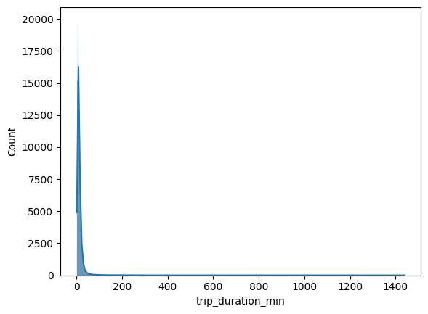
Figure 1: Distribution of trip duration (minutes)
Most trips are concentrated within shorter durations, with frequency gradually decreasing as duration increases — a positively skewed distribution. This indicates the service is primarily used for short-distance travel and daily commuting rather than extended journeys.

5.2 User Type
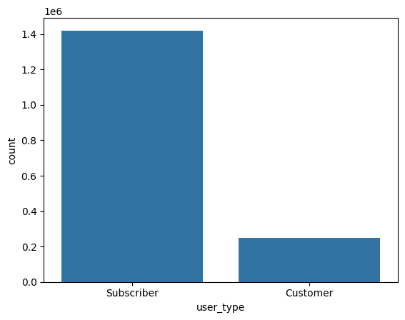
Figure 2: Ride count by user type
The count plot compares rides made by Subscribers versus Customers, highlighting the relative contribution of each category to overall ridership and the importance of subscription-based memberships.

5.3 Gender Distribution
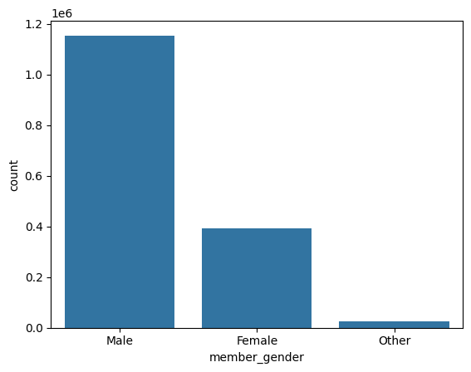
Figure 3: Ride count by member gender
Male riders form the largest identifiable gender group using the bike-sharing service.

5.4 Hour of Trip
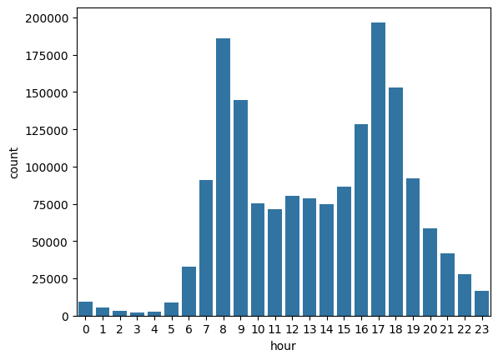
Figure 4: Ride count by hour of day
Ride activity peaks during early morning and late evening hours, consistent with commuting patterns. These insights are useful for optimizing bike availability during peak operational periods.

5.5 Day of the Week
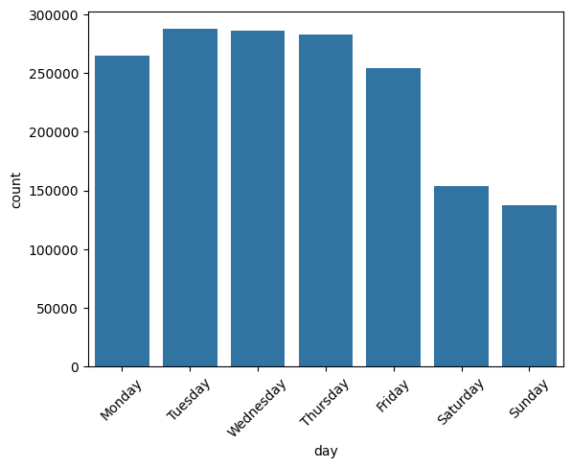
Figure 5: Ride count by day of week
Customer activity is noticeably higher on weekdays than on weekends, reinforcing the commuting-oriented nature of usage.

5.6 Monthly Ride Count
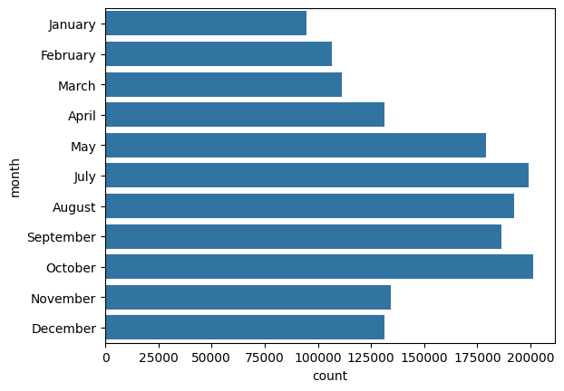
Figure 6: Ride count by month
Ride frequency varies across months, likely reflecting seasonal conditions, weather influences, and changes in travel behavior throughout the year.

6. Bivariate & Trip-Duration Analysis

6.1 Average Trip Duration
The overall average trip duration across the cleaned dataset was calculated as:
Average Trip Duration = 14.19 minutes
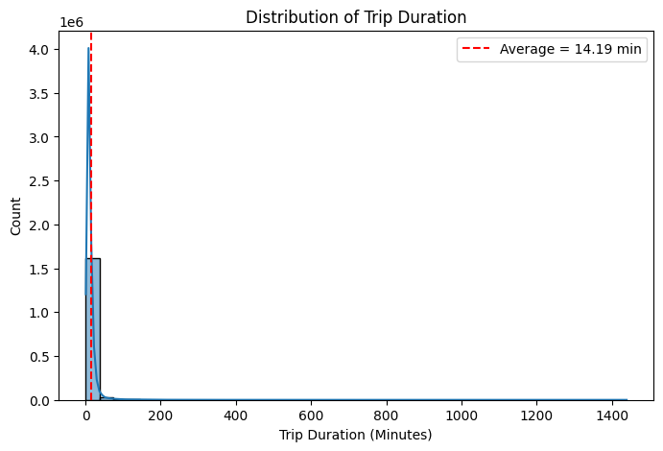
Figure 7: Distribution of trip duration with average marked

6.2 Trip Duration by Month
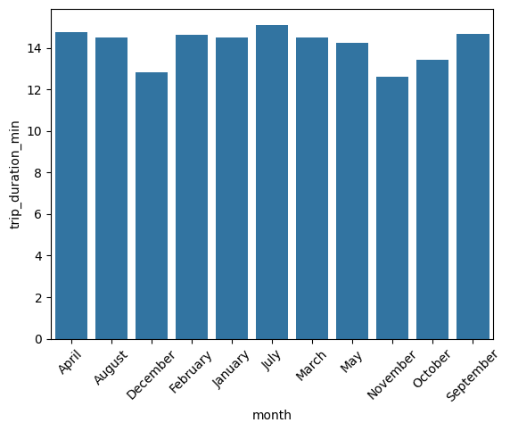
Figure 8: Average trip duration by month
Average trip duration varies across months, indicating that seasonal factors influence how long riders use bikes for, beyond simply how often they ride.

6.3 Trip Duration by Gender
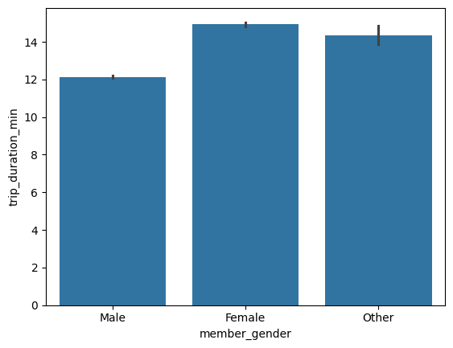
Figure 9: Average trip duration by gender
The comparison of average trip duration across gender categories reveals differences in average travel time, contributing to a demographic understanding of riding behavior.

6.4 Subscribers vs Customers
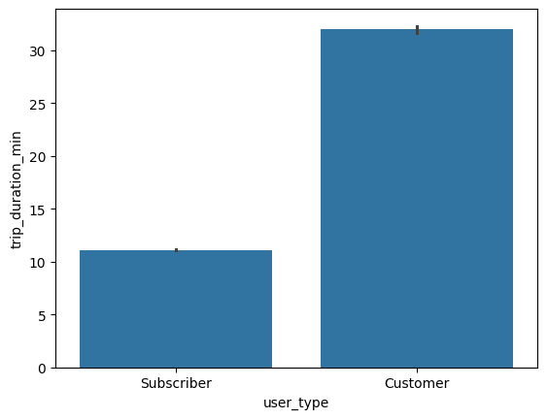
Figure 10: Average trip duration — Subscriber vs Customer
A clear behavioural difference emerges between the two membership types:
Customer (casual) | 31.99 minutes average trip duration
Subscriber (member) | 11.09 minutes average trip duration
Customers take substantially longer trips on average than Subscribers, suggesting Customers use the service more for leisure or occasional longer rides, while Subscribers use it for quick, routine commuting.

6.5 Trips per Hour
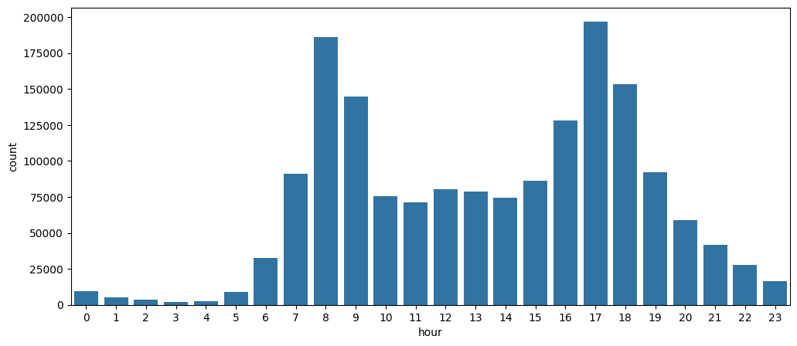
Figure 12: Ride count by hour of day
The hourly distribution confirms two clear demand peaks — early morning and late evening — corresponding to typical commute times, highlighting when additional bike availability is most needed.

6.6 Monthly Trip Duration by User Type
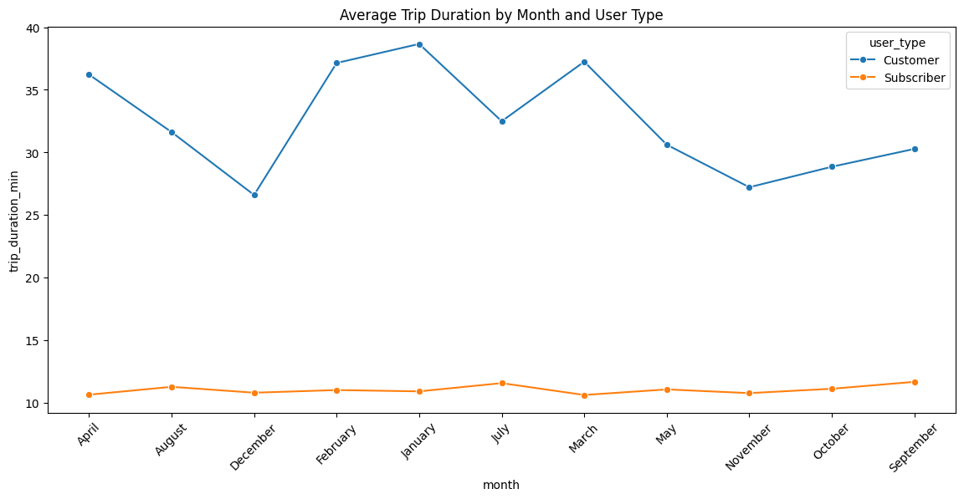
Figure 13: Average trip duration by month, split by user type
When trip duration is examined jointly by month and user type, the Subscriber–Customer gap in trip length persists across nearly every month, confirming that membership type — not just seasonality — is a consistent driver of trip duration.

6.7 Age vs Trip Duration
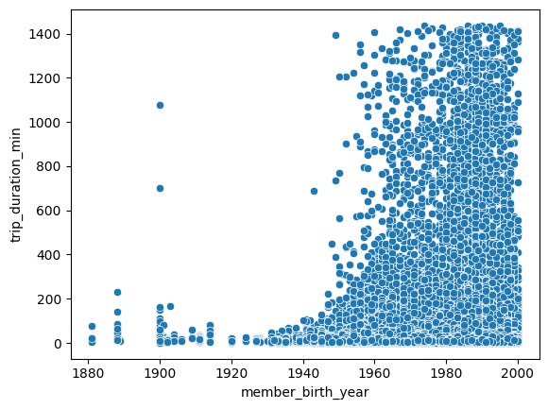
Figure 14: Rider birth year vs trip duration
The scatter plot of member birth year against trip duration shows the bulk of riders fall within the 25–45 age group, with no strong linear trend between age and trip duration, though a long tail of longer-duration outlier trips is visible.

7. Multivariate Analysis

7.1 Correlation Analysis
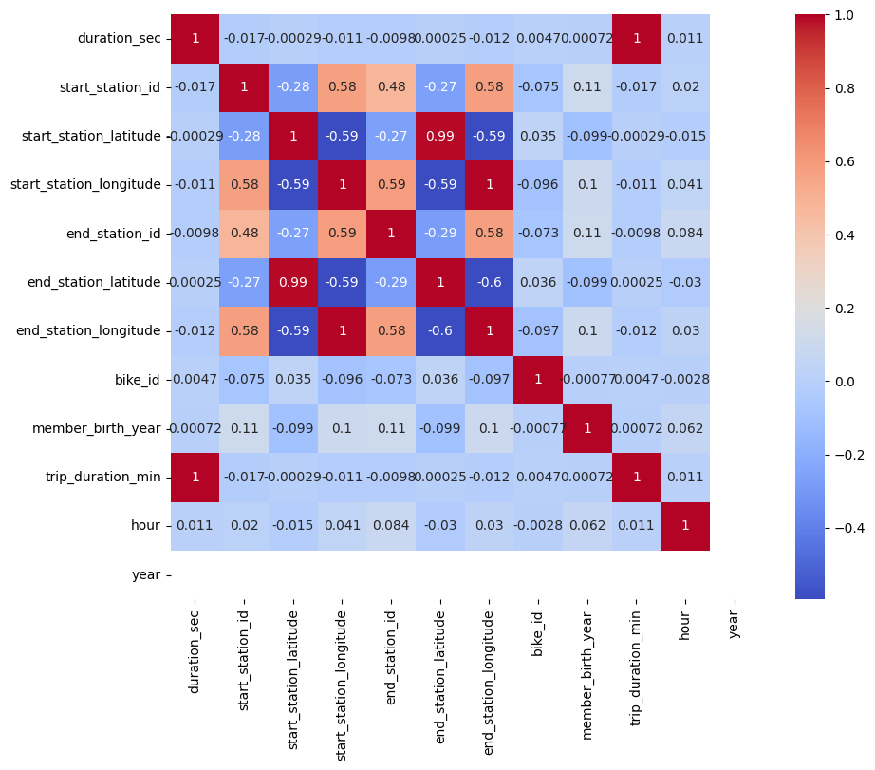
Figure 15: Correlation heatmap of numerical variables
The correlation heatmap indicates that most numerical variables share weak to moderate relationships with one another, suggesting that rider behavior is shaped by a combination of factors rather than any single dominant variable.
7.2 Trip Duration by Season
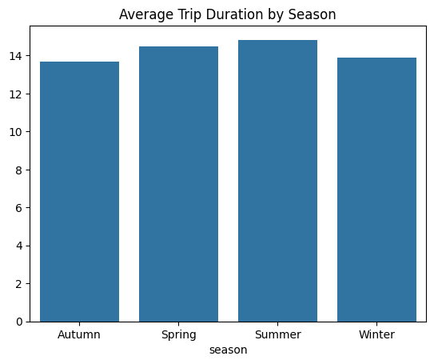
Figure 16: Average trip duration by season
Average trip duration varies across seasons (Winter, Spring, Summer, Autumn), with certain seasons showing noticeably longer average rides — evidence that weather and seasonal conditions influence riding behavior.

7.3 Duration by User Type — Exact Values
User Type | Average Trip Duration (minutes)
Customer | 31.99
Subscriber | 11.09

8. Business Insights
- The majority of bike trips are of relatively short duration, indicating the service is primarily used for short-distance travel and daily commuting.
- Ride demand varies across hours of the day, with clear peak periods reflecting regular commuting schedules.
- Monthly and seasonal analysis shows trip duration and ride frequency change over time, indicating weather and seasonal trends influence usage.
- Subscribers and Customers show markedly different riding behavior — Customers ride nearly 3x longer on average than Subscribers — showing membership type is a key driver of trip length and frequency.
- Demographic analysis shows the primary user base is concentrated in the 25–45 age group, with a male-dominant rider base.
- Outlier analysis identified a small number of unusually long trips, while most rides remained within a typical duration range.
- Correlation analysis shows numerical variables have weak-to-moderate relationships, indicating rider behavior is multi-factorial rather than driven by a single variable.

9. Recommendations
- Increase bike availability and station capacity during peak commuting hours (early morning and late evening) to meet demand and reduce shortages.
- Monitor seasonal and monthly demand patterns to optimize bike redistribution, maintenance scheduling, and staffing throughout the year.
- Develop promotional campaigns to convert casual Customers into Subscribers by highlighting membership benefits, given the large duration/behavior gap between the two groups.
- Improve operational planning at consistently high-usage stations to reduce waiting times and enhance customer satisfaction.
- Use demographic insights (age, gender skew) to design targeted marketing strategies that broaden adoption across underrepresented user groups.
- Continuously monitor unusually long trips and data-quality outliers to catch potential operational issues early.
- Use this EDA as the foundation for advanced analytics — demand forecasting, customer segmentation, and predictive modelling — to support long-term business growth.

10. Conclusion
The primary objective of this project was to perform Exploratory Data Analysis on the Ford GoBike dataset to understand customer travel behavior, identify usage patterns, and generate meaningful business insights. The analysis focused on average trip duration, the impact of monthly and seasonal variation on ride behavior, and differences between Subscribers and Customers.
The dataset was systematically prepared through cleaning, missing-value handling, duplicate removal, and datetime/feature transformations that enabled a comprehensive examination of ride duration, demographics, ride frequency, and temporal trends. The findings show that bike usage is influenced by a combination of temporal factors, customer demographics, and membership type — with the Subscriber/Customer distinction emerging as one of the strongest behavioural signals in the data.
This project demonstrates the value of Exploratory Data Analysis in transforming raw operational data into actionable business knowledge, and establishes a strong analytical foundation for future work involving predictive analytics, demand forecasting, and customer segmentation.

