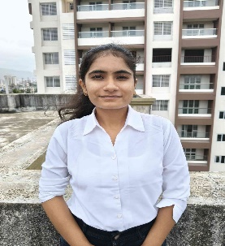
NEHA KATAKE Phone -+91 9322592783 Email Id- katakeneha2003@gmail.com Address – rajas society, katraj
Education
Bachelor of Engineering in Electronics and communication
Savitri Bai Phule Pune University, PVG'S College Of Engineering, Technology And Management CGPA : 7.42 (Till 6th Semester )
J.K college of science arts commerce ^{March 2022 percentage : 70.67}
Shivaji English Medium School and Jr college March 2020 percentage : 90.4
Projects
Otp based door lock system. Worked on the design and development using ESP32, relays, sensors. Utilized Arduino IDE for programming and Blynk for backend and user interface Electric vehicle charger using solar energy. Designed a solar-powered EV charging system using solar panels, charge controller, and DC-DC converters to enable energy-based vehicle charging Smart wristband for stress detection and control. Designed a device to monitor stress levels using physiological signals like heart rate. Generated a specific frequency using a vibration motor to help calm the user down Utilized sensors and a microcontroller (ESP32) to detect elevated stress in real time
Internship
Veblogy innovative pvt Ltd Jan 2025 - Feb 25
Gained practical experience in designing and developing IoT-based solutions using Arduino, ESP32 and various sensors.developed a wireless smart door lock system using Arduino, enabling remote control via mobile app with real-time monitoring and secure access.
Skills
C language javascript java My SQL Circuit Design and simulation Software tools : Proteus, multisim Time Management collaborative working

