ISO 20022
Post Trade Matching - Maintenance 2024 - 2025

Message Definition Report Part 1
Approved by the Securities SEG on 13th February 2025
This document provides information about the use of the messages for market claims and includes, for example, business scenarios and messages flows.
February 2025

Table of Contents
Table of Contents 2
1 Introduction 4
1.1 Terms and Definitions 4
1.2 Abbreviations and Acronyms 4
1.3 Document Scope and Objectives 5
1.4 References 5
2 Scope and Functionality 6
2.1 Background 6
2.2 Scope 6
2.3 Groups of MessageDefinitions and Functionality 7
3 BusinessRoles and Participants 9
3.1 Participants and BusinessRoles Definitions 9
3.2 BusinessRoles and Participants Table 10
4 BusinessProcess Description 11
4.1 Scenario 1 – Account Servicer (CSD system) generates market claims 11
4.2 Scenario 2 – Bilateral input of market claim 14
5 Description of BusinessActivities 17
5.1 Advise Account Holders of Market Claim Transaction 17
5.2 Provide Status of Market Claim Transaction 18
5.3 Cancel Market Claim Transaction (by Account Holder) 19
5.4 Cancel Market Claim Transaction (by Account Servicer) 20
6 BusinessTransactions 21
6.1 Simple Scenario 21
6.2 Complex Scenario 21
7 Business Examples 24
7.1 MarketClaimCreation - seev.050.001.03 24
7.2 MarketClaimCancellationRequest - seev.051.001.02 27
7.3 MarketClaimStatusAdvice - seev.052.001.03 29
7.4 MarketClaimCancellationRequestStatusAdvice - seev.053.001.03 32
8 Revision Record 35

Introduction

Terms and definitions
The following terms are reserved words defined in part one of the 2014 edition of the ISO 20022 standard. When used in this document, they will be in italic and follow the UpperCamelCase notation.

Term | Definition
BusinessRole |  | functional role played by a business actor in a particular BusinessProcess or BusinessTransaction
Participant |  | involvement of a BusinessRole in a BusinessTransaction
BusinessProcess |  | unrealized definition of the business activities undertaken by BusinessRoles within a BusinessArea whereby each BusinessProcess fulfills one type of business activity and whereby a BusinessProcess may include and extend other BusinessProcesses
BusinessTransaction |  | particular solution that meets the communication requirements and the interaction requirements of a particular BusinessProcess and BusinessArea
MessageDefinition |  | formal description of the structure of a message instance

Glossary
Terms
Term | Definition
Pre-Trade | The pre-Trade area covers all activities which occur prior to a trade. Examples of pre-trade activity are indications of interest (IOI), trade advertisements, quotes and market data (in support of trade through post-trade functions, i.e. market data dissemination, instrument identifiers, descriptive data, attributes, rates, codes and contact data, etc...).
Trade | The trade area includes the order and execution processes, including order management, order routing and trade execution.
Notice/Advise of Execution | This is used to provide the instructing party with information about a deal executed at its instruction. This advice applies to a deal that cannot yet be fully confirmed, for example, because it is a block trade which is to be allocated. (The Notice of Execution may also include information pertaining to commission and fees for the block trade.)
Post-Trade | The post-trade area covers all activity after execution up until clearing and pre-settlement begins.
Allocation Instruction | This is used by the instructing party to inform the executing party or an interested party of how the block trade is to be allocated across different accounts.
Allocation Report/Details | This is used by the executing party (or the party that received the Allocation Instruction) to provide the instructing party with additional information such as the fees, commission or interest accrued that will be allocated to each account.
Confirmation | This is used to confirm the details of a purchase or sale executed by the executing party on behalf of the instructing party. It is also used to provide details on the payment side of the transaction.
Affirmation | This is used to positively affirm or reject the details of a previously received confirmation/contract note. If positively affirmed, this message binds the Sender and the Receiver of the message to the trade details contained in the confirmation being affirmed.
Clearing/Pre-Settlement | This denotes all activities from the time confirmation is made for a transaction until settlement begins. In theory, this includes the management of clearing and pre-settlement activities, pre-settlement credit exposure; ensuring trades are settled in accordance with market rules.
Settlement | Settlement can be simply defined as the actual exchange of obligations (cash, securities, others). Settlement is the next step in the trade lifecycle after clearing / pre-settlement.
Acronyms
Acronym | Definition
B/D | Broker/Dealer
CCP | Central Counterparty
CMU | Central matching utility (analogous to virtual matching utility)
CSD | Central Securities Depository
FPL | FIX Protocol Limited
FIX | Financial Information Exchange (refer to FPL)
IDB | Inter-dealer/broker
IM | Investment Manager
JASDEC | Japan Securities Depository Centre
OMGEO | Independent central-matching utility the Depository Trust & Clearing Corporation (DTCC) and Thomson Reuters
NOE | Notice Of Execution
PSMS | Pre Settlement Matching System (JASDEC’s settlement matching system)
SBI | Société de Bourse Intermédiaire (EuroClear France’s matching system)
SSI | Standing Settlement Instructions
SWIFT | Society for Worldwide Interbank Financial Telecommunication
VMU | Virtual matching utility
Abbreviations
Abbreviation | Definition

Document Scope and Objectives
This document is the first part of the SWIFT Message Definition Report (MDR) that describes the BusinessTransactions and underlying message set. For the sake of completeness, the document may also describe BusinessActivities that are not in the scope of the project.
This document describes the following:
- The BusinessProcess scope (business processes addressed or impacted by the project)
- The BusinessRoles involved in these BusinessProcesses
The main objectives of this document are as follows:
- To explain what BusinessProcesses and BusinessActivities these MessageDefinitions have addressed
- To give a high level description of BusinessProcesses and the associated BusinessRoles
- To document the BusinessTransactions and their Participants (sequence diagrams)
- To list the MessageDefinitions

References

Document | Version | Date | Author
ISO 20022 Business Justification – Securities Post-trade messages |  | 2006-10-02 | OMGEO, SWIFT
ISO 20022 Settlement and Reconciliation Maintenance Change Request 2024/2025 |  | August 2024 | SWIFT

Scope and Functionality

Background
This Message Definition Report (MDR) covers a set of five SWIFT MessageDefinitions developed by SWIFT in close collaboration with JASDEC, FPL (Fix Protocol Limited), Omgeo, Euroclear. These messages are specifically designed to support post-trade messaging.
This project is to be considered phase one of a larger “Post-trade/Pre-settlement program” proposed by SWIFT Standards and Market Management based upon input from current and potential interested parties.
The purpose of the program is the development of a business model covering the full scope of post-trade processing from trade notification through confirmation/affirmation with an emphasis on the activities engaged between an investment manager and broker/dealer.

Scope
This project will cover only the first phase of the post trade/pre-settlement program with activities of the securities trade lifecycle on the client side being concentrated on with minimal exception. Subsequent business justifications will be submitted to cover 1) Clearing activities and 2) Collateral Management. These additional projects will be documented in detail in separate work plan and business requirement documents.
The scope of the project is currently defined as to include the following:

Financial instruments | Equity  Fixed income  Listed Derivatives  Repo and Lending and borrowing contracts
Business agreement types | Buy / Sell  Repo  Lending / Borrowing
Business areas | Post-Trade Matching  (ISO 20022 business area: Securities trade (setr)).
Business processes | Trade Notification  Trade Allocation  Trade Matching  Trade Confirmation  Trade Affirmation
Out of Scope | Trade executing reporting  Clearing and Securities Settlement Activities  Asset Servicing (Corporate Actions)  Collateral Management Activities  Matching of foreign exchange (FX)

The scope of processing to be covered by the Post-Trade messages includes the business processes from trade notification through confirmation/affirmation. Although we are still analysing the requirements, we expect to design approximately 10 messages to cover the business processes described above:
- Notice/Advise Of Execution (+ Cancellation and Modification)
- Allocation Instruction (+Allocation Cancellation & Modification)
- Allocation Report/Details (+ cancellation & modification)
- Matching Status (Accept Trade/Reject Trade/Trade Status/ Confirmation Reject)
- Confirmation (+ Confirmation Cancellation and Modification)
- Affirmation
The following diagram is an illustration of the primary communication flows which this business justification is addressing (the green is what is in scope).

In the current environment, Post-Trade communication, as scoped, is mainly supported by the following ISO 15022 messages as well as a number of proprietary message formats:MT509 – Trade Status Message
- MT513 – Client Advice of Execution
- MT514 – Trade Allocation Instruction
- MT515 – Client Confirmation of Purchase or Sale
- MT517 – Trade Confirmation Affirmation
New ISO 20022 messages are expected to be reverse-engineered from current industry practices, ISO 15022 standards and the FIX standard. Additional messages, functionality and information will be added to support defined functionality as determined by industry participants.

Groups of MessageDefinitions and Functionality
Note that these MessageDefinitions are to be used with the ISO 20022 Business Application Header (head.001.001.01). The schema and more information about the Business Application Header can be found in the Standards section of the User Handbook (UHB) Online on www.swift.com and also on www.iso20022.org.

Groups

Securities Trade
SecuritiesTradeConfirmation setr.027.001.xx
SecuritiesTradeConfirmationStatusAdvice setr.044.001.xx
SecuritiesTradeConfirmationResponse setr.030.001.xx
SecuritiesTradeConfirmationCancellation setr.029.001.xx

Securities Management
SecuritiesEndOfProcessReport semt.023.001.xx

Functionality
See the Message Definition Report Part 2 for the scopes of the messages.

BusinessRoles and Participants
A BusinessRole represents an entity (or a class of entities) of the real world, physical or legal, a person, a group of persons, a corporation. Examples of BusinessRoles: “Financial Institution”, “ACH”, “CSD”.
A Participant is a functional role performed by a BusinessRole in a particular BusinessProcess or BusinessTransaction: for example the “user” of a system, “debtor”, “creditor”, “investor” etc.
The relationship between BusinessRoles and Participants is many-to-many. One BusinessRole (that is, a person) can be involved as different Participants at different moments in time or at the same time: "user", "debtor”, "creditor", "investor", etc. Different BusinessRoles can be involved as the same Participant.
In the context of Post Trade Matching, the high-level BusinessRoles and typical Participants can be represented as follows.
Central Matching Utility
(
Business Actor
)
Executing Broker
(
Business Actor
)
Central Securities Depository
(
Business Actor
)
Investment Manager
(
Business Actor
)
Central Counterparty
(
Business Actor
)
Party
(
Business Actor
)
Confirmation Party
(
Business Actor
)

Custodian
(
Business Actor
)
Exchange
(
Business Actor
)
Financial Intermediary
(
Business Actor
)
Affirmation Party
(
Business Actor
)
(Business Actor)
Prime Broker

Participants and BusinessRoles definitions
Description | Definition
Participants
Instructing Party | Party that instructs the executing/servicing party to process and monitor a transaction. The party must own the account or have a power of attorney on the account.
Executing/Servicing Party | Party that processes, monitors and reports on transactions received from an instructing party.
BusinessRoles
Investment Manager | Partners with the broker / dealer to communicate details, execute modifications and settle financial instrument transactions.
Broker/Executing Broker | Partners with the investment manager to communicate details, execute modifications and settle financial instrument transactions. The executing broker generally executes the trade in the local market.
Central Counterparty | An infrastructure that is very often a component of a clearinghouse, and facilitates clearing and settlement for its members by standing between the buyer and the seller of a trade. It may net transactions, and substitutes itself as settlement counterparty to each position.
Confirmation Party | An infrastructure that issues trade confirmations, receives trade affirmations, matches allocations to confirmations and confirmations to instructions, and generates standing or special instructions to create settlement instructions.
Central Securities Depositories | An infrastructure that, holds or controls, the holding of physical or dematerialised financial instruments belonging to all, or a large portion of, the investors in a securities market. This effects the centralised transfer of ownership of such securities by entries on its books and records. A CSD may also offer additional services such as trade matching or custody.
Central Matching Utility (CMU) | Mediates communication between the broker / dealer and investment manager to exchange trade details, match settlement criteria and confirm completion of financial instrument transactions. The CMU may be operated as a separate utility or as part of another market utility eg, CSD.
Custodian | The Custodian and/or Trust Bank partners with the investment manager and broker/dealer to confirm and settle financial instrument transactions.
Exchange | The exchange is the venue at which a trade is agreed and executed.
Order Giver | The firm which instructs an order, also known as the ordering firm or orderer.
Affirming Party | The party which affirms the trade.
Prime Broker | A broker which acts as settlement agent, provides custody for assets, provides financing for leverage, and prepares daily account statements for its clients, who are money managers, hedge funds, market makers, arbitrageurs, specialists and other professional investors.
Underwriter | Company or other entity that administers the public issuance and distribution of securities from a corporation or other issuing body.

BusinessRoles/Participants Matrix Table
Participants  BusinessRoles | Instructing Party | Executing/Servicing Party
Investment Manager | X
Broker/Executing Broker |  | X
Central Counterparty |  | X
Confirmation Party | X
Central Securities Depositories |  | X
Central Matching Utility (CMU) | X | X
Custodian | X | X
Exchange |  | X
Order Giver | X
Affirming Party | X
Prime Broker | X | X
Underwriter | X | X

BusinessProcess Description

BusinessProcess Diagram
This section presents the business processes. Describing the business processes and their need for business information helps in the identification of the communication problems which exist among Business Actors.
The following diagram reflects the trade lifecycle from order through confirmation/affirmation. Additional updates and diagrams will be made before final publication. It should be noted that the Order and Market-Side confirmation processes are outside the scope of this project but are shown to provide clarity.
Out Of scope
Order Process
Notification of Execution Process
Allocation Process
/
No Allocation
Confirmation/Affirmation Process
Allocation
Market-Side Confirmation Process
Matching Process
Matching Process
Definitions of the business processes:
- Order Process – Process by which an instructing party places an order to buy or sell to an executing party, at a given price (OUT OF SCOPE).
- Market-Side Confirmation Process - Upon receipt of an order, the executing party looks in the market place for a Trade Counterparty willing to buy or sell the specific securities in the amounts needed, at a given price. For each trade agreed, the two Trade Counterparties exchange information to agree on the details of the trade (OUT OF SCOPE).
- Notification of Execution Process – Once the order has been fully or partially executed, the executing party advises the instructing party (in real-time) by providing the trade details. Such advices are particularly critical in the instance of a block trade that needs to be allocated prior to confirmation. They are also important when the order is carried out partially over several days, or any other period, with differing prices.
- Allocation Process – The instructing party instructs the executing party about how the block is to be allocated among the different funds or clients.
- Confirmation/Matching/Affirmation Process - The executing party advises the instructing party of his client trade confirmation per order or, if a block trade, per allocation. Trade details from both the instructing and executing parties are compared. Matching is completed to verify that all aspects of a trade are communicated and confirmed as agreed upon in the original trade agreement. Matching can occur either via a central facility (CMU) or locally. A final step in some markets is the positive acknowledgment by the instructing party of the confirmation - the affirmation.

Description of BusinessActivities
This section presents the different BusinessActivities within each BusinessProcess. BusinessActivities of a process are described in swim lane diagrams and are referred in this document as activity diagrams.
The development of an activity diagram is part of the SWIFT modelling process and allows for requirements to be captured.
The activity diagram provides a zoom-in on the BusinessActivities taking place during each of the BusinessProcesses described in Section 4. It also shows the BusinessActivities that are triggered when another BusinessAtivity has a negative result.
What is the activity diagram about?
- It is a diagram representing the ‘common lifecycle’ of a BusinessProcess
- A start point shows where the lifecycle of the business process commences and the end points show  where the lifecycle may possibly end
- A lozenge means a that a choice between several actions can be made
- A bar means a that several actions are initiated in parallel
- The flow of activities between the involved Participants (parties)
- BusinessActivities may result in different actions, that is, information is conveyed from one party to another party.
Both in scope and out of scope activities are included, with a different level of details. There is no information about requirements for out of scope activities, except that they should be clearly identified in the diagram.
Activity diagrams are always accompanied with a text describing the BusinessActivities and their interactions.

BusinessProcess – Local Matching

Through Type
The executing broker and the investment manager send a confirmation to the CMU. The CMU will forward the two confirmations received to the trustee. The trustee will send an affirmation message to the CMU if it agrees with the detail of the trade. The message will bind the parties to the trade details of the confirmation being affirmed. The CMU will send an affirmation status message to the executing broker upon receipt of the affirmation message from the trustee. The trade will then move into the settlement process.

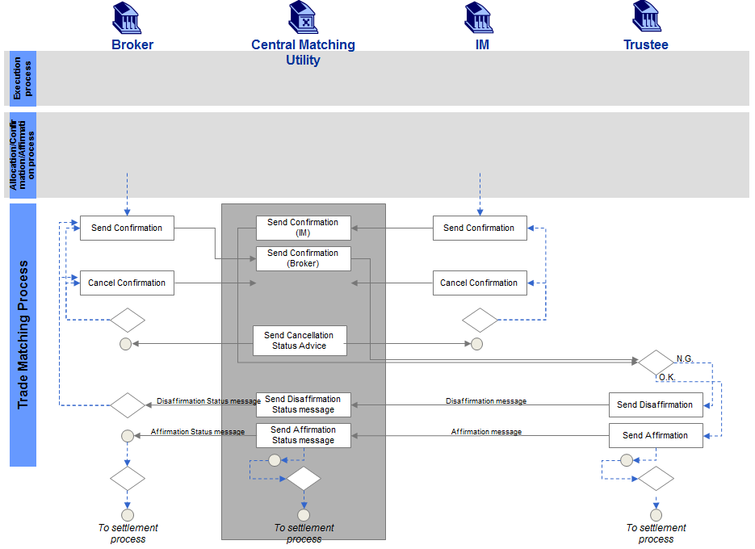

Description of Activities
Broker | Central Matching Utility (JASDEC) | Investment Manager | Trust Bank
Confirmation: The broker sends a confirmation to JASDEC . | JASDEC will compare the Confirmation details received from the broker and investment manager. | Confirmation: The investment manager sends a confirmation of the trade to JASDEC.
Cancel Confirmation: The broker and investment manager may, for whatever reason, decide to cancel the confirmation and a new confirmation may be sent. Cancellation of the confirmation may also imply the cancellation of the trade, in which case a new confirmation will not be sent. |  | Cancel Confirmation: The investment manager and broker may decide to cancel the confirmation and a new confirmation may be sent. Cancellation of the confirmation may also imply the cancellation of the trade, in which case a new confirmation will not be sent.
 | Status Advice: JASDEC will send a cancellation status advice to the broker and investment manager.
 | Confirmation (broker and IM): JASDEC will forward the confirmation received from both the broker and investment manager to the Trust Bank.
 | Disaffirmation Status Message: JASDEC will send a disaffirmation status message to the broker upon receipt of the disaffirmation message from the Trust Bank. Once received it may lead to a cancellation of the confirmation or the sending of a new confirmation. |  | Disaffirmation: Should the Trust Bank not agree with the details of the trade, it will send a disaffirmation message to JASDEC.
 | Affirmation Status Message: JASDEC will send an affirmation status message to the broker upon receipt of the affirmation message from the Trust Bank. The trade will then move into the settlement process. |  | Affirmation: The Trust Bank will send an affirmation message to JASDEC if it agrees with the detail of the trade. The message will bind the parties to the trade details of the confirmation being affirmed.

Own Account Trade Type
The executing broker sends a trade confirmation to the CMU. Once received from the broker, The CMU forwards the trade confirmation to the Institutional Investor. Should the Institutional Investor agree with the detail of the confirmation an affirmation message is sent to the CMU. The message will bind the parties to the trade details of the confirmation being affirmed. The CMU sends an affirmation status message to the executing broker upon receipt of an affirmation message from the Institutional Investor. The trade will then move into the settlement process.
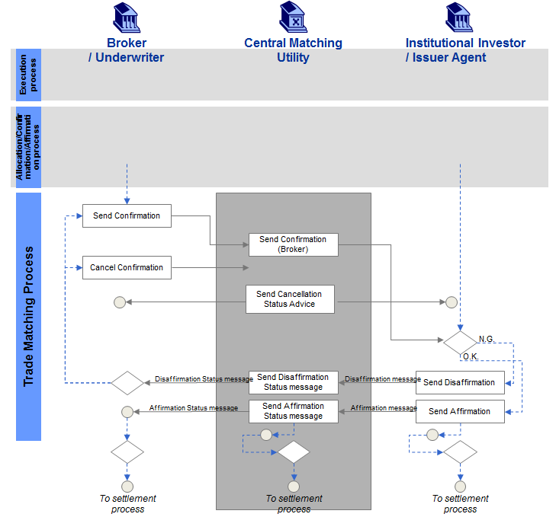

Description of Activities
Broker/Underwriter | Central Matching Utility (JASDEC) | Institutional Investor/Issuer Agent
Confirmation: The broker or Underwriter sends a trade confirmation to JASDEC. | Confirmation (broker): Once received from the broker, JASDEC forwards the trade confirmation to the Institutional Investor or Issuer Agent.
Cancel Confirmation: The trade may, for some reason, be cancelled upon which the broker will send a cancellation message to JASDEC.
 | Status Advice: JASDEC will send a cancellation status advice to the broker or Underwriter and Institutional Investor or Issuer Agent.
 | Disaffirmation Status Message: JASDEC sends a disaffirmation status message to the broker upon receipt of the disaffirmation message from the institutional investor which may result in the cancellation of the trade or the sending of a new confirmation. | Disaffirmation: The Institutional Investor or Issuer Agent will compare the details of the confirmation with their details of the trade. If the details are irreconcilable, a disaffirmation message will be sent to JASDEC.
 | Affirmation Status Message: JASDEC sends an affirmation status message to the broker upon receipt of an affirmation message from the Institutional Investor. The trade will then move into the settlement process. | Affirmation: Should the Institutional Investor or Issuer Agent agree with the detail of the confirmation an affirmation message is sent to JASDEC. The message will bind the parties to the trade details of the confirmation being affirmed.

Duplex Type
The Underwriter sends a trade confirmation to the CMU. The CMU forwards the confirmation received from the Underwriter to the Transfer Agent. Should the trade detail on the confirmation agree with that of the Transfer Agent, it sends an affirmation message to the CMU. Upon receipt of the affirmation message from the Transfer Agent, the CMU forwards the confirmation received from the Underwriter to the Cash Settlement Agent. Should the trade detail on the confirmation agree with that of the Cash Settlement Agent, it sends an affirmation message to the CMU. The message will bind the parties to the trade details of the confirmation being affirmed. The CMU sends an affirmation status message to the Underwriter and the trade can move into the settlement process.
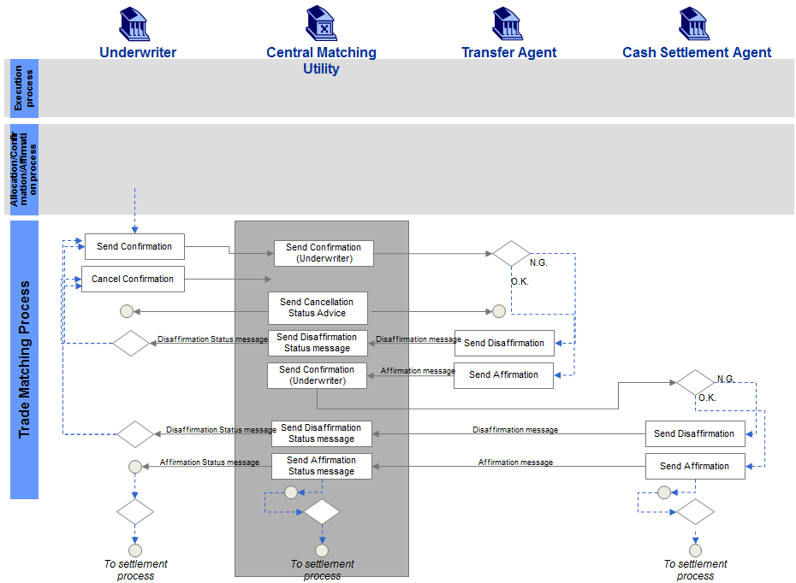

Description of Activities
Underwriter | Central Matching Utility (JASDEC) | Transfer Agent | Cash Settlement Agent
Confirmation: The Underwriter sends a trade confirmation to JASDEC. | Confirmation (Underwriter): JASDEC forwards the confirmation received from the Underwriter to the Transfer Agent.
Cancel Confirmation: Should the parties decide, for whatever reason, to cancel the trade a cancellation of the confirmation is sent from the Underwriter to JASDEC. A new confirmation may be sent. | Disaffirmation Status Message: Upon receipt of the disaffirmation message, JASDEC sends a disaffirmation status message to the Underwriter which may lead to a new trade confirmation message from the Underwriter to JASDEC or a confirmation cancellation message from the Underwriter to JASDEC. | Disaffirmation: The Transfer Agent compares the trade detail with its own trade detail and if there are irreconcilable differences, sends a disaffirmation message to JASDEC.
 | Status Advice: JASDEC will send a cancellation status advice to the Underwriter and Transfer Agent
 | Confirmation (Underwriter): Upon receipt of the affirmation message from the Transfer Agent, JASDEC forwards the confirmation received from the Underwriter to the Cash Settlement Agent. | Affirmation: Should the trade detail on the confirmation agree with that of the Transfer Agent, it sends an affirmation message to JASDEC.
 | Disaffirmation Status Message: Upon receipt of the disaffirmation message from the Cash Settlement Agent, JASDEC sends a disaffirmation status message to the Underwriter which may lead to a trade confirmation cancellation or a new trade confirmation message from the Underwriter to JASDEC. |  | Disaffirmation: The Cash Settlement Agent compares the trade details of the confirmation (Underwriter) with its own trade detail and if there are irreconcilable differences sends a disaffirmation message to JASDEC.
 | Affirmation Status Message: JASDEC sends an affirmation status message to the Underwriter and the trade can move into the settlement process. |  | Affirmation: Should the trade detail on the confirmation agree with that of the Cash Settlement Agent, it sends an affirmation message to JASDEC. The message will bind the parties to the trade details of the confirmation being affirmed.

End of Process Report for Listed Derivatives
The executing broker sends a confirmation of the trade to the CMU. The investment manager sends a confirmation of the trade to the CMU. The CMU will forward the two confirmations received to the trustee. After the executing broker sends all the trade confirmations on that day, the executing broker sends a delivery amount report to the CMU. The CMU forwards the delivery amount report to the trustee. The executing broker sends an end of process report of the confirmation to the CMU. After the investment manager sends all the trade confirmations on that day, the investment manager sends an end of process report of the confirmation to the CMU. The CMU forwards the end of day reports of the confirmation from both parties to the trustee.

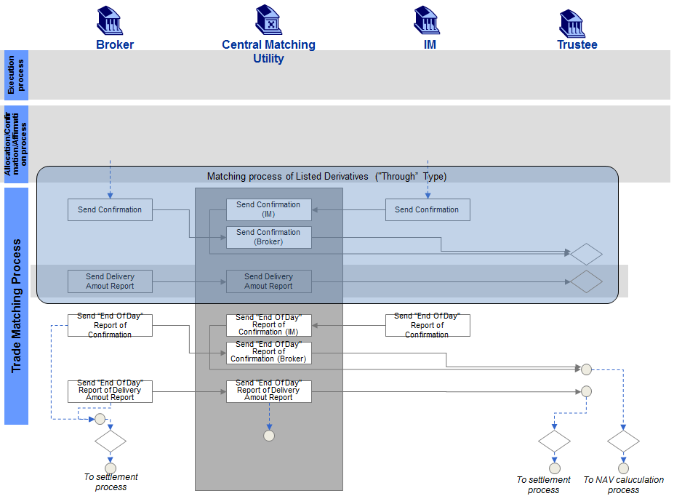

Description of Activities
Broker | Central Matching Utility (JASDEC) | Investment Manager | Trust Bank:
Confirmation The broker sends a confirmation of the trade to JASDEC . | JASDEC will compare the Confirmation details received from the broker and investment manager. | Confirmation: The investment manager sends a confirmation of the trade to JASDEC.
 | Confirmation (broker and IM): JASDEC will forward the confirmation received from both the broker and investment manager to the Trust Bank.
Delivery Amount Report: The broker sends a delivery amount report to JASDEC. | Delivery Amount Report: JASDEC forwards the delivery amount report to the Trust bank
End of Day Report of Confirmation: The broker sends an end of day report of the confirmation to JASDEC. |  | End of Day Report of Confirmation: The investment manager sends an end of day report of the confirmation to JASDEC.
 | End of Day Report (IM): JASDEC forwards the end of day report of the confirmation of both parties to the Trust Bank and the trade can move to the NAV calculation process.
End of Day Report of Delivery Amount: The broker sends an end of day report of delivery amount to JASDEC. | End of Day Report of Delivery Amount: JASDEC forwards the end of day report of delivery amount to the Trust Bank and the trade can move into the settlement process.

BusinessProcess – Central Matching

Tripartite Central Matching Without Confirmation Distribution Service
The executing broker sends a trade confirmation to the CMU. The CMU advise both parties that the trade confirmation is not paired yet. The investment manager sends the corresponding trade confirmation to the CMU. The CMU performs a matching process between the two confirmations and sends matching status messages to both parties, reflecting the outcome of the matching process. The CMU will forward the confirmation received from both the executing broker and investment manager to the trustee. If the trustee agrees with the details of the confirmations, it may send an affirmation message to the CMU. The message will bind the parties to the trade details of the confirmation being affirmed. Upon receipt of the affirmation message, the CMU will send an affirmation status message to the executing broker and the trade may move into the settlement process.
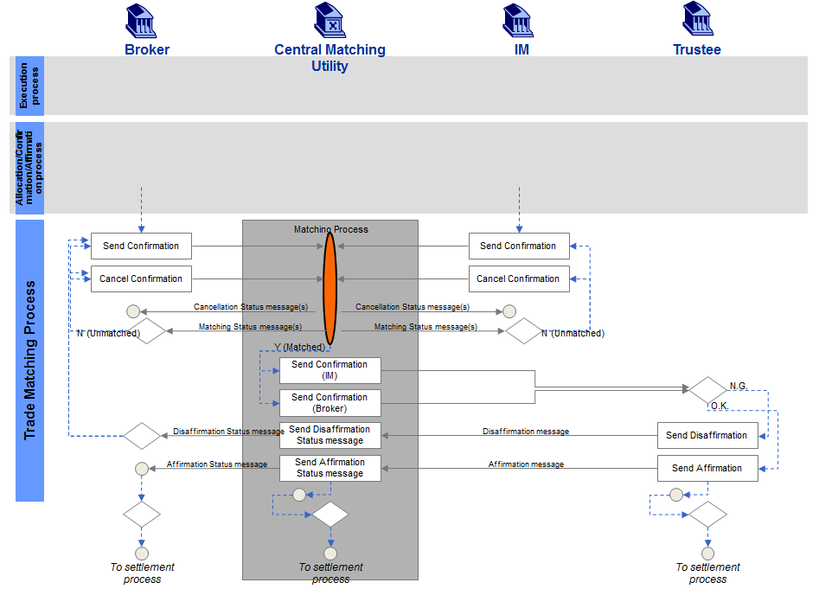

Description of Activities
Broker | Central Matching Utility (JASDEC) | Investment Manager | Trust Bank
Confirmation: The broker sends a trade confirmation to the CMU (JASDEC). | Matching Status Messages: The CMU (JASDEC) performs a matching process between the two confirmations and sends matching status messages to both parties, reflecting the outcome of the matching process. | Confirmation: The investment manager sends a trade confirmation to the CMU (JASDEC).
Cancel Confirmation: If unmatched, the broker may send a new confirmation or may, upon mutual agreement, send a confirmation cancellation. |  | Cancel Confirmation: If unmatched, the investment manager may send a new confirmation or may, upon mutual agreement, send a confirmation cancellation.
 | Status Advice: JASDEC will send a cancellation status advice to the broker and investment manager.
 | Confirmation (IM & broker): If matched, the CMU forwards both confirmations to the Trust Bank.
 | Disaffirmation Status Message: The CMU sends a disaffirmation status message to the broker, which may lead to a new confirmation being sent to the CMU of a confirmation cancellation being sent to the CMU. |  | Disaffirmation: Should the Trust Bank not agree with the details of the confirmations, it may send a disaffirmation message to the CMU (JASDEC).
 | Affirmation Status Message: Upon receipt of the affirmation message, the CMU will send an affirmation status message to the broker and the trade may move into the settlement process. |  | Affirmation: If the Trust Bank agrees with the details of the confirmations, it may send an affirmation message to the CMU. The message will bind the parties to the trade details of the confirmation being affirmed.

Tripartite Central Matching With Confirmation Distribution Service
The executing broker sends a trade confirmation to the CMU. The CMU forwards the confirmation received from the broker to the investment manager. The investment manager compares the details of the trade to its own details and sends a trade confirmation to the CMU. The CMU performs a matching process and sends matching status messages to both parties reflecting the outcome of the matching process. If matched, the CMU sends both the confirmations received from the investment manager and from the executing broker to the trustee. If the trustee agrees with the details of the trade, it sends an affirmation message to the CMU. The message will bind the parties to the trade details of the confirmation being affirmed. Upon receipt of the affirmation message from the trustee, the CMU sends an affirmation status message to the executing broker and the trade can move into the settlement process.
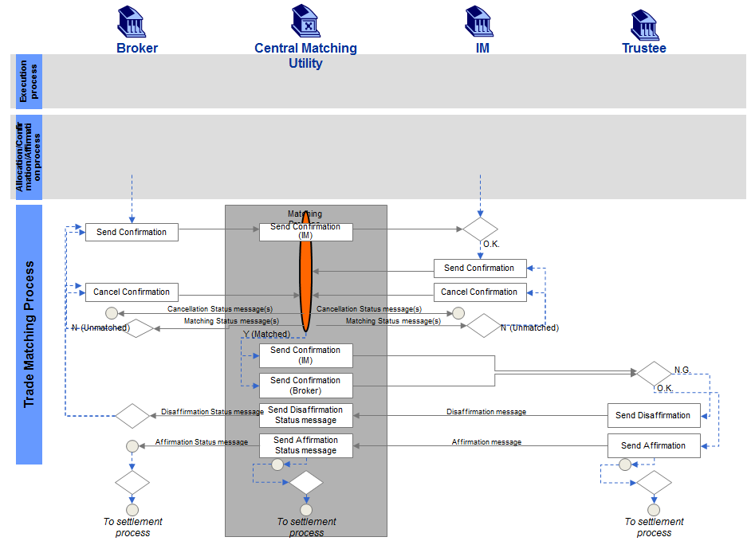
Description of Activities
Broker | Central Matching Utility (JASDEC) | Investment Manager | Trust Bank
Confirmation: The broker sends a trade confirmation to the CMU (JASDEC). | Confirmation (IM): The CMU (JASDEC) forwards the confirmation received from the broker to the investment manager. | Confirmation: The investment manager compares the details of the trade to its own details and sends a trade confirmation to the CMU.
Cancel Confirmation: If unmatched, the broker may send a confirmation cancellation message to the CMU or it may send a new confirmation to the CMU. | Matching Status Messages: The CMU performs a matching process and sends matching status messages to both parties reflecting the outcome of the matching process. | Cancel Confirmation: If unmatched, the investment manager may send a confirmation cancellation message to the CMU or it may send a new confirmation to the CMU.
 | Status Advice: JASDEC will send a cancellation status advice to the broker and investment manager.
 | Confirmation (IM & broker): If matched, the CMU sends both the confirmations received from the investment manager and from the broker to the Trust Bank.
 | Disaffirmation Status Message: Upon receipt of the disaffirmation message from the Trust Bank, the CMU sends a disaffirmation status message to the broker, which may lead to the broker sending a new confirmation to the CMU or a confirmation cancellation. |  | Disaffirmation: If the Trust Bank does not agree with the details of the trade, it sends a disaffirmation message to the CMU.
 | Affirmation Status Message: Upon receipt of the affirmation message from the Trust Bank, the CMU sends an affirmation status message to the and the trade can move into the settlement process. |  | Affirmation: If the Trust Bank agrees with the details of the trade, it sends an affirmation message to the CMU. The message will bind the parties to the trade details of the confirmation being affirmed.

Bilateral Central Matching
The executing broker sends a confirmation to the CMU. The CMU advise both parties that the trade confirmation is not paired yet. The prime broker sends a confirmation to the CMU. The CMU performs a matching process between the two confirmations and sends matching status messages to both parties reflecting the outcome of the matching process. If the confirmations are matched, the trade can move into the settlement process.
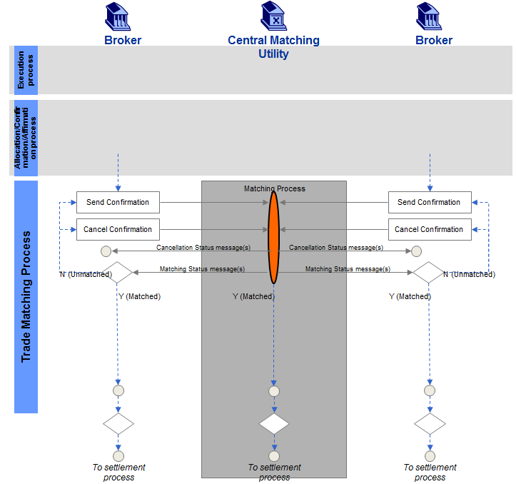

Description of Activities
Broker | Central Matching Utility (JASDEC) | Broker
Confirmation: Broker 1 sends a confirmation to the CMU (JASDEC). | Matching Status Messages: The CMU performs a matching process between the two confirmations and sends matching status messages to both parties reflecting the outcome of the matching process. If the confirmations are matched, the trade can move into the settlement process. | Confirmation: Broker 2 sends a confirmation to the CMU (JASDEC).
Cancel Confirmation: If the confirmation is unmatched, it may lead to the sending of a confirmation cancellation from the broker to the CMU or to the sending of a new confirmation from the broker to the CMU. |  | Cancel Confirmation: If the confirmation is unmatched, it may lead to the sending of a confirmation cancellation from the broker to the CMU or to the sending of a new confirmation from the broker to the CMU.
 | Status Advice: JASDEC will send a cancellation status advice to the broker and investment manager.

BusinessTransactions
This section describes the message flows based on the activity diagrams documented above. It shows the typical exchanges of information in the context of a BusinessTransaction.

BusinessTransactions - Local Matching Scenarios

Through Type Scenarios

Through Type
The executing broker and the investment manager send a confirmation to the CMU. The CMU will forward the two confirmations received to the trustee. The trustee will send an affirmation message to the CMU if it agrees with the detail of the trade. The message will bind the parties to the trade details of the confirmation being affirmed. The CMU will send an affirmation status message to the executing broker upon receipt of the affirmation message from the trustee. The trade will then move into the settlement process.
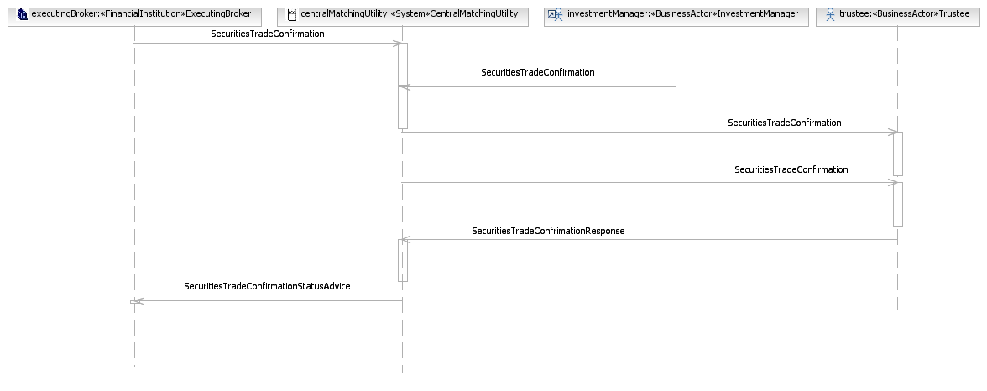

Through Type Cancellation
The executing broker and the investment manager send a confirmation to the CMU. The CMU will forward the two confirmations received to the trustee. The trustee will send an affirmation message to the CMU if it agrees with the detail of the trade. The message will bind the parties to the trade details of the confirmation being affirmed. The CMU will send an affirmation status message to the executing broker upon receipt of the affirmation message from the trustee. The executing broker and investment manager may, for whatever reason, decide to cancel the confirmation and a new confirmation may be sent. Cancellation of the confirmation may also imply the cancellation of the trade, in which case a new confirmation will not be sent.
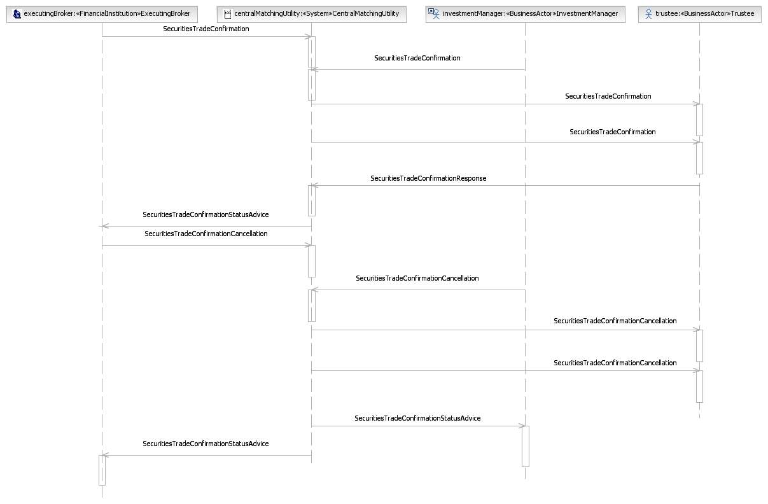

Own Account Trade Type Scenarios

Own Account Trade Type
The executing broker sends a trade confirmation to the CMU. Once received from the broker, The CMU forwards the trade confirmation to the Institutional Investor. Should the Institutional Investor agree with the detail of the confirmation an affirmation message is sent to the CMU. The message will bind the parties to the trade details of the confirmation being affirmed. The CMU sends an affirmation status message to the executing broker upon receipt of an affirmation message from the Institutional Investor. The trade will then move into the settlement process.
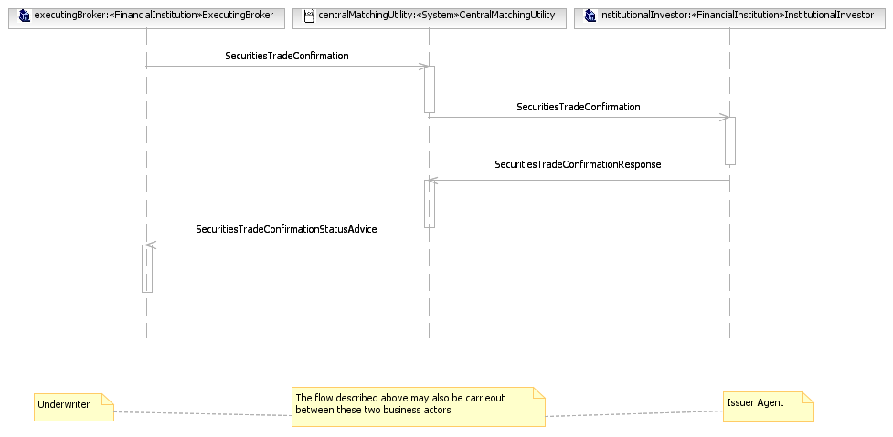

Own Account Trade Type Cancellation
The executing broker sends a trade confirmation to the CMU. Once received from the broker, The CMU forwards the trade confirmation to the Institutional Investor. The Institutional Investor will compare the details of the confirmation with their details of the trade. If the details are irreconcilable, a disaffirmation message will be sent to the CMU. The CMU sends a disaffirmation status message to the executing broker upon receipt of the disaffirmation message from the Institutional Investor which may result in the cancellation of the trade or the sending of a new confirmation.
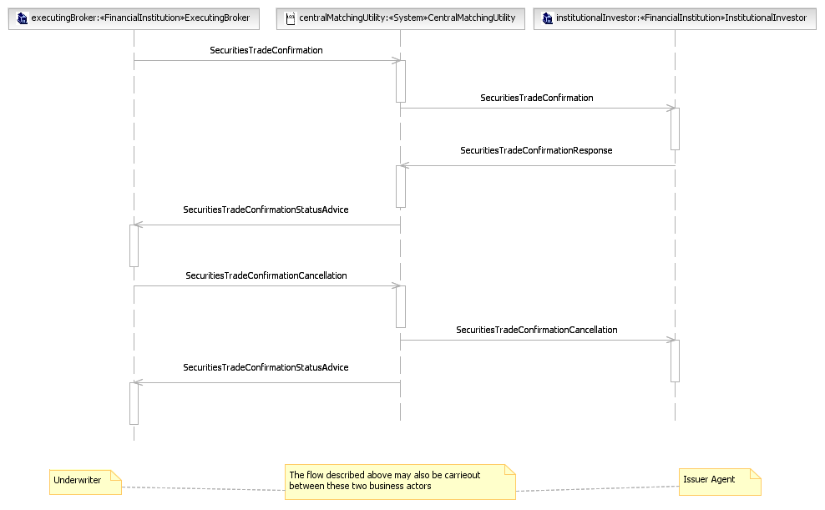

Duplex Type Scenarios

Duplex Type
The Underwriter sends a trade confirmation to the CMU. The CMU forwards the confirmation received from the Underwriter to the Transfer Agent. Should the trade detail on the confirmation agree with that of the Transfer Agent, it sends an affirmation message to the CMU. Upon receipt of the affirmation message from the Transfer Agent, the CMU forwards the confirmation received from the Underwriter to the Cash Settlement Agent. Should the trade detail on the confirmation agree with that of the Cash Settlement Agent, it sends an affirmation message to the CMU. The message will bind the parties to the trade details of the confirmation being affirmed. The CMU sends an affirmation status message to the Underwriter and the trade can move into the settlement process.
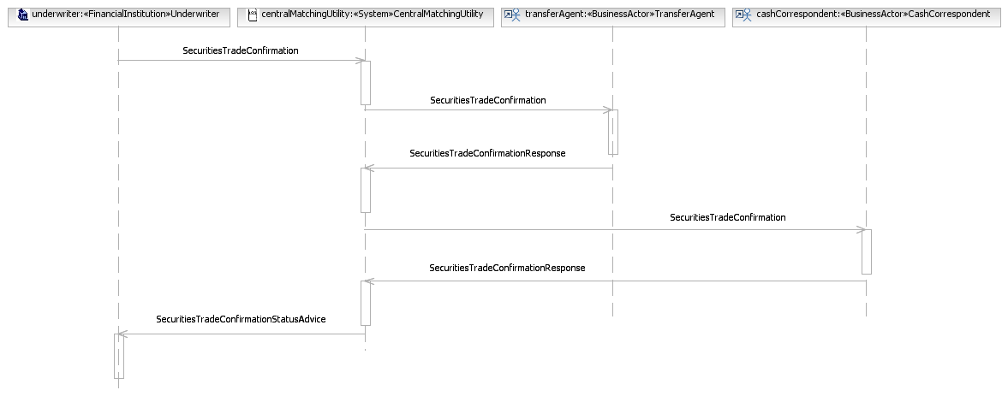

Duplex Type Rejection by Transfer Agent
The Underwriter sends a trade confirmation to the CMU. The CMU forwards the confirmation received from the Underwriter to the Transfer Agent. The Transfer Agent compares the trade detail with its own trade detail and if there are irreconcilable differences, sends a disaffirmation message to the CMU. Upon receipt of the disaffirmation message, the CMU sends a disaffirmation status message to the Underwriter which may lead to a new trade confirmation message from the Underwriter to the CMU or a confirmation cancellation message from the Underwriter to the CMU. The CMU will forward a cancellation to the Transfer Agent and send a cancellation status advice to the Underwriter.
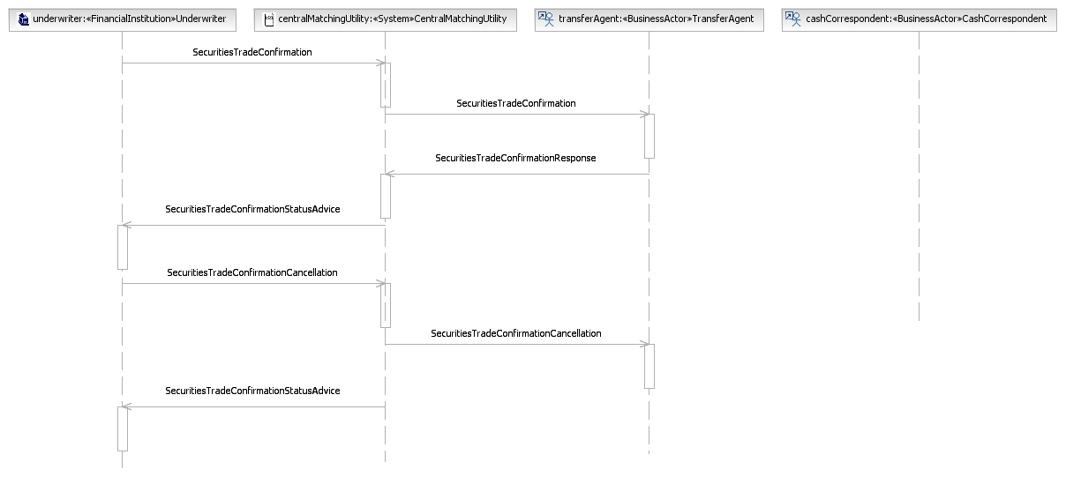

Duplex Type Rejection by Cash Correspondent
The Underwriter sends a trade confirmation to the CMU. The CMU forwards the confirmation received from the Underwriter to the Transfer Agent. Should the trade detail on the confirmation agree with that of the Transfer Agent, it sends an affirmation message to the CMU. Upon receipt of the affirmation message from the Transfer Agent, The CMU forwards the confirmation received from the Underwriter to the Cash Settlement Agent. The Cash Settlement Agent compares the trade details of the confirmation (Underwriter) with its own trade detail and if there are irreconcilable differences sends a disaffirmation message to the CMU. Upon receipt of the disaffirmation message from the Cash Settlement Agent, the CMU sends a disaffirmation status message to the Underwriter which may lead to a trade confirmation cancellation or a new trade confirmation message from the Underwriter to the CMU.
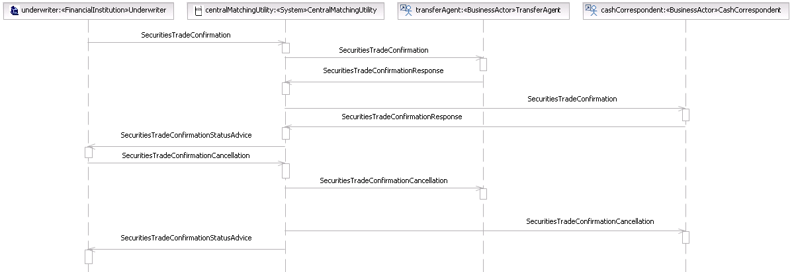

End of Process Report for Listed Derivatives Scenarios

End of Process Report for Listed Derivatives
The executing broker sends a confirmation of the trade to the CMU. The investment manager sends a confirmation of the trade to the CMU. The CMU will forward the two confirmations received to the trustee. After the executing broker sends all the trade confirmations on that day, the executing broker sends a delivery amount report to the CMU. The CMU forwards the delivery amount report to the trustee. The executing broker sends an end of process report of the confirmation to the CMU. After the investment manager sends all the trade confirmations on that day, the investment manager sends an end of process report of the confirmation to the CMU. The CMU forwards the end of day reports of the confirmation from both parties to the trustee.
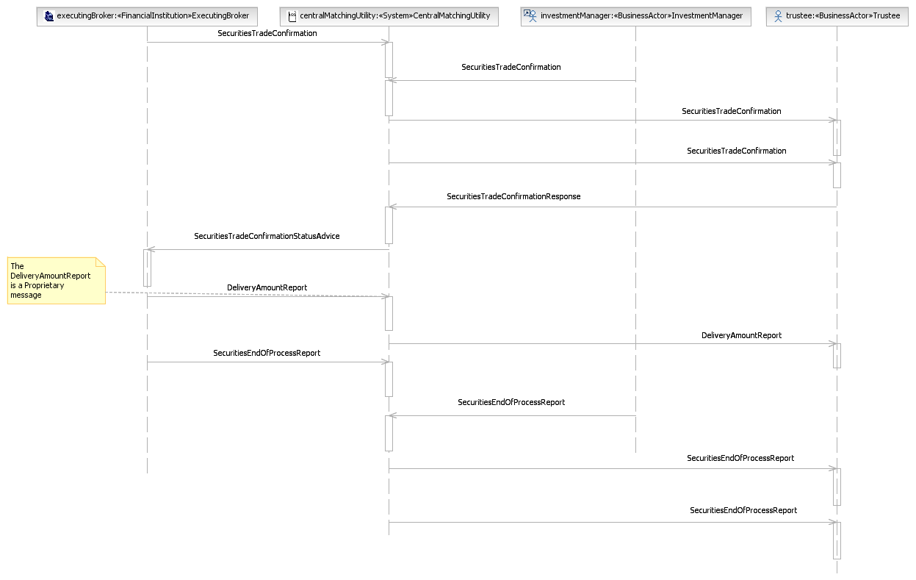

BusinessTransactions - Central Matching

Tripartite Central Matching Without Confirmation Distribution Service Scenarios

Tripartite Central Matching Without Confirmation Distribution Service
The executing broker sends a trade confirmation to the CMU. The CMU advise both parties that the trade confirmation is not paired yet. The investment manager sends the corresponding trade confirmation to the CMU. The CMU performs a matching process between the two confirmations and sends matching status messages to both parties, reflecting the outcome of the matching process. The CMU will forward the confirmation received from both the executing broker and investment manager to the trustee. If the trustee agrees with the details of the confirmations, it may send an affirmation message to the CMU. The message will bind the parties to the trade details of the confirmation being affirmed. Upon receipt of the affirmation message, the CMU will send an affirmation status message to the executing broker and the trade may move into the settlement process.
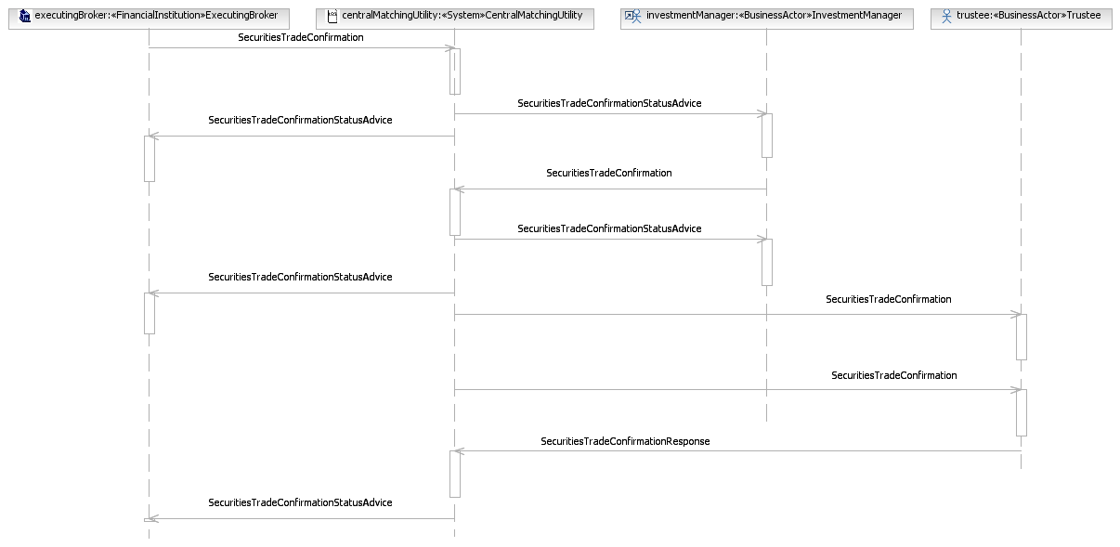

Tripartite Central Matching Without Confirmation Distribution Service Cancellation
The executing broker sends a trade confirmation to the CMU. The CMU advise both parties that the trade confirmation is not paired yet. The investment manager sends the corresponding trade confirmation to the CMU. The CMU performs a matching process between the two confirmations and sends matching status messages to both parties, reflecting the outcome of the matching process. If unmatched, the investment manager may send a new confirmation or may, upon mutual agreement, send a confirmation cancellation. Or, the executing broker may send a new confirmation or may, upon mutual agreement, send a confirmation cancellation. The CMU will send a cancellation status advice to the counterparty.
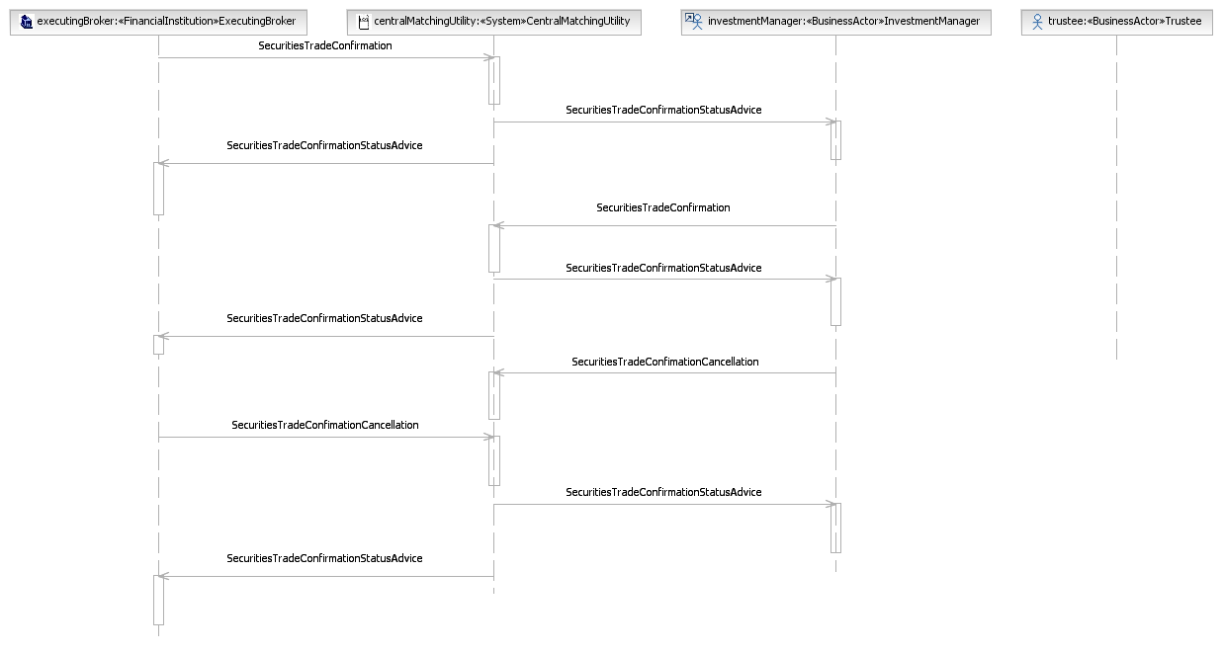

Tripartite Central Matching Without Confirmation Distribution Service Cancellation by Executing Broker
The executing broker sends a trade confirmation to the CMU. The CMU advise both parties that the trade confirmation is not paired yet. The investment manager sends the corresponding trade confirmation to the CMU. The CMU performs a matching process between the two confirmations and sends matching status messages to both parties, reflecting the outcome of the matching process. The executing broker may, for whatever reason, send a new confirmation or may, upon mutual agreement, send a confirmation cancellation. The CMU will forward the cancellation to the investment manager. The CMU advise the executing broker that they send the cancellation to the investment manager. The CMU will forward the cancellation received from the executing broker and send the cancellation on the behalf of investment manager to the trustee.
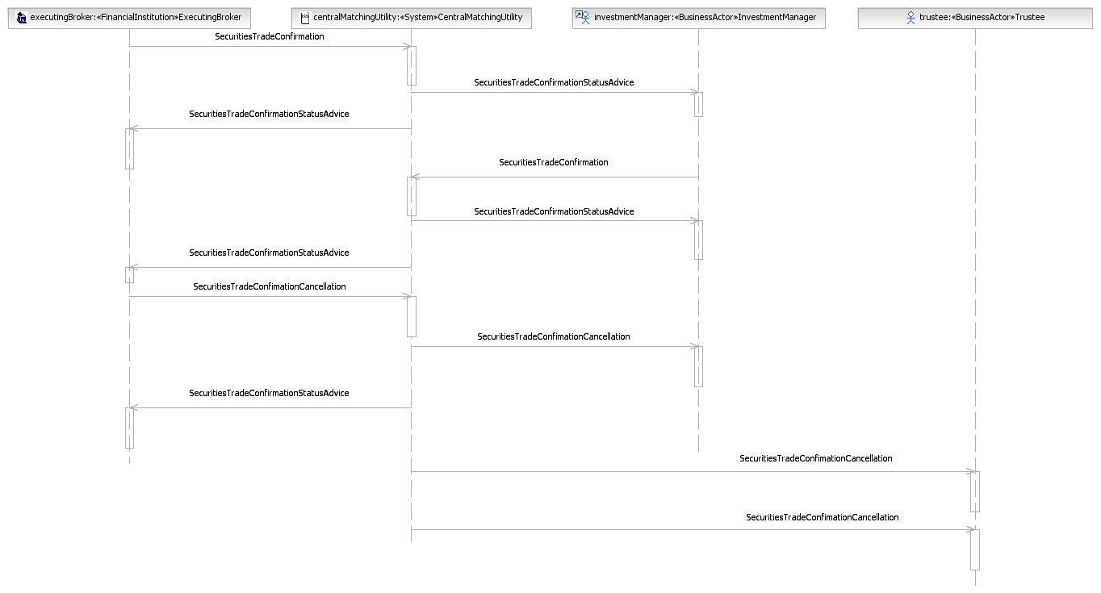

Tripartite Central Matching Without Confirmation Distribution Service Cancellation by Investment Manager
The executing broker sends a trade confirmation to the CMU. The CMU advise both parties that the trade confirmation is not paired yet. The investment manager sends the corresponding trade confirmation to the CMU. The CMU performs a matching process between the two confirmations and sends matching status messages to both parties, reflecting the outcome of the matching process. The investment manager may, for whatever reason, send a new confirmation or may, upon mutual agreement, send a confirmation cancellation. The CMU advise the investment manager that they send the cancellation to the executing broker. The CMU will forward the cancellation received from the investment manager and send the cancellation on behalf of the executing broker to the trustee.
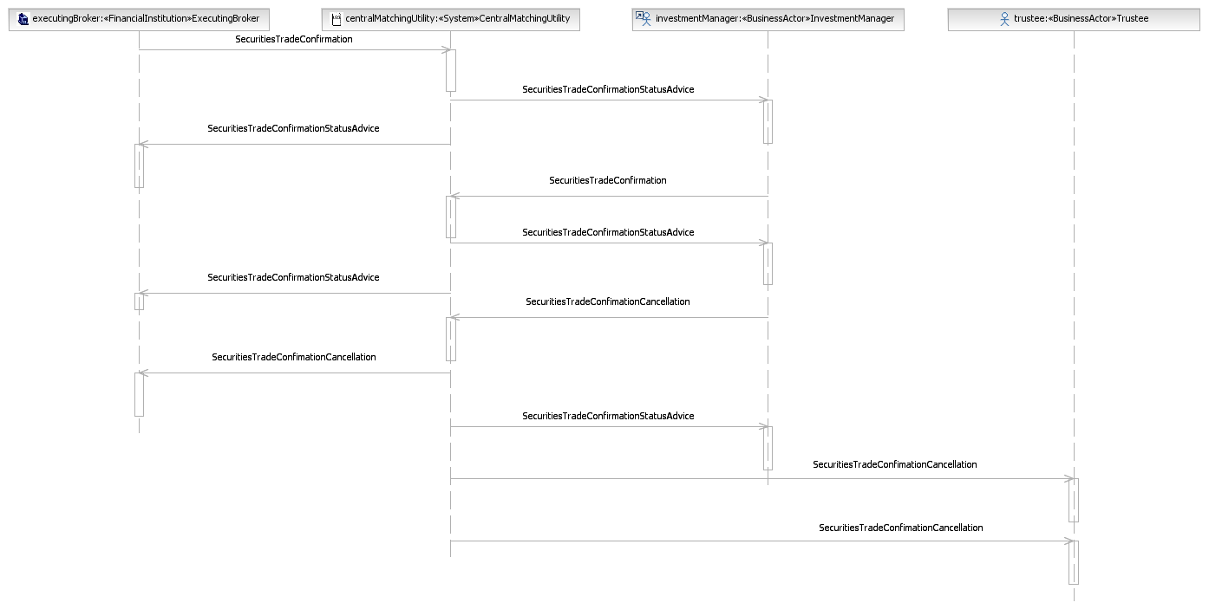

Tripartite Central Matching Without Confirmation Distribution Service Rejection
The executing broker sends a trade confirmation to the CMU. The CMU advise both parties that the trade confirmation is not paired yet. The investment manager sends the corresponding trade confirmation to the CMU. The CMU performs a matching process between the two confirmations and sends matching status messages to both parties, reflecting the outcome of the matching process. The CMU forward the confirmation received from both the executing broker and investment manager to the trustee. Should the trustee not agree with the details of the confirmations, it may send a disaffirmation message to the CMU. The CMU sends a disaffirmation status message to the executing broker, which may lead to a new confirmation being sent to the CMU of a confirmation cancellation being sent to the CMU. The CMU forward the cancellation to the investment manager. The CMU advise the executing broker that they send the cancellation to the investment manager. The CMU will forward the cancellation received from the investment manager and send the cancellation on behalf of the executing broker to the trustee.
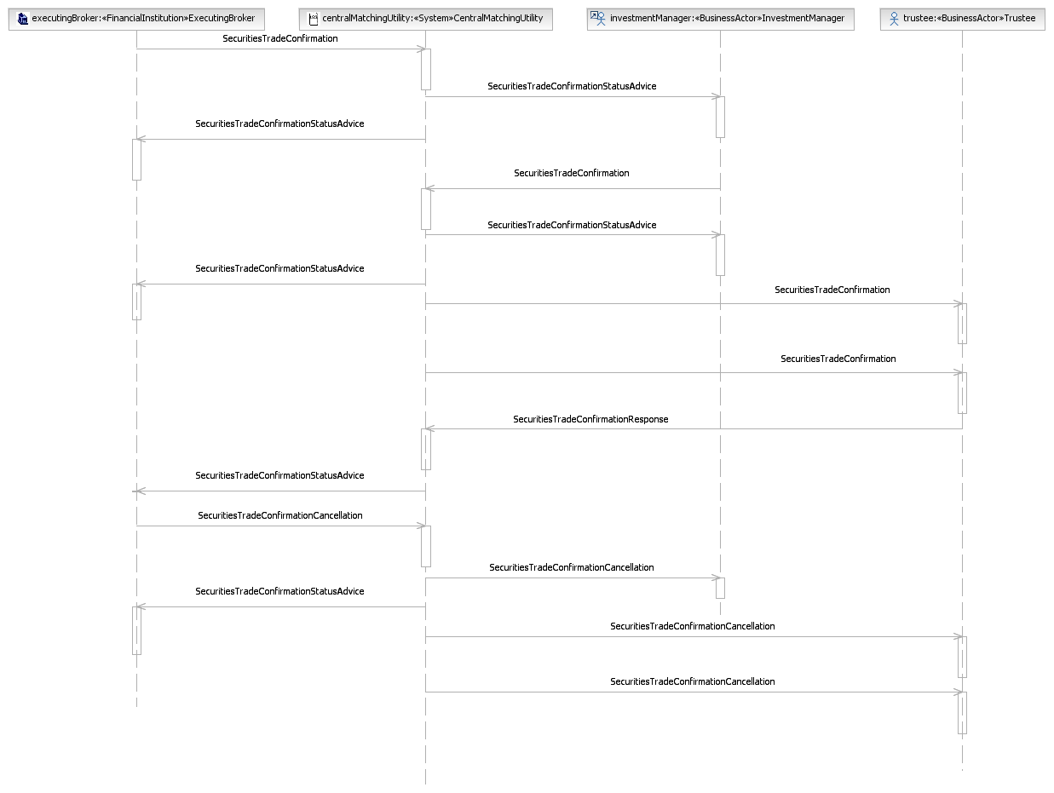

Tripartite Central Matching With Confirmation Distribution Service Scenarios

Tripartite Central Matching With Confirmation Distribution Service
The executing broker sends a trade confirmation to the CMU. The CMU forwards the confirmation received from the broker to the investment manager. The investment manager compares the details of the trade to its own details and sends a trade confirmation to the CMU. The CMU performs a matching process and sends matching status messages to both parties reflecting the outcome of the matching process. If matched, the CMU sends both the confirmations received from the investment manager and from the executing broker to the trustee. If the trustee agrees with the details of the trade, it sends an affirmation message to the CMU. The message will bind the parties to the trade details of the confirmation being affirmed. Upon receipt of the affirmation message from the trustee, the CMU sends an affirmation status message to the executing broker and the trade can move into the settlement process.
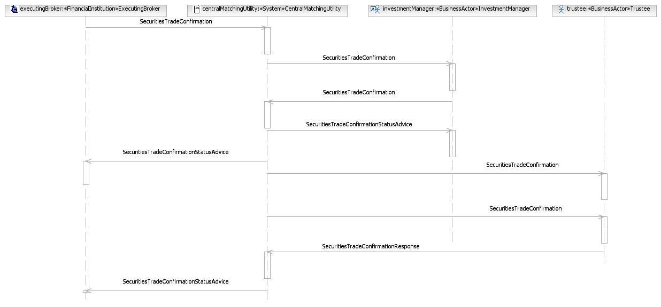

Tripartite Central Matching With Confirmation Distribution Service Cancellation by Executing Broker
The executing broker sends a trade confirmation to the CMU. The CMU forwards the confirmation received from the broker to the investment manager. The investment manager compares the details of the trade to its own details and sends a trade confirmation to the CMU. The CMU performs a matching process and sends matching status messages to both parties reflecting the outcome of the matching process. The broker may, for whatever reason, send a confirmation cancellation message to the CMU or it may send a new confirmation to the CMU. The CMU forwards a cancellation message to the investment manager. The CMU advise the executing broker that they send a cancellation to the investment manager. The CMU will forward the cancellation received from the investment manager and send the cancellation on behalf of the executing broker to the trustee.
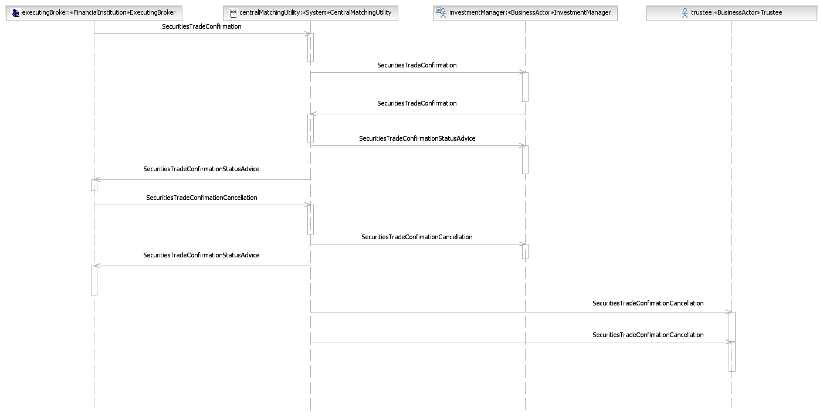

Tripartite Central Matching With Confirmation Distribution Service Cancellation by Investment Manager
The executing broker sends a trade confirmation to the CMU. The CMU forwards the confirmation received from the broker to the investment manager. The investment manager compares the details of the trade to its own details and sends a trade confirmation to the CMU. The CMU performs a matching process and sends matching status messages to both parties reflecting the outcome of the matching process. The investment manager may, for whatever reason, send a confirmation cancellation message to the CMU or it may send a new confirmation to the CMU. The CMU forwards a cancellation message to the executing broker. The CMU advise the investment manager that they send a cancellation to the executing broker. The CMU will forward the cancellation received from the investment manager and send the cancellation on behalf of the executing broker to the trustee.
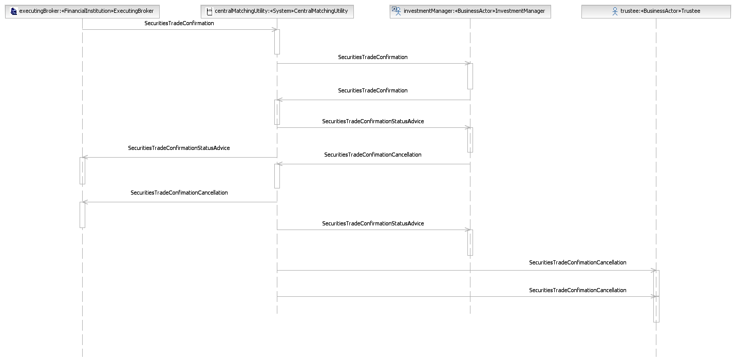

Tripartite Central Matching With Confirmation Distribution Service Rejection
The executing broker sends a trade confirmation to the CMU. The CMU forwards the confirmation received from the broker to the investment manager. The investment manager compares the details of the trade to its own details and sends a trade confirmation to the CMU. The CMU performs a matching process and sends matching status messages to both parties reflecting the outcome of the matching process. If matched, the CMU sends both the confirmations received from the investment manager and from the executing broker to the trustee. If the trustee does not agree with the details of the trade, it sends a disaffirmation message to the CMU. Upon receipt of the disaffirmation message from the trustee, the CMU sends a disaffirmation status message to the broker, which may lead to the broker sending a new confirmation to the CMU or a confirmation cancellation. The CMU forwards a cancellation message to the investment manager. The CMU advise the executing broker that they send a cancellation to the investment manager. The CMU will forward the cancellation received from the investment manager and send the cancellation on behalf of the executing broker to the trustee.
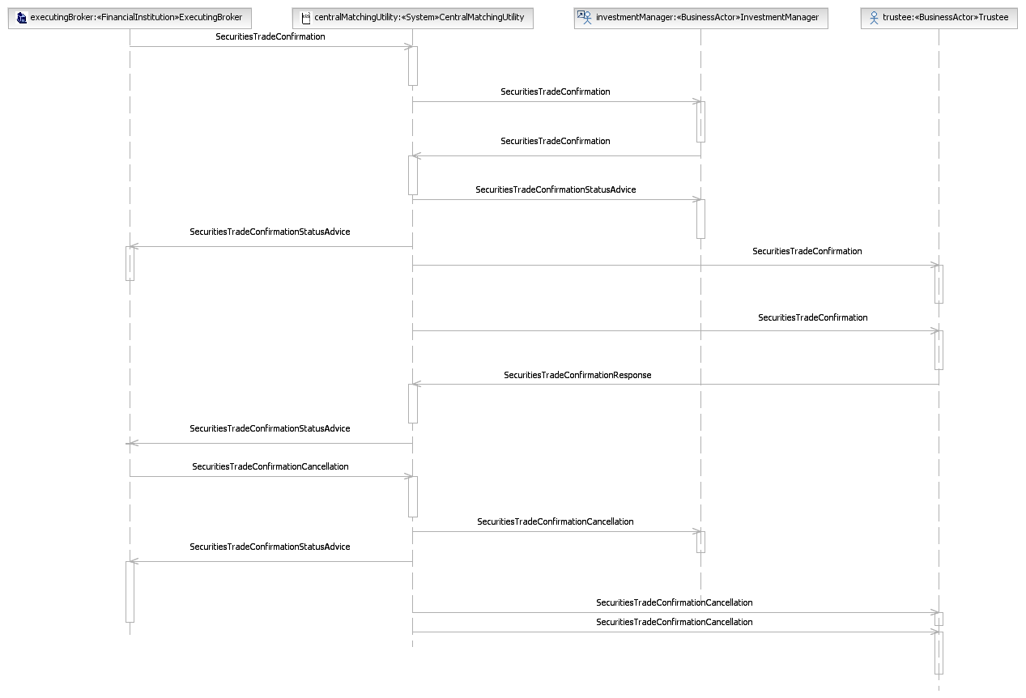

Bilateral Central Matching Scenarios

Bilateral Central Matching
The executing broker sends a confirmation to the CMU. The CMU advise both parties that the trade confirmation is not paired yet. The prime broker sends a confirmation to the CMU. The CMU performs a matching process between the two confirmations and sends matching status messages to both parties reflecting the outcome of the matching process. If the confirmations are matched, the trade can move into the settlement process.
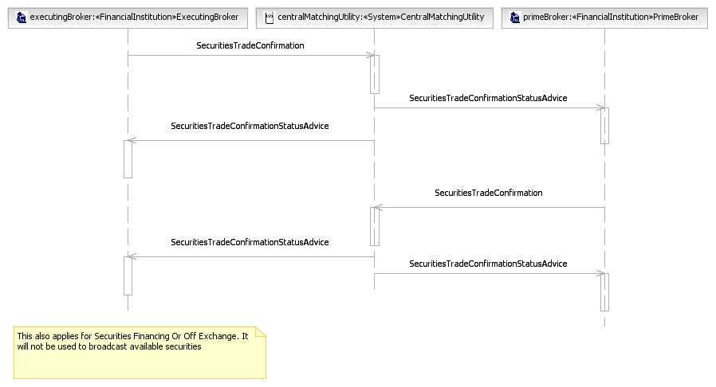

Bilateral Central Matching Cancellation
The executing broker sends a confirmation to the CMU. The CMU advise both parties that the trade confirmation is not paired yet. The prime broker sends a confirmation to the CMU. The CMU performs a matching process between the two confirmations and sends matching status messages to both parties reflecting the outcome of the matching process. It may, for whatever reason, lead to the sending of a confirmation cancellation from the executing broker to the CMU or to the sending of a new confirmation from the broker to the CMU. Or, it may lead to the sending of a confirmation cancellation from the prime broker to the CMU or to the sending of a new confirmation from the broker to the CMU. The CMU will send a cancellation status advice to the executing broker and the prime broker.
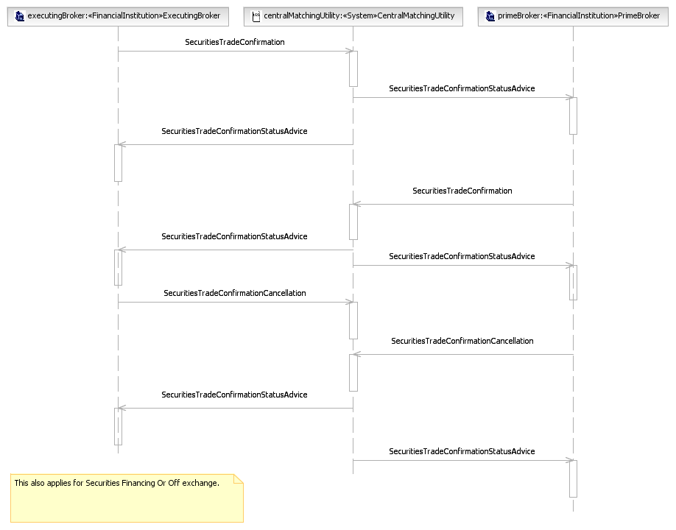

Tripartite Central Matching With End of Process Report Scenarios

Tripartite Central Matching With End of Process Report
The broker sends a confirmation to the CMU. The CMU advise both parties that the trade confirmation is not paired yet. The investment manager sends a confirmation to the CMU. The CMU performs a matching process between the two confirmations and sends matching status messages to both parties reflecting the outcome of the matching process. If the confirmations are matched, the trade can move into the settlement process. If the confirmations are matched, the trade can move into the settlement process. After the investment manager sends all the trade confirmations on that day, the investment manager sends an end of day report to the CMU. If there are unmatched data, the CMU sends a pre-advising confirmation to the trustee. The CMU sends unmatched data as pre-advice and forwards end of process report received from the investment manager to trustee, but this does not mean that investment manager and executing broker's data do not need to match at CMU. The investment manager's unmatched data will be matched with executing broker's data at a later time, and be sent to the trustee. If there is no unmatched data, the CMU sends an end of process report to the trustee.
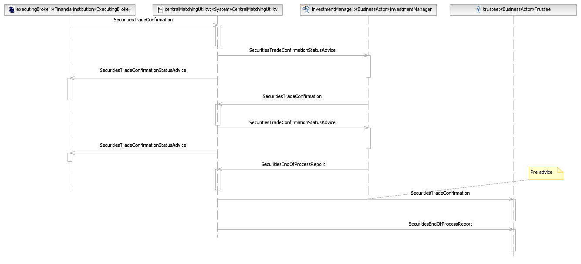

Revision Record

Revision | Date | Author | Description | Section Affected
1.0 | 1 Dec 2024 | SWIFT | Edition for SEG review | All
2.0 | February 2025 | ISO 20022 RA | Approved version | All
Disclaimer
Although the Registration Authority has used all reasonable efforts to ensure accuracy of the contents of the iso20022.org website and the information published thereon, the Registration Authority assumes no liability whatsoever for any inadvertent errors or omissions that may appear thereon. Moreover, the information is provided on an "as is" basis. The Registration Authority disclaims all warranties and conditions, either express or implied, including but not limited to implied warranties of merchantability, title, non-infringement and fitness for a particular purpose.
The Registration Authority shall not be liable for any direct, indirect, special or consequential damages arising out of the use of the information published on the iso20022.org website, even if the Registration Authority has been advised of the possibility of such damages.
Intellectual Property Rights
The ISO 20022 MessageDefinitions described in this document were contributed by SWIFT. The ISO 20022 IPR policy is available at www.ISO20022.org > About ISO 20022 > Intellectual Property Rights.

