ISO 20022
Target2-Securities - Collateral Reporting -Maintenance 2023 - 2024

Message Definition Report Part 1
Approved by the Securities and Payments SEG under the leadership of the Securities SEG on 15 February 2024
This document provides information about the use of the messages for Target2-Securities - Collateral Reporting and includes, for example, business transactions and messages flows.

March 2024

Table of Contents
Table of Contents 2
1 Introduction 5
1.1 Terms and Definitions 5
1.2 Abbreviations and Acronyms 5
1.3 Document Scope and Objectives 6
1.4 References 6
2 Scope and Functionality 7
2.1 Background 7
2.2 Scope 7
2.3 Groups of MessageDefinitions and Functionality 7
3 BusinessRoles and Participants 10
3.1 Participants and BusinessRoles Definitions 10
3.2 BusinessRoles and Participants Table 11
4 BusinessProcess Description 12
5 Description of BusinessActivities 15
5.1 Party Reference Data 15
6 BusinessTransactions 22
6.1 Creation Process 22
6.2 Modification Process 24
6.3 Deletion Process 27
6.4 Query/Response Process 29
6.5 Statement Process 31
7 Business Examples 32
7.1 Party Creation Request - reda.014.001.XX 32
7.2 Party Modification Request - reda.022.001.XX 34
7.3 Party Deletion Request - reda.031.001.XX 35
7.4 Party Status Advice- reda.016.001.XX 36
7.5 Party Query - reda.015.001.XX 39
7.6 Party Report - reda.017.001.XX 40
7.7 Party Activity Advice - reda.041.001.XX 42
7.8 Party Audit Trail Query - reda.042.001.XX 44
7.9 Party Audit Trail Report - reda.043.001.XX 45
8 Revision Record 47

Preliminary Note
The Message Definition Report (MDR) is made of three parts:
MDR Part 1
This describes the contextual background required to understand the functionality of the proposed message set. Part 1 is produced by the submitting organization that developed or maintained the message set in line with an MDR Part 1 template provided by the ISO 20022 Registration Authority (RA) on www.iso20022.org.
MDR Part 2
This is the detailed description of each message definition of the message set. Part 2 is produced by the RA using the model developed by the submitting organization.
MDR Part 3
This is an extract if the ISO 20022 Business Model describing the business concepts used in the message set. Part 2 is an Excel document produced by the RA.

Introduction

Terms and Definitions
The following terms are reserved words defined in ISO 20022 Edition 2013 – Part1. When used in this document, the UpperCamelCase notation is followed.
Term | Definition
BusinessRole | Functional role played by a business actor in a particular BusinessProcess or BusinessTransaction.
Participant | Involvement of a BusinessRole in a BusinessTransaction.
BusinessProcess | Definition of the business activities undertaken by BusinessRoles within a BusinessArea whereby each BusinessProcess fulfils one type of business activity and whereby a BusinessProcess may include and extend other BusinessProcesses.
BusinessTransaction | Particular solution that meets the communication requirements and the interaction requirements of a particular BusinessProcess and BusinessArea.
MessageDefinition | Formal description of the structure of a message instance.
When a MessageDefinition or message identifier is specified, it should include the variant and version number. However, in this document (except in the business examples section, if present), variant and version numbers are not included. In order to know the correct variant and version number for a MessageDefinition, the related Message Definition Report Part 2 document should be consulted.

Abbreviations and Acronyms
The following is a list of abbreviations and acronyms used in the document.
Abbreviation/Acronyms | Definition
4CB | Banca d’Italia, Banque de France, Deutsche Bundesbank and Banco d’España
ACH | Automated Clearing House
A2A | Application-to-Application mode. Defines a mode of technical communication that permits the exchange of information between software applications of T2S and a directly connected T2S actor.
BAH/head.001 | Business Application Header
BIC | Business Identifier Code
CeBM | Central Bank Money
CSD | Central Securities Depository
ID | Identification
MDR | Message Definition Report
NCB | National Central Bank
RTGS | Real-time gross settlement (RTGS) system.  A settlement system in which processing and settlement take place in real-time on a gross basis.
SEG | Standards Evaluation Group
T2S | TARGET2-Securities
TM | Technical Message. Messages which cover technical functions within T2S System
U2A | User-to-Application mode. Defines a mode of technical communication that permits the exchange of information between software applications of T2S and a T2S system user through a graphical user interface (GUI).
URD | T2S User Requirement Document
XML | eXtensible Mark-up language

Document Scope and Objectives
This document is the first part of the Target2-Securities - Party Reference Data Message Definition Report (MDR) that describes the BusinessTransactions and underlying message set. For the sake of completeness, the document may also describe BusinessActivities that are not in the scope of the business processes covered in this document.
This document describes the following:
- the BusinessProcess scope
- the BusinessRoles involved in these BusinessProcesses
The main objectives of this document are as follows:
- to provide information about the messages that support the business processes
- to explain the BusinessProcesses and BusinessActivities these messages have addressed
- to give a high level description of BusinessProcesses and the associated BusinessRoles
- to document the BusinessTransactions
- to provide business examples
The messages definitions are specified in Message Definition Report Part 2.

References
Document | Version | Date | Author
ISO 20022 Business Justification #042 – Securities settlement and reconciliation  Status of ISO 20022 submissions | ISO20022 (RA ID: 042) | 2.0 |  | 4CB
T2S User Requirements (URD)  https://www.ecb.europa.eu/paym/t2s/pdf/2016-08-01_urd_v5_05.pdf | 5.05 | Aug 2016 | ECB
ISO 20022 Payments Maintenance 2023/2024 - Maintenance Change Request (Catalogue of change requests | ISO20022 – RA ID: MCR #234) | 2023 | Sep 2023 | Swift

Scope and Functionality

Background
This Message Definition Report covers a set of two candidate Collateral Reporting Message Definitions developed by Deutsche Bundesbank, on behalf of 4CB in close collaboration with SWIFT, and approved by the Securities and Payments SEG under the leadership of the Securities Standards Evaluation Group (SEG) on 15 February 2024.
Originally, the messages have been designed to support the T2S community for Collateral management. T2S (TARGET2-Securities) is a European securities settlement engine which offers centralised settlement in central bank money across all European securities markets. The fundamental objective of T2S is to integrate and harmonise the highly fragmented securities settlement infrastructure in Europe. It aims to reduce the costs of cross-border securities settlement and increase competition and choice among providers of post-trading services in Europe.
To support information about collateral values, the Query Management module of T2S supports three different query types, providing a drill-down of the current collateral value of securities on stock per T2S dedicated cash account and securities account.

Scope
These two candidate Message Definitions (colr.001 and colr.002) support three different query types and are specifically designed to provide information on the current collateral value of securities on stock per cash account and securities account. The response to a query always contains the timestamp specifying the system time when the data selection was actually performed. The response messages to value queries will deliver information on all securities and cash balances that meet the specifications defined in the query. In addition, the information on securities balances is complemented with their balance types and the system time at which the balance snapshot was taken.

Groups of MessageDefinitions and Functionality
The collateral reporting messages are specifically designed to query the current available value of securities used in T2S for auto-collateralisation management.
These messages are to be used with the ISO 20022 Business Application Header (head.001). The schema and more information about the Business Application Header (BAH) can be found on the www.iso20022.org web site

Groups

Collateral Reporting
This Party Reference Data message set consists of:
MessageDefinition | Message Identifier
CollateralValueQuery | colr.001
CollateralValueReport | colr.002

These Collateral query messages are foreseen to support the following message usages:
- The Total collateral value per Cash Account Query/Response allows the system user to query the total current collateral value of securities that is earmarked and available (on stock) for auto-collateralisation for a cash account.

- The Collateral value per Cash Account Query/Response allows the system user to receive information on the collateral value of securities on stock per Cash Account and per security.

- The Collateral value of a security Query/Response allows the system user to query for a specific security the current collateral value of the security, earmarked and available (on stock) for auto-collateralisation, in every securities account linked to a specific cash account.

See Message Definition Report Part 2 for the message and formats.

BusinessRoles and Participants
A BusinessRole represents an entity (or a class of entities) of the real world, physical or legal, a person, a group of persons, a corporation. Examples of BusinessRoles: “Financial Institution”, “Automated Clearing House”, “Central Securities Depository”.
A Participant is a functional role performed by a BusinessRole in a particular BusinessProcess or BusinessTransaction. Examples of Participants: the “user” of a system, “debtor”, “creditor”, “investor”.
The relationship between BusinessRoles and Participants is many-to-many. One BusinessRole can be involved as different Participants at different moments in time or at the same time. Examples of BusinessRoles: "user", "debtor”, "creditor", "investor". Different BusinessRoles can be involved as the same Participant.
A business actor represents an entity (or a class of entities) of the real world, physical or legal, a person, a group of persons, a corporation. E.g. of business actors: “Financial Institution”, “ACH”, “CSD”, NCB.
A business role is a role performed by a business actor in a specific business context and process: e.g. the “user” of a system, “debtor”, “creditor”, “investor” etc.
Relationship between business roles and actors is many-to-many. One business actor (i.e. a person) can play different roles at different moments in time or at the same time: "user", "debtor, "creditor", "investor" etc. One role can also be played by different actors.

In the context of Collateral Reporting, the high-level business roles and typical actors can be represented as follows, based on the hierarchy of Roles defined in T2S as a securities settlement engine:

T2S supports a hierarchical model of roles and access rights to ensure the segregation of both functions and data. The area of the slide shaded in grey represents the data set-up for T2S dedicated cash accounts required in the static data of T2S. An NCB, acting as a CSD in its home country and providing dedicated cash accounts in T2S, will have the role of NCB and CSD and will exist in T2S as both a CSD and an NCB.

Participants and BusinessRoles Definitions
Participants
Description | Definition
System Transaction Administrator | In a central system, the entity or neutral body, in charge of providing services to the system's members. It is in charge of performing specified tasks on behalf and under the responsibility of the system's direct members. It can be a matching engine, a settlement engine, or a financial institution. It also maintains accounts or netting balances for the direct members of the system, registers transactions, performs checks and validations, and manages the settlement cycle or other value added processes, as specified in the functional specifications of the system.
System Member | The party that is entitled to make full or partial use of the system transaction administrator, to make it perform business processes on its behalf. A member can submit transactions, and request and/or receive information. A member can be a direct or indirect member.
Business Roles
Description | Definition
Instructing Party | Party that instructs the executing/servicing party to process and monitor a transaction.
Executing/Servicing Party | Party that processes, monitors and reports on transactions received from an instructing party.
Settlement Infrastructure | The party that provides services to its members for the settlement of transactions and holding of assets (e. g. T2S, RTGS).
T2S operator | The T2S operator is the top level of the hierarchical role and access rights model. The T2S operator role classification includes all T2S system users of the entity, which will be responsible for the day-to-day operation and management of T2S. The T2S actors managed by this entity shall be CSDs and NCBs participating in T2S. At the highest level, the T2S operator shall have access to all data and functionality in the subordinate level.
Settlement Infrastructure Direct Participant | The party which is not a CSD and that is directly connected to the Settlement Infrastructure Platform. It could be a local custodian, a global custodian, a stock exchange, a central counterparty…
Executing / Servicing Party | Party that processes, monitors and reports on transactions received from the Instructing party.
Central Securities Depositories (CSD) | An infrastructure that, holds or controls, the holding of physical or dematerialised financial instruments belonging to all, or a large portion of, the investors in a securities market. This affects the centralised transfer of ownership of such securities by entries on its books and records.
National Central Bank (NCB) | The principal monetary authority of a nation, a central bank performs several key functions, including issuing currency and regulating the supply of credit in the economy.
System Member | The party that is entitled to make full or partial use of the system transaction administrator, to make it perform business processes on its behalf. A member can submit transactions, and request and/or receive information. A member can be a direct or indirect member.
Payment Bank | The payment bank role includes all T2S system users of payment banks that require access to the T2S dedicated cash account balances and postings of the T2S dedicated cash accounts they provide for the purpose of securities settlement.

BusinessRoles and Participants Table
BusinessRole | System Member | System Transaction Administrator
T2S operator | x
National Central Bank | x
Payment Bank | x
Settlement Infrastructure |  | x
Settlement Infrastructure Direct Participant | x
Instructing Party | x
Executing/Servicing Party | x | x

BusinessProcess Description

BusinessProcess Diagram
The following diagram gives an overview of different types of queries used within Central System:
Settlement Instruction Queries:
Central System shall allow Central System Actors to perform queries on settlement instructions based on the actor’s roles and privileges. For example, for System Actors all instructions that have been sent by either the System Actor or by other Central System Actors that have been authorised by the System Actor to do so;
Securities Account Position Queries:
System users of CSD Participants, CSDs as well as payment banks and NCBs are allowed to send Securities Account Position and Securities Account Position History Queries.
Cash Related Queries:
Central System shall provide NCBs, settlement banks and payment banks, in accordance with their access rights, with the possibility to query e. g. the current balance of one or more Central System dedicated cash accounts.
Dynamic Data Queries:
The only query in this section is the “Report Query”, which provides a System user with the possibility to query the latest available report.
Static Data Queries:
Central System shall provide static data queries to all directly connected System actors. A System Actor shall be able to perform only those queries for which the actor has the necessary privileges. The queries shall return only those data for which the System actor has the necessary access right.
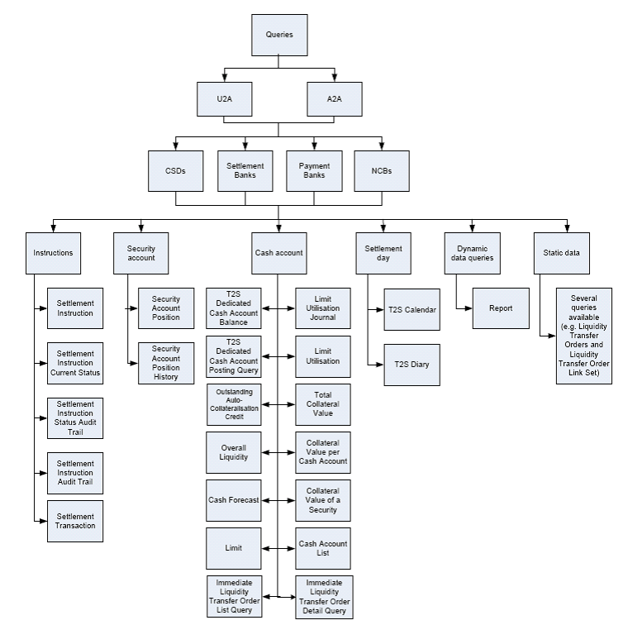

BusinessProcess Flow

Description of BusinessActivities
This section presents the different BusinessActivities within each BusinessProcess. The BusinessActivities of a process are described with activity diagrams.
Legend
Symbol | Name | Definition
 | Start Point | Shows where the lifecycle of the business process commences.
 | End Point | Shows where the lifecycle of the business process may ends.
 | Lozenge (or diamond) | Indicates that a choice between several actions can be made.
 | Bar | Indicates that several actions are initiated in parallel.

Query Management Process

Notes: In the frame of Central System flow, instructing party corresponds to the direct participant, payment bank or CSD, the servicing/executing party or the receiving party is the settlement infrastructure who achieves the report query request.

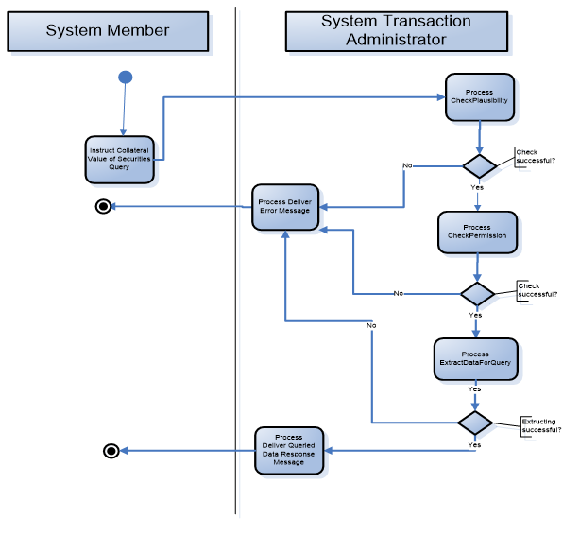
Step | Description | Initiator
Query | Request for Information concerning collateral values on a specific account | System Member
Rejection | Informs the instruction party (by error and description) in case if the instruction of a collateral value query was not valid for processing.  There could be three different reasons for a rejection message:  - plausibility check not successful  - permission check not successful  - extracting process not successful | System Transaction Administrator
Response | Delivers the requested data, if available, to the infrastructure of the requesting system member Party of the completeness of this instruction. | System Transaction Administrator

BusinessTransactions
This section describes the message flows based on the activity diagrams documented above. It shows the typical exchanges of information in the context of a BusinessTransaction.

As outlined above, an NCB, CSD or directly connected Central System party sends a Collateral Value Query to the Central System (e.g. T2S platform) to request information on the current available value of securities for auto collateralisation. The value will represent the amount of intraday credit that a party may receive through collateralising of their securities. Error Response or Collateral Value Response are both exclusive.

An overview of the communication flow and sequence diagram can be found below:

Revision Record

Revision | Date | Author | Description | Sections affected
1.0 | Dec 2023 | 4CB and SWIFT | Draft version for SEG review, based on maintenance 2023/2024 | All
2.0 | March 2024 | ISO 20022 RA | Approved version | all

Disclaimer:
Although the Registration Authority has used all reasonable efforts to ensure accuracy of the contents of the iso20022.org website and the information published thereon, the Registration Authority assumes no liability whatsoever for any inadvertent errors or omissions that may appear thereon. Moreover, the information is provided on an "as is" basis. The Registration Authority disclaims all warranties and conditions, either express or implied, including but not limited to implied warranties of merchantability, title, non-infringement and fitness for a particular purpose.
The Registration Authority shall not be liable for any direct, indirect, special or consequential damages arising out of the use of the information published on the iso20022.org website, even if the Registration Authority has been advised of the possibility of such damages.

Intellectual Property Rights:
The ISO 20022 MessageDefinitions described in this document were contributed described in this document were contributed Deutsche Bundesbank on behalf of 4CB and SWIFT for Target2-Securites. The ISO 20022 IPR policy is available at www.ISO20022.org > About ISO 20022 > Intellectual Property Rights.

