ISO 20022
Target2-Securities – Limit Utilisation Journal

Message Definition Report Part 1
Approved by the Securities SEG on the 16th January 2025 and Payments SEG on the 24th January 2025 under the lead of the Securities SEG.
This document provides information about the use of the candidate messages for Target2-Securities - Limit Utilisation Journal and includes, for example, business transactions and messages flows.

February 2025
Table of Contents
1 Introduction 4
1.1 Terms and Definitions 4
1.2 Abbreviations and Acronyms 4
1.3 Document Scope and Objectives 5
1.4 References 5
2 Scope and Functionality 6
2.1 Background 6
2.2 Scope 6
2.2.1 Groups 7
2.2.2 Functionality 7
3 BusinessRoles and Participants 9
3.1 Participants and BusinessRoles Definitions 10
3.2 BusinessRoles and Participants Table 11
4 BusinessProcess Description 12
5 Description of BusinessActivities 15
5.1 Pull mode 15
5.2 Push mode 16
6 BusinessTransactions 18
6.1 Limit Utilisation Journal Query 18
6.2 Limit Utilisation Journal Report 18
7 Business Examples 19
7.1 Example #1: Business Report 19
7.1.1 Description 19
7.1.2 Message example 19
7.2 Example #2: Operational Errors 22
7.2.1 Description 22
7.2.2 Message example 22
8 Revision Record 24

Preliminary Note
The Message Definition Report (MDR) is made of three parts:
MDR Part 1
This describes the contextual background required to understand the functionality of the proposed message set. Part 1 is produced by the submitting organization that developed or maintained the message set in line with an MDR Part 1 template provided by the ISO 20022 Registration Authority (RA) on www.iso20022.org.
MDR Part 2
This is the detailed description of each message definition of the message set. Part 2 is produced by the RA using the model developed by the submitting organization.
MDR Part 3
This is an extract if the ISO 20022 Business Model describing the business concepts used in the message set. Part 2 is an Excel document produced by the RA.

Introduction

Terms and Definitions
The following terms are reserved words defined in ISO 20022 Edition 2013 – Part1. When used in this document, the UpperCamelCase notation is followed.
Term | Definition
BusinessRole | Functional role-played by a business actor in a particular BusinessProcess or BusinessTransaction.
Participant | Involvement of a BusinessRole in a BusinessTransaction.
BusinessProcess | Definition of the business activities undertaken by BusinessRoles within a BusinessArea whereby each BusinessProcess fulfils one type of business activity and whereby a BusinessProcess may include and extend other BusinessProcesses.
BusinessTransaction | Particular solution that meets the communication requirements and the interaction requirements of a particular BusinessProcess and BusinessArea.
MessageDefinition | Formal description of the structure of a message instance.
When a MessageDefinition or message identifier is specified, it should include the variant and version number. However, in this document (except in the business examples section, if present), variant and version numbers are not included. In order to know the correct variant and version number for a MessageDefinition, the related Message Definition Report Part 2 document should be consulted.

Abbreviations and Acronyms
The following is a list of abbreviations and acronyms used in the document.
Abbreviation/Acronyms | Definition
4CB | Banca d’Italia, Banque de France, Deutsche Bundesbank and Banco d’España
A2A | Application-to-Application mode. Defines a mode of technical communication that permits the exchange of information between software applications of T2S and a directly connected T2S actor.
BAH/head.001 | Business Application Header
BIC | Business Identifier Code
CeBM | Central Bank Money
CSD | Central Securities Depository
ID | Identification
MDR | Message Definition Report
NCB | National Central Bank
RTGS | Real-time gross settlement (RTGS) system.  A settlement system in which processing and settlement take place in real-time on a gross basis.
SEG | Standards Evaluation Group
T2S | TARGET2-Securities
TM | Technical Message. Messages which cover technical functions within T2S System
U2A | User-to-Application mode. Defines a mode of technical communication that permits the exchange of information between software applications of T2S and a T2S system user through a graphical user interface (GUI).
URD | T2S User Requirement Document
XML | eXtensible Mark-up language

Document Scope and Objectives
This document is the first part of the Message Definition Report (MDR) that describes the BusinessTransactions and underlying message set. For the sake of completeness, the document may also describe BusinessActivities that are not in the scope of the business processes covered in this document.
This document describes the following:
- the BusinessProcess scope
- the BusinessRoles involved in these BusinessProcesses

The main objectives of this document are as follows:
- to provide information about the messages that support the business processes
- to explain the BusinessProcesses and BusinessActivities these messages have addressed
- to give a high level description of BusinessProcesses and the associated BusinessRoles
- to document the BusinessTransactions
- to provide business examples

The messages definitions are specified in Message Definition Report Part 2.

References
Document | Version | Date | Author
ISO 20022 Business Justification #042 – Securities settlement and reconciliation  Status of ISO 20022 submissions | ISO20022 (RA ID: 042) | 2.0 |  | 4CB
T2S User Requirements (URD)  https://www.ecb.europa.eu/paym/target/t2s/profuse/sdd/shared/pdf/T2S_URD_R2024.JUN_clean_20240222.en.pdf | R2024.  JUN | 15JAN  2024 | ECB

Scope and Functionality

Background
This Message Definition Report covers a set of two MessageDefinitions developed by Banque de France on behalf of 4CB in close collaboration with SWIFT, submitted by Deutsche Bundesbank on behalf of 4CB and Approved by the Securities Standards Evaluation Group (SEG) on the 16th January 2025 and Payments SEG on the 24th January 2025 under the lead of the Securities SEG.
Originally, these messages have been designed to support the T2S community for Limit Utilisation Journal Query and Report. T2S (TARGET2-Securities) is a European securities settlement engine which offers centralised settlement in central bank money across all European securities markets. The fundamental objective of T2S is to integrate and harmonise the highly fragmented securities settlement infrastructure in Europe. It aims to reduce the costs of cross-border securities settlement and increase competition and choice among providers of post-trading services in Europe.
The detailed description of each MessageDefinition is provided in Message Definition Report Part 2.

Scope
As described in the ISO 20022 Business Justification, The candidate Limit Utilisation Journal Query and Report messages are specifically designed to give the possibility to a NCBs, CSDs, payment and settlement banks to query for all journal activity impacting existing limits defined within a settlement infrastructure, satisfying a set of criteria including limit type, account identification, party identification of the credit consumer, responsible party identification of the credit consumer and dates. The settlement infrastructure, in this case T2S, will report back with the Limit Utilisation Journal Report which will provide the corresponding limit utilisation and related transactions for all journal activity satisfying the query criteria.

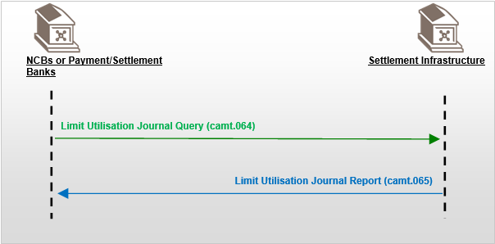
Settlement Infrastructure

These messages are to be used with the ISO 20022 Business Application Header (head.001). The schema and more information about the Business Application Header (BAH) can be found on the www.iso20022.org web site

Groups
Limit Utilisation Journal Query and Report message set consists of:
MessageDefinition | Message Identifier
Limit Utilisation Journal Query | camt.064
Limit Utilisation Journal Report | camt.065

Functionality
The Limit Utilisation Journal Query Report message definitions are specifically designed to support the following technical functions:
- Limit Utilisation Journal Query

A CSD, NCB, payment bank or a directly connected system participant (the central securities depository participant granted direct access, like a bank or a central counterparty) sends the Limit Utilisation Journal Query message (camt.064) to T2S. It is used to request information regarding the journaling of cash limits utilisation (including limit amounts, utilisation and journal of transactions impacting the utilisation of limits) as managed by the credit provider and corresponding to the criteria as defined within the message as the following:
- Mandatory business attributes include:
- Party identification (party as credit consumer)
- Responsible party identification (NCB acting as parent and as credit provider or CSD acting as parent of the client)
- Date (journal activity date)
- Optional business attributes include:
- Dedicated cash account
- Limit type:
- Auto Collateralisation
- External Guarantee
- Unsecured Credit
In response to the Limit Utilisation Journal Query T2S sends a Limit Utilisation Journal Report message (camt.065) with the corresponding limit amounts, utilisations and journal activity matching the criteria as defined within the query.

- Limit Utilisation Journal Report

The Limit Utilisation Journal Report message (camt.065) is sent by T2S to CSD, NCB, payment bank or a directly connected system participant (the central securities depository participant granted direct access, like a bank or a central counterparty). It is used to report information regarding the limits (including limit amounts, utilisation and journal of transactions impacting the utilisation of limits) as managed by the credit provider and corresponding to the criteria received within the incoming query message (camt.064).
It includes the following business attributes as output parameters:
- Party identification
- Responsible party identification
- Date
- Dedicated cash account
- Limit type
- Debit/Credit indicator
- Limit currency
- Amount (initial amount of the limit)
- Utilisation amount (utilised amount of the limit)
- Available amount (remaining available headroom of the limit)
- Transaction reference
See Message Definition Report Part 2 for the message and formats.

BusinessRoles and Participants
A BusinessRole represents an entity (or a class of entities) of the real world, physical or legal, a person, a group of persons, a corporation. Examples of BusinessRoles: “Financial Institution”, “Automated Clearing House”, “Central Securities Depository”.
A Participant is a functional role performed by a BusinessRole in a particular BusinessProcess or BusinessTransaction. Examples of Participants: the “user” of a system, “debtor”, “creditor”, “investor”.
The relationship between BusinessRoles and Participants is many-to-many. One BusinessRole can be involved as different Participants at different moments in time or at the same time. Examples of BusinessRoles: "user", "debtor”, "creditor", "investor". Different BusinessRoles can be involved as the same Participant.
In the context of the Limit Utilisation Journal Query and Report, the high-level BusinessArea, Processes, BusinessRoles and typical Participants can be represented as follows:
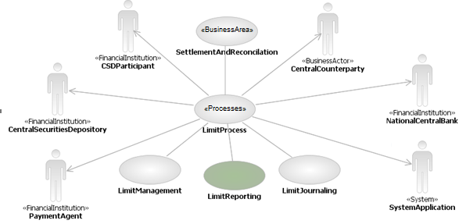
The Limit Utilisation Journaling Query and Limit Utilisation Journaling Report only covers the reporting processes in green. The other processes are included for completeness.
Moreover, the Limit Reporting communication flow with the relevant Participants can be represented as follows:
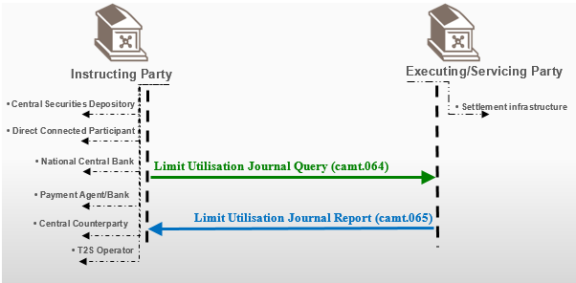

Participants and BusinessRoles Definitions

- Participants
Description | Definition
Instructing Party | Party that instructs the executing/servicing party to process and monitor a transaction.
Executing / Servicing Party | Party that processes, monitors and reports on transactions received from the Instructing party.

- Business Roles
Description | Definition
Settlement Infrastructure | The party that provides services to its members for the settlement of transactions and holding of assets (e.g., T2S, RTGS).
Central Securities Depositories (CSD) | An infrastructure that, holds or controls, the holding of physical or dematerialised financial instruments belonging to all, or a large portion of, the investors in a securities market. This affects the centralised transfer of ownership of such securities by entries on its books and records.
Direct Connected Participant (DCP) | The party, which is not a CSD and that, is directly connected to the Settlement Infrastructure Platform. It could be a local custodian, a global custodian, a stock exchange , a central counterparty, etc.
National Central Bank (NCB) | The principal monetary authority of a nation, a central bank performs several key functions, including issuing currency and regulating the supply of credit in the economy.  The NCB role classification shall include all T2S system users of an NCB as a liquidity provider through T2S dedicated cash accounts.
Payment Bank | The payment bank role includes all T2S system users of payment banks that require access to the T2S dedicated cash account balances and postings of the T2S dedicated cash accounts they provide for the purpose of securities settlement.
Central Counterparty | An infrastructure that is very often a component of a clearinghouse, and facilitates clearing and settlement for its members by standing between the buyer and the seller of a trade. It may net transactions, and substitutes itself as settlement counterparty to each position.
T2S Operator | The T2S operator is the top level of the hierarchical role and access rights model. The T2S operator role classification includes all T2S system users of the entity, which will be responsible for the day-to-day operation and management of T2S. The T2S actors managed by this entity shall be CSDs and NCBs participating in T2S. At the highest level, the T2S operator shall have access to all data and functionality in the subordinate level.

BusinessRoles and Participants Table

BusinessRole | Instructing Party | Executing/Servicing Party
Settlement Infrastructure |  | X
Central Securities Depositories (CSD) | X
Direct Connected Participant (DCP) | X
National Central Bank (NCB) | X
Payment Bank | X
Central Counterparty | X
T2S Operator | X

BusinessProcess Description
The subsequent diagram shows the high level business processes covered by the T2S project concerning Limit Utilisation. However the Limit Utilisation Journaling Query and Limit Utilisation Journaling Report only covers the reporting processes in green. The other processes are included for completeness.

The aim of the diagram below is to describe the high-level scope of “Limit Utilisation Journal Query Report” and the main processes are highlighted within the green boxes.

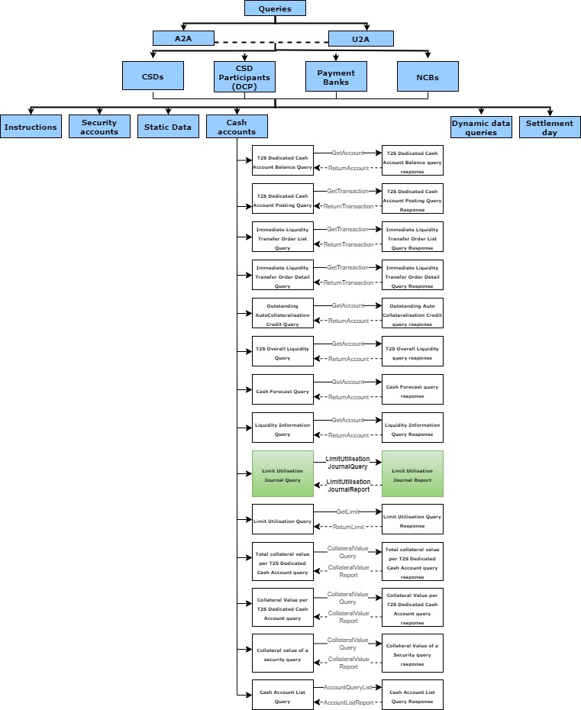
- Query Report Process
Item | Description
Definition | The instructing party requests a journaling of limit utilisation with selected criteria, from the executing party who replies with the limit activity within the settlement domain corresponding to the query criteria.
Trigger | The process is triggered either by the system through a scheduled event at the end of day or the sending of a query request by the Instructing Party.
Pre-conditions | Limits must exist to query within the scope of the Instructing Party.
Post-conditions | none
Role | • Instructing Party for the Query.  • Executing/Servicing Party for the Report.

Description of BusinessActivities
For the BusinessActivities description of a Limit Utilisation Journal Reporting process, two activities can be described: a pull mode activity and a push mode activity.
- Legend
Symbol | Name | Definition
 | Start Point | Shows where the lifecycle of the business process commences.
 | End Point | Shows where the lifecycle of the business process ends.
 | Lozenge (or diamond) | Indicates that a choice between several actions can be made.
 | Bar | Indicates that several actions are initiated in parallel.

Pull mode
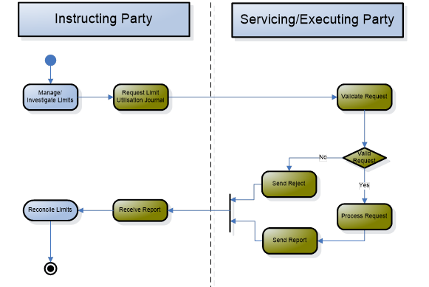

Step | Description | Initiator
Request Limit Utilisation Journal | Send a query to the Executing/Servicing Party to request information regarding the limits as managed by the credit provider and corresponding to the criteria as defined within the message. | Instructing Party
Validate Request | Technical and business validation of the request before further processing or not.  • If Yes, i.e., the request is valid, go to the Process Request.  • If No, the Send Reject is triggered. | Executing/Servicing Party (T2S in this case)
Send Reject | Generate a report and route it to the communication layer to inform the Instructing Party that the Request is rejected with a specification of the operational error resulting from the validation of a request. | Executing/Servicing Party (T2S in this case)
Process Request | Generate a report providing information regarding the limits as managed by the credit provider and corresponding to the criteria received within the incoming query message and trigger the Send Report. | Executing/Servicing Party (T2S in this case)
Send Report | Route a report to the communication layer. | Executing/Servicing Party (T2S in this case)
Receive Report | Go to the requested reporting activity. | Instructing Party

Push mode
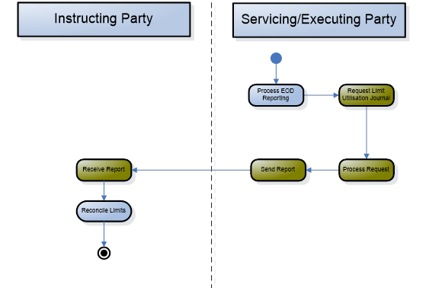
Step | Description | Initiator
Request Limit Utilisation Journal | Requests reports as part of end of day report management events. | Executing/Servicing Party (T2S in this case)
Process Request | Generate a report providing information regarding the limits as managed by the credit provider and trigger the Send Report. | Executing/Servicing Party (T2S in this case)
Send Report | Route a report to the communication layer. | Executing/Servicing Party (T2S in this case)
Receive Report | Go to the requested reporting activity. | Instructing Party (Subscriber to receive the report)

BusinessTransactions
This section describes the message flows based on the activity diagrams documented above. It shows the typical exchanges of information in the context of a BusinessTransaction.
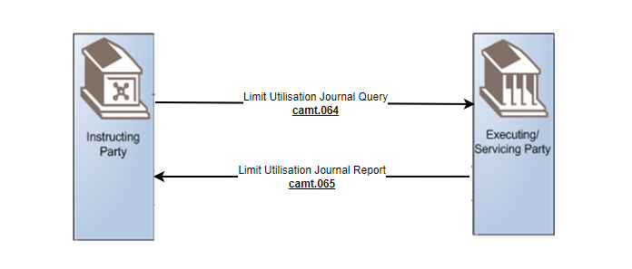

Limit Utilisation Journal Query
A CSD, NCB, payment bank or a directly connected system participant (the central securities depository participant granted direct access, like a bank or a central counterparty) sends a Limit Utilisation Journal Query via camt.064 to the central system (e.g. T2S in this case). Its purpose is to query information regarding the journal of transaction impacting the utilisation of limits that have been defined by the system participant.

Limit Utilisation Journal Report
The LimitUtilisationJournalReport message (camt.065) is exchanged between the central system, (e.g. T2S in this case) and a CSD, NCB, payment bank or a directly connected system party (the central securities depository participant granted direct access, like a bank or central counterparty). It is used to return information about the limit amounts, utilisation and journal of transactions impacting the utilisation of limits. Its purpose is to report information regarding the limits as managed by the credit provider and corresponding to the criteria received within the incoming query message (camt.064).

Business Examples
This section describes business examples of the use of the various candidate Message Definitions for the Limit Utilisation Journal Query and Report message set. All XML instances are embedded in the BAH, but the XML message instance provided below does only show the content of the pure business message.
In the business context, we can distinguish two possible scenarios for Limit Utilisation Journal Query and Report:
- Business Report.
- Operational Errors.

Example #1: Business Report

Description
In this example the “LimitUtilisationJournalQuery” is used by an NCB (A) "CBAABIC1XXX”, participating in T2S, to query via camt.064 the journal utilisation of Auto-collateralisation limits for the payment bank “PAYBKBICXXX” on January 9th, 2015, as the current business date, which corresponds to Limit Utilisation activity date.
The result of this query is sent using “LimitUtilisationJournalReport” (camt.065) containing the Auto-collateralisation limit, associated limit information and corresponding journal transaction activity of the utilisation of the limit for the bank linked to the Dedicated Cash Account identified by “9000000123”.
In this example, the following limit information is returned:
- Limit Amount: 100000 Euros;
- Utilisation: 40000 Euros;
- Available: 60000 Euros;
- Journal Activity :
- 15000 Euros Debit for Entry Reference T2SREF1234
- 12000 Euros Debit for Entry Reference T2SREF2345
- 13000 Euros Debit for Entry Reference T2SREF3456

Message example
- Limit Utilisation Journal Query - camt.064.001.01

<LmtUtlstnJrnlQry>
<MsgHdr>
<MsgId>REFABC</MsgId>
</MsgHdr>
<SchCrit>
<LmtTp>ACOL</LmtTp>
<JrnlActvtyDt>2015-01-09</JrnlActvtyDt>
<BilLmtCtrPtyId>
<Id>
<Id>
<AnyBIC>PAYBKBICXXX</AnyBIC>
</Id>
</Id>
<RspnsblPtyId>
<Id>
<AnyBIC>CBAABIC1XXX</AnyBIC>
</Id>
</RspnsblPtyId>
</BilLmtCtrPtyId>
</SchCrit>
</LmtUtlstnJrnlQry>

- Limit Utilisation Journal Report - camt.065.001.01

<LmtUtlstnJrnlRpt>
<MsgHdr>
<MsgId>NONREF</MsgId>
<OrgnlBizInstr>
<MsgId>REFABC</MsgId>
</OrgnlBizInstr>
</MsgHdr>
<Pgntn>
<PgNb>1</PgNb>
<LastPgInd>true</LastPgInd>
</Pgntn>
<RptOrErr>
<BizRpt>
<LmtId>
<AcctId>
<Othr>
<Id>9000000123</Id>
</Othr>
</AcctId>
<Tp>ACOL</Tp>
<LmtCcy>EUR</LmtCcy>
<AcctOwnr>
<FinInstnId>
<BICFI>PAYBKBICXXX</BICFI>
</FinInstnId>
</AcctOwnr>
<BilLmtCtrPtyId>
<Id>
<Id>
<AnyBIC>PAYBKBICXXX</AnyBIC>
</Id>
</Id>
<RspnsblPtyId>
<Id>
<AnyBIC>CBAABIC1XXX</AnyBIC>
</Id>
</RspnsblPtyId>
</BilLmtCtrPtyId>
</LmtId>
<LmtRpt>
<LmtJrnl>
<Lmt>
<Amt>
<Amt>
<AmtWthCcy Ccy="EUR">100000</AmtWthCcy>
</Amt>
<CdtDbtInd>CRDT</CdtDbtInd>
</Amt>
<UtlstnAmt>
<Amt>
<AmtWthCcy Ccy="EUR">40000</AmtWthCcy>
</Amt>
<CdtDbtInd>DBIT</CdtDbtInd>
</UtlstnAmt>
<AvlblAmt>
<Amt>
<AmtWthCcy Ccy="EUR">60000</AmtWthCcy>
</Amt>
<CdtDbtInd>CRDT</CdtDbtInd>
</AvlblAmt>
</Lmt>
<JrnlActvtyDt>2015-01-09</JrnlActvtyDt>
<JrnlNtry>
<JrnlDt>
<Dt>2015-01-09</Dt>
</JrnlDt>
<CdtDbtInd>DBIT</CdtDbtInd>
<Amt>
<AmtWthCcy Ccy="EUR">15000</AmtWthCcy>
</Amt>
<NtryRef>T2SREF1234</NtryRef>
<TxId>AOREF123</TxId>
<AcctSvcrRef>ASREFABC</AcctSvcrRef>
</JrnlNtry>
<JrnlNtry>
<JrnlDt>
<Dt>2015-01-09</Dt>
</JrnlDt>
<CdtDbtInd>DBIT</CdtDbtInd>
<Amt>
<AmtWthCcy Ccy="EUR">12000</AmtWthCcy>
</Amt>
<NtryRef>T2SREF2345</NtryRef>
<TxId>AOREF234</TxId>
<AcctSvcrRef>ASREFBCD</AcctSvcrRef>
</JrnlNtry>
<JrnlNtry>
<JrnlDt>
<Dt>2015-01-09</Dt>
</JrnlDt>
<CdtDbtInd>DBIT</CdtDbtInd>
<Amt>
<AmtWthCcy Ccy="EUR">13000</AmtWthCcy>
</Amt>
<NtryRef>T2SREF3456</NtryRef>
<TxId>AOREF345</TxId>
<AcctSvcrRef>ASREFCDE</AcctSvcrRef>
</JrnlNtry>
</LmtJrnl>
</LmtRpt>
</BizRpt>
</RptOrErr>
</LmtUtlstnJrnlRpt>

Example #2: Operational Errors

Description
In this example the “LimitUtilisationJournalQuery” is used by an NCB (H) "CBHHBIC2XXX”, participating in T2S, to query via camt.064 the journal utilisation of Auto-collateralisation limits for the payment bank “PBKHBIC0XXX” on January 9th, 2015 with Limit Utilisation activity date in the future.
The result of this query is sent using “LimitUtilisationJournalReport” (camt.065) specifying the operational error resulting from the processing of this request.
In this example, the Error Code “Q065” is returned with the corresponding Error description.

Message example
- Limit Utilisation Journal Query - camt.064.001.01

<LmtUtlstnJrnlQry>
<MsgHdr>
<MsgId>REFKLM</MsgId>
</MsgHdr>
<SchCrit>
<LmtTp>ACOL</LmtTp>
<JrnlActvtyDt>2015-01-21</JrnlActvtyDt>
<BilLmtCtrPtyId>
<Id>
<Id>
<AnyBIC> PBKHBIC0XXX </AnyBIC>
</Id>
</Id>
<RspnsblPtyId>
<Id>
<AnyBIC> CBHHBIC2XXX </AnyBIC>
</Id>
</RspnsblPtyId>
</BilLmtCtrPtyId>
</SchCrit>
</LmtUtlstnJrnlQry>

- Limit Utilisation Journal Report - camt.065.001.01

<LmtUtlstnJrnlRpt>
<MsgHdr>
<MsgId>NONREF</MsgId>
<OrgnlBizInstr>
<MsgId>REFKLM</MsgId>
</OrgnlBizInstr>
</MsgHdr>
<Pgntn>
<PgNb>1</PgNb>
<LastPgInd>true</LastPgInd>
</Pgntn>
<RptOrErr>
<OprlErr>
<Err>
<Prtry>Q065</Prtry>
</Err>
<Desc>The specified business date is in the future</Desc>
</OprlErr>
</RptOrErr>
</LmtUtlstnJrnlRpt>

Revision Record

Revision | Date | Author | Description | Sections affected
0.1 | 30-05-2024 | Stal/Jraied (BDF,4CB) | First draft based on the available HLBR’s | all
0.2 | 11-06-2024 | Sigrid Wiley for Swift | Correction of 4 samples after latest draft of messages | 7
0.3 | 13-06-2024 | Stéphanie Radet (4CB) | Final review before submission to ISO RA; minor correction in chapter 2.1 | 2.1
1.0 | 30-07-2024 | ISO 20022 RA | Final version for submission to the T2S Evaluation Team | Cover page, 2.1 and 8
2.0 | 07-02-2024 | ISO 20022 RA | Approved version | Cover page, 2.1 and 8

Disclaimer:
Although the Registration Authority has used all reasonable efforts to ensure accuracy of the contents of the iso20022.org website and the information published thereon, the Registration Authority assumes no liability whatsoever for any inadvertent errors or omissions that may appear thereon. Moreover, the information is provided on an "as is" basis. The Registration Authority disclaims all warranties and conditions, either express or implied, including but not limited to implied warranties of merchantability, title, non-infringement and fitness for a particular purpose.
The Registration Authority shall not be liable for any direct, indirect, special or consequential damages arising out of the use of the information published on the iso20022.org website, even if the Registration Authority has been advised of the possibility of such damages.

Intellectual Property Rights:
The ISO 20022 MessageDefinitions described in this document were contributed described in this document were contributed by Banque de France and SWIFT for T2-Securites. The ISO 20022 IPR policy is available at www.ISO20022.org > About ISO 20022 > Intellectual Property Rights.

