ISO 20022
Target2-Securities - Link Reference Data

Message Definition Report Part 1
Approved by the Securities SEG on 21 November 2024.

This document provides information about the use of the messages for Target2-Securities - Link Reference Data and includes, for example, business transactions and messages flows.

December 2024
Table of Contents
1 Introduction 5
1.1 Terms and Definitions 5
1.2 Abbreviations and Acronyms 5
1.3 Document Scope and Objectives 6
1.4 References 6
2 Scope and Functionality 7
2.1 Background 7
2.2 Scope 7
2.2.1 Groups 7
2.2.2 Functionality 7
3 BusinessRoles and Participants 10
3.1 Participants and BusinessRoles Definitions 10
3.2 BusinessRoles and Participants Table 11
4 BusinessProcess Description 12
5 Description of BusinessActivities 14
5.1 Link Reference Data 14
5.1.1 Link Creation Process 14
5.1.2 Link Modification Process 16
6 BusinessTransactions 18
6.1 Creation Process 18
6.1.1 Confirmation Scenario 18
6.1.2 Rejection Scenario 19
6.2 Modification Process 20
6.2.1 Confirmation Scenario 20
6.2.2 Rejection Scenario 21
7 Business Examples 22
7.1 Link Creation and Maintenance 22
7.1.1 Security CSD Link Creation Request - reda.045.001.01 22
7.1.2 Security CSD Link Modification Request - reda.046.001.01 23
7.1.3 Security CSD Link Status Advice - reda.047.001.01 24
7.1.4 Account Link Creation Request- reda.049.001.01 28
7.1.5 Account Link Maintenance Request - reda.050.001.01 29
7.1.6 Account Link Status Advice - reda.051.001.01 30
8 Revision Record 33

Preliminary Note
The Message Definition Report (MDR) is made of three parts:
MDR Part 1
This describes the contextual background required to understand the functionality of the proposed message set. Part 1 is produced by the submitting organization that developed or maintained the message set in line with an MDR Part 1 template provided by the ISO 20022 Registration Authority (RA) on www.iso20022.org.
MDR Part 2
This is the detailed description of each message definition of the message set. Part 2 is produced by the RA using the model developed by the submitting organization.
MDR Part 3
This is an extract if the ISO 20022 Business Model describing the business concepts used in the message set. Part 2 is an Excel document produced by the RA.

Introduction

Terms and Definitions
The following terms are reserved words defined in ISO 20022 Edition 2013 – Part1. When used in this document, the UpperCamelCase notation is followed.
Term | Definition
BusinessRole | Functional role played by a business actor in a particular BusinessProcess or BusinessTransaction.
Participant | Involvement of a BusinessRole in a BusinessTransaction.
BusinessProcess | Definition of the business activities undertaken by BusinessRoles within a BusinessArea whereby each BusinessProcess fulfils one type of business activity and whereby a BusinessProcess may include and extend other BusinessProcesses.
BusinessTransaction | Particular solution that meets the communication requirements and the interaction requirements of a particular BusinessProcess and BusinessArea.
MessageDefinition | Formal description of the structure of a message instance.
When a MessageDefinition or message identifier is specified, it should include the variant and version number. However, in this document (except in the business examples section, if present), variant and version numbers are not included. In order to know the correct variant and version number for a MessageDefinition, the related Message Definition Report Part 2 document should be consulted.

Abbreviations and Acronyms
The following is a list of abbreviations and acronyms used in the document.
Abbreviation/Acronyms | Definition
4CB | Banca d’Italia, Banque de France, Deutsche Bundesbank and Banco d’España
A2A | Application-to-Application mode. Defines a mode of technical communication that permits the exchange of information between software applications of T2S and a directly connected T2S actor.
BAH/head.001 | Business Application Header
BIC | Business Identifier Code
CeBM | Central Bank Money
CSD | Central Securities Depository
ID | Identification
MDR | Message Definition Report
NCB | National Central Bank
RTGS | Real-time gross settlement (RTGS) system.  A settlement system in which processing and settlement take place in real-time on a gross basis.
SEG | Standards Evaluation Group
T2S | TARGET2-Securities
TM | Technical Message. Messages which cover technical functions within T2S System
U2A | User-to-Application mode. Defines a mode of technical communication that permits the exchange of information between software applications of T2S and a T2S system user through a graphical user interface (GUI).
URD | T2S User Requirement Document
XML | eXtensible Mark-up language

Document Scope and Objectives
This document is the first part of the Message Definition Report (MDR) that describes the BusinessTransactions and underlying message set. For the sake of completeness, the document may also describe BusinessActivities that are not in the scope of the business processes covered in this document.
This document describes the following:
- the BusinessProcess scope
- the BusinessRoles involved in these BusinessProcesses

The main objectives of this document are as follows:
- to provide information about the messages that support the business processes
- to explain the BusinessProcesses and BusinessActivities these messages have addressed
- to give a high level description of BusinessProcesses and the associated BusinessRoles
- to document the BusinessTransactions
- to provide business examples

The messages definitions are specified in Message Definition Report Part 2.

References
Document | Version | Date | Author
ISO 20022 Business Justification #042 – Securities settlement and reconciliation  ISO 20022 Business Justifications (RA ID: 042) | 2.0 |  | 4CB
T2S User Requirements (URD)  https://www.ecb.europa.eu/paym/target/t2s/profuse/sdd/shared/pdf/T2S_URD_R2024.JUN_clean_20240222.en.pdf | R2024.  JUN | 15JAN  2024 | ECB

Scope and Functionality

Background
This Message Definition Report covers a set of six MessageDefinitions developed by Banca d'Italia on behalf of 4CB in close collaboration with SWIFT and submitted for the approval of the Securities Standards Evaluation Groups (SEG).
Originally, these messages have been designed to support the T2S community for reference data management. T2S (TARGET2-Securities) is a European securities settlement engine which offers centralised settlement in central bank money across all European securities markets. The fundamental objective of T2S is to integrate and harmonise the highly fragmented securities settlement infrastructure in Europe. It aims to reduce the costs of cross-border securities settlement and increase competition and choice among providers of post-trading services in Europe.
The detailed description of each MessageDefinition is provided in Message Definition Report Part 2.

Scope
As described in the ISO 20022 Business Justification, The candidate Link Reference Data messages are specifically designed to support the management of Links on both Securities CSD and Account sides.

These messages are to be used with the ISO 20022 Business Application Header (head.001). The schema and more information about the Business Application Header (BAH) can be found on the www.iso20022.org web site

Groups

Link Creation and Maintenance
This Link Reference Data message set consists of:
MessageDefinition | Message Identifier
Security CSD Link Creation Request | reda.045
Security CSD Link Maintenance Request | reda.046
Security CSD Link Status Advice | reda.047
Account Link Creation Request | reda.049
Account Link Maintenance Request | reda.050
Account Link Status Advice | reda.051

Functionality
The Link Reference Data message definitions are specifically designed to support the following technical functions:

- the Security CSD Link Creation Request (reda.045) provides a user, granted with the appropriate rights, with the possibility to create a link between a financial instrument and a CSD in their system.
This functionality is available to an authorised party, who must provide specific information, such as the financial instrument identification, the Issuer or Investor CSD identification, technical issuer identification, whether that CSD is responsible for the security maintenance, issuance account identification, as well as the start and the end date for the validity of the link, in order to link a financial instrument to a CSD.
- The Security CSD Link Maintenance Request (reda.046) provides a user, granted with the appropriate rights, with the possibility to update an existing Security CSD Link.
This functionality is available to all authorised parties.

- The Security CSD Link Status Advice (reda.047) informs the Instructing Party about the lifecycle of the creation or the modification of the link, using the following statuses:
Rejected
The Creation or Maintenance Request did not pass validation, some reasons could be:
- the mandatory information is not present or incorrect,
- the instruction is not a new occurrence,
- the Instructing Party or the user do not have the rights to create a Security CSD link,
- the instruction has already been received and is being processed.
It is possible to have more than one reason for the rejection status.
Queued
The processing of the Security CSD Link Creation Request or maintenance request has been delayed.
Completed
The instruction or maintenance has been successfully processed.

- The Account Link Creation Request (reda.049) provides a user, granted with the appropriate rights, with the possibility to create a link between a Cash Account and a Securities Account.
This functionality is available to an authorised party, who must provide specific information, such as the identification of the securities account and the dedicated cash account, whether the account link is set as default:
- for settlement,
- for auto-collateralisation usage,
- for settlement of cash legs
the request must also specify the start and end date for the Account link validity.

- The Account Link Maintenance Request (reda.050) provides a user, granted with the appropriate rights, with the possibility to update an existing Account Link.
This functionality is available to all authorised parties.

- The Account Link Status Advice (reda.051) informs the Instructing Party about the lifecycle of the Account link creation request or maintenance request, with following statuses:
Rejected
The instruction did not pass validation, some reasons could be:
- the mandatory information is not present or incorrect,
- the instruction is not a new occurrence,
- the Instructing Party do not have the rights to create an Account Link,
- the instruction has already been received and is being processed.
It is possible to have more than one reason for the rejection status.
Queued
The processing of the Account link Creation Request or maintenance request has been delayed.
Completed
The link request or maintenance has been successfully processed.
See Message Definition Report Part 2 for the message and formats.

BusinessRoles and Participants
A BusinessRole represents an entity (or a class of entities) of the real world, physical or legal, a person, a group of persons, a corporation. Examples of BusinessRoles: “Financial Institution”, “Automated Clearing House”, “Central Securities Depository”.
A Participant is a functional role performed by a BusinessRole in a particular BusinessProcess or BusinessTransaction. Examples of Participants: the “user” of a system, “debtor”, “creditor”, “investor”.
The relationship between BusinessRoles and Participants is many-to-many. One BusinessRole can be involved as different Participants at different moments in time or at the same time. Examples of BusinessRoles: "user", "debtor”, "creditor", "investor". Different BusinessRoles can be involved as the same Participant.
In the context of the Party Reference Data, the high-level BusinessRoles and typical Participants can be represented as follows:
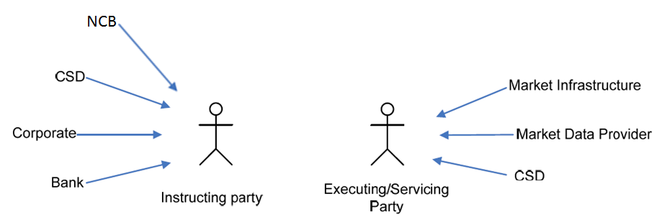

Participants and BusinessRoles Definitions
Participants
Description | Definition
Instructing Party | Party that instructs the executing/servicing party to process and monitor a transaction.
Executing / Servicing Party | Party that processes, monitors and reports on transactions received from the Instructing party.
Business Roles
Description | Definition
Central Securities Depositories (CSD) | An infrastructure that, holds or controls, the holding of physical or dematerialised financial instruments belonging to all, or a large portion of, the investors in a securities market. This affects the centralised transfer of ownership of such securities by entries on its books and records.
National Central Bank (NCB) | The principal monetary authority of a nation, a central bank performs several key functions, including issuing currency and regulating the supply of credit in the economy.
Corporate | The most common form of business organization, and one which is chartered by a state and given many legal rights as an entity separate from its owners. This form of business is characterized by the limited liability of its owners, the issuance of shares of easily transferable stock, and its existence as a going concern.
Bank | A business establishment in which money is kept for saving or commercial purposes or is invested, supplied for loans, or exchanged. A bank is licensed by a government. Its primary activity is to lend money.  A bank does most or all of the following: receives demand deposits and time deposits, honors instruments drawn on them, and pays interest on them; discounts notes, makes loans, and invests in securities; collects checks, drafts, and notes; certifies depositor's checks; and issues drafts and cashier's checks.
Market Infrastructure | The party that provides, through common membership, services to create a fair and open process for the execution of transactions between trading parties and the creation of settlement obligations.
Market Data Provider | An organization that provides data on financial instruments to other parties. Such as services provided by Thomson, Reuters, Bloomberg …

BusinessRoles and Participants Table
BusinessRole | Instructing Party | Executing/Servicing Party
Bank | X
Corporate | X
NCB | X
CSD | X | X
Market Data Provider | X | X
Market Infrastructure |  | X

BusinessProcess Description
This diagram represents the high level BusinessProcesses.
The aim of the below is to describe the high-level scope of T2S concerning “Link Reference Data” and is not to be exhaustive.
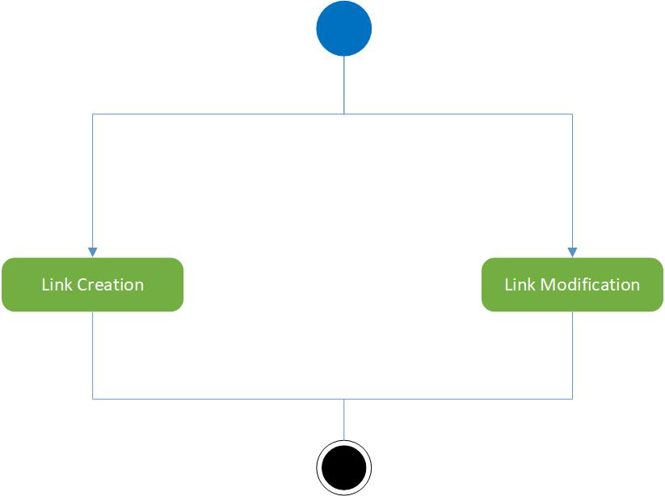

Link Creation Process
Item | Description
Definition | When an Instructing Party would like to create a specific Reference Data Link that is not yet supported by the Executing/Servicing Party, an Instructing Party asks the Executing/Servicing Party to create the Reference Data Link in its system.
Trigger | The process is triggered when the Instructing Party sends a Reference Data Link Creation Request message.
Pre-conditions | The Instructing Party is known by the Executing/Servicing Party system and has been granted the appropriate privileges. The Instructing Party identified a gap in the Reference Data Links coverage of the Executing/Servicing Party. The Instructing Party needs this Reference Data Link to be set-up at the Executing /Servicing Party to perform its activities.
Post-conditions | The acknowledgement of the processing of the creation request.
Role | Instructing Party

Link Modification Process
Item | Description
Definition | When an Instructing Party is in charge of the modification of a specific Reference Data Link already supported by the Executing/Servicing Party system, the Instructing Party asks the Executing/Servicing Party to modify the Reference Data Link in the Executing/Servicing Party system.
Trigger | The process is triggered when the Instructing Party sends a Reference Data  Link Modification Request message.
Pre-conditions | The Instructing Party is known by the Executing/Servicing Party system and has been granted the appropriate privileges. An attribute of the Reference Data Link has changed which requires a modification of the Reference Data Link in the Executing/Servicing Party system.
Post-conditions | The acknowledgement of the processing of the modification request.
Role | Instructing Party

Description of BusinessActivities
This section presents the different BusinessActivities within each BusinessProcess. The BusinessActivities of a process are described with activity diagrams.
Legend
Symbol | Name | Definition
 | Start Point | Shows where the lifecycle of the business process commences.
 | End Point | Shows where the lifecycle of the business process may ends.
 | Lozenge (or diamond) | Indicates that a choice between several actions can be made.
 | Bar | Indicates that several actions are initiated in parallel.

Link Reference Data

Link Creation Process
Step | Description | Initiator
Instruction | Instructing Party instructs the Executing/Servicing Party to create a link. | Instructing Party
Validate | Executing/Servicing Party system checks if this instruction is a new occurrence or not.  It also checks if this instruction is already handled or not.  If validation of the message fails, a status message “REJECTED” will be sent including the related errors and reason information.  If the message is valid and the time permits the creation of the link, the data will be processed and a status message “COMPLETED” will be sent.  Otherwise a status message “QUEUED” will be sent and the instruction will be resubmit to validation after a specific event. | Executing/Servicing Party
Process | If the instruction is accepted, the Executing/Servicing Party processes the instruction and informs the Instructing Party of the completeness of this instruction. | Executing/Servicing Party
Report | Executing/Servicing Party informs the Instructing Party that this instruction is rejected and why. | Executing/Servicing Party
Monitor process | Instructing Party monitors the status of the instruction. | Instructing Party

Link Modification Process
Step | Description | Initiator
Instruction | Instructing Party instructs the Executing/Servicing Party to modify a link. | Instructing Party
Validate: | Executing/Servicing Party checks if the instruction already exists in the system.  It checks also if the data can or cannot be updated.  If validation of the message fails, a status message “REJECTED” will be sent including the related errors and reason information.  If the message is valid and the time permits the update of the link, the data will be processed and a status message “COMPLETED” will be sent.  Otherwise a status message “QUEUED” will be sent and the instruction will be resubmit to validation after a specific event. | Executing/Servicing Party
Process | If the instruction is accepted, the Executing/Servicing Party processes the instruction and informs the Instructing Party of the completeness of this instruction. | Executing/Servicing Party
Report | Executing/Servicing Party informs the Instructing Party that this instruction is rejected and why. | Executing/Servicing Party
Monitor process | Instructing Party monitors the status of the instruction. | Instructing Party

BusinessTransactions
This section describes the message flows based on the activity diagrams documented above. It shows the typical exchanges of information in the context of a BusinessTransaction.

Creation Process

Confirmation Scenario
Applies when the instruction sent by the Instructing Party is processed and confirmed by the Executing/Servicing Party.

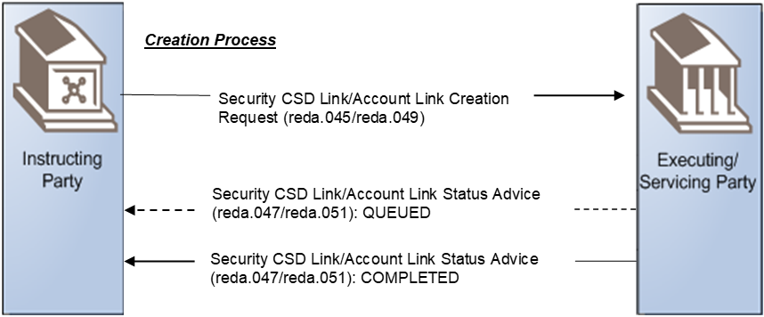

Reference Data Link Creation Request
The Instructing Party sends the instruction to the Executing/Servicing Party to create a new Reference Data Link. This instruction contains information that clearly identify the Reference Data Link.
Reference Data Link Status Advice
The Executing/Servicing Party informs the Instructing Party about the lifecycle of its instruction with the following statuses:

- Queued
The Executing/Servicing Party might inform the Instructing party that the processing of the Create Reference Data Link instruction has been delayed.

- Completed
The Executing/Servicing Party informs the Instructing party that the Create Reference Data Link instruction has been successfully processed. The Executing/Servicing Party present to the Instructing Party the identification of the Reference Data Link that has been processed.

Rejection Scenario
Applies when the instruction sent by the Instructing Party is rejected by the Executing/Servicing Party.

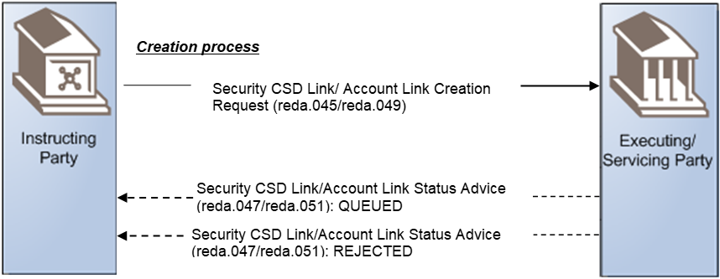

Reference Data Link Creation Request:
The Instructing Party sends the instruction to the Executing/Servicing Party to create a new Reference Data Link. This instruction contains information that clearly identify the party.
Reference Data Link Status Advice:
The Executing/Servicing Party informs the Instructing Party about the lifecycle of its instruction with the following statuses:
- Rejected:
The instruction did not pass validation; some reasons could be:
- the mandatory information is not present or incorrect,
- the instruction is not a new occurrence,
- the instruction has already been received and is being processed.
- This instruction contains information that identifies the status and the reasons why the instruction is rejected. It is possible to have more than one reason for this status.
- Queued:
The Executing/Servicing Party might inform the Instructing party that the processing of the Reference Data Link instruction has been delayed.

- Rejected after dequeuing:
After the re-validation of the instruction, with the new set of data the current instruction did not pass validation, some reasons could be:
- the mandatory information is not present or incorrect,
- the instruction is not a new occurrence,
- the instruction has already been received and is being processed.

This instruction contains information that identifies the status and the reasons why the instruction is rejected. It is possible to have more than one reason for this status.

Modification Process

Confirmation Scenario
Applies when the instruction sent by the Instructing Party is processed and confirmed by the Executing/Servicing party

Security CSD Link/Account Link Maintenance Request (reda.046/reda.050)
Modification process
Security CSD Link/Account Link Status Advice (reda.047/reda.051): QUEUED
Security CSD Link/Account Link Status Advice (reda.047/reda.051): COMPLETED

Reference Data Link Maintenance Request
The Instructing Party sends an instruction to the Executing/Servicing Party to modify data for a Reference Data Link. This instruction contains information that uniquely identify the Reference Data Link.
Reference Data Link Status Advice
The Executing/Servicing Party informs the Instructing Party about the lifecycle of its instruction with the following statuses:
- Queued:
The Executing/Servicing Party might inform the Instructing party that the processing of the Modify Reference Data Link instruction has been delayed.
- Completed:
The Executing/Servicing Party informs the Instructing party that the Modify Reference Data Link instruction has been successfully processed. The Executing/Servicing Party present to the Instructing Party the identification of the Reference Data Link that has been processed.

Rejection Scenario
Applies when the instruction sent by the Instructing Party is rejected by the Executing/Servicing Party

Security CSD Link/Account Link Maintenance Request (reda.046/reda.050)

Modification process
Security CSD Link/Account Link Status Advice (reda.047/reda.051): QUEUED
Security CSD Link/Account Link Status Advice (reda.047/reda.051): REJECTED

Reference Data Link Maintenance Request
The Instructing Party sends an instruction to the Executing/Servicing Party to modify reference data for a link.
Reference Data Link Status Advice
The Executing/Servicing Party informs the Instructing Party about the lifecycle of its instruction with the following statuses:
- Rejected:
The instruction did not pass validation; some reasons could be:
- the mandatory information is not present or incorrect,
- the data cannot be updated,
- the instruction has already been received and is being processed.
This instruction contains information that identifies the status and the reasons why the instruction is rejected. It is possible to have more than one reason for this status.
- Queued:
The Executing/Servicing Party might inform the Instructing party that the processing of the Modify Reference Data Link instruction has been delayed.

- Rejected:
After the re-validation of the instruction, with the new set of data the current instruction did not pass validation, some reasons could be:
- the mandatory information is not present or incorrect,
- the data cannot be updated,
- the instruction has already been received and is being processed.
This instruction contains information that identifies the status and the reasons why the instruction is rejected. It is possible to have more than one reason for this status.

Business Examples
This section describes business examples of the use of the various candidate Message Definitions for the Link Reference Data message set. All XML instances are to be used with the BAH, but the XML message instance provided below does only show the content of the pure business message.

Link Creation and Maintenance

Security CSD Link Creation Request - reda.045.001.01
Description
The instructing Party wants to create a new Security CSD Link between an ISIN and its issuer CSD with the following information:
ISIN: XXABCDEFGHI1
Issuer CSD: CSDAXXYYAAA
Security Maintenance: true
Issuance Account: ISSACCT01
Primary Account Indicator: true
Issuance Account: ISSACCT02
Primary Account Indicator: false
Default Link: true
Valid From: 2015-06-01
Message Instance
<SctyCSDLkCreReq>
<MsgHdr>
<MsgId>SECCSDLINKREQ</MsgId>
</MsgHdr>
<SctyCSDLk>
<FinInstrmId>
<ISIN>XXABCDEFGHI1</ISIN>
</FinInstrmId>
<IssrInvstrCSD>
<IssrCSD>
<OrgId>
<Id>
<AnyBIC>CSDAXXYYAAA</AnyBIC>
</Id>
</OrgId>
</IssrCSD>
</IssrInvstrCSD>
<SctyMntnc>true</SctyMntnc>
<IssncAcct>
<IssncAcct>
<Id>ISSACCT01</Id>
</IssncAcct>
<PmryAcctInd>true</PmryAcctInd>
</IssncAcct>
<IssncAcct>
<IssncAcct>
<Id>ISSACCT02</Id>
</IssncAcct>
<PmryAcctInd>false</PmryAcctInd>
</IssncAcct>
<DfltLk>true</DfltLk>
<VldFr>
<Dt>2015-06-01</Dt>
</VldFr>
</SctyCSDLk>
</SctyCSDLkCreReq>

Security CSD Link Modification Request - reda.046.001.01
Description
In this example, the instructing party wants to update the end of the validity period of a Security CSD Link identified by the couple ISIN-Investor CSD:
ISIN: XXABCDEFGHI1
Investor CSD: CSDAXXYYAAA
Valid From: 2015-06-01
Valid To: 2015-12-31

Message Instance
<SctyCSDLkMntncReq>
<MsgHdr>
<MsgId>SECCSDLINKUPD</MsgId>
</MsgHdr>
<SctyCSDLkId>
<FinInstrmId>
<ISIN>XXABCDEFGHI1</ISIN>
</FinInstrmId>
<IssrInvstrCSD>
<InvstrCSD>
<OrgId>
<Id>
<AnyBIC>CSDAXXYYAAA</AnyBIC>
</Id>
</OrgId>
</InvstrCSD>
</IssrInvstrCSD>
<VldFr>
<Dt>2015-06-01</Dt>
</VldFr>
</SctyCSDLkId>
<Upd>
<VldTo>
<Dt>2015-12-31</Dt>
</VldTo>
</Upd>
</SctyCSDLkMntncReq>

Security CSD Link Status Advice - reda.047.001.01
Description
The following examples are referred to the status advice related to the Security CSD Link Creation request of the chapter 7.1. in three different cases:
- Creation completed successfully;
- Creation queued;
- Creation rejected.

      - Security CSD Link Status Advice- reda.047.001.01 – Completed example
In this case the Security CSD Link Creation Request has been successfully executed.
Request Message ID: SECCSDINVLINKREQ
ISIN: XXABCDEFGHI1
Investor CSD: CSDAXXYYAAA
Valid From: 2015-06-01
Status. COMP

Message Instance
<SctyCSDLkStsAdvc>
<MsgHdr>
<MsgId>NONREF</MsgId>
<OrgnlBizInstr>
<Id> SECCSDLINCRE </Id>
</OrgnlBizInstr>
</MsgHdr>
<SctyCSDLkSts>
<Sts>COMP</Sts>
</SctyCSDLkSts>
<SctyCSDLkId>
<FinInstrmId>
<ISIN>XXABCDEFGHI1</ISIN>
</FinInstrmId>
<IssrInvstrCSD>
<InvstrCSD>
<OrgId>
<Id>
<AnyBIC>CSDAXXYYAAA</AnyBIC>
</Id>
</OrgId>
</InvstrCSD>
</IssrInvstrCSD>
<VldFr>
<Dt>2015-06-01</Dt>
</VldFr>
</SctyCSDLkId>
</SctyCSDLkStsAdvc>

      - Security CSD Link Status Advice- reda.047.001.01 – Queued example
This example describes the case in which the Security CSD Link Creation Request has been delayed.
Request Message ID: SECCSDLINCRE
Status: QUED

Message Instance
<SctyCSDLkStsAdvc>
<MsgHdr>
<MsgId>NONREF</MsgId>
<OrgnlBizInstr>
<Id> SECCSDLINCRE </Id>
</OrgnlBizInstr>
</MsgHdr>
<SctyCSDLkSts>
<Sts>QUED</Sts>
</SctyCSDLkSts>
</SctyCSDLkStsAdvc>
      - Security CSD Link Status Advice- reda.047.001.01 – Rejected example
In this example the Security CSD Link Status Advice reports that the Security CSD Link Creation Request has been rejected, specifying the rejection reason.
Request Message ID: SECCSDLINCRE
Status. REJT
Additional Information: ABCD000 Creation rejected

Message Instance
<SctyCSDLkStsAdvc>
<MsgHdr>
<MsgId>NONREF</MsgId>
<OrgnlBizInstr>
<Id> SECCSDLINCRE </Id>
</OrgnlBizInstr>
</MsgHdr>
<SctyCSDLkSts>
<Sts>REJT</Sts>
<StsRsn>
<Rsn>
<Prtry>REJT</Prtry>
</Rsn>
<AddtlInf>ABCD000 Creation rejected</AddtlInf>
</StsRsn>
</SctyCSDLkSts>
</SctyCSDLkStsAdvc>

Account Link Creation Request- reda.049.001.01
Description
The instructing Party wants to create a new Account Link between a Securities Account and a dedicated cash account, with default link flag set to true, with the following information:
Securities Account: SACCCSDA
Dedicated Cash Account: CASHACCOUNT
Valid From: 2015-06-01
Default Indicator: true
Collateralisation Indicator: false
Cash Settlement Indicator: false

Message Instance
<AcctLkCreReq>
<MsgHdr>
<MsgId>CREACCLINK</MsgId>
</MsgHdr>
<AcctLk>
<SctiesAcct>
<Id>SACCCSDA</Id>
</SctiesAcct>
<CshAcct>
<Id>
<Othr>
<Id>CASHACCOUNT</Id>
</Othr>
</Id>
</CshAcct>
<VldFr>
<Dt>2015-06-01</Dt>
</VldFr>
<DfltInd>true</DfltInd>
<CollstnInd>false</CollstnInd>
<CshSttlmInd>true</CshSttlmInd>
</AcctLk>
</AcctLkCreReq>

Account Link Maintenance Request - reda.050.001.01
Description
In this example, the instructing party wants to update the end of the validity period of an Account Link identified by the couple Securities Account-Dedicated Cash Account:
Securities Account: SACCCSDA
Dedicated Cash Account: CASHACCOUNT
Valid From: 2015-06-01
Valid To: 2015-07-01

Message Instance
<AcctLkMntncReq>
<MsgHdr>
<MsgId>ACCTLINKMANT</MsgId>
</MsgHdr>
<AcctLkId>
<SctiesAcct>
<Id>SACCCSDA</Id>
</SctiesAcct>
<CshAcct>
<Id>
<Othr>
<Id>CASHACCOUNT</Id>
</Othr>
</Id>
</CshAcct>
<VldFr>
<Dt>2015-06-01</Dt>
</VldFr>
</AcctLkId>
<Upd>
<VldTo>
<Dt>2015-07-01</Dt>
</VldTo>
</Upd>
</AcctLkMntncReq>

Account Link Status Advice - reda.051.001.01
Description
The following examples are referred to the status advice related to the Account Link Creation request of the chapter 7.4. in three different cases:
- Creation completed successfully;
- Creation queued;
- Creation rejected.
      - Account Link Status Advice- reda.051.001.01 – Completed example
In this case the Account Link Creation Request has been successfully executed.
Request Message ID: ACCLINKCREAT
Securities Account: SACCCSDA
Dedicated Cash Account: CASHACCOUNT
Valid From: 2015-06-01
Status. COMP

Message Instance
<AcctLkStsAdvc>
<MsgHdr>
<MsgId>ACCLINKSTATCOMP</MsgId>
<OrgnlBizInstr>
<Id>ACCLINKCREAT</Id>
</OrgnlBizInstr>
</MsgHdr>
<AcctLkSts>
<Sts>COMP</Sts>
</AcctLkSts>
<AcctLkId>
<SctiesAcct>
<Id>SACCCSDA</Id>
</SctiesAcct>
<CshAcct>
<Id>
<Othr>
<Id>CASHACCOUNT</Id>
</Othr>
</Id>
</CshAcct>
<VldFr>
<Dt>2015-06-01</Dt>
</VldFr>
</AcctLkId>
</AcctLkStsAdvc>
      - Account Link Status Advice- reda.051.001.01 – Queued example
This example describes the case in which the Account Link Creation Request has been delayed.
Request Message ID: ACCLINKCREAT
Status: QUED

Message Instance
<AcctLkStsAdvc>
<MsgHdr>
<MsgId>ACCLINKSTATQUE</MsgId>
<OrgnlBizInstr>
<Id>ACCLINKCREAT</Id>
</OrgnlBizInstr>
</MsgHdr>
<AcctLkSts>
<Sts>QUED</Sts>
</AcctLkSts>
</AcctLkStsAdvc>

      - Account Link Status Advice- reda.051.001.01 – Rejected example
In this example the Account Link Status Advice reports that the Account Link Creation Request has been rejected, specifying the rejection reason.
Request Message ID: ACCLINKCREAT
Status. REJT
Additional Information: ERROR IN CREATION

Message Instance
<AcctLkStsAdvc>
<MsgHdr>
<MsgId>ACCLINKSTATREJ</MsgId>
<OrgnlBizInstr>
<Id>ACCLINKCREAT</Id>
</OrgnlBizInstr>
</MsgHdr>
<AcctLkSts>
<Sts>REJT</Sts>
<StsRsn>
<Rsn>
<Prtry>REJT</Prtry>
</Rsn>
<AddtlInf>ERROR IN CREATION</AddtlInf>
</StsRsn>
</AcctLkSts>
</AcctLkStsAdvc>

Revision Record

Revision | Date | Author | Description | Sections affected
0.1 | 15-03-2024 | Coco/Del Vecchio/Mancini (BDI, 4CB) | First draft based on the available HLBR’s | all
0.2 | 27-03-2024 | Sigrid Wiley for Swift | Review; corrections and correction of template according to ISO RA | All
0.3 | 08-04-2024 | Mancini (4CB) | Editorial updates. | All
0.4 | 10-04-2024 | Stéphanie Radet (4CB) | Final review before submission to ISO RA; minor correction in chapter 6.2.2 | 6.2.2 Rejection Scenario
1.0 | 27-05-2024 | ISO 20022 RA | Preparation for SEG evaluation | All
1.1 | 29-06-2024 | ISO 20022 RA | Update of the samples to align with new schemas | 7
2.0 | 10-12-2024 | ISO 20022 RA | Approved version | All

Disclaimer:
Although the Registration Authority has used all reasonable efforts to ensure accuracy of the contents of the iso20022.org website and the information published thereon, the Registration Authority assumes no liability whatsoever for any inadvertent errors or omissions that may appear thereon. Moreover, the information is provided on an "as is" basis. The Registration Authority disclaims all warranties and conditions, either express or implied, including but not limited to implied warranties of merchantability, title, non-infringement and fitness for a particular purpose.
The Registration Authority shall not be liable for any direct, indirect, special or consequential damages arising out of the use of the information published on the iso20022.org website, even if the Registration Authority has been advised of the possibility of such damages.

Intellectual Property Rights:
The ISO 20022 MessageDefinitions described in this document were contributed by Banca d’Italia and SWIFT for T2-Securities. The ISO 20022 IPR policy is available at www.ISO20022.org > About ISO 20022 > Intellectual Property Rights.

