ISO 20022
Target-2 Securities - Securities Reference Data

Message Definition Report Part 1
Approved by the Securities and Payments SEG under the leadership of the Securities SEG on 28 June 2021.
This document provides information about the use of the messages for Target-2 Securities - Securities Reference Data messages and includes, for example, business transactions and examples.
June 2021

Table of Contents
Table of Contents 2
1 Introduction 5
1.1 Terms and Definitions 5
1.2 Abbreviations and Acronyms 5
1.3 Document Scope and Objectives 6
1.4 References 6
2 Scope and Functionality 8
2.1 Background 8
2.2 Scope 8
2.3 Groups of MessageDefinitions and Functionality 8
3 BusinessRoles and Participants 11
3.1 Participants and BusinessRoles Definitions 11
3.2 BusinessRoles and Participants Table 12
4 BusinessProcess Description 13
5 Description of BusinessActivities 16
5.1 Creation Process 16
5.2 Modification Process 18
5.3 Deletion Process 19
5.4 Query/Query Response Process 20
5.5 Statement Process 21
6 BusinessTransactions 23
6.1 Creation Process 23
6.2 Modification Process 25
6.3 Deletion Process 27
6.4 Query/Response Process 29
6.5 Statement Process 30
7 Business Examples 31
7.1 Security Creation Request - reda.006.001.01 31
7.2 Security Creation Status Advice - reda.008.001.01 32
7.3 Security Maintenance Request - reda.007.001.01 35
7.4 Security Maintenance Status Advice - reda.029.001.01 36
7.5 Security Deletion Request - reda.013.001.01 39
7.6 Security Deletion Status Advice - reda.030.001.01 39
7.7 Security Query - reda.010.001.01 43
7.8 Security Report - reda.012.001.01 43
7.9 Security Activity Advice - reda.009.001.01 46
7.10 Securities Audit Trail Query - reda.033.001.01 47
7.11 Securities Audit Trail Report - reda.034.001.01 47
8 Revision Record 49
Preliminary Note
The Message Definition Report (MDR) is made of three parts:
MDR Part 1
This describes the contextual background required to understand the functionality of the proposed message set. Part 1 is produced by the submitting organization that developed or maintained the message set in line with an MDR Part 1 template provided by the ISO 20022 Registration Authority (RA) on www.iso20022.org.
MDR Part 2
This is the detailed description of each message definition of the message set. Part 2 is produced by the RA using the model developed by the submitting organization.
MDR Part 3
This is an extract if the ISO 20022 Business Model describing the business concepts used in the message set. Part 2 is an Excel document produced by the RA.

Introduction

Terms and Definitions
The following terms are reserved words defined in ISO 20022 Edition 2013 – Part1. When used in this document, the UpperCamelCase notation is followed.
Term | Definition
BusinessRole | Functional role played by a business actor in a particular BusinessProcess or BusinessTransaction.
Participant | Involvement of a BusinessRole in a BusinessTransaction.
BusinessProcess | Definition of the business activities undertaken by BusinessRoles within a BusinessArea whereby each BusinessProcess fulfils one type of business activity and whereby a BusinessProcess may include and extend other BusinessProcesses.
BusinessTransaction | Particular solution that meets the communication requirements and the interaction requirements of a particular BusinessProcess and BusinessArea.
MessageDefinition | Formal description of the structure of a message instance.
When a MessageDefinition or message identifier is specified, it should include the variant and version number. However, in this document (except in the business examples section, if present), variant and version numbers are not included. In order to know the correct variant and version number for a MessageDefinition, the related Message Definition Report Part 2 document should be consulted.

Abbreviations and Acronyms
The following is a list of abbreviations and acronyms used in the document.
Abbreviation/Acronyms | Definition
4CB | Banca d’Italia, Banque de France, Deutsche Bundesbank and Banco d’España
ACH | Automated Clearing House
A2A | Application-to-Application mode. Defines a mode of technical communication that permits the exchange of information between software applications of T2S and a directly connected T2S actor.
BAH/head.001 | Business Application Header
BIC | Business Identifier Code
CeBM | Central Bank Money
CSD | Central Securities Depository
ID | Identification
MDR | Message Definition Report
NCB | National Central Bank
RTGS | Real-time gross settlement (RTGS) system.  A settlement system in which processing and settlement take place in real-time on a gross basis.
SEG | Standards Evaluation Group
T2S | TARGET2-Securities
TM | Technical Message. Messages which cover technical functions within T2S System
U2A | User-to-Application mode. Defines a mode of technical communication that permits the exchange of information between software applications of T2S and a T2S system user through a graphical user interface (GUI).
URD | T2S User Requirement Document
XML | eXtensible Mark-up language

Document Scope and Objectives
This document is the first part of the <Name of message set> Message Definition Report (MDR) that describes the BusinessTransactions and underlying message set. For the sake of completeness, the document may also describe BusinessActivities that are not in the scope of the business processes covered in this document.
This document describes the following:
- the BusinessProcess scope
- the BusinessRoles involved in these BusinessProcesses
The main objectives of this document are as follows:
- to provide information about the messages that support the business processes
- to explain the BusinessProcesses and BusinessActivities these messages have addressed
- to give a high level description of BusinessProcesses and the associated BusinessRoles
- to document the BusinessTransactions
- to provide business examples
The messages definitions are specified in Message Definition Report Part 2.

References
Document | Version | Date | Author
ISO 20022 Business Justification # 42 – Target2-Securities | 2.0 | 15-09-2009 | 4CB
T2S User Requirements (URD)  https://www.ecb.europa.eu/paym/t2s/pdf/2016-08-01_urd_v5_05.pdf | 5.05 | 01-08-2016 | ECB

Scope and Functionality

Background
This Message Definition Report covers a set of 11 ISO 20022 Securities Reference Data Message Definitions developed by Banca d’Italia on behalf of 4CB in close collaboration with SWIFT and approved by the Securities Standards Evaluation Group (SEG).
Originally, these messages have been designed to support the T2S community for reference data management. T2S (TARGET2-Securities) is a European securities settlement engine which offers centralised settlement in central bank money across all European securities markets. The fundamental objective of T2S is to integrate and harmonise the highly fragmented securities settlement infrastructure in Europe. It aims to reduce the costs of cross-border securities settlement and increase competition and choice among providers of post-trading services in Europe.
The detailed description of each MessageDefinition is provided in Message Definition Report Part 2.

Scope
The Securities messages are specifically designed to support the management of the securities reference data, the monitoring of the execution of the requests and the activity reporting, including audit trail information.

Groups of MessageDefinitions and Functionality
These messages are to be used with the ISO 20022 Business Application Header (head.001). The schema and more information about the Business Application Header (BAH) can be found on the www.iso20022.org web site

Groups

Securities Reference Data message
MessageDefinition | Message Identifier
- Security Creation Request | reda.006
- Security Creation Status Advice | reda.008
- Security Maintenance Request | reda.007
- Security Maintenance Status Advice | reda.029
- Security Deletion Request | reda.013
- Security Deletion Status Advice | reda.030
- Security Query | reda.010
- Security Report | reda.012
- Security Activity Advice | reda.009
- Securities Audit Trail Query | reda.033
- Securities Audit Trail Report | reda.034
The securities reference data messages are specifically designed to support the following functions:

- Security Creation Request (reda.006) provides a user, granted with the appropriate rights, with the possibility to create a new Security.
The user has to specify information that clearly identifies the Security, as for example ISIN, security long name, security short name, valid from name, denomination currency, classification type, issuance details, settlement information.
The Security Creation Status Advice (reda.008) informs the Instructing Party about the lifecycle of its security creation request.

- Security Maintenance Request (reda.007) provides a user, granted with the appropriate rights, with the possibility to update an active and valid security.
The Security Maintenance Status Advice (reda.029) informs the Instructing Party about the lifecycle of its security modification request.

- Security Deletion Request (reda.013) provides a user, granted with the appropriate rights, with the possibility to delete an existing security.
The Security Deletion Status Advice (reda.030) informs the Instructing Party about the lifecycle of its security deletion request.

- Security Query (reda.010) is sent by an authorised party to query on security reference data.
This message is sent to the servicing party to make the following type of queries:
- Securities Reference Data Query;
- ISIN List Query;
- Securities CSD Link Query;
- Securities Deviating Nominal Query.

Depending on the query criteria, it is possible that the processing will take more than a certain time or that the query will not retrieve any record. In this case, an error is sent to the Instructing Party within the Security Report (reda.012);
Search criteria include the following elements:
- ISIN;
- Classification Type;
- Maturity Date;
- Issue Date;
- Issue Currency;
- Country of Issue;
- Maintainer CSD;
- Investor CSD;
- Issuer CSD;
- Technical Issuer CSD;
- Generic CSD of a security, both investor and issuer CSDs.

Security Report (reda.012) is sent to the Instructing Party and includes all of the Securities records that meet the specified criteria or reports any possible error (e.g. not allowed set of search criteria).
This query response contains the timestamp specifying the system time when the data selection was actually performed.
The Security Report is capable to report any piece of information related to a security, including ISIN, financial instrument name, denomination currency, expiry date, classification type, country of issuance, issue date, restriction, financial instrument identification validity, settlement information.

- Security Activity Advice (reda.009) is sent to authorised recipients by the servicing party to provide with information on changes occurred during the business day on security reference data.
Security Activity Advice is capable to report any change applied to every piece of information for a security, including financial instrument name, denomination currency, expiry date, classification type, country of issuance, issue date, restriction, financial instrument identification validity, settlement information.

- Securities Audit Trail Query (reda.033) is sent by an authorised party to query on audit trail for securities reference data.
Depending on the query criteria, it is possible that the processing will take more than a certain time or that the query will not retrieve any record. In this case, an error is sent to the Instructing Party within the Securities Audit Trail Report message (reda.034).
Search criteria include the following elements:
- ISIN;
- Date Period.

Securities Audit Trail Report (reda.034) is sent to the Instructing Party and includes all of the securities audit trail records that meet the specified criteria or reports any possible error (e.g. empty list retrieved).
This query response contains the timestamp specifying the system time when the data selection was actually performed.
Securities Audit Trail Report is capable to report any change applied to every piece of information for a security along with the reference of the user performing the change and the related timestamp.

Functionality
See Message Definition Report Part 2 for the message and formats.

BusinessRoles and Participants
A BusinessRole represents an entity (or a class of entities) of the real world, physical or legal, a person, a group of persons, a corporation. Examples of BusinessRoles: “Financial Institution”, “Automated Clearing House”, “Central Securities Depository”.
A Participant is a functional role performed by a BusinessRole in a particular BusinessProcess or BusinessTransaction. Examples of Participants: the “user” of a system, “debtor”, “creditor”, “investor”.
The relationship between BusinessRoles and Participants is many-to-many. One BusinessRole can be involved as different Participants at different moments in time or at the same time. Examples of BusinessRoles: "user", "debtor”, "creditor", "investor". Different BusinessRoles can be involved as the same Participant.
In the context of Security, the high-level BusinessRoles and typical Participants can be represented as follows:
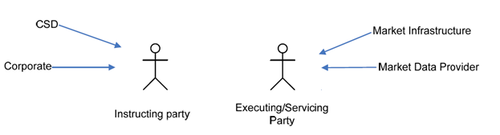

Participants and BusinessRoles Definitions
Participants
Description | Definition
Instructing Party | Party that instructs the executing/servicing party to process and monitor a transaction.
Executing/Servicing Party | Party that processes, monitors and reports on transactions received from the Instructing party.
Business Roles
Description | Definition
Central Securities Depositories (CSD) | An infrastructure that, holds or controls, the holding of physical or dematerialised financial instruments belonging to all, or a large portion of, the investors in a securities market. This affects the centralised transfer of ownership of such securities by entries on its books and records.
Corporate | Most common form of business organization, and one which is chartered by a state and given many legal rights as an entity separate from its owners. This form of business is characterized by the limited liability of its owners, the issuance of shares of easily transferable stock, and its existence as a going concern.
Market Infrastructure | Party that provides, through common membership, services to create a fair and open process for the execution of transactions between trading parties and the creation of settlement obligations.
Market Data Provider | An organization that provides data on financial instruments to other parties.

BusinessRoles and Participants Table
BusinessRole | Participant  Instructing Party | Participant  Executing/Servicing Party
Central Securities Depositories (CSD) | X
Corporate | X
Market Infrastructure |  | X
Market Data Provider |  | X

BusinessProcess Description
This diagram represents the high level BusinessProcesses, used to describe the high-level scope of T2S concerning “Securities Reference Data” and is not to be exhaustive.
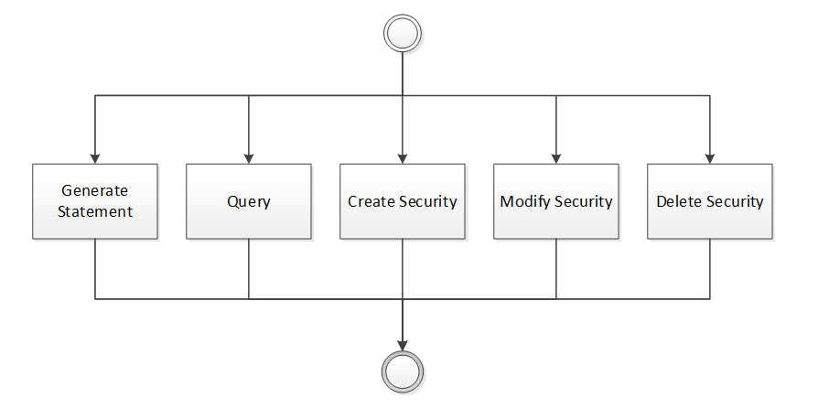
Create Security
Item | Description
Definition | When an Instructing Party would like to create a specific security that is not yet supported by the Executing/Servicing Party, an Instructing Party asks the Executing/Servicing Party to create the security in its system.
Trigger | The process is triggered when the Instructing Party sends a Security Creation Request message.
Pre-conditions | The Instructing Party is known by the Executing/Servicing Party system and has been granted the appropriate privileges. The Instructing Party identified a gap in the securities’ coverage of the Executing/Servicing Party. The Instructing Party needs this security to be set-up at the Executing /Servicing Party to perform its activities.
Post-conditions | The acknowledgement of the processing of the creation request.
Role | Instructing Party
Modify Security
Item | Description
Definition | When an Instructing Party is in charge of the modification of a specific security already supported by the Executing/Servicing Party system, the Instructing Party asks the Executing/Servicing Party to modify a security in the Executing/Servicing Party system.
Trigger | The process is triggered when the Instructing Party sends a Security Maintenance Request message.
Pre-conditions | The Instructing Party is known by the Executing/Servicing Party system and has been granted the appropriate privileges. An attribute of the security has changed which requires a modification of the security in the Executing/Servicing Party system.
Post-conditions | The acknowledgement of the processing of the maintenance request.
Role | Instructing Party
Delete Security
Item | Description
Definition | When an Instructing Party would like to delete a specific security already supported by the Executing/Servicing Party system, an Instructing Party asks the Executing/Servicing Party to delete the security in its system.
Trigger | The process is triggered when the Instructing Party sends a Security Deletion Request message.
Pre-conditions | The Instructing Party is known by the Executing/Servicing Party system and has been granted the appropriate privileges. The Instructing Party identified a gap in the Security’ coverage of the Executing/Servicing Party. The Instructing Party needs to remove this security at the Executing /Servicing Party.
Post-conditions | The acknowledgement of the processing of the deletion request.
Role | Instructing Party
Query
Item | Description
Definition | The Instructing Party asks the Executing/Servicing Party a response to a query or to an Audit Trail query.
Trigger | The process is triggered when the Instructing Party sends a Security Query message or a Securities Audit Trail Query message.
Pre-conditions | The query type must be known by the Instructing party and the Executing/Servicing Party.
Post-conditions | The Security Report message including all of the retrieved securities records or the Securities Audit Trail Report message with all the requested audit trail information.
Role | Instructing Party
General Statement
Item | Description
Definition | The Recipient Party receives a Security Activity Advice statement which has been automatically produced by the Executing/Servicing Party.
Trigger | The process is triggered automatically.
Pre-conditions | A standing instruction is in place at the Executing/Servicing Party for sending of the statement.
Post-conditions | The acknowledgement of the sending of the statement.
Role | Executing/Servicing Party

Description of BusinessActivities
This section presents the different BusinessActivities within each BusinessProcess. The BusinessActivities of a process are described with activity diagrams.
Legend
Symbol | Name | Definition
 | Start Point | Shows where the lifecycle of the business process commences.
 | End Point | Shows where the lifecycle of the business process may ends.
 | Lozenge (or diamond) | Indicates that a choice between several actions can be made.
 | Bar | Indicates that several actions are initiated in parallel.

Creation Process
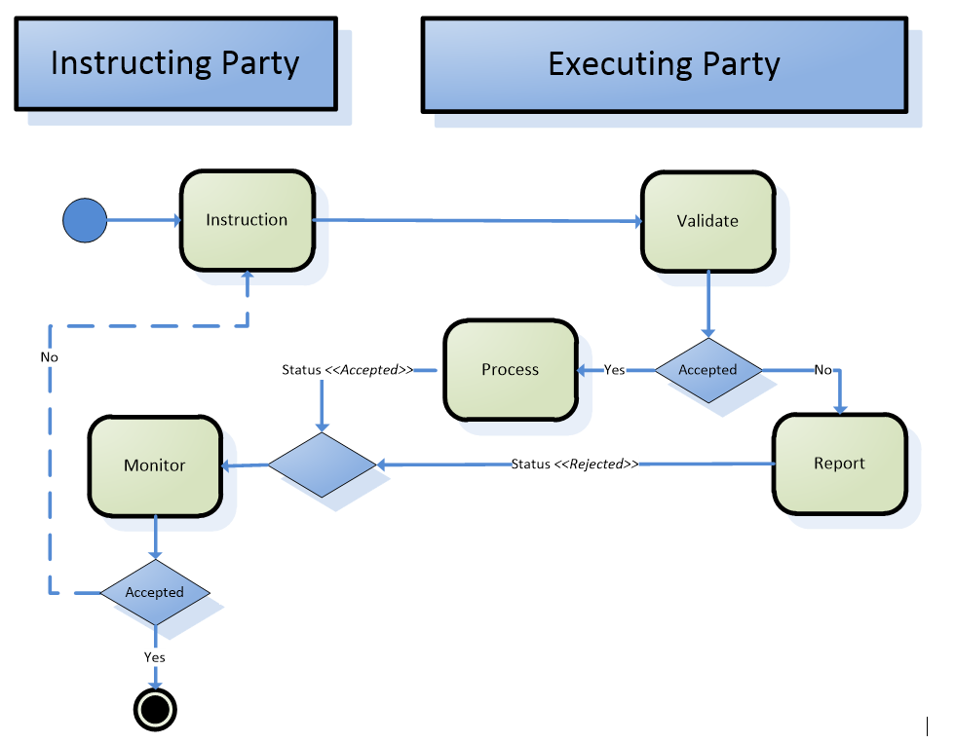
Step | Description | Initiator
Instruction | Instructing Party instructs the Executing/Servicing Party to create a security. | Instructing Party
Validate | Executing/Servicing Party system checks if this instruction is a new occurrence or not.  It also checks if this instruction is already handled or not.  If validation of the message fails, a status message “REJECTED” will be sent including the related errors and reason information.  If the message is valid and the time permits the creation of the security (e.g. not during a night – time sequence), the data will be processed and a status message “COMPLETED” will be sent.  Otherwise a status message “QUEUED” will be sent and the instruction will be resubmit to validation after e.g. a night –time cycle. | Executing/Servicing Party
Process | If the instruction is accepted, the Executing/Servicing Party processes the instruction and informs the Instructing Party of the completeness of this instruction. | Executing/Servicing Party
Report | Executing/Servicing Party informs the Instructing Party that this instruction is rejected and why. | Executing/Servicing Party
Monitor Process | Instructing Party monitors the status of the instruction. | Instructing Party

Modification Process
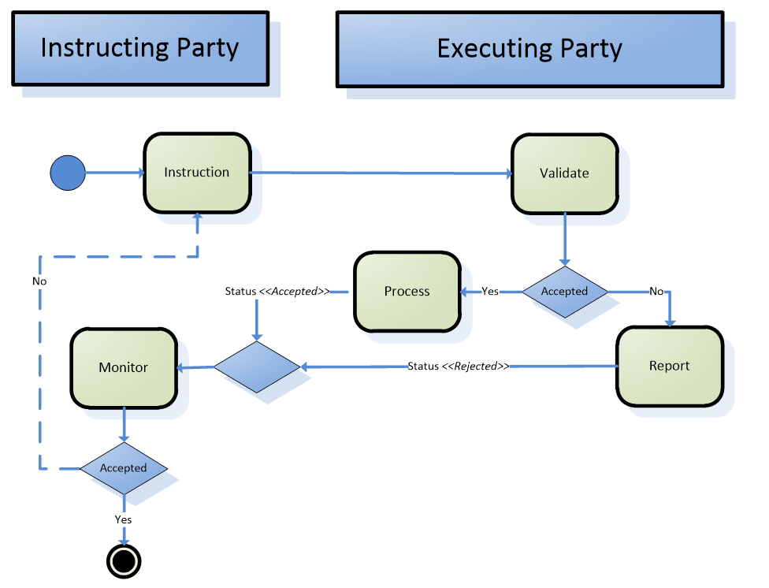
Step | Description | Initiator
Instruction | Instructing Party instructs the Executing/Servicing Party to modify a security. | Instructing Party
Validate | Executing/Servicing Party checks if the instruction already exists in the system.  It checks also if the data can or cannot be updated.  If validation of the message fails, a status message “REJECTED” will be sent including the related errors and reason information.  If the message is valid and the time permits the update of the security (e.g. not during a night – time sequence), the data will be processed and a status message “COMPLETED” will be sent.  Otherwise a status message “QUEUED” will be sent and the instruction will be resubmit to validation after e.g. a night –time cycle. | Executing/Servicing Party
Process | If the instruction is accepted, the Executing/Servicing Party processes the instruction and informs the Instructing Party of the completeness of this instruction. | Executing/Servicing Party
Report | Executing/Servicing Party informs the Instructing Party that this instruction is rejected and why. | Executing/Servicing Party
Monitor Process | Instructing Party monitors the status of the instruction. | Instructing Party

Deletion Process
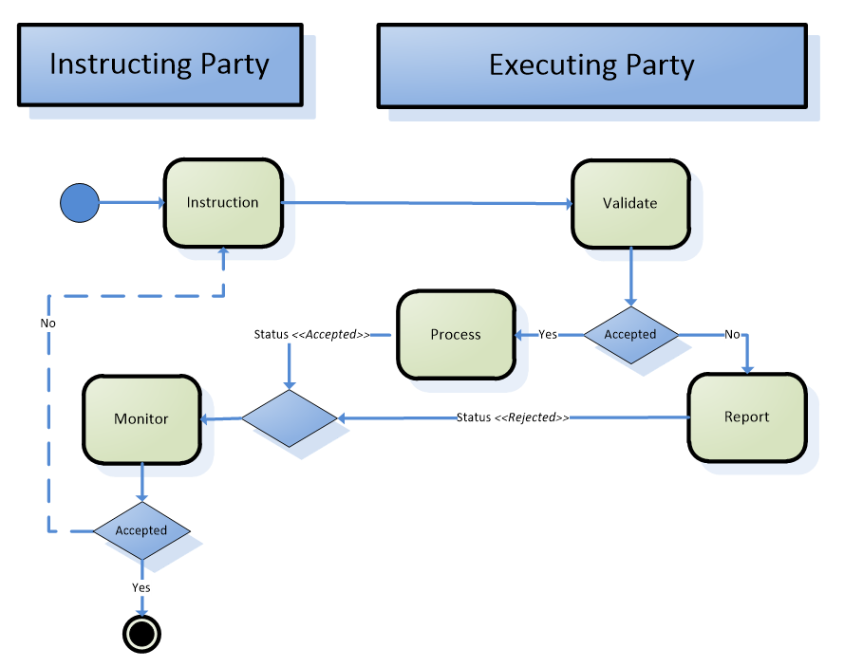
Step | Description | Initiator
Instruction | Instructing Party instructs the Executing/Servicing Party to delete a security. | Instructing Party
Validate | Executing/Servicing Party checks if the instruction already exists in the system.  It checks also if the security can or cannot be deleted.  If validation of the message fails, a status message “REJECTED” will be sent including the related errors and reason information.  If the message is valid and the time permits the deletion of the security (e.g. not during a night – time sequence), the data will be processed and a status message “COMPLETED” will be sent.  Otherwise a status message “QUEUED” will be sent and the instruction will be resubmit to validation after e.g. a night –time cycle. | Executing/Servicing Party
Process | If the instruction is accepted, the Executing/Servicing Party processes the instruction and informs the Instructing Party of the completeness of this instruction. | Executing/Servicing Party
Report | Executing/Servicing Party informs the Instructing Party that this instruction is rejected and why. | Executing/Servicing Party
Monitor Process | Instructing Party monitors the status of the instruction. | Instructing Party

Query/Query Response Process
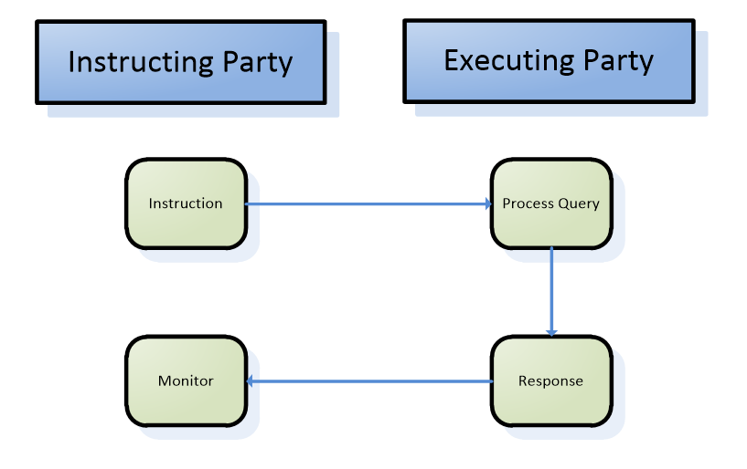
Step | Description | Initiator
Instruction | Instructing Party instructs Executing/Servicing Party to run a query or Audit Trail Query. | Instructing Party
Process query | Executing/Servicing Party processes the request.  In case the processing of the query takes too much time or cannot give any positive response, the Executing/Servicing Party sends an error message back to the Instructing Party with the error code and the related explanation. | Executing/Servicing Party
Response | Executing/Services Party sends the response to the Instructing Party according to query results. | Executing/Servicing Party
Monitor Process | Instructing Party monitors the status of the instruction. | Instructing Party

Statement Process
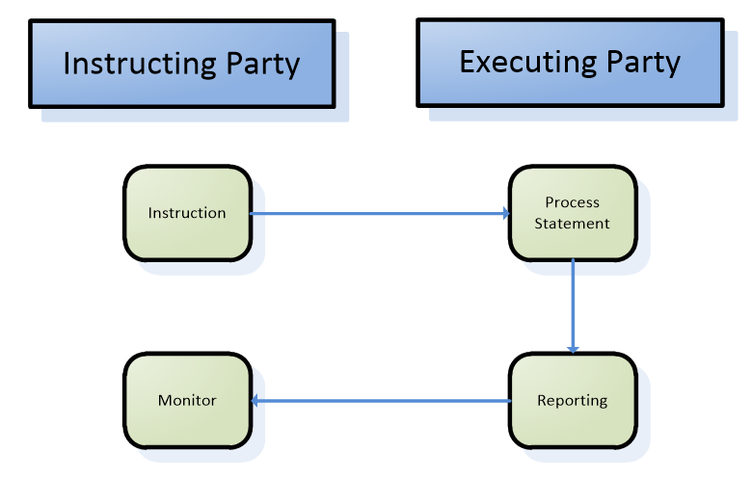
Step | Description | Initiator
Instruction | Instructing Party might instruct Executing/Servicing Party to run a statement.  This is not covered by the current process as NO message will be created to cover this. | Instructing Party
Process statement | Executing/Servicing Party processes the statement. | Executing/Servicing Party
Response | Executing/Servicing Party sends the statement to the Instructing Party. | Executing/Servicing Party
Monitor Process | Instructing Party monitors the status of the instruction. | Instructing Party

BusinessTransactions
This section describes the message flows based on the activity diagrams documented above. It shows the typical exchanges of information in the context of a BusinessTransaction.

Creation Process

Confirmation Scenario
Applies when the instruction sent by the Instructing Party is processed and confirmed by the Executing/Servicing Party.


Creation Process
Security Creation Status Advice (reda.008): QUEUED
Security Creation Status Advice (reda.008): COMPLETED
COMPLETED
Security Creation Request (reda.006)
Security Creation Request
The Instructing Party sends the instruction to the Executing/Servicing Party to create a new security. This instruction contains information that clearly identify the security.
Security Creation Status Advice
The Executing/Servicing Party informs the Instructing Party about the lifecycle of its instruction with the following statuses:
Queued
The Executing/Servicing Party might inform the Instructing party that the processing of Security Creation Request has been delayed. In case of e.g. a night-time cycle is running.
Completed
The Executing/Servicing Party informs the Instructing party that the Security Creation Request has been successfully processed. The Executing/Servicing Party present to the Instructing Party the identification of the Security that has been processed.

Rejection Scenario
Applies when the instruction sent by the Instructing Party is rejected by the Executing/Servicing Party.
Creation Process
Security Creation Status Advice (reda.008): QUEUED
Security Creation Status Advice (reda.008): REJECTED
COMPLETED
Security Creation Request (reda.006)

Security Creation Request
The Instructing Party sends the instruction to the Executing/Servicing Party to create a new security. This instruction contains information that clearly identify the security.
Security Creation Status Advice
The Executing/Servicing Party informs the Instructing Party about the lifecycle of its instruction with the following statuses:
Rejected
The instruction did not pass validation, some reasons could be:
- the mandatory information is not present or incorrect,
- the instruction is not a new occurrence,
- the instruction has already been received and is being processed.
This instruction contains information that identifies the status and the reasons why the instruction is rejected. It is possible to have more than one reason for this status.
Queued
The Executing/Servicing Party might inform the Instructing party that the processing of the Create Security instruction has been delayed. In case of e.g. a night-time cycle is running.
Rejected
After the re-validation of the instruction, with the new set of data the current instruction did not pass validation, some reasons could be:
- the mandatory information is not present or incorrect,
- the instruction is not a new occurrence,
- the instruction has already been received and is being processed
This instruction contains information that identifies the status and the reasons why the instruction is rejected. It is possible to have more than one reason for this status.

Modification Process

Confirmation Scenario
Applies when the instruction sent by the Instructing Party is processed and confirmed by the Executing/Servicing party

Security Maintenance Request (reda.007)
Modification process
Security Maintenance Status Advice (reda.029): QUEUED

Security Maintenance Status Advice (reda.029): COMPLETED

Security Maintenance Request
The Instructing Party sends an instruction to the Executing/Servicing Party to modify data for a security. This instruction contains information that uniquely identify the security.
In this case, this instruction contains details of the restriction like the restriction type and timeframe.
Security Maintenance Status Advice
The Executing/Servicing Party informs the Instructing Party about the lifecycle of its instruction with the following statuses:
Queued
The Executing/Servicing Party might informs the Instructing party that the processing of the Modify Security instruction has been delayed. In case of e.g. a night-time cycle is running.
Completed
The Executing/Servicing Party informs the Instructing party that the Modify Security instruction has been successfully processed. The Executing/Servicing Party present to the Instructing Party the identification of the security that has been processed.

Rejection Scenario
Applies when the instruction sent by the Instructing Party is rejected by the Executing/Servicing Party

Security Maintenance Request (reda.007)
Modification process
Security Maintenance Status Advice (reda.029): QUEUED

Security Maintenance Status Advice (reda.029): REJECTED

Security Maintenance Request
The Instructing Party sends an instruction to the Executing/Servicing Party to modify reference data for a Security.
Security Maintenance Status Advice
The Executing/Servicing Party informs the Instructing Party about the lifecycle of its instruction with the following statuses:
Rejected
The instruction did not pass validation, some reasons could be:
- the mandatory information is not present or incorrect,
- the data cannot be updated,
- the instruction has already been received and is being processed.
This instruction contains information that identifies the status and the reasons why the instruction is rejected. It is possible to have more than one reason for this status.
Queued
The Executing/Servicing Party might inform the Instructing party that the processing of the Modify Security instruction has been delayed. In case of e.g. a night-time cycle is running.
Rejected
After the re-validation of the instruction, with the new set of data the current instruction did not pass validation, some reasons could be:
- the mandatory information is not present or incorrect,
- the data cannot be updated,
- the instruction has already been received and is being processed.
This instruction contains information that identifies the status and the reasons why the instruction is rejected. It is possible to have more than one reason for this status.

Deletion Process

Confirmation Scenario
Applies when the instruction sent by the Instructing Party is processed and confirmed by the Executing/Servicing party

Security Deletion Request (reda.013)
Deletion process
Security Deletion Status Advice (reda.030): QUEUED
Security Deletion Status Advice (reda.030): COMPLETED
Security Deletion Request
The Instructing Party sends an instruction to the Executing/Servicing Party to delete a security. This instruction contains information that uniquely identifies the security and it is used when a security is no longer active.
Security Deletion Status Advice
The Executing/Servicing Party informs the Instructing Party about the lifecycle of its instruction with the following statuses:
Queued
The Executing/Servicing Party might inform the Instructing party that the processing of the Delete Security instruction has been delayed. In case of e.g. a night-time cycle is running.
Completed
The Executing/Servicing Party informs the Instructing party that the Delete Securiy instruction has been successfully processed. The Executing/Servicing Party present to the Instructing Party the identification of the security that has been processed.

Rejection Scenario
Applies when the instruction sent by the Instructing Party is rejected by the Executing/Servicing Party

Security Deletion Request (reda.013)
Deletion process
Security Deletion Status Advice (reda.030): QUEUED
Security Deletion Status Advice (reda.030): REJECTED
Security Deletion Request
The Instructing Party sends an instruction to the Executing/Servicing Party to delete a security.
Security Status Advice
The Executing/Servicing Party informs the Instructing Party about the lifecycle of its instruction with the following statuses:
Rejected
The instruction did not pass validation, some reasons could be:
- the mandatory information is not present or incorrect,
- the Instructing Party does not have the right to delete security,
- the instruction has already been received and is being processed.
This instruction contains information that identifies the status and the reasons why the instruction is rejected. It is possible to have more than one reason for this status.
Queued
The Executing/Servicing Party might inform the Instructing party that the processing of the Delete Security instruction has been delayed. In case of e.g. a night-time cycle is running.
Rejected
After the re-validation of the instruction, with the new set of data the current instruction did not pass validation, some reasons could be:
- the mandatory information is not present or incorrect,
- the security cannot be deleted,
- the Instructing Party does not have the right to delete security,
- the instruction has already been received and is being processed
This instruction contains information that identifies the status and the reasons why the instruction is rejected. It is possible to have more than one reason for this status.

Query/Response Process

Security Query/Security Report Scenario


Security Query (reda.010)
Query/Report Process
Security Report (reda.012): ERROR
Security Report (reda.012)
Security Query
The Instructing Party sends an instruction to the Executing/Servicing Party to run a query according to specified criteria.
Security Report
Depending on the query criteria, it is possible that the processing will take more than a certain time or that the result of the query will be empty due to wrong combination of criteria or no result set. In this case, an error message within a query response message is sent to the Instructing Party.
Security Report
The Executing/Servicing Party sends a query response that meets the specified criteria to the Instructing Party.

Securities Audit Trail Query and Report Scenario
Securities Audit Trail Query (reda.033)
Query/Response Process
Securities Audit Trail Report (reda.034): ERROR
Securities Audit Trail Report (reda.034)
Securities Audit Trail Query
The Instructing Party sends an instruction to the Executing/Servicing Party to run a query according to specified criteria’s to retrieve the complete audit trail on a specific security.
Securities Audit Trail Report
Depending on the query criteria, it is possible that the processing will take more than a certain time or that the result of the query will be empty due to wrong combination of criteria or no result set. In this case, an error message within a query response message is sent to the Instructing Party.
Securities Audit Trail Report
The Executing/Servicing Party sends a query response that meets the specified criteria to the Instructing Party.

Statement Process
Security Activity Advice (reda.009)
Statement Process
Security Activity Advice
The Executing/Servicing Party sends a statement to the Instructing Party containing information on changes occurred for securities reference data during the business day.
The statement is sent unilaterally in an unsolicited manner.

Business Examples
This section describes business examples of the use of the various MessageDefinitions.

Security Creation Request - reda.006.001.01
Description
The instructing Party wants to create a new security with the following information:
- ISIN: SECXXXYYYZZ1
- Security Long Name: Sample equity shares, Fixed Interest Rate
- Security Short Name: Sample ES, FIR
- Valid From Name: 2020-01-01
- Denomination Currency: EUR
- Expiry Date: 2030-12-31
- Classification Type: ESFUFR
- Country of Issue: IT
- Issue Date: 2020-01-01
- ISIN Valid From: 2020-01-01
- Quantity Type: UNIT
- Minimum Denomination: 100
- Minimum Multiple Quantity: 10
- Deviating Settlement Unit: 60,67
Message Instance
<Document>
<SctyCreReq>
<MsgHdr>
<MsgId>SAMPLECRESEC001</MsgId>
</MsgHdr>
<Scty>
<FinInstrmId>
<ISIN>SECXXXYYYZZ1</ISIN>
</FinInstrmId>
<FinInstrmAttrbts>
<ISOSctyLngNm>Sample equity shares, Fixed Interest Rate</ISOSctyLngNm>
<ISOSctyShrtNm>Sample ES, FIR</ISOSctyShrtNm>
<NmVldFr>
<Dt>2020-01-01</Dt>
</NmVldFr>
<DnmtnCcy>EUR</DnmtnCcy>
<XpryDt>2030-12-31</XpryDt>
<ClssfctnTp>
<ClssfctnFinInstrm>ESXXXX</ClssfctnFinInstrm>
</ClssfctnTp>
<Issnc>
<CtryOfIsse>IT</CtryOfIsse>
<IsseDt>2020-01-01</IsseDt>
<ISINVldFr>2020-01-01</ISINVldFr>
</Issnc>
<SttlmInf>
<SctiesQtyTp>
<Cd>UNIT</Cd>
</SctiesQtyTp>
<MinDnmtn>
<Unit>100</Unit>
</MinDnmtn>
<MinMltplQty>
<Unit>10</Unit>
</MinMltplQty>
<DevtgSttlmUnit>
<Unit>60</Unit>
</DevtgSttlmUnit>
<DevtgSttlmUnit>
<Unit>67</Unit>
</DevtgSttlmUnit>
</SttlmInf>
</FinInstrmAttrbts>
</Scty>
</SctyCreReq>
</Document>

Security Creation Status Advice - reda.008.001.01
Description
The Executing/Servicing Party informs the Instructing Party about the lifecycle of its Create Security instruction with the following statuses:
- Completed
- Queued
- Rejected

Security Creation Status Advice - reda.008.001.01 – Completed example
Description
In this case the Security Creation Request has been successfully executed.
- Original Message ID: SAMPLECRESEC001
- ISIN: SECXXXYYYZZ1
- Status: COMP
Message Instance
<Document>
<MsgHdr>
<MsgId>NONREF</MsgId>
<OrgnlBizInstr>
<MsgId>SAMPLECRESEC001</MsgId>
</OrgnlBizInstr>
</MsgHdr>
<FinInstrmId>
<ISIN>SECXXXYYYZZ1</ISIN>
</FinInstrmId>
<PrcgSts>
<Prtry>
<PrtrySts>
<Id>COMP</Id>
<Issr>T2S</Issr>
<SchmeNm>SCSS</SchmeNm>
</PrtrySts>
</Prtry>
</PrcgSts>
</SctyCreStsAdvc>
</Document>

Security Creation Status Advice - reda.008.001.01 – Queued example
Description
In this case the Securities Creation Request has been delayed. In case of e.g. a night-time cycle is running.
- Original Message ID: SAMPLECRESEC001
- Status: QUED
- Additional Information: CREATION QUEUED
Message Instance
<Document>
<SctyCreStsAdvc>
<MsgHdr>
<MsgId>NONREF</MsgId>
<OrgnlBizInstr>
<MsgId>SAMPLECRESEC001</MsgId>
</OrgnlBizInstr>
</MsgHdr>
<PrcgSts>
<Prtry>
<PrtrySts>
<Id>QUED</Id>
<Issr>T2S</Issr>
<SchmeNm>SCSS</SchmeNm>
</PrtrySts>
<PrtryRsn>
<Rsn>
<Id>QUED</Id>
<Issr>T2S</Issr>
<SchmeNm>SCSR</SchmeNm>
</Rsn>
<AddtlRsnInf>CREATION QUEUED</AddtlRsnInf>
</PrtryRsn>
</Prtry>
</PrcgSts>
</SctyCreStsAdvc>
</Document>

Security Creation Status Advice - reda.008.001.01 – Rejected example
Description
In this example the Securities Creation Status Advice reports that the Securities Creation Request has been rejected, specifying the rejection reason.
- Original Message ID: SAMPLECRESEC001
- Status. REJT
- Additional Information: ERRC001 CREATION REJECTED
Message Instance
<Document>
<SctyCreStsAdvc>
<MsgHdr>
<MsgId>NONREF</MsgId>
<OrgnlBizInstr>
<MsgId>SAMPLECRESEC001</MsgId>
</OrgnlBizInstr>
</MsgHdr>
<PrcgSts>
<Prtry>
<PrtrySts>
<Id>REJT</Id>
<Issr>T2S</Issr>
<SchmeNm>SCSS</SchmeNm>
</PrtrySts>
<PrtryRsn>
<Rsn>
<Id>REJT</Id>
<Issr>T2S</Issr>
<SchmeNm>SCSR</SchmeNm>
</Rsn>
<AddtlRsnInf>ERRC001 CREATION REJECTED</AddtlRsnInf>
</PrtryRsn>
</Prtry>
</PrcgSts>
</SctyCreStsAdvc>
</Document>

Security Maintenance Request - reda.007.001.01
Description
In this example, the instructing party wants to update the classification type of the security SECXXXYYYZZ1.
- Security Identification: SECXXXYYYZZ1
- Classification Type: ESFTFR
Message Instance
<Document>
<SctyMntncReq>
<MsgHdr>
<MsgId>SAMPLEUPDSEC001</MsgId>
</MsgHdr>
<UpdTp>
<UpdTp>
<Modfy>
<FinInstrmAttrbts>
<ClssfctnTp>
<ClssfctnFinInstrm>ESFTFR</ClssfctnFinInstrm>
</ClssfctnTp>
</FinInstrmAttrbts>
</Modfy>
</UpdTp>
</UpdTp>
<FinInstrmId>
<ISIN>SECXXXYYYZZ1</ISIN>
</FinInstrmId>
</SctyMntncReq>
</Document>

Security Maintenance Status Advice - reda.029.001.01
Description
The Executing/Servicing Party informs the Instructing Party about the lifecycle of its Maintenance Security instruction with the following statuses:
- Completed
- Queued
- Rejected

Security Maintenance Status Advice - reda.029.001.01 – Completed example
Description
In this case the Security Maintenance Request has been successfully executed.
- Original Message ID: SAMPLEUPDSEC001
- ISIN: SECXXXYYYZZ1
- Status: COMP
Message Instance
<Document>
<SctyMntncStsAdvc>
<MsgHdr>
<MsgId>NONREF</MsgId>
<OrgnlBizInstr>
<MsgId>SAMPLEUPDSEC001</MsgId>
</OrgnlBizInstr>
</MsgHdr>
<FinInstrmId>
<ISIN>SECXXXYYYZZ1</ISIN>
</FinInstrmId>
<PrcgSts>
<Prtry>
<PrtrySts>
<Id>COMP</Id>
<Issr>T2S</Issr>
<SchmeNm>SMSS</SchmeNm>
</PrtrySts>
</Prtry>
</PrcgSts>
</SctyMntncStsAdvc>
</Document>

Security Maintenance Status Advice - reda.029.001.01 – Queued example
Description
In this case the Security Maintenance Request has been delayed. In case of e.g. a night-time cycle is running.
- Original Message ID: SAMPLEUPDSEC001
- Status: QUED
- Reason: MAINTENANCE QUEUED
Message Instance
<Document>
<SctyMntncStsAdvc>
<MsgHdr>
<MsgId>NONREF</MsgId>
<OrgnlBizInstr>
<MsgId>SAMPLEUPDSEC001</MsgId>
</OrgnlBizInstr>
</MsgHdr>
<PrcgSts>
<Prtry>
<PrtrySts>
<Id>QUED</Id>
<Issr>T2S</Issr>
<SchmeNm>SMSS</SchmeNm>
</PrtrySts>
<PrtryRsn>
<Rsn>
<Id>QUED</Id>
<Issr>T2S</Issr>
<SchmeNm>SMSR</SchmeNm>
</Rsn>
<AddtlRsnInf>MAINTENANCE QUEUED</AddtlRsnInf>
</PrtryRsn>
</Prtry>
</PrcgSts>
</SctyMntncStsAdvc>
</Document>

Security Maintenance Status Advice - reda.029.001.01 – Rejected example
Description
In this example the Securities Maintenance Status Advice reports that the Securities Maintenance Request has been rejected, specifying the rejection reason.
- Original Message ID: SAMPLEUPDSEC001
- Status: REJT
- Reason: ERRU001 MAINTENANCE REJECTED
Message Instance
<Document>
<SctyMntncStsAdvc>
<MsgHdr>
<MsgId>NONREF</MsgId>
<OrgnlBizInstr>
<MsgId>SAMPLEUPDSEC001</MsgId>
</OrgnlBizInstr>
</MsgHdr>
<PrcgSts>
<Prtry>
<PrtrySts>
<Id>REJT</Id>
<Issr>T2S</Issr>
<SchmeNm>SMSS</SchmeNm>
</PrtrySts>
<PrtryRsn>
<Rsn>
<Id>REJT</Id>
<Issr>T2S</Issr>
<SchmeNm>SMSR</SchmeNm>
</Rsn>
<AddtlRsnInf>ERRU001 MAINTENANCE REJECTED</AddtlRsnInf>
</PrtryRsn>
</Prtry>
</PrcgSts>
</SctyMntncStsAdvc>
</Document>

Security Deletion Request - reda.013.001.01
Description
This example message is sent in order to delete the security SECXXXYYYZZ1:
- ISIN: SECXXXYYYZZ1
Message Instance
<Document>
<SctyDeltnReq>
<MsgHdr>
<MsgId>SAMPLEDELSEC001</MsgId>
</MsgHdr>
<FinInstrmId>
<ISIN>SECXXXYYYZZ1</ISIN>
</FinInstrmId>
</SctyDeltnReq>
</Document>

Security Deletion Status Advice - reda.030.001.01
Description
The Executing/Servicing Party informs the Instructing Party about the lifecycle of its Deletion Security instruction with the following statuses:
- Completed
- Queued
- Rejected

Security Deletion Status Advice - reda.030.001.01 – Completed example
Description
In this case the Security Deletion Request has been successfully executed.
- Original Message ID: SAMPLEDELSEC001
- ISIN: SECXXXYYYZZ1
- Status: COMP
Message Instance
<Document>
<SctyDeltnStsAdvc>
<MsgHdr>
<MsgId>NONREF</MsgId>
<OrgnlBizInstr>
<MsgId>SAMPLEDELSEC001</MsgId>
</OrgnlBizInstr>
</MsgHdr>
<FinInstrmId>
<ISIN>SECXXXYYYZZ1</ISIN>
</FinInstrmId>
<PrcgSts>
<Prtry>
<PrtrySts>
<Id>COMP</Id>
<Issr>T2S</Issr>
<SchmeNm>SDSS</SchmeNm>
</PrtrySts>
</Prtry>
</PrcgSts>
</SctyDeltnStsAdvc>
</Document>

Security Deletion Status Advice - reda.030.001.01 – Queued example
Description
In this case the Securities Deletion Request has been delayed. In case of e.g. a night-time cycle is running:
- Original Message ID: SAMPLEDELSEC001
- Status: QUED
- Reason: DELETION QUEUED
Message Instance
<Document>
<SctyDeltnStsAdvc>
<MsgHdr>
<MsgId>NONREF</MsgId>
<OrgnlBizInstr>
<MsgId>SAMPLEDELSEC001</MsgId>
</OrgnlBizInstr>
</MsgHdr>
<PrcgSts>
<Prtry>
<PrtrySts>
<Id>QUED</Id>
<Issr>T2S</Issr>
<SchmeNm>SDSS</SchmeNm>
</PrtrySts>
<PrtryRsn>
<Rsn>
<Id>QUED</Id>
<Issr>T2S</Issr>
<SchmeNm>SDSR</SchmeNm>
</Rsn>
<AddtlRsnInf>DELETION QUEUED</AddtlRsnInf>
</PrtryRsn>
</Prtry>
</PrcgSts>
</SctyDeltnStsAdvc>
</Document>

Security Deletion Status Advice - reda.030.001.01 – Rejected example
Description
In this example the Securities Deletion Status Advice reports that the Securities Deletion Request has been rejected, specifying the rejection reason.
- Original Message ID: SAMPLEDELSEC001
- Status: REJT
- Reason: ERRD001 DELETION REJECTED
Message Instance
<Document>
<SctyDeltnStsAdvc>
<MsgHdr>
<MsgId>NONREF</MsgId>
<OrgnlBizInstr>
<MsgId>SAMPLEDELSEC001</MsgId>
</OrgnlBizInstr>
</MsgHdr>
<PrcgSts>
<Prtry>
<PrtrySts>
<Id>REJT</Id>
<Issr>T2S</Issr>
<SchmeNm>SDSS</SchmeNm>
</PrtrySts>
<PrtryRsn>
<Rsn>
<Id>REJT</Id>
<Issr>T2S</Issr>
<SchmeNm>SDSR</SchmeNm>
</Rsn>
<AddtlRsnInf>ERRD001 DELETION REJECTED</AddtlRsnInf>
</PrtryRsn>
</Prtry>
</PrcgSts>
</SctyDeltnStsAdvc>
</Document>

Security Query - reda.010.001.01
Description
The Security Query message can be used to perform the following queries:
- Securities Reference Data Query;
- ISIN List Query;
- Securities CSD Link Query;
- Securities Deviating Nominal Query.
In this example the Party CSDXCCYY001 performs a Securities Reference Data Query to request reference data about all the securities issued after “2020-01-01” and before “2020-31-12”.
Message Instance
<Document>
<SctyQry>
<MsgHdr>
<MsgId>SAMPLEQRYSEC001</MsgId>
</MsgHdr>
<ReqTp>
<Id>SECR</Id>
<SchmeNm>SECQ</SchmeNm>
<Issr>T2S</Issr>
</ReqTp>
<SchCrit>
<IsseDt>
<FrToDt>
<FrDt>2020-01-01</FrDt>
<ToDt>2020-12-31</ToDt>
</FrToDt>
</IsseDt>
</SchCrit>
</SctyQry>
</Document>

Security Report - reda.012.001.01
Description
The Security Report message can be used as answer for:
- Securities Reference Data Query;
- ISIN List Query;
- Securities CSD Link Query;
- Securities Deviating Nominal Query;
performed using the Security Query. This example shows the answer to the Securities Reference Data Query described in the chapter 7.7. The query returns only one security:
- Security Identification: SECXXXYYYZZ1
- Security Long Name: Sample equity shares, Fixed Interest Rate
- Security Short Name: Sample ES, FIR
- Valid From Name: 2020-01-01
- Denomination Currency: EUR
- Expiry Date: 2030-12-31
- Classification Type: ESFTFR
- Country of Issue: IT
- Issue Date: 2020-01-01
- ISIN Valid From: 2020-01-01
- Quantity Type: UNIT
- Minimum Denomination: 100
- Minimum Multiple Quantity: 10
- Deviating Settlement Unit: 13
Message Instance
<Document>
<SctyRpt>
<MsgHdr>
<MsgId>NONREF</MsgId>
<OrgnlBizInstr>
<MsgId>SAMPLEQRYSEC001</MsgId>
</OrgnlBizInstr>
</MsgHdr>
<Pgntn>
<PgNb>1</PgNb>
<LastPgInd>true</LastPgInd>
</Pgntn>
<SctyRptOrErr>
<SctyRptOrBizErr>
<SctyRpt>
<FinInstrmId>
<ISIN>SECXXXYYYZZ1</ISIN>
</FinInstrmId>
<FinInstrmAttrbts>
<FinInstrmNm>
<ISOShrtNm>Sample ES, FIR</ISOShrtNm>
<ISOLngNm>Sample equity shares, Fixed Interest Rate</ISOLngNm>
<VldFr>
<Dt>2020-01-01</Dt>
</VldFr>
</FinInstrmNm>
<DnmtnCcy>EUR</DnmtnCcy>
<XpryDt>2030-12-31</XpryDt>
<ClssfctnTp>
<ClssfctnFinInstrm>ESFTFR</ClssfctnFinInstrm>
</ClssfctnTp>
<Issnc>
<CtryOfIsse>IT</CtryOfIsse>
<IsseDt>2020-01-01</IsseDt>
</Issnc>
<FinInstrmIdVldty>
<FinInstrmId>
<ISIN>SECXXXYYYZZ1</ISIN>
</FinInstrmId>
<ISINVldFr>2020-01-01</ISINVldFr>
</FinInstrmIdVldty>
<SttlmInf>
<SctiesQtyTp>
<Cd>UNIT</Cd>
</SctiesQtyTp>
<MinDnmtn>
<Unit>100</Unit>
</MinDnmtn>
<MinMltplQty>
<Unit>10</Unit>
</MinMltplQty>
<DevtgSttlmUnit>
<Unit>13</Unit>
</DevtgSttlmUnit>
</SttlmInf>
</FinInstrmAttrbts>
</SctyRpt>
</SctyRptOrBizErr>
</SctyRptOrErr>
</SctyRpt>
</Document>

Security Activity Advice - reda.009.001.01
Description
The Security Activity Advice message provides information on changes occurred for securities reference data during the business day. In this example, it shows one change occurred on 2020-09-01 to the security SECXXXYYYZZ1 regarding the classification type.
System date: 2020-09-01
Security Identification ID: SECXXXYYYZZ1
Field changed: ClassificationType
Old Filed Value: ESFUFR
New Field Value: ESFTFR
Message Instance
<Document>
<SctyActvtyAdvc>
<MsgHdr>
<MsgId>NONREF</MsgId>
</MsgHdr>
<Pgntn>
<PgNb>1</PgNb>
<LastPgInd>true</LastPgInd>
</Pgntn>
<SctyActvty>
<SysDt>2020-09-01</SysDt>
<Chng>
<FinInstrmId>
<ISIN>SECXXXYYYZZ1</ISIN>
</FinInstrmId>
<FldNm>ClassificationType</FldNm>
<OdFldVal>ESFUFR</OdFldVal>
<NewFldVal>ESFTFR</NewFldVal>
<OprTmStmp>2020-09-01T09:10:10</OprTmStmp>
</Chng>
</SctyActvty>
</SctyActvtyAdvc>
</Document>

Securities Audit Trail Query - reda.033.001.01
Description
The following Securities Audit Trail Query message is used to query all the audit trail records regarding the security with identification SECXXXYYYZZ1 in the period between 2020-01-01 and 2020-09-30.
Message Instance
<Document>
<SctiesAudtTrlQry>
<MsgHdr>
<MsgId>SAMPLEATQSEC001</MsgId>
</MsgHdr>
<SchCrit>
<FinInstrmId>
<ISIN>SECXXXYYYZZ1</ISIN>
</FinInstrmId>
<DtPrd>
<FrToDt>
<FrDt>2020-01-01</FrDt>
<ToDt>2020-09-30</ToDt>
</FrToDt>
</DtPrd>
</SchCrit>
</SctiesAudtTrlQry>
</Document>

Securities Audit Trail Report - reda.034.001.01
Description
The following Securities Audit Trail Report represents the answer to the Securities Audit Trail Query described in the chapter 7.10. In this case, the security with identification SECXXXYYYZZ1 had only one change performed by the user USER1 and approved by the user USER2 on 2020-02-15T13:45:00, regarding the change of the short name from the value “Sample ES, FIR” to the new value “Sample ES”.
Message Instance
<Document>
<SctiesAudtTrlRpt>
<MsgHdr>
<MsgId>NONREF</MsgId>
<OrgnlBizInstr>
<MsgId>SAMPLEATQSEC001</MsgId>
</OrgnlBizInstr>
</MsgHdr>
<RptOrErr>
<SctiesAudtTrlRpt>
<SctiesAudtTrlOrErr>
<AudtTrl>
<FldNm>ShortName</FldNm>
<OdFldVal>Sample ES, FIR</OdFldVal>
<NewFldVal>Sample ES</NewFldVal>
<OprTmStmp>2020-02-15T13:45:00</OprTmStmp>
<InstgUsr>USER1</InstgUsr>
<ApprvgUsr>USER2</ApprvgUsr>
</AudtTrl>
</SctiesAudtTrlOrErr>
<FinInstrmId>
<ISIN>SECXXXYYYZZ1</ISIN>
</FinInstrmId>
</SctiesAudtTrlRpt>
</RptOrErr>
</SctiesAudtTrlRpt>
</Document>

Revision Record

Revision | Date | Author | Description | Sections affected
1.0 | April 2021 | Banca d'Italia on behalf of the 4CBs and SWIFT | Draft version for SEG review, including revision requested by Evaluation Team | Banca d'Italia on behalf of the 4CBs and SWIFT
2.0 | June-2021 | ISO 20022 RA | Approved version and conversion into new template | ISO 20022 RA

Disclaimer:
Although the Registration Authority has used all reasonable efforts to ensure accuracy of the contents of the iso20022.org website and the information published thereon, the Registration Authority assumes no liability whatsoever for any inadvertent errors or omissions that may appear thereon. Moreover, the information is provided on an "as is" basis. The Registration Authority disclaims all warranties and conditions, either express or implied, including but not limited to implied warranties of merchantability, title, non-infringement and fitness for a particular purpose.
The Registration Authority shall not be liable for any direct, indirect, special or consequential damages arising out of the use of the information published on the iso20022.org website, even if the Registration Authority has been advised of the possibility of such damages.

Intellectual Property Rights:
The ISO 20022 MessageDefinitions described in this document were contributed by Banca d’Italia (BDI) and SWIFT for Target2-Securities. The ISO 20022 IPR policy is available at www.ISO20022.org > About ISO 20022 > Intellectual Property Rights.

