In-Depth Statistical Analysis and
Predictive Modeling in R
Dataset: Titanic Passenger Survival Data
Model: Logistic Regression Classification (10-Fold Cross-Validated)
Prepared using R 4.3.3 (caret, pROC, car, e1071)
Weekly Task Submission – Data Analytics Track

1. Dataset and Task Rationale
This task continues with the Titanic Passenger Survival dataset used in Weeks 1 and 2 (891 records, cleaned and feature-engineered in Week 1). The dataset was retained deliberately rather than switching to a new one, for three reasons that make it well suited to statistical testing and predictive modeling specifically:
- It has a clearly defined binary outcome (Survived: Yes/No), making it a natural fit for classification modeling rather than requiring an artificial target variable to be constructed.
- It contains a mix of categorical predictors (Sex, Pclass, Embarked) and continuous predictors (Age, Fare) with genuine, interpretable relationships to the outcome, allowing for a meaningful range of hypothesis tests (chi-square tests of independence, t-tests, correlation tests) before modeling begins.
- The predictors have plausible real-world interactions (e.g., class and fare both reflecting wealth, sex and age both reflecting evacuation priority), giving the statistical analysis genuine substance to investigate rather than testing arbitrary variables.
The overall workflow for this task followed the standard applied statistics pipeline: state hypotheses about individual predictors, test them formally, then build a multivariate predictive model that combines all predictors simultaneously, and finally validate that model's performance and diagnostic soundness using a held-out test set it never saw during training.

2. Exploratory Statistical Analysis and Hypothesis Testing
Before building any predictive model, each candidate predictor was tested individually against the outcome variable to establish which relationships are statistically defensible. This also surfaces which statistical test is appropriate for each variable type: chi-square tests for two categorical variables, t-tests (with a non-parametric cross-check) for a numeric variable split by a categorical outcome, and correlation tests for two numeric variables.

2.1 Normality Testing (Shapiro-Wilk)
Before choosing between parametric (t-test) and non-parametric (Wilcoxon) tests for the numeric variables, the Shapiro-Wilk test was used to formally check whether Age and Fare follow a normal distribution.
shapiro_age <- shapiro.test(titanic$Age)
shapiro_fare <- shapiro.test(titanic$Fare_capped)
R Code: Shapiro-Wilk normality tests
Shapiro-Wilk normality test (Age): W = 0.9655, p-value = 1.12e-13
Shapiro-Wilk normality test (Fare): W = 0.6013, p-value < 2.2e-16

Console Output: Shapiro-Wilk test results
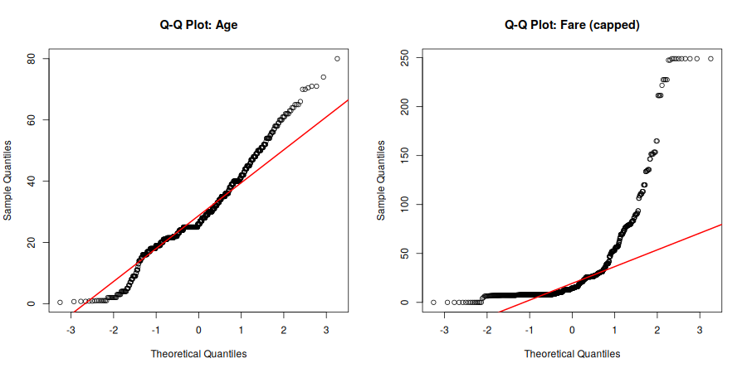
Figure 1: Q-Q plots for Age and Fare against a theoretical normal distribution
Both p-values are far below 0.05, so the null hypothesis of normality is rejected for both variables. The Q-Q plots visually confirm this: Age deviates from the red reference line at both tails, and Fare deviates dramatically due to its strong right skew. This finding justifies running a non-parametric Wilcoxon test alongside each t-test below, as a robustness check that does not assume normality.

2.2 Age vs. Survival
Hypothesis: H₀ (null) = mean age is equal between survivors and non-survivors; H₁ (alternative) = mean age differs by survival outcome.
t.test(Age ~ Survived_f, data = titanic)
wilcox.test(Age ~ Survived_f, data = titanic)
R Code: Age vs. survival hypothesis tests
Welch Two Sample t-test: t = 1.7432, df = 675.11, p-value = 0.0817
mean age (Did Not Survive) = 29.74 mean age (Survived) = 28.11

Wilcoxon rank sum test: W = 98172, p-value = 0.250

Console Output: Age vs. survival test results
Both tests produced p-values well above 0.05 (0.082 and 0.250 respectively), so we fail to reject the null hypothesis: on its own, mean age does not differ significantly between survivors and non-survivors. This is a useful and slightly counter-intuitive finding given the age-group survival trend observed in Week 2 — it shows that while children had a survival advantage, adult age alone does not cleanly separate the two groups on average. As demonstrated in Section 3, age's true relationship with survival only becomes clearly significant once sex and class are controlled for in a multivariate model.

2.3 Fare vs. Survival
Hypothesis: H₀ = mean fare is equal between survivors and non-survivors; H₁ = mean fare differs by survival outcome.
t.test(Fare_capped ~ Survived_f, data = titanic)
wilcox.test(Fare_capped ~ Survived_f, data = titanic)
R Code: Fare vs. survival hypothesis tests
Welch Two Sample t-test: t = -7.5428, df = 487.38, p-value = 2.27e-13
mean fare (Did Not Survive) = 22.07 mean fare (Survived) = 45.93

Wilcoxon rank sum test: W = 57808, p-value < 2.2e-16

Console Output: Fare vs. survival test results
Both tests strongly reject the null hypothesis (p < 0.001). Survivors paid, on average, more than double the fare of non-survivors ($45.93 vs. $22.07), a highly significant and practically large difference that supports fare (and by extension, class) as a meaningful predictor.

2.4 Sex vs. Survival (Chi-Square Test of Independence)
Hypothesis: H₀ = sex and survival are independent; H₁ = sex and survival are associated.
chisq.test(table(titanic$Sex, titanic$Survived_f))
R Code: Chi-square test, Sex vs. Survival
 | Did Not Survive | Survived
Female | 81 | 233
Male | 468 | 109

Pearson's Chi-squared test (Yates' continuity correction):
X-squared = 260.72, df = 1, p-value < 2.2e-16

Console Output: Chi-square test result for Sex vs. Survival
This is the strongest association found in the entire analysis (p < 0.001, very large chi-squared statistic). Sex and survival are highly dependent — the null hypothesis of independence is decisively rejected.

2.5 Passenger Class vs. Survival (Chi-Square Test)
chisq.test(table(titanic$Pclass, titanic$Survived_f))
R Code: Chi-square test, Pclass vs. Survival
Class | Did Not Survive | Survived
1st | 80 | 136
2nd | 97 | 87
3rd | 372 | 119

Pearson's Chi-squared test: X-squared = 102.89, df = 2, p-value < 2.2e-16

Console Output: Chi-square test result for Pclass vs. Survival
Passenger class is also very significantly associated with survival (p < 0.001), reinforcing the Week 2 visual findings with a formal statistical test.

2.6 Port of Embarkation vs. Survival (Chi-Square Test)
chisq.test(table(titanic$Embarked, titanic$Survived_f))
R Code: Chi-square test, Embarked vs. Survival
Pearson's Chi-squared test: X-squared = 25.964, df = 2, p-value = 2.30e-06

Console Output: Chi-square test result for Embarked vs. Survival
Port of embarkation is also significantly associated with survival (p < 0.001), though with a smaller test statistic than sex or class. As discussed in Week 2, this is best understood as an indirect effect: embarkation port correlates with passenger class mix, which in turn drives survival, rather than the port itself having any causal influence.

2.7 Correlation Test: Age vs. Fare
Hypothesis: H₀ = there is no monotonic correlation between Age and Fare (ρ = 0). Given the non-normality confirmed in Section 2.1, Spearman's rank correlation was used instead of Pearson's, since it does not assume a linear relationship or normally distributed data.
cor.test(titanic$Age, titanic$Fare_capped, method = "spearman")
R Code: Spearman correlation test
Spearman's rank correlation rho: S = 97337405, p-value = 1.63e-07
rho = 0.174

Console Output: Spearman correlation result
The correlation is statistically significant (p < 0.001) but weak in magnitude (ρ = 0.17), meaning older passengers tended to pay slightly higher fares, but the relationship is far from strong enough to be useful as a standalone predictor of either variable.

3. Predictive Model: Logistic Regression Classification
A logistic regression model was selected for this task because the outcome variable (Survived) is binary, and logistic regression offers a strong balance of predictive performance and interpretability — every coefficient can be converted into an odds ratio with a clear, explainable meaning, which is valuable both for this report and for any real decision-making built on top of it.

3.1 Train/Test Split
The data was split into a 75% training set and a 25% held-out test set, stratified on the outcome variable to preserve the same survival rate in both sets. The test set was not used at all during model training or cross-validation, ensuring an unbiased final performance evaluation.
train_idx <- createDataPartition(model_data$Survived_f, p = 0.75, list = FALSE)
train_data <- model_data[train_idx, ]
test_data <- model_data[-train_idx, ]
R Code: Stratified train/test split
Training set: 669 rows | Test set: 222 rows
Training set survival rate: 38.4% | Test set survival rate: 38.3%

Console Output: Train/test split sizes and class balance

3.2 10-Fold Cross-Validation
Rather than fitting the model once on the full training set, 10-fold cross-validation was used: the training data was split into 10 equal folds, the model was trained on 9 folds and validated on the remaining fold, and this was repeated 10 times so every fold served as the validation set exactly once. This gives a much more reliable estimate of how the model will generalize to new data than a single train/validation split, and reduces the risk of the reported performance being a lucky (or unlucky) artifact of one particular split.
ctrl <- trainControl(method = "cv", number = 10,
classProbs = TRUE, summaryFunction = twoClassSummary)

log_model_cv <- train(Survived_f ~ Pclass + Sex + Age + SibSp + Parch +
Fare_capped + Embarked + Has_Cabin,
data = train_data, method = "glm", family = "binomial",
trControl = ctrl, metric = "ROC")
R Code: 10-fold cross-validated logistic regression via caret
Resampling: Cross-Validated (10 fold)
Resampling results:
ROC Sens Spec
0.8408 0.8790 0.7115

Console Output: Cross-validation performance summary (training set, averaged across 10 folds)
The cross-validated ROC (AUC) of 0.84 indicates strong discriminative ability even before touching the test set, with high sensitivity (87.9% — correctly identifying most non-survivors, the majority class) and reasonable specificity (71.2% — correctly identifying survivors, the minority class).

3.3 Final Model Coefficients and Odds Ratios
The table below summarizes the fitted model's coefficients, their statistical significance, and the corresponding odds ratios, which express each predictor's effect in units that are easier to interpret than raw log-odds coefficients.
Predictor | Odds Ratio | p-value | Interpretation
Sex: male | 0.068 | < 0.001 *** | Being male reduces survival odds by ~93%
Pclass: 3rd | 0.217 | 0.001 ** | 3rd class reduces survival odds by ~78% vs. 1st class
Pclass: 2nd | 0.764 | 0.557 | Not statistically significant vs. 1st class
Age | 0.965 | < 0.001 *** | Each additional year reduces survival odds by ~3.5%
SibSp | 0.705 | 0.005 ** | Each additional sibling/spouse reduces odds by ~30%
Parch | 0.870 | 0.292 | Not statistically significant
Fare (capped) | 1.003 | 0.431 | Not statistically significant once class is included
Has_Cabin | 1.914 | 0.088 . | Marginal positive effect (borderline significance)
Embarked: S | 0.627 | 0.092 . | Marginal negative effect vs. Cherbourg

Table: Selected model coefficients, odds ratios, and significance levels (*** p<0.001, ** p<0.01, . p<0.10)
A key finding here is that Age becomes highly statistically significant (p < 0.001) in this multivariate model, despite showing no significant difference in the simple two-sample t-test in Section 2.2. This is a classic example of confounding: age's effect on survival was being masked in the simple comparison because age is correlated with other factors (e.g., family structure via SibSp/Parch) that also affect survival. Once those factors are held constant in the regression, age's true negative effect on survival odds emerges clearly. Similarly, Fare's effect becomes non-significant once Pclass is included, since fare and class capture much of the same underlying information (a point already flagged by their shared correlation with Has_Cabin during Week 1's analysis).

3.4 Multicollinearity Check
Since several predictors (Fare, Pclass, Has_Cabin) plausibly measure overlapping information (wealth/class), Variance Inflation Factors (VIF) were computed to check whether this overlap was severe enough to distort the model's coefficient estimates.
vif(final_glm)
R Code: Variance Inflation Factor check
Pclass2 Pclass3 Sexmale Age SibSp Parch
3.626 5.257 1.239 1.417 1.285 1.317
Fare_capped EmbarkedQ EmbarkedS Has_Cabin
1.920 1.449 1.435 2.422

Console Output: VIF values for each predictor
All VIF values are below the commonly used caution threshold of 5 (Pclass3 is right at the boundary at 5.26, reflecting its natural overlap with fare and cabin status), indicating multicollinearity is not a serious concern for this model and the coefficient estimates can be interpreted with reasonable confidence.

4. Model Diagnostics and Test-Set Evaluation
With the model finalized on the training data, its performance was evaluated on the held-out 25% test set (222 passengers) that played no role in training or cross-validation, giving an honest estimate of how the model would perform on genuinely new data.

4.1 Confusion Matrix
test_pred <- predict(log_model_cv, newdata = test_data)
confusionMatrix(test_pred, test_data$Survived_f, positive = "Yes")
R Code: Generating predictions and the confusion matrix
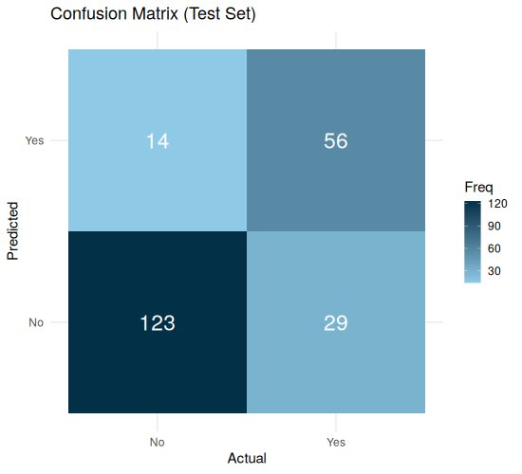
Figure 2: Confusion matrix heatmap on the test set
Metric | Value | Meaning
Accuracy | 80.6% | Overall proportion of correct predictions
Sensitivity (Recall) | 65.9% | Of actual survivors, % correctly identified
Specificity | 89.8% | Of actual non-survivors, % correctly identified
Precision | 80.0% | Of predicted survivors, % who actually survived
Balanced Accuracy | 77.8% | Average of sensitivity and specificity
Kappa | 0.576 | Agreement beyond chance (moderate-to-substantial)

Table: Test-set performance metrics at the default 0.5 classification threshold
The model correctly classified 179 of 222 test passengers (80.6% accuracy), comfortably beating the 61.7% "no information rate" (the accuracy of simply always predicting the majority class). The model is noticeably better at correctly identifying non-survivors (89.8% specificity) than survivors (65.9% sensitivity) — a pattern discussed further in Section 5.

4.2 ROC Curve and AUC
The ROC (Receiver Operating Characteristic) curve plots the trade-off between sensitivity and specificity across all possible classification thresholds, and the Area Under the Curve (AUC) summarizes overall discriminative power in a single number, where 0.5 represents random guessing and 1.0 represents perfect separation.
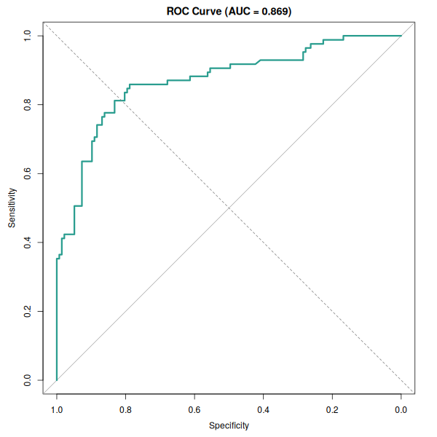
Figure 3: ROC curve on the test set
AUC: 0.8693 | 95% CI: 0.8185 - 0.9201

Console Output: Test-set AUC with 95% confidence interval
An AUC of 0.87 indicates strong discriminative ability — substantially better than chance and consistent with (in fact slightly higher than) the 0.84 ROC observed during cross-validation, suggesting the model generalizes well to unseen data rather than having overfit the training set.

4.3 Residual and Influence Diagnostics
Standard generalized linear model diagnostic plots were reviewed to check for problematic patterns, poorly fit observations, or overly influential data points.
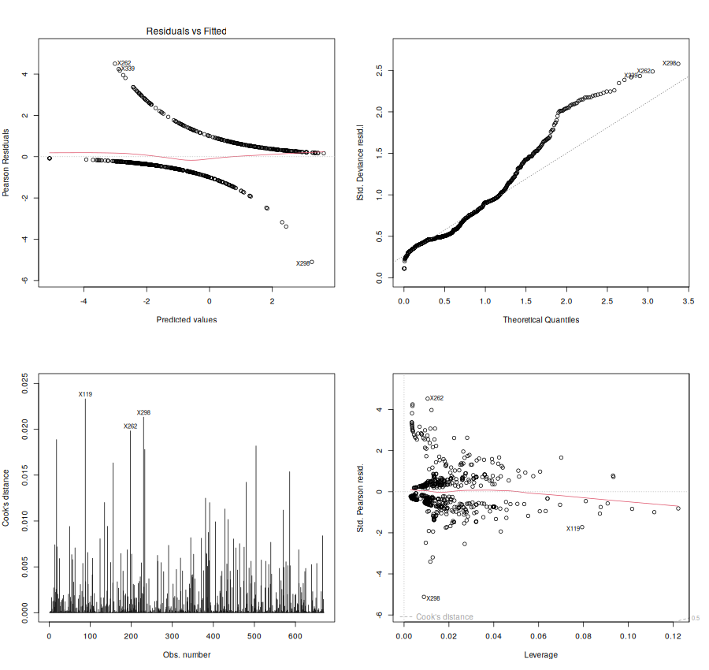
Figure 4: Residuals vs. Fitted, Normal Q-Q of deviance residuals, Cook's Distance, and Residuals vs. Leverage
The Residuals vs. Fitted plot shows the expected curved banding pattern typical of logistic regression residuals (this shape is normal for binary outcomes and is not itself a warning sign). The Cook's Distance plot shows no observation exceeding roughly 0.025 — far below the conventional concern threshold of 1.0 — meaning no single passenger's record is disproportionately distorting the model's fit. The Residuals vs. Leverage plot likewise shows no points crossing into high-leverage, high-residual territory. A few individual passengers (flagged as rows 119, 262, and 298) show comparatively larger deviance residuals, meaning the model is more surprised by their actual outcome than by most other cases (for example, a high-fare passenger who did not survive), but none rise to the level of a true outlier requiring removal.

4.4 Variable Importance
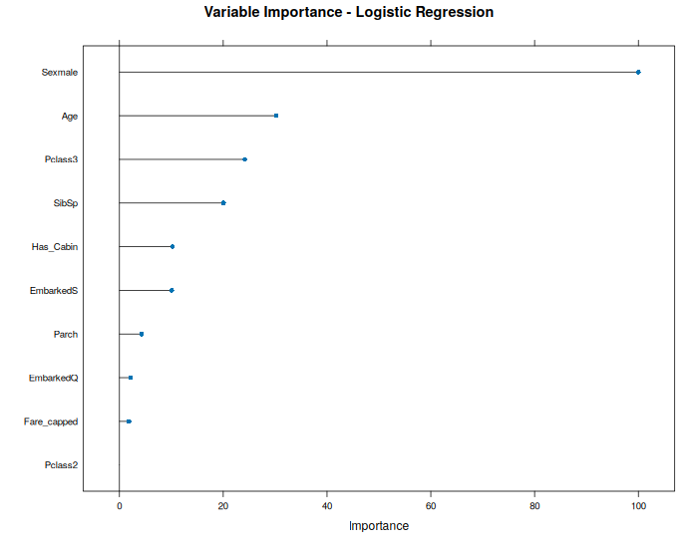
Figure 5: Relative variable importance, based on standardized coefficient magnitude
Consistent with the hypothesis tests in Section 2, Sex is overwhelmingly the most important predictor, followed by Age, 3rd class membership, and family size (SibSp). Fare contributes comparatively little once class is already in the model, echoing the multicollinearity discussion in Section 3.4.

4.5 Threshold Sensitivity Analysis
Logistic regression outputs a probability, and the default rule of classifying anyone above 0.5 probability as a predicted survivor is a choice, not a requirement. The table below shows how performance shifts at other thresholds, which is useful context depending on whether false negatives (missing an actual survivor) or false positives (wrongly predicting survival) are considered more costly in a given use case.
Threshold | Accuracy | Sensitivity | Specificity | Precision
0.3 | 81.1% | 84.7% | 78.8% | 71.3%
0.4 | 82.9% | 74.1% | 88.3% | 79.7%
0.5 (default) | 80.6% | 65.9% | 89.8% | 80.0%
0.6 | 79.3% | 57.6% | 92.7% | 83.1%
0.7 | 76.6% | 42.4% | 97.8% | 92.3%

Table: Performance metrics across a range of classification thresholds
Lowering the threshold to 0.4 actually produces the best overall accuracy (82.9%) in this dataset, alongside a better-balanced sensitivity/specificity trade-off than the default 0.5 cutoff. This highlights that the "best" threshold depends on the goal: 0.4 for balanced overall accuracy, or a higher threshold like 0.7 if the priority is being very confident before predicting survival (97.8% specificity, at the cost of missing more true survivors).

5. Summary Interpretation and Potential Improvements

5.1 Model Strengths
- Strong discrimination: an AUC of 0.87 on the held-out test set indicates the model separates survivors from non-survivors substantially better than chance, and cross-validated performance (0.84 ROC) confirms this is not an artifact of a lucky test split.
- Interpretability: every predictor's effect is expressed as an odds ratio with a clear real-world meaning (e.g., "each additional year of age reduces survival odds by about 3.5%"), which is valuable for explaining the model's reasoning to a non-technical audience.
- Statistically sound: hypothesis testing in Section 2 and the VIF check in Section 3.4 confirm the modeling assumptions are reasonably well satisfied, and diagnostic plots in Section 4.3 show no problematic outliers or overly influential points.
- Findings align with historical record: the model's strongest predictors (sex, class, age) match the well-documented "women and children first" evacuation protocol and the disaster's known class disparities, lending real-world credibility to the results.

5.2 Model Limitations
- Sensitivity (65.9%) is noticeably weaker than specificity (89.8%) at the default threshold, meaning the model misses roughly a third of actual survivors. This is common when a model is trained on a class-imbalanced outcome (only 38% of passengers survived), which biases the model toward the majority "did not survive" class.
- Logistic regression assumes a linear relationship between each predictor and the log-odds of survival, and does not automatically capture interaction effects (for example, that being young mattered much more for boys than for girls) unless those interactions are explicitly added to the model formula.
- Some predictors (Fare, 2nd class, Parch, Embarked) did not reach conventional statistical significance in the final model, suggesting the current feature set may include some redundant or noisy variables.

5.3 Potential Improvements
- Add interaction terms (e.g., Sex × Pclass, or Sex × Age) to test whether the protective effect of being female or young differs meaningfully across passenger classes, which the current additive model cannot capture.
- Address class imbalance directly, for example via class weighting in the model or resampling techniques (SMOTE, up/down-sampling), which could improve the model's currently weaker sensitivity for the minority "Survived" class.
- Compare against alternative classification algorithms (e.g., random forest or gradient boosting) which can automatically capture non-linear relationships and interactions; these are natural next steps if predictive accuracy is prioritized over interpretability.
- Engineer additional features from existing data not fully exploited here, such as extracting a title (Mr./Mrs./Miss/Master) from passenger names, or a family-size variable combining SibSp and Parch, both of which are known in the wider literature to improve predictive performance on this dataset.
- Tune the classification threshold deliberately (Section 4.5) rather than defaulting to 0.5, based on whatever real-world cost trade-off between false positives and false negatives applies to the intended use case.

5.4 Tools and Reproducibility
All statistical tests and modeling were performed in R 4.3.3 using caret for model training and cross-validation, pROC for ROC/AUC analysis, car for multicollinearity diagnostics (VIF), and e1071 (a caret dependency for classification metrics). The full annotated R script (statistical_modeling.R) accompanies this report and can be re-run end-to-end against the Week 1 cleaned dataset (titanic_cleaned.csv) to reproduce every statistic, plot, and model result presented here.

