Data Cleaning, Preprocessing, and
Preliminary Analysis in R
Dataset: Titanic Passenger Survival Data
Prepared using R 4.3.3 (dplyr, ggplot2, corrplot)
Weekly Task Submission – Data Analytics Track

1. Dataset Overview
The dataset selected for this task is the Titanic Passenger Survival dataset, a widely used public dataset originally released as part of the Kaggle "Titanic: Machine Learning from Disaster" competition. It was retrieved from a public GitHub mirror of the dataset in CSV format. The dataset was chosen because it satisfies all of the complexity requirements for this task: it contains a realistic mix of numerical and categorical variables, genuine missing values across multiple columns, several extreme outliers in the fare variable, and enough structure to support meaningful exploratory analysis.
The dataset contains 891 passenger records with the following 12 original variables:
Variable | Type | Description
PassengerId | Integer | Unique identifier for each passenger
Survived | Binary (0/1) | Survival outcome (target variable)
Pclass | Categorical (Ordinal) | Ticket class: 1 = 1st, 2 = 2nd, 3 = 3rd
Name | Text | Passenger full name
Sex | Categorical (Nominal) | Gender of passenger
Age | Numeric | Age in years (contains missing values)
SibSp | Integer | Number of siblings/spouses aboard
Parch | Integer | Number of parents/children aboard
Ticket | Text | Ticket number
Fare | Numeric | Passenger fare (contains extreme outliers)
Cabin | Categorical | Cabin number (77% missing)
Embarked | Categorical (Nominal) | Port of embarkation: C, Q, or S

This variable mix is ideal for the objectives of this task: Age and Fare are continuous numeric variables suitable for outlier detection and normalization; Cabin has a very high missing-value rate suitable for demonstrating missing-data strategy; Sex, Embarked, and Pclass are categorical variables suitable for encoding; and Survived provides a natural binary outcome around which to frame exploratory insights.

1.1 Loading the Data and Initial Structure
The dataset was loaded using read.csv(), explicitly marking empty strings as NA so that missingness in text columns such as Cabin and Embarked is captured correctly rather than being read as blank strings.
titanic <- read.csv("data/titanic.csv", stringsAsFactors = FALSE,
na.strings = c("", "NA"))
str(titanic)
dim(titanic)

R Code: Loading the dataset and inspecting its structure
The str() output below confirms the dataset has 891 observations across 12 variables, with Age stored as numeric (containing NA values) and Cabin/Embarked stored as character columns:
'data.frame': 891 obs. of 12 variables:
$ PassengerId: int 1 2 3 4 5 6 7 8 9 10 ...
$ Survived : int 0 1 1 1 0 0 0 0 1 1 ...
$ Pclass : int 3 1 3 1 3 3 1 3 3 2 ...
$ Name : chr "Braund, Mr. Owen Harris" ...
$ Sex : chr "male" "female" "female" "female" ...
$ Age : num 22 38 26 35 35 NA 54 2 27 14 ...
$ SibSp : int 1 1 0 1 0 0 0 3 0 1 ...
$ Parch : int 0 0 0 0 0 0 0 1 2 0 ...
$ Ticket : chr "A/5 21171" "PC 17599" ...
$ Fare : num 7.25 71.28 7.92 53.1 8.05 ...
$ Cabin : chr NA "C85" NA "C123" ...
$ Embarked : chr "S" "C" "S" "S" ...

Console Output: str(titanic) confirming variable types and the presence of NA values

2. Data Cleaning Process
The cleaning methodology followed a structured sequence: (1) assess missing values, (2) treat missing values column-by-column using a strategy appropriate to each column's missingness rate and type, (3) detect and treat outliers, (4) normalize numeric variables, and (5) encode categorical variables for downstream analysis.

2.1 Missing Value Assessment
The first step was to quantify missingness across all columns using colSums(is.na(titanic)). This revealed three affected columns: Cabin, Age, and Embarked.
missing_counts <- colSums(is.na(titanic))
missing_pct <- round(100 * missing_counts / nrow(titanic), 2)
missing_summary <- data.frame(Column = names(missing_counts),
Missing_Count = missing_counts,
Missing_Percent = missing_pct)
print(missing_summary[order(-missing_summary$Missing_Count), ])

R Code: Quantifying missing values per column
Column | Missing Count | Missing %
Cabin | 687 | 77.10%
Age | 177 | 19.87%
Embarked | 2 | 0.22%
All other columns | 0 | 0.00%

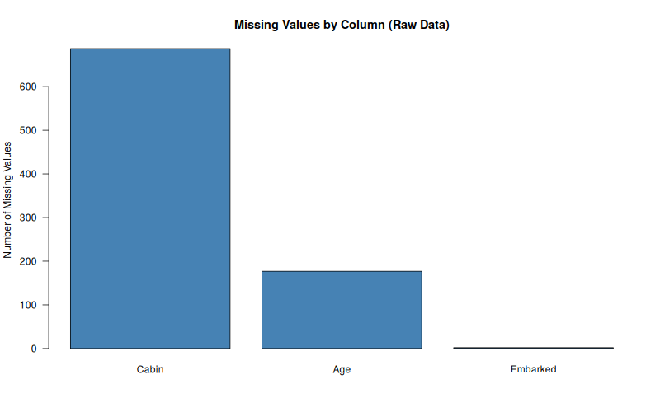
Figure 1: Bar chart of missing values by column (raw data)

2.2 Handling Missing Values
Each column was treated with a strategy tailored to its missingness rate and analytic role, rather than applying one blanket rule:
- Cabin (77.1% missing): Given the extremely high missingness rate, imputing plausible cabin numbers would be unreliable and could introduce bias. Rather than dropping the column entirely and losing information, it was replaced with a binary indicator variable, Has_Cabin (1 = cabin recorded, 0 = missing), since whether a cabin was recorded is itself informative (it tends to correlate with class and fare).
- Age (19.9% missing): Age was imputed using the median Age grouped by Pclass and Sex, rather than a single global median. This is more accurate because age distributions differ systematically by class and gender in this dataset (e.g., 1st class passengers skew older than 3rd class passengers).
- Embarked (0.22% missing, 2 records): Given the negligible number of affected rows, the mode (most frequent port, "S" – Southampton) was used for imputation, which is standard practice for low-missingness categorical variables.
# Cabin -> binary flag
titanic_clean$Has_Cabin <- ifelse(is.na(titanic_clean$Cabin), 0, 1)
titanic_clean$Cabin <- NULL

# Age -> median imputation grouped by Pclass and Sex
age_medians <- titanic_clean %>%
group_by(Pclass, Sex) %>%
summarise(median_age = median(Age, na.rm = TRUE), .groups = "drop")

titanic_clean <- titanic_clean %>%
left_join(age_medians, by = c("Pclass", "Sex")) %>%
mutate(Age = ifelse(is.na(Age), median_age, Age)) %>%
select(-median_age)

# Embarked -> mode imputation
embarked_mode <- names(sort(table(titanic_clean$Embarked), decreasing = TRUE))[1]
titanic_clean$Embarked[is.na(titanic_clean$Embarked)] <- embarked_mode

R Code: Missing value treatment for Cabin, Age, and Embarked
The grouped median ages computed for imputation are shown below, illustrating why grouping matters — median age varies from 21.5 (3rd class females) to 40 (1st class males):
Pclass Sex median_age
1 1 female 35
2 1 male 40
3 2 female 28
4 2 male 30
5 3 female 21.5
6 3 male 25

Mode used to impute Embarked: S

Console Output: Grouped median ages and Embarked mode
PassengerId, Name, and Ticket were also dropped at this stage, as they are unique identifiers/free text with no direct analytic value for statistical summarization or correlation analysis. After treatment, verification confirmed zero remaining missing values across all retained columns.

2.3 Outlier Detection
Outliers in the two continuous numeric variables, Age and Fare, were identified using the interquartile range (IQR) rule: a value is flagged as an outlier if it falls below Q1 − 1.5×IQR or above Q3 + 1.5×IQR. This method was chosen because it is distribution-free (does not assume normality) and is the standard convention reflected in boxplot whiskers.
detect_outliers_iqr <- function(x) {
q1 <- quantile(x, 0.25, na.rm = TRUE)
q3 <- quantile(x, 0.75, na.rm = TRUE)
iqr <- q3 - q1
lower <- q1 - 1.5 * iqr
upper <- q3 + 1.5 * iqr
which(x < lower | x > upper)
}
age_outliers <- detect_outliers_iqr(titanic_clean$Age)
fare_outliers <- detect_outliers_iqr(titanic_clean$Fare)

R Code: IQR-based outlier detection function
Number of Age outliers: 33
Number of Fare outliers: 116

Console Output: Outlier counts by IQR rule
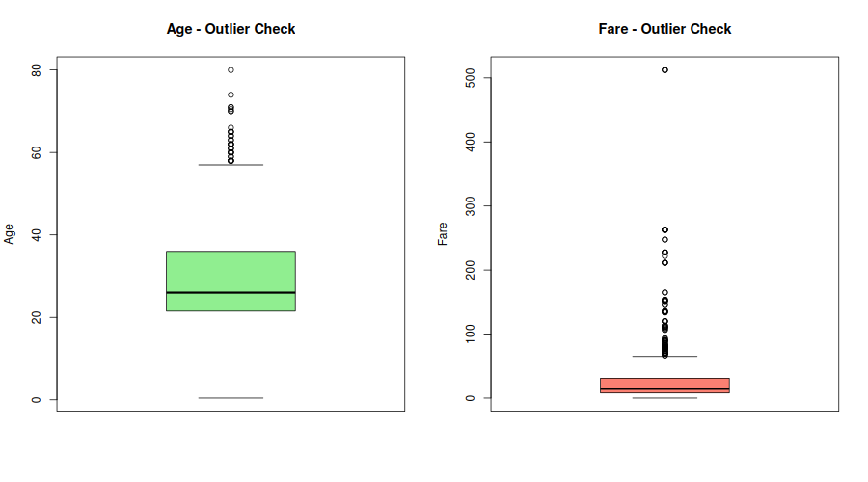
Figure 2: Boxplots of Age and Fare highlighting outliers
Age outliers were relatively modest (33 records, mostly elderly passengers), so they were retained as-is since they represent plausible real ages. Fare, however, showed a much larger number of outliers (116 records) driven by a small number of extremely expensive first-class tickets (maximum fare of 512.33 versus a median of 14.45). Rather than deleting these rows and losing sample size, Fare was winsorized (capped) at the 99th percentile, which limits the influence of extreme values while preserving all 891 records.
fare_cap <- quantile(titanic_clean$Fare, 0.99, na.rm = TRUE)
titanic_clean$Fare_capped <- ifelse(titanic_clean$Fare > fare_cap,
fare_cap, titanic_clean$Fare)

R Code: Winsorizing Fare at the 99th percentile
99th percentile Fare cap applied at: 249.01

2.4 Normalization
Age and the capped Fare variable were rescaled to a [0, 1] range using min-max normalization. This step is useful for any downstream modeling that is sensitive to feature scale (e.g., distance-based or gradient-based algorithms), and it also makes the two variables directly comparable in visualizations.
min_max_norm <- function(x) {
(x - min(x, na.rm = TRUE)) / (max(x, na.rm = TRUE) - min(x, na.rm = TRUE))
}
titanic_clean$Age_norm <- min_max_norm(titanic_clean$Age)
titanic_clean$Fare_norm <- min_max_norm(titanic_clean$Fare_capped)

R Code: Min-max normalization of Age and Fare
Age_norm Fare_norm
Min. :0.0000 Min. :0.00000
1st Qu.:0.2649 1st Qu.:0.03177
Median :0.3214 Median :0.05805
Mean :0.3605 Mean :0.12540
3rd Qu.:0.4471 3rd Qu.:0.12449
Max. :1.0000 Max. :1.00000

Console Output: summary() of the normalized Age and Fare columns

2.5 Encoding Categorical Variables
Three encoding strategies were applied depending on each variable's nature:
- Sex (binary nominal): encoded directly as a 0/1 binary indicator, Sex_encoded (1 = male, 0 = female).
- Pclass (ordinal): converted to an ordered factor (1 < 2 < 3), preserving its natural class ranking for any ordinal-aware analysis.
- Embarked (nominal, 3 levels): one-hot encoded into three dummy columns (Embarked_C, Embarked_Q, Embarked_S) using model.matrix(), since it has no natural order and one-hot encoding avoids implying a false ranking between ports.
titanic_clean$Sex_encoded <- ifelse(titanic_clean$Sex == "male", 1, 0)
titanic_clean$Pclass <- factor(titanic_clean$Pclass, levels = c(1,2,3),
ordered = TRUE)

embarked_dummies <- model.matrix(~ Embarked - 1, data = titanic_clean)
colnames(embarked_dummies) <- gsub("Embarked", "Embarked_",
colnames(embarked_dummies))
titanic_clean <- cbind(titanic_clean, embarked_dummies)

R Code: Encoding Sex, Pclass, and Embarked
After cleaning, transformation, and encoding, the dataset grew from 12 to 16 well-structured columns with zero missing values, ready for exploratory analysis. The cleaned dataset was exported to titanic_cleaned.csv for reproducibility.

3. Exploratory Data Analysis
With a clean dataset in hand, exploratory analysis was performed using R's core inspection functions (str(), summary()) together with descriptive statistics, cross-tabulations, correlation analysis, and a series of visualizations built with ggplot2.

3.1 Structural and Statistical Summary
str(titanic_clean)
summary(titanic_clean)
R Code: Post-cleaning structural and statistical summary
The summary() output confirms sensible ranges across all variables post-cleaning — for example, Fare_capped now tops out at 249.01 (versus 512.33 pre-capping), and both Age_norm and Fare_norm span the expected [0, 1] range:
Fare_capped Age_norm Fare_norm Sex_encoded
Min. : 0.00 Min. :0.0000 Min. :0.00000 Min. :0.0000
1st Qu.: 7.91 1st Qu.:0.2649 1st Qu.:0.03177 1st Qu.:0.0000
Median : 14.45 Median :0.3214 Median :0.05805 Median :1.0000
Mean : 31.22 Mean :0.3605 Mean :0.12540 Mean :0.6476
3rd Qu.: 31.00 3rd Qu.:0.4471 3rd Qu.:0.12449 3rd Qu.:1.0000
Max. :249.01 Max. :1.0000 Max. :1.00000 Max. :1.0000

Console Output: summary() of key cleaned/derived variables

3.2 Survival Breakdown
The overall survival rate in the dataset is 38.4% (342 of 891 passengers). Cross-tabulating survival against Sex and Pclass reveals two of the strongest patterns in the dataset:
Survival rate by Sex:
Died Survived
female 25.80% 74.20%
male 81.11% 18.89%

Survival rate by Pclass:
Died Survived
1 37.04% 62.96%
2 52.72% 47.28%
3 75.76% 24.24%

Console Output: Survival rate cross-tabulated by Sex and Pclass
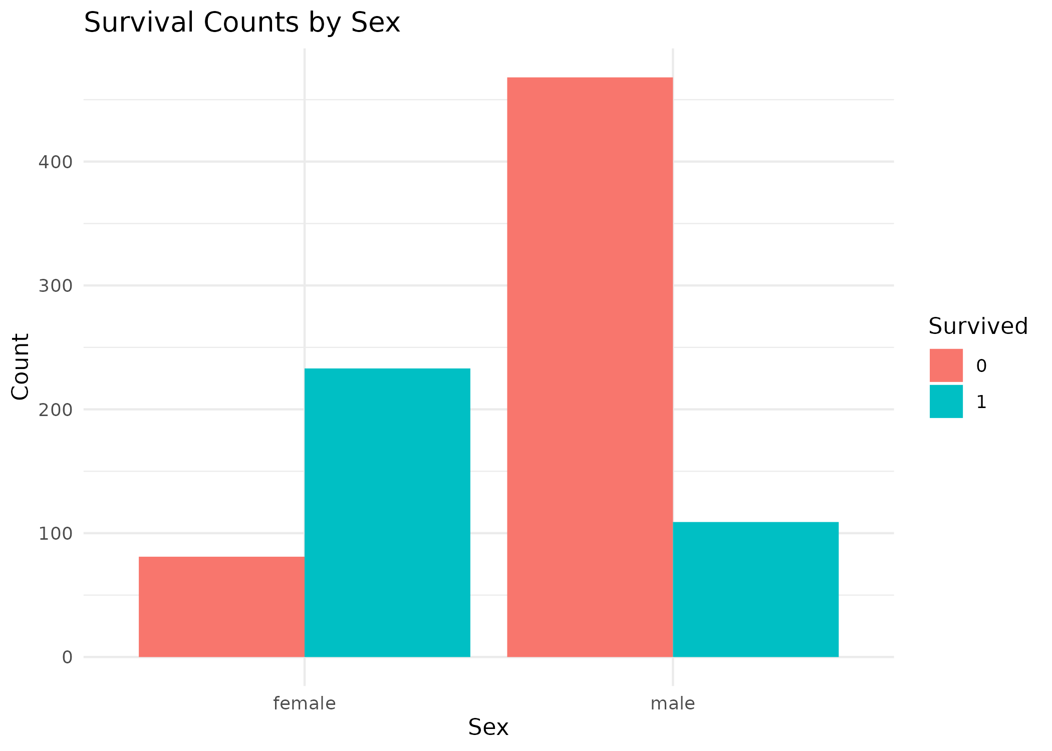
Figure 3: Survival counts by sex — women survived at a much higher rate than men
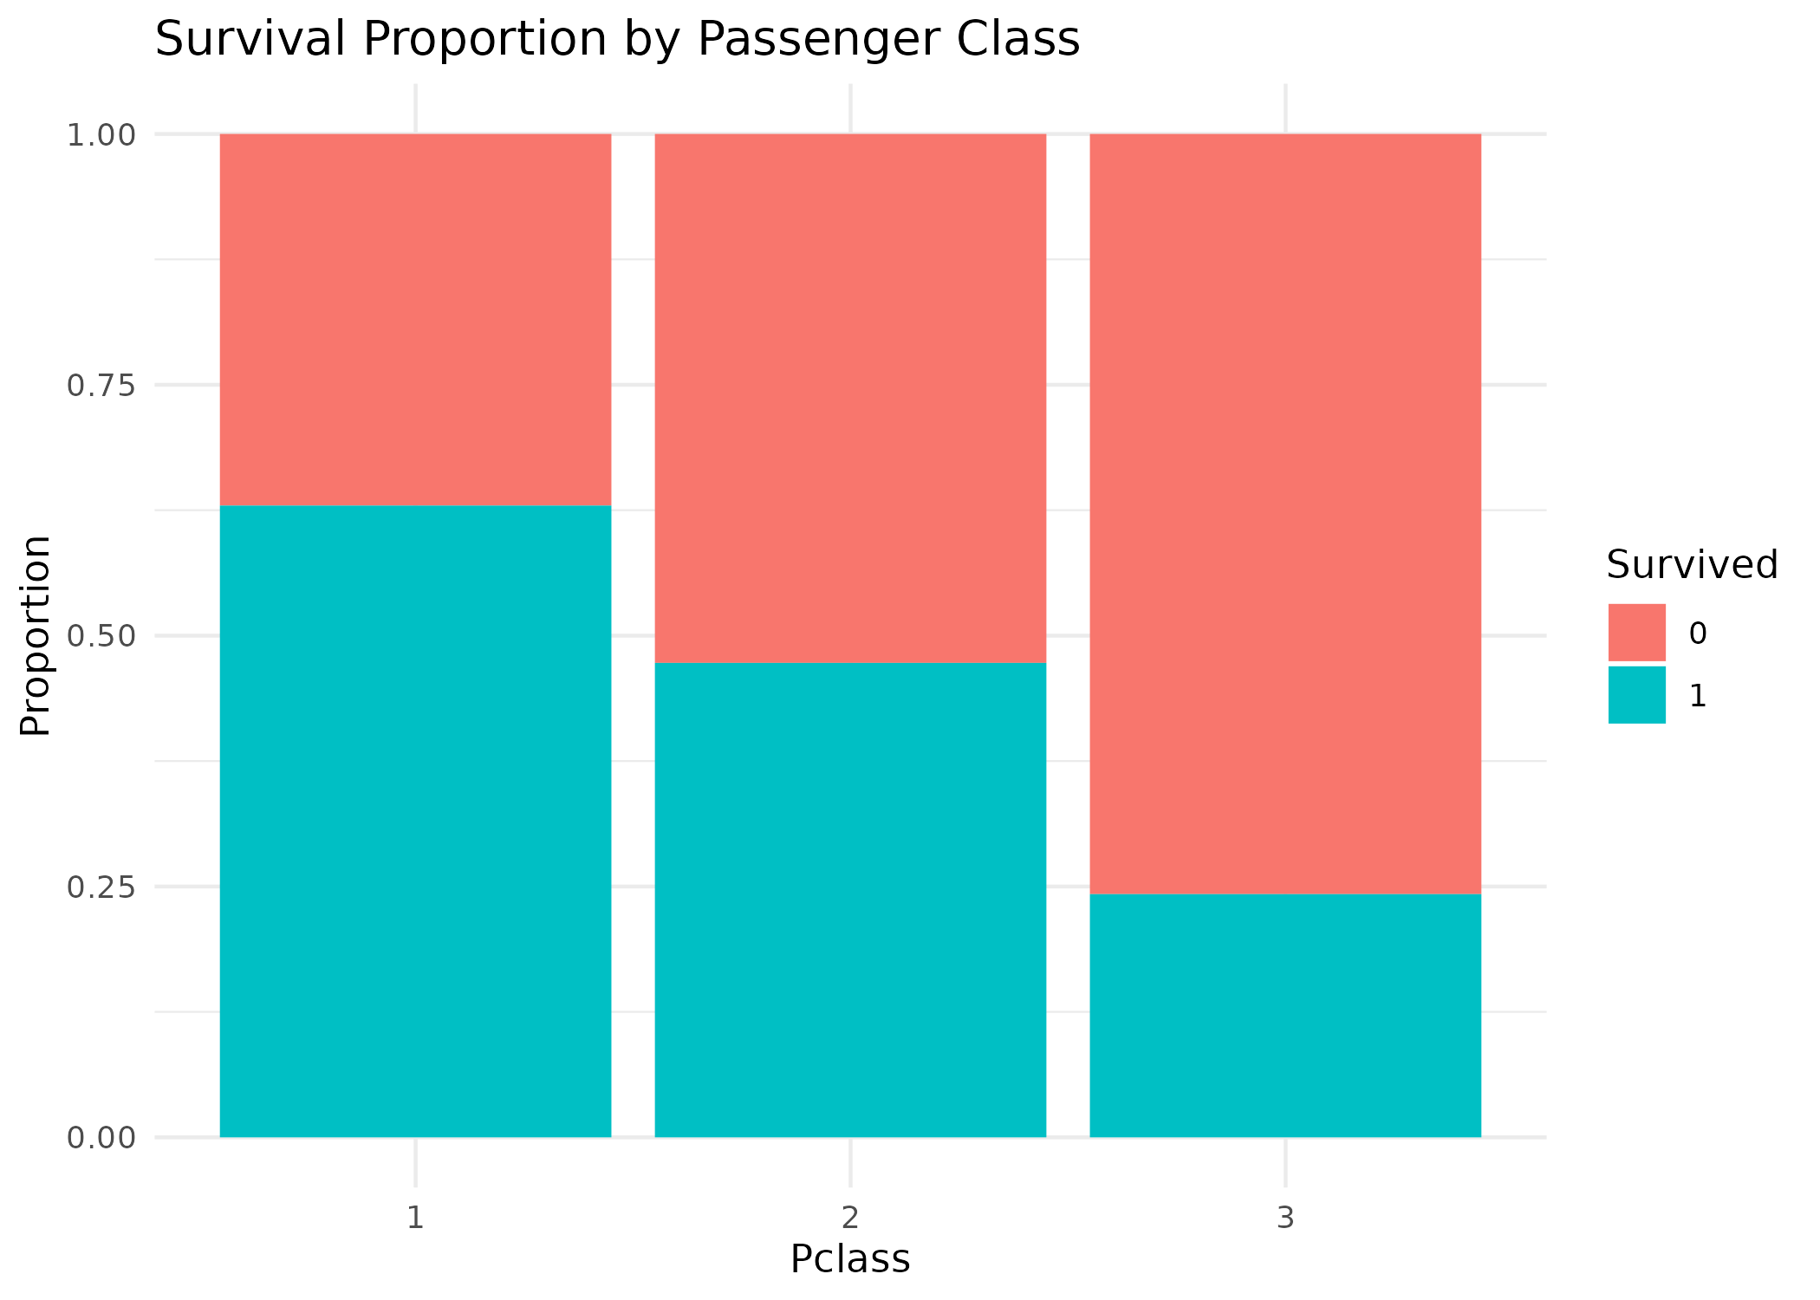
Figure 4: Survival proportion by passenger class — survival declines sharply from 1st to 3rd class

3.3 Distribution of Numeric Variables
Histograms of the (imputed) Age and (capped) Fare distributions show that Age is roughly unimodal and centered in the 20–35 range — consistent with the grouped-median imputation strategy not distorting the distribution's overall shape — while Fare remains right-skewed even after capping, reflecting the reality that most passengers purchased economical tickets while a minority purchased premium fares.
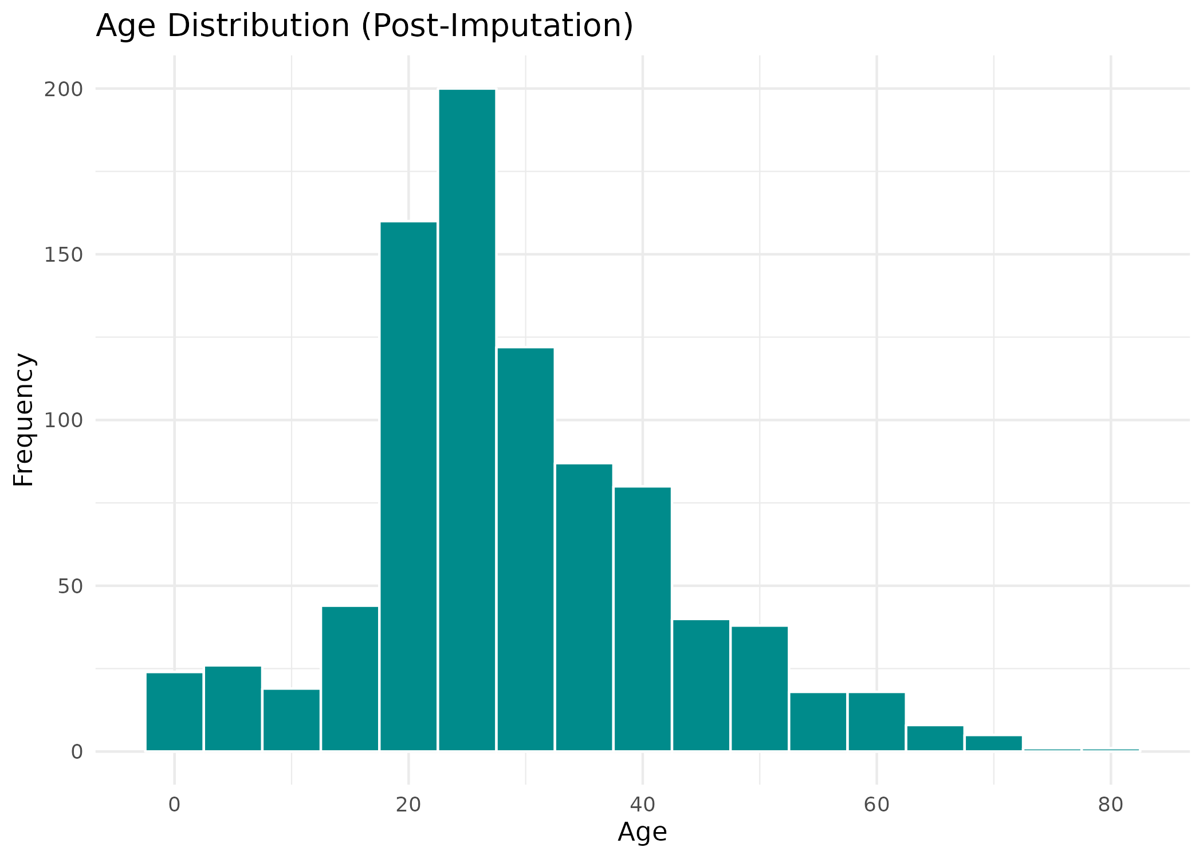
Figure 5: Age distribution after median imputation
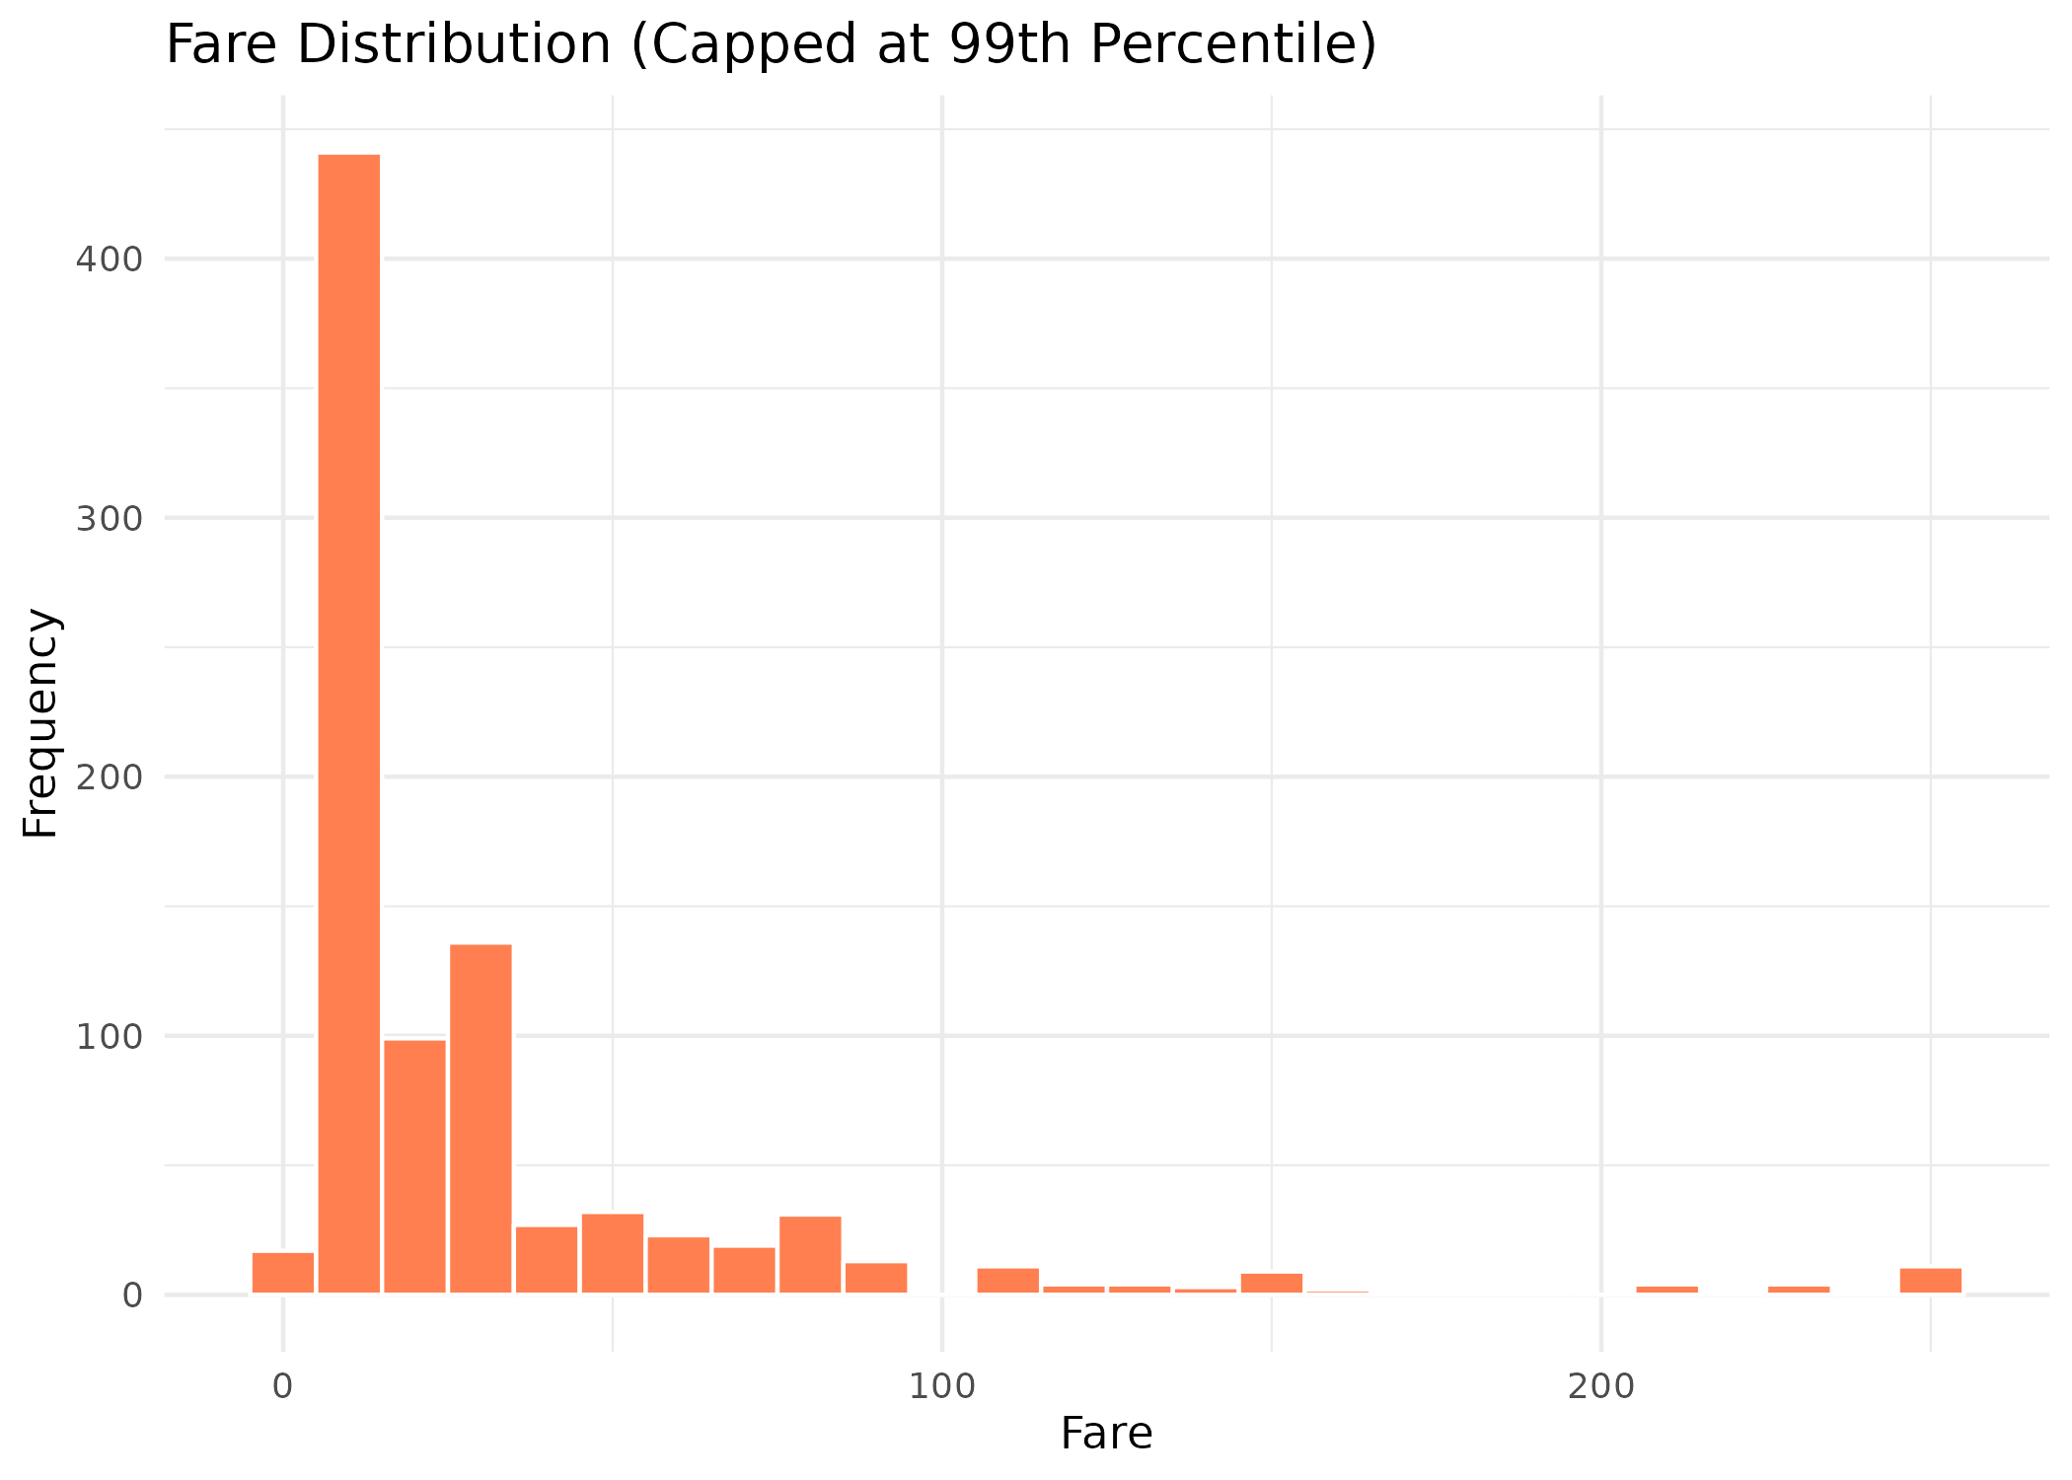
Figure 6: Fare distribution after capping at the 99th percentile

3.4 Relationship Between Age, Fare, and Survival
A scatter plot of Age against capped Fare, colored by survival outcome, shows that survivors (teal points) are noticeably concentrated at higher fare levels, while non-survivors (red points) are spread more evenly across lower fares — visually reinforcing the fare/class effect on survival observed in the cross-tabulations.
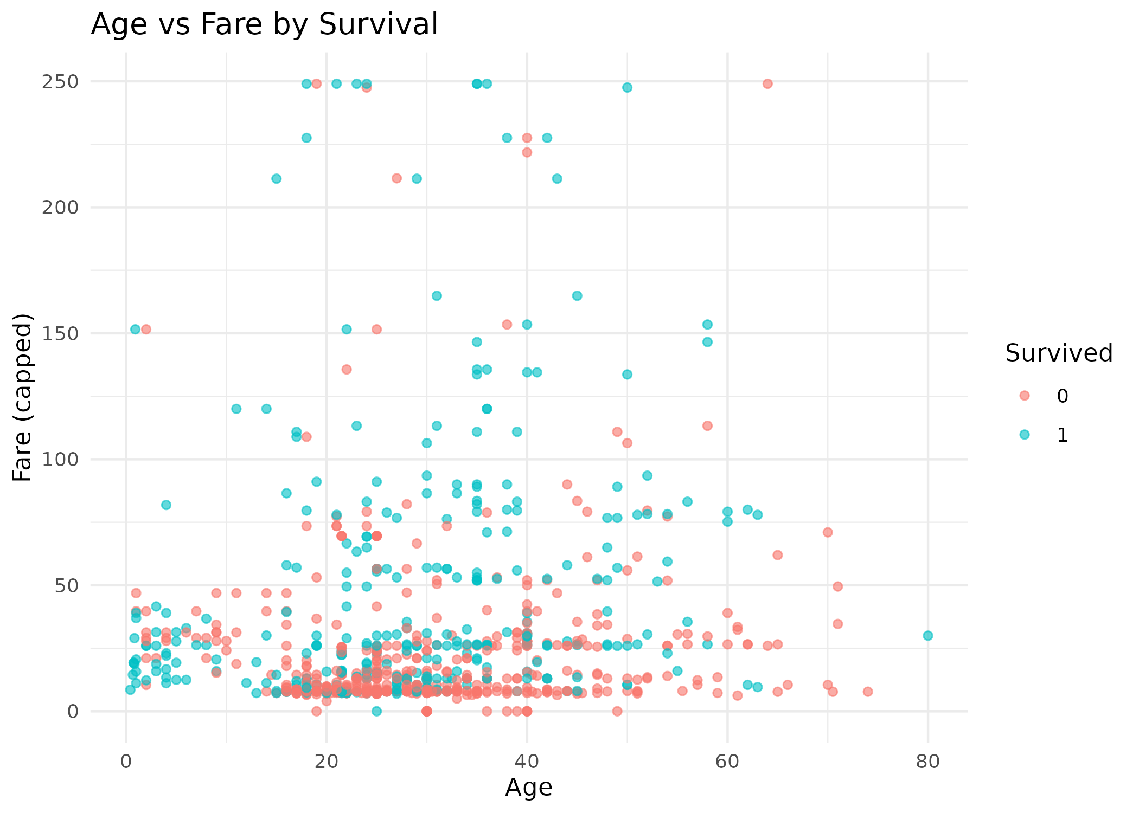
Figure 7: Age vs. Fare scatter plot colored by survival outcome

3.5 Correlation Analysis
A correlation matrix was computed across the key numeric and encoded variables to quantify relationships and identify which features are most associated with survival.
Survived Age SibSp Parch Fare_capped Has_Cabin Sex_encoded
Survived 1.00 -0.06 -0.04 0.08 0.27 0.32 -0.54
Age -0.06 1.00 -0.25 -0.18 0.13 0.28 0.10
SibSp -0.04 -0.25 1.00 0.41 0.19 -0.04 -0.11
Parch 0.08 -0.18 0.41 1.00 0.25 0.04 -0.25
Fare_capped 0.27 0.13 0.19 0.25 1.00 0.54 -0.21
Has_Cabin 0.32 0.28 -0.04 0.04 0.54 1.00 -0.14
Sex_encoded -0.54 0.10 -0.11 -0.25 -0.21 -0.14 1.00

Console Output: Correlation matrix of numeric and encoded variables
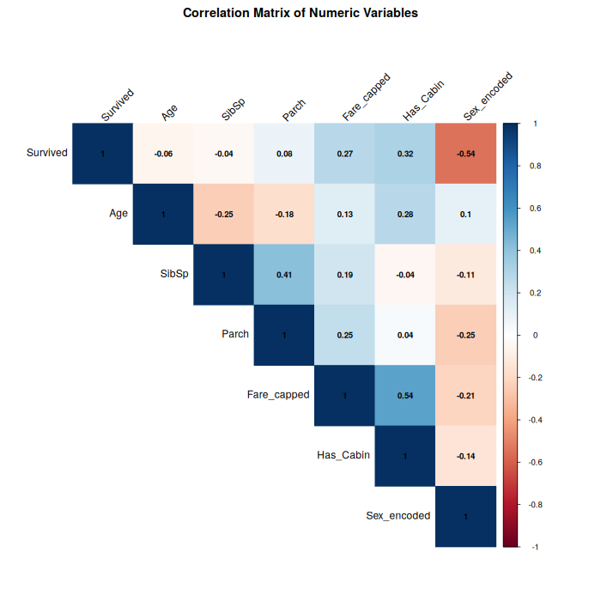
Figure 8: Correlation heatmap of numeric variables
Sex_encoded shows the strongest correlation with Survived (r = −0.54), confirming that being male was strongly associated with lower survival odds. Has_Cabin (r = 0.32) and Fare_capped (r = 0.27) are the next strongest positive correlates, both acting as proxies for socio-economic class and deck location. SibSp and Parch are moderately correlated with each other (r = 0.41), as expected since both describe family group size aboard.

4. Key Insights and Conclusion
- Overall survival rate was 38.4% (342 of 891 passengers).
- Sex was the single strongest predictor of survival in this dataset: women survived at 74.2% versus 18.9% for men, and Sex_encoded had the highest-magnitude correlation with Survived (r = −0.54).
- Passenger class had a clear, monotonic effect on survival: 1st class passengers survived at 63.0%, versus 47.3% for 2nd class and only 24.2% for 3rd class.
- Fare and having a recorded cabin (Has_Cabin) both correlate positively with survival, reinforcing that wealth and cabin location (proxies for deck and lifeboat access) shaped survival odds.
- Age had only a weak, slightly negative overall correlation with survival, suggesting age alone was a much less decisive factor than sex or class, though the "women and children first" protocol is visible within the female/child subgroup.
- The IQR method identified Fare as considerably more outlier-prone (116 records) than Age (33 records) — a small number of premium first-class fares heavily skewed the raw Fare distribution, motivating the choice to cap rather than delete these observations.

In summary, this task demonstrated a complete, defensible R workflow for preparing a real-world dataset for analysis: assessing and treating missing data with column-appropriate strategies, detecting and controlling for outliers without discarding data, rescaling numeric features, and encoding categorical variables for downstream use. The resulting exploratory analysis surfaced clear, well-supported insights — chiefly that sex and passenger class were the dominant factors shaping survival aboard the Titanic — validated through descriptive statistics, cross-tabulations, correlation analysis, and multiple visualizations.

4.1 Tools and Reproducibility
All analysis was performed in R 4.3.3 using the dplyr package for data manipulation, ggplot2 for visualization, and corrplot for the correlation heatmap. The full annotated R script (analysis.R) and the cleaned dataset (titanic_cleaned.csv) accompany this report for full reproducibility.

