Dynamic and Informative Visualizations in R
Dataset: Titanic Passenger Survival Data
Prepared using R 4.3.3 (ggplot2, lattice, base graphics)
Weekly Task Submission – Data Analytics Track

1. Data Overview
This week's visualizations continue with the Titanic Passenger Survival dataset used in Week 1, now working from the cleaned version produced during the data cleaning stage (891 passengers, zero missing values, outliers already treated). Building on the same dataset allows this week's work to focus entirely on visual storytelling rather than re-cleaning data, while still using a rich, real-world dataset that non-technical readers can intuitively understand: passengers on a ship, and whether or not they survived.
The variables featured most heavily in this week's charts are summarized below:
Variable | Type | What It Represents
Survived | Categorical (Yes/No) | Whether the passenger survived the sinking
Pclass | Categorical (Ordinal) | Ticket class: 1st, 2nd, or 3rd
Sex | Categorical (Nominal) | Passenger gender
Age | Numeric | Passenger age in years
Fare_capped | Numeric | Ticket fare, capped to limit the effect of extreme outliers
Embarked | Categorical (Nominal) | Port where the passenger boarded (Cherbourg, Queenstown, Southampton)
Age_Group | Categorical (derived) | Age bucketed into 10-year bands, created this week for trend analysis

In total, eleven visualizations were produced across three R graphics systems — base R graphics, the lattice package, and ggplot2 — deliberately chosen to demonstrate range and to show how the same story can be told through different chart types and tools. Each chart below is presented with its R code, a description of why that chart type was chosen, and a plain-language interpretation of what it reveals.

2. Visualizations, Code, and Interpretation
Every chart in this section follows the same three-part structure: the R code used to generate it, the chart itself, and an explanation written for a non-technical reader — focusing on what the picture shows and why it matters, rather than on statistical jargon.

2.1 Histogram of Passenger Age (Base R)
A histogram was chosen here because it is the simplest, most familiar way to show how a numeric value — age, in this case — is spread across a population. This chart was built with base R graphics (hist()) rather than ggplot2, to demonstrate that clear, publication-ready charts can be produced without any external packages.
hist(titanic$Age, breaks = 20, col = "steelblue", border = "white",
main = "Distribution of Passenger Age (Base R)",
xlab = "Age (years)", ylab = "Number of Passengers")
abline(v = median(titanic$Age), col = "red", lwd = 2, lty = 2)
R Code: Histogram of Passenger Age (Base R)
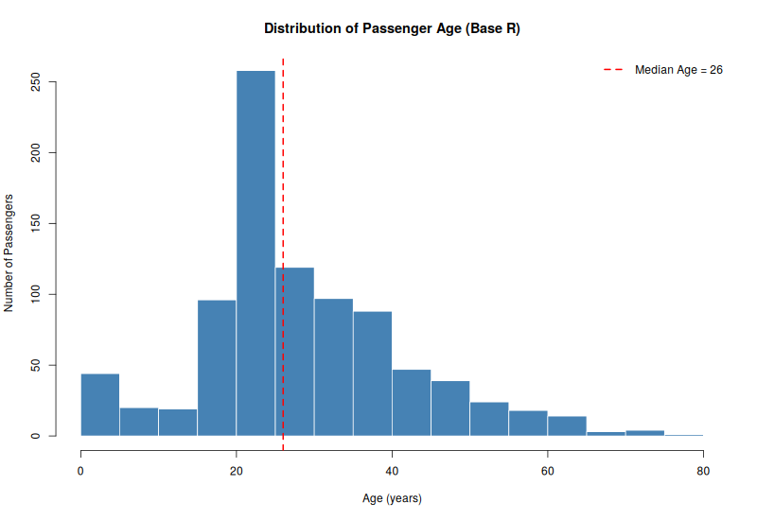
Figure 1: Distribution of passenger age, with the median age marked in red
Most passengers were young adults: the largest single group falls between roughly 20 and 30 years old, and the median age across all passengers was 26. There is a long tail of older passengers stretching out toward 80, but very few passengers were elderly. There is also a small but noticeable bump of infants and young children under 10, which becomes important later when we look at survival by age.

2.2 Boxplot of Fare by Passenger Class (Base R)
A boxplot is the ideal chart for comparing a numeric value across several categories at once, because it summarizes the typical value, the spread, and any unusually high or low values in a single compact shape — here comparing ticket fares across the three passenger classes.
boxplot(Fare_capped ~ Pclass, data = titanic,
col = c("#66c2a5","#fc8d62","#8da0cb"),
main = "Fare Paid by Passenger Class (Base R)",
xlab = "Passenger Class", ylab = "Fare (capped at 99th percentile)")
R Code: Boxplot of Fare by Passenger Class (Base R)
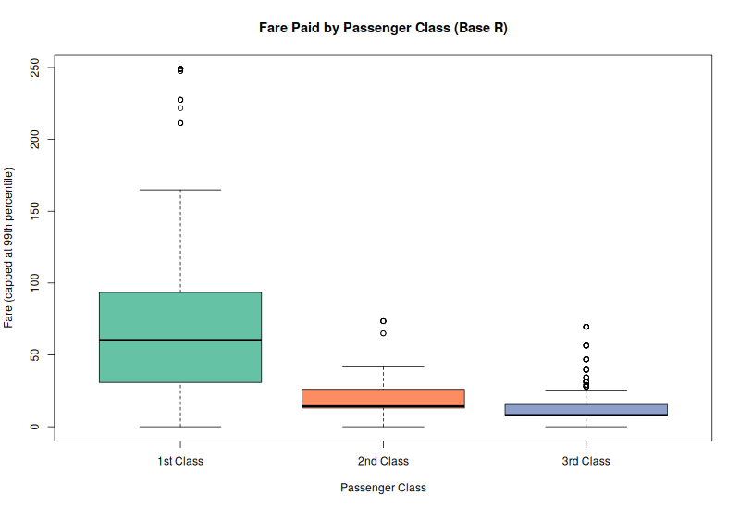
Figure 2: Fare distribution by passenger class
As expected, 1st class fares were dramatically higher and far more variable than 2nd or 3rd class fares, while 3rd class fares were low and tightly clustered together. This confirms that Pclass is a strong proxy for wealth, and sets up the expectation — confirmed in later charts — that class would also be strongly linked to survival, since wealthier passengers were more likely to be housed on higher decks closer to the lifeboats.

2.3 Bar Chart of Passenger Counts by Class (ggplot2)
A simple bar chart is the clearest way to show how many passengers fall into each category. This establishes the baseline group sizes that all later percentage-based charts build on.
ggplot(titanic, aes(x = Pclass, fill = Pclass)) +
geom_bar() +
geom_text(stat = "count", aes(label = after_stat(count)), vjust = -0.4, size = 5) +
labs(title = "Number of Passengers by Class",
x = "Passenger Class", y = "Number of Passengers") +
theme_minimal(base_size = 14) +
theme(legend.position = "none")
R Code: Bar Chart of Passenger Counts by Class (ggplot2)
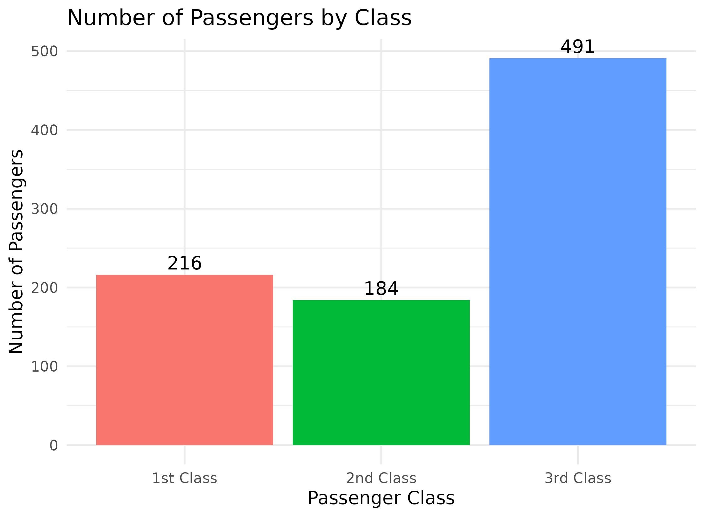
Figure 3: Number of passengers travelling in each class
Third class was by far the largest group, with 491 passengers, compared to 216 in 1st class and 184 in 2nd class. This is an important piece of context for interpreting the survival charts that follow: even though 3rd class passengers made up over half of everyone aboard, we will see they had the lowest chance of survival.

2.4 Stacked Bar Chart of Survival by Class (ggplot2)
A stacked bar chart builds directly on the previous chart by splitting each class's passenger count into those who survived and those who did not, making it easy to see both the total size of each group and its outcome split in one image.
ggplot(titanic, aes(x = Pclass, fill = Survived_lbl)) +
geom_bar(position = "stack") +
scale_fill_manual(values = c("Did Not Survive" = "#e76f51",
"Survived" = "#2a9d8f")) +
labs(title = "Survival Outcomes by Passenger Class",
x = "Passenger Class", y = "Number of Passengers", fill = "Outcome") +
theme_minimal(base_size = 14)
R Code: Stacked Bar Chart of Survival by Class (ggplot2)
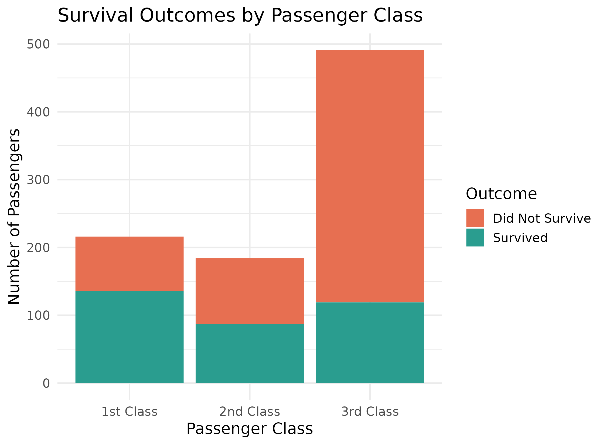
Figure 4: Survival outcomes broken down by passenger class
The visual imbalance is striking: in 3rd class, the red (did not survive) portion dominates the bar, while in 1st class the green (survived) portion is the majority. This is one of the clearest single-image summaries of the disaster's outcome: your ticket class had a major bearing on whether you lived or died.

2.5 Grouped Bar Chart of Survival Rate by Class and Sex (ggplot2)
A grouped (dodged) bar chart was used here to compare survival rate percentages across two categorical variables at once — class and sex — side by side, which is more precise than the stacked chart above for reading exact percentage differences between groups.
rate_df <- titanic %>%
group_by(Pclass, Sex) %>%
summarise(Survival_Rate = mean(Survived) * 100, .groups = "drop")

ggplot(rate_df, aes(x = Pclass, y = Survival_Rate, fill = Sex)) +
geom_col(position = position_dodge(width = 0.7), width = 0.6) +
geom_text(aes(label = paste0(round(Survival_Rate,1),"%")),
position = position_dodge(width = 0.7), vjust = -0.4, size = 4) +
labs(title = "Survival Rate (%) by Class and Sex",
x = "Passenger Class", y = "Survival Rate (%)", fill = "Sex")
R Code: Grouped Bar Chart of Survival Rate by Class and Sex (ggplot2)
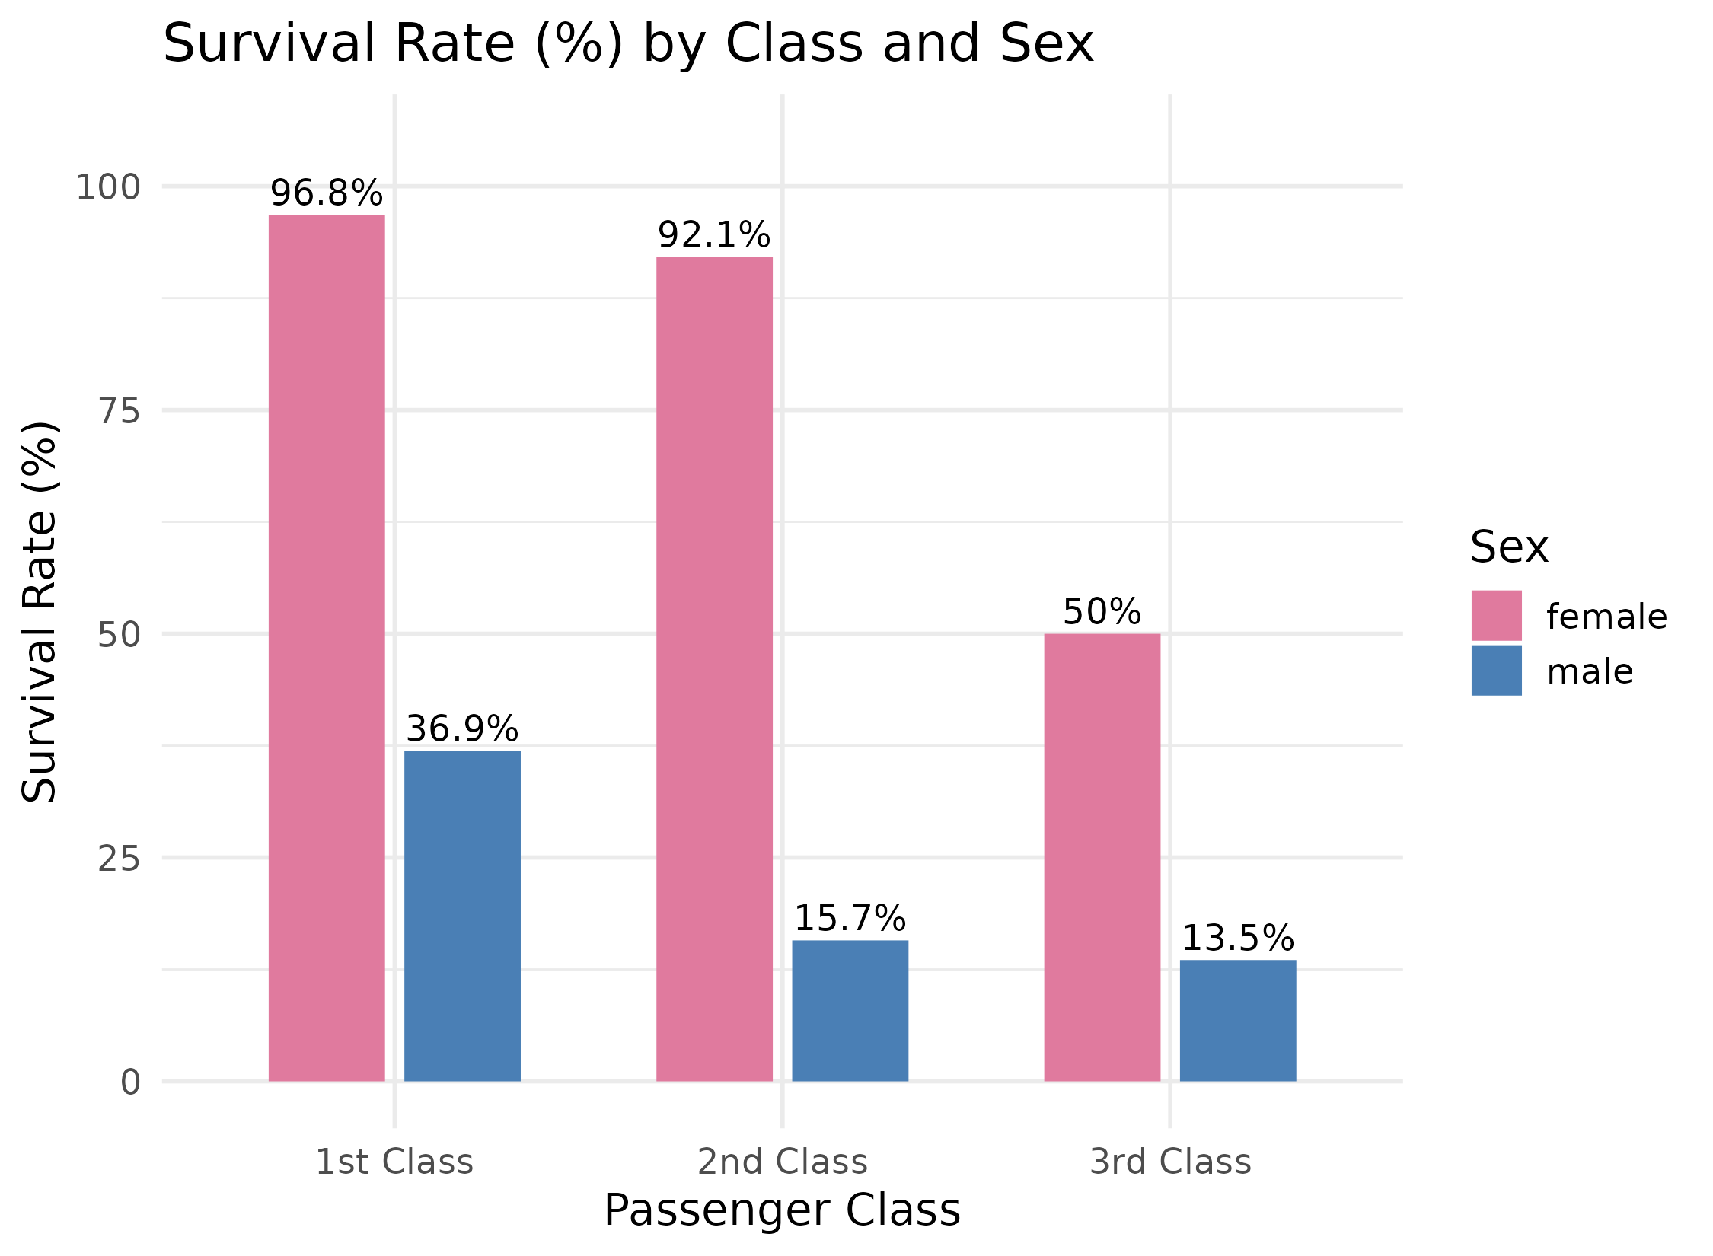
Figure 5: Survival rate percentages split by class and sex
This is arguably the single most powerful chart in the report. Women in 1st and 2nd class survived at almost universal rates (96.8% and 92.1%), while men in every class survived far less often, dropping as low as 13.5% for men in 3rd class. Even 3rd class women (50%) had a better survival rate than 1st class men (36.9%) — clear evidence that sex was an even stronger factor in survival than wealth or class alone, consistent with the historical "women and children first" evacuation protocol.

2.6 Density Plot of Age by Survival Outcome (ggplot2)
A density plot is a smoothed version of a histogram that makes it easier to compare the overall shape of a distribution between two groups — here, comparing the age profile of survivors against non-survivors on the same chart.
ggplot(titanic, aes(x = Age, fill = Survived_lbl)) +
geom_density(alpha = 0.5) +
scale_fill_manual(values = c("Did Not Survive" = "#e76f51",
"Survived" = "#2a9d8f")) +
labs(title = "Age Distribution: Survivors vs Non-Survivors",
x = "Age (years)", y = "Density", fill = "Outcome")
R Code: Density Plot of Age by Survival Outcome (ggplot2)
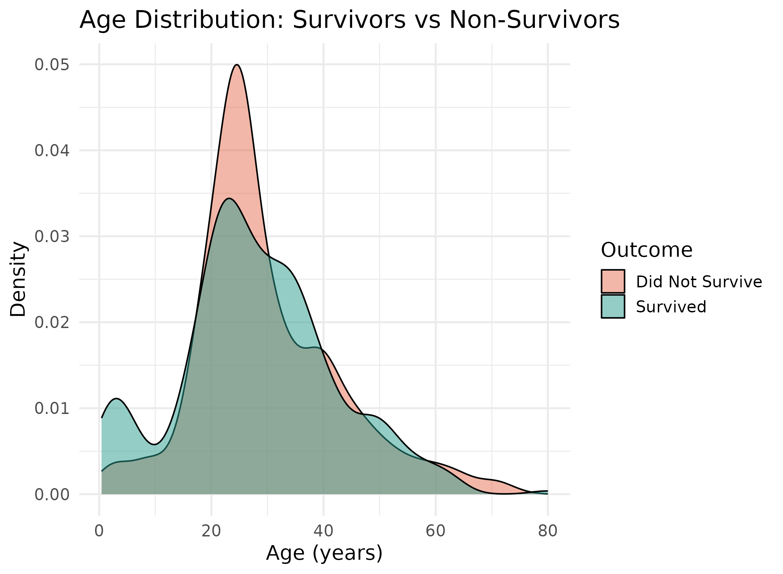
Figure 6: Smoothed age distributions for survivors versus non-survivors
The two curves largely overlap for adults, showing that age alone did not separate survivors from non-survivors very strongly among grown passengers. However, there is a visible bump in the survivor curve (green) at very young ages that is far less pronounced in the non-survivor curve (red) — a gentle visual confirmation that young children had a somewhat better chance of survival than the general adult population.

2.7 Faceted Scatter Plot of Age vs Fare by Survival and Class (ggplot2)
A scatter plot is the natural choice for showing the relationship between two numeric variables — age and fare — for individual passengers. Faceting (splitting the chart into three side-by-side panels, one per class) was added so that the age/fare/survival relationship can be compared fairly within each class, since fare ranges differ so much between classes.
ggplot(titanic, aes(x = Age, y = Fare_capped, color = Survived_lbl)) +
geom_point(alpha = 0.6, size = 2) +
scale_color_manual(values = c("Did Not Survive" = "#e76f51",
"Survived" = "#2a9d8f")) +
facet_wrap(~ Pclass) +
labs(title = "Age vs Fare by Survival, Split by Class",
x = "Age (years)", y = "Fare (capped)", color = "Outcome")
R Code: Faceted Scatter Plot of Age vs Fare by Survival and Class (ggplot2)
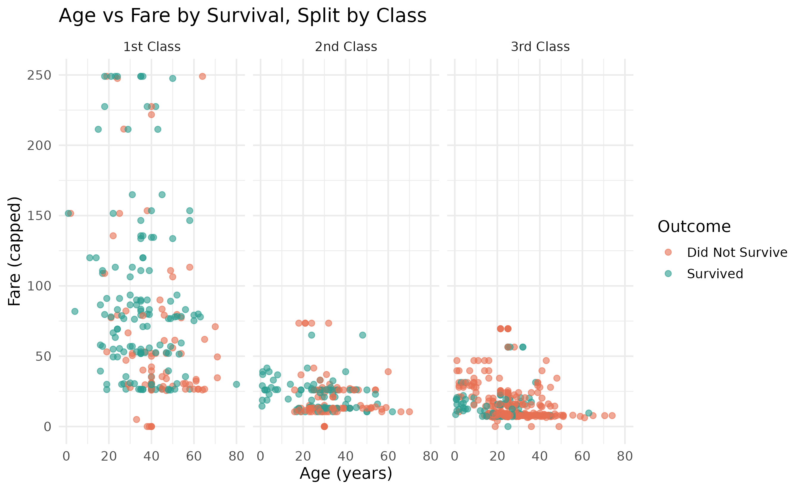
Figure 7: Age versus fare, colored by survival, one panel per class
Within the 1st class panel, green (survived) points are scattered throughout the higher fare range, while in the 3rd class panel red (did not survive) points dominate almost the entire cloud, regardless of age or the (much lower) fare paid. This reinforces, at the level of individual passengers rather than group averages, that being in 3rd class was associated with poor survival odds almost independent of exactly how much was paid or how old the passenger was.

2.8 Line Chart of Survival Rate Across Age Groups (ggplot2)
A line chart is the standard choice for showing a trend across an ordered sequence of categories — here, ten-year age bands from youngest to oldest — making it easy to see whether survival rate rises, falls, or fluctuates as age increases.
titanic$Age_Group <- cut(titanic$Age,
breaks = c(0,10,20,30,40,50,60,70,80),
labels = c("0-10","11-20","21-30","31-40",
"41-50","51-60","61-70","71-80"),
include.lowest = TRUE)

age_trend <- titanic %>%
group_by(Age_Group) %>%
summarise(Survival_Rate = mean(Survived) * 100, n = n(), .groups = "drop")

ggplot(age_trend, aes(x = Age_Group, y = Survival_Rate, group = 1)) +
geom_line(color = "#264653", linewidth = 1.2) +
geom_point(color = "#e76f51", size = 3) +
geom_text(aes(label = paste0(round(Survival_Rate,0),"%")), vjust = -1)
R Code: Line Chart of Survival Rate Across Age Groups (ggplot2)
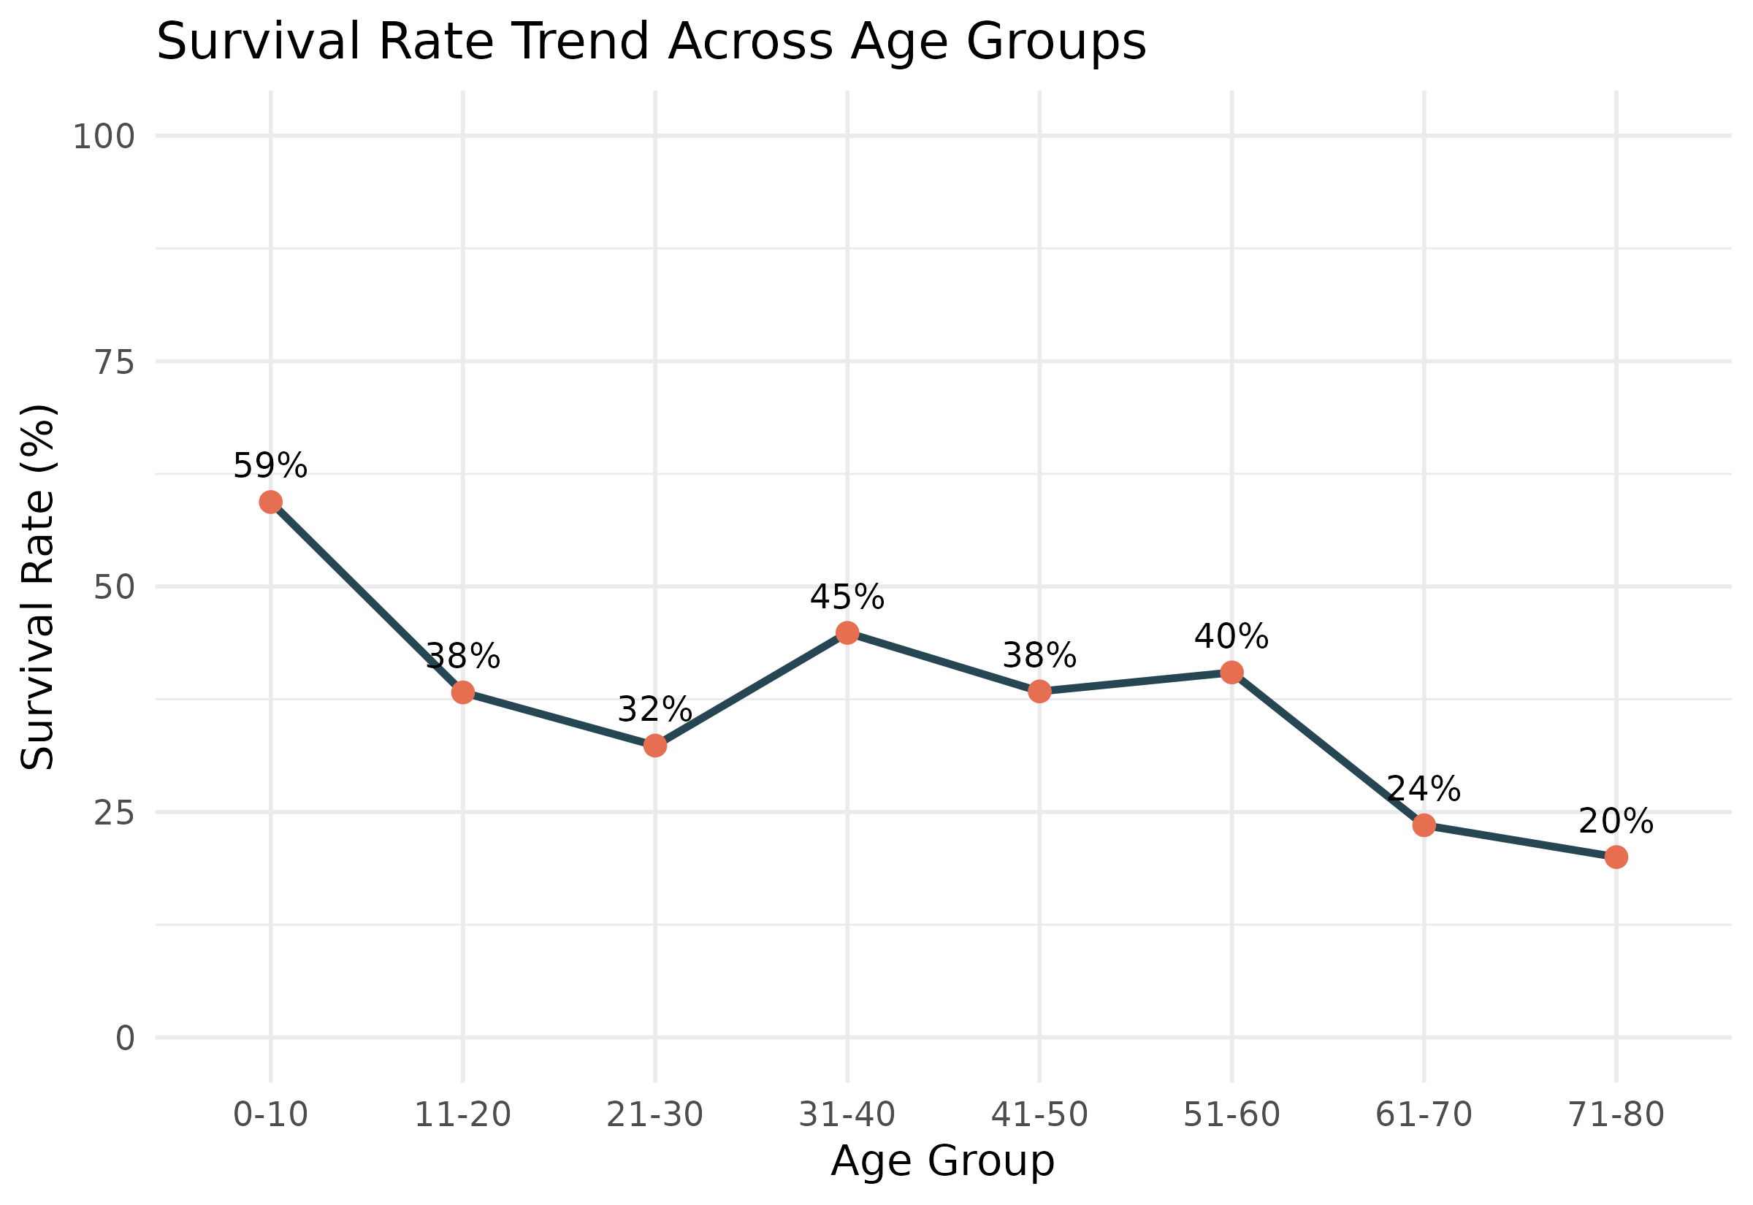
Figure 8: Survival rate trend across ten-year age bands
The line chart makes the "children first" pattern unmistakable: children aged 0–10 had the highest survival rate of any age group at 59%, survival rate drops through the teenage and young-adult years, recovers slightly in the 31–40 band, and then declines steadily for older passengers, falling to just 20% for those aged 71–80. This is exactly the kind of non-obvious trend a line chart is built to reveal — it would be very difficult to spot this rise-then-fall-then-decline pattern from a plain data table.

2.9 Proportional Bar Chart of Class Mix by Embarkation Port (ggplot2)
A proportional (100%-filled) bar chart was used to compare the mix of passenger classes at each boarding port, since the three ports had very different numbers of total passengers and raw counts would be harder to compare fairly.
ggplot(titanic, aes(x = Embarked, fill = Pclass)) +
geom_bar(position = "fill") +
scale_fill_manual(values = c("1st Class" = "#264653",
"2nd Class" = "#2a9d8f",
"3rd Class" = "#e9c46a")) +
labs(title = "Passenger Class Mix by Port of Embarkation",
x = "Port of Embarkation", y = "Proportion", fill = "Class")
R Code: Proportional Bar Chart of Class Mix by Embarkation Port (ggplot2)
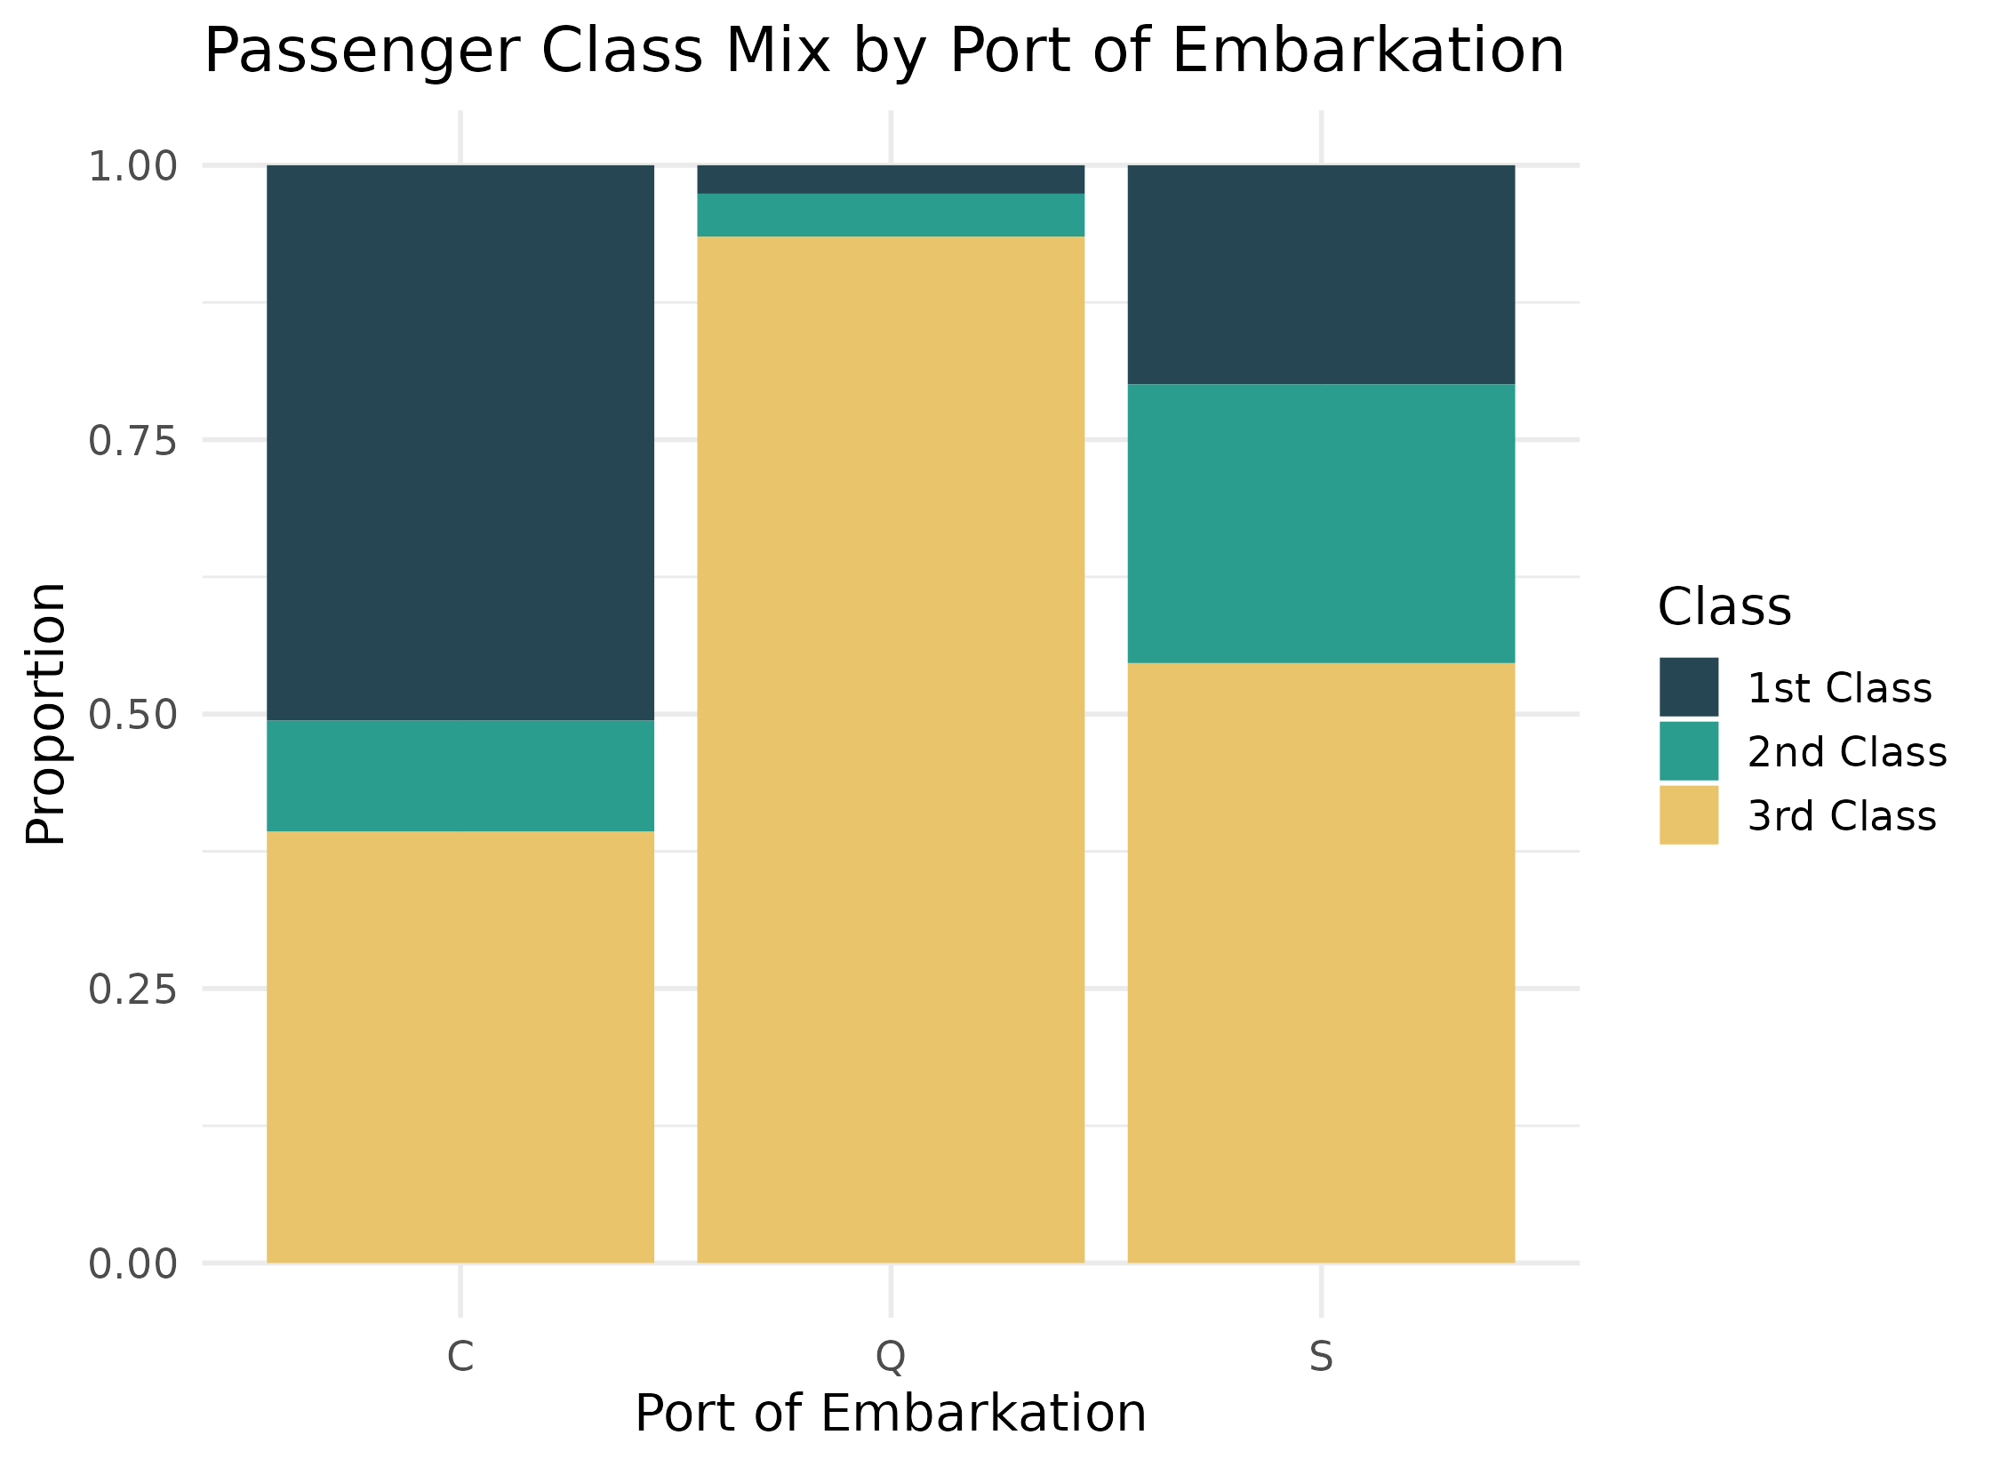
Figure 9: Class composition of passengers boarding at each port
Passengers who boarded at Cherbourg (C) had a noticeably higher share of 1st class travelers than those who boarded at Queenstown (Q), which was almost entirely 3rd class passengers. This is a useful piece of context: because port of embarkation is tied to class, and class is tied to survival, this chart helps explain why Cherbourg passengers, as a group, ended up with a higher overall survival rate than Queenstown passengers — it is really a reflection of the underlying class mix rather than the port itself.

2.10 Panelled Histogram of Age by Survival Outcome (Lattice)
This chart uses the lattice package rather than ggplot2, to demonstrate an alternative R visualization system. Lattice's conditioning ( | ) syntax is well suited to automatically producing one panel per group — here, one histogram of age for those who survived and one for those who did not, placed side by side for direct comparison.
histogram(~ Age | Survived_lbl, data = titanic,
layout = c(2,1), col = "darkorange", type = "count",
main = "Age Distribution Panelled by Survival Outcome (Lattice)",
xlab = "Age (years)", ylab = "Count")
R Code: Panelled Histogram of Age by Survival Outcome (Lattice)
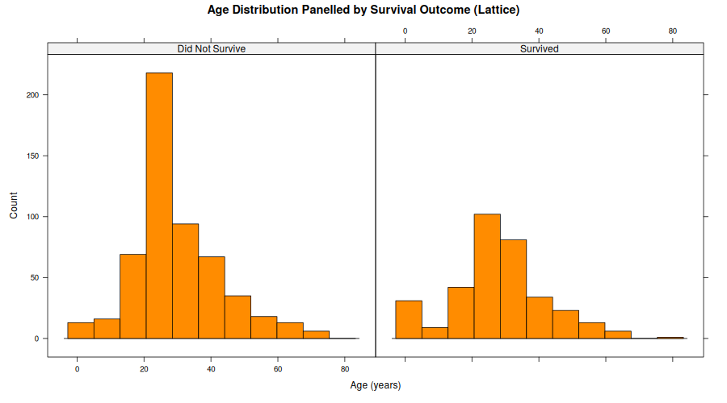
Figure 10: Age distribution split into two panels by survival outcome
Placed side by side, the two panels confirm what the earlier density plot suggested: the general shape of the age distribution is similar for both groups, but the "Did Not Survive" panel has a noticeably larger peak in the 20–30 range relative to its own total, reflecting the large number of adult men in that age range who did not survive.

2.11 Lattice Scatter Plot of Age vs Fare Conditioned on Class
This second lattice example conditions a scatter plot on passenger class, producing three panels automatically from a single line of plotting code — a good demonstration of how lattice can express faceted comparisons (similar to Figure 7's ggplot2 facets) with a more compact, formula-based syntax.
xyplot(Fare_capped ~ Age | Pclass, data = titanic,
groups = Survived_lbl, auto.key = list(space = "right"),
pch = 19, alpha = 0.6, layout = c(3,1),
main = "Age vs Fare Conditioned on Passenger Class (Lattice)",
xlab = "Age (years)", ylab = "Fare (capped)")
R Code: Lattice Scatter Plot of Age vs Fare Conditioned on Class
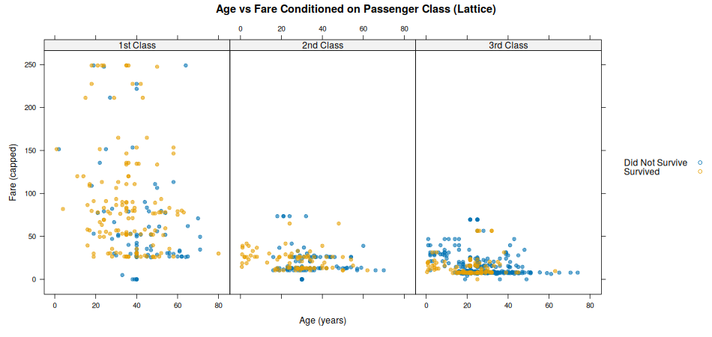
Figure 11: Age versus fare scatter plot, one panel per class, colored by survival
This chart tells the same underlying story as the ggplot2 faceted scatter plot (Figure 7), but produced with a different R package — useful evidence that the same dataset and insight can be communicated through more than one visualization toolkit. The 3rd class panel (right) again shows survival (orange points) scattered thinly among a much denser cloud of non-survivors (blue points), while the 1st class panel (left) shows a healthier mix of both outcomes throughout the fare range.

3. Summary of Key Insights
- Sex was the strongest single factor in survival: women survived at dramatically higher rates than men in every passenger class, most strikingly in 1st and 2nd class (96.8% and 92.1%).
- Passenger class had a clear, compounding effect on top of sex: even among men, 1st class passengers fared better than 3rd class passengers, and the same held true for women.
- Children aged 0–10 had the highest survival rate of any age group (59%), consistent with a "women and children first" evacuation approach, while survival rates generally declined with age among adults.
- Fare and class are tightly linked, and both these charts and the underlying data confirm this: 1st class fares were far higher and more variable than 2nd or 3rd class fares.
- Port of embarkation is not itself a cause of survival, but reflects the class mix of passengers who boarded there — Cherbourg passengers included a larger share of 1st class travelers than Queenstown, which was overwhelmingly 3rd class.

3.1 Why These Chart Types Were Chosen
Chart selection followed a simple principle: match the chart type to the question being asked. Histograms and density plots were used to understand the shape of a single numeric variable (age). Boxplots and grouped bar charts were used to compare a numeric or percentage value across categories (fare by class, survival rate by class and sex). Scatter plots (in both ggplot2 and lattice) were used to examine the relationship between two numeric variables while faceting/conditioning controlled for a third categorical variable (class). The line chart was used specifically because age groups have a natural order, making a trend line the most intuitive way to show how survival rate changes as passengers get older. Together, these eleven charts, across three different R graphics systems, demonstrate that the same dataset can be explored from many angles, with each chart type contributing a distinct piece of the overall story.

3.2 Tools and Reproducibility
All visualizations were produced in R 4.3.3 using three complementary systems: base R graphics (hist(), boxplot()) for simple, dependency-free charts; the lattice package for automatically panelled/conditioned plots; and ggplot2 for the majority of the more heavily styled and annotated charts. The full annotated R script (visualizations.R) accompanies this report, and all charts can be regenerated directly from the Week 1 cleaned dataset (titanic_cleaned.csv).

