A DOZEN QUESTIONS ABOUT THE TRIANGULAR NUMBERS
James Tanton

Drawing one dot, two dots, three dots, and so forth, in successive rows produces a triangular array of dots and counting the total number of dots in such an array with n rows gives the n^{th} triangular number: 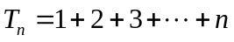. Adjoining two triangular arrays, each with n rows, produces an 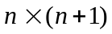rectangle of dots showing that 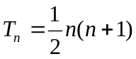. (This happens to equal 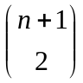, the number of ways to choose a pair from a selection of 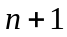 objects.)
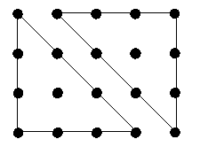
Figurate numbers, such as the triangular numbers and the square numbers 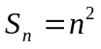 have fascinated scholars since the time of the Pythagoreans (if not earlier) and many of their properties were deemed of mystical importance. The number of the beast, 666, is triangular and it is the largest triangular number composed of a single repeated digit. (There are two more. What are they?) In 1796 Carl Friedrich Gauss proved that every positive integer is a sum of at most three triangular numbers and Leonhard Euler established that every even perfect number must be triangular. As we shall see, one will never find a triangular number that ends in a seven nor one that whose “digital root” equals seven, but there are plenty of triangular numbers that are palindromic (1,264,114,621, for instance) and many that are “reversible” (such as 12,145,056 and 65,054,121, both triangular.)
Some specific triangle numbers have remarkable properties. Although Fermat’s Last Theorem shows that there is no Pythagorean triple composed of square numbers there do exist triangular Pythagorean triples: 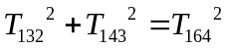, for instance. The 90th and the 415th triangular numbers sum to 90,415, the 585th and 910th numbers sum to 585,910, the 700th and 3676th sum to 7,003,676, and 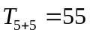, 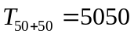, 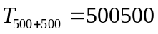, and so on.
Your dozenal correspondent could not resist writing a piece about these fascinating numbers. So here are twelve triangular delights for you to ponder upon, some well known, some not. Enjoy!

Question 1: Triangle and Square Interplay
The diagrams below suggest that two consecutive triangular numbers sum to a square number and that two copies of the same triangular number plus a square number give another triangular number.
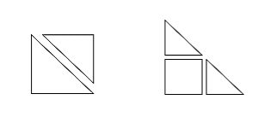
(Specifically: 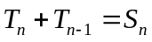 and 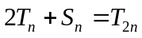.) Use geometry to show that eight times any triangular number, plus one, is square. Also establish the relations 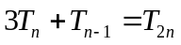 and 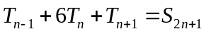.
Question 2: A Neat Sum
What does the following diagram suggest about the sum of the first four (in general, n) triangular numbers?
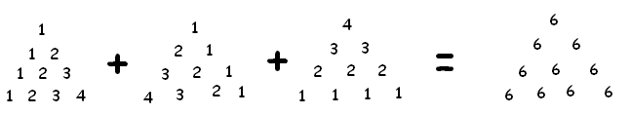
Question 3: Intersection Math
Here’s a new type of math called “intersection math.” To compute the product of two numbers, say four times three, draw two horizontal lines, place four dots on the top line, three on the bottom, and then connect each dot on the top line to each and every dot on the bottom line. The number of intersections that occur between the two horizontal lines is the product. (One must make sure that the dots are sufficiently spaced so that no point of intersection is crossed multiple times.) In intersection math, 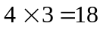.
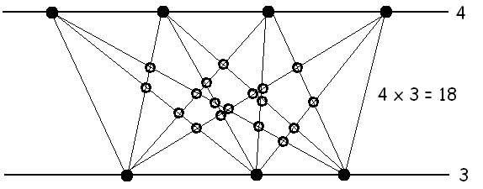
What’s 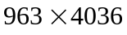 in intersection math? What’s 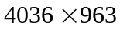?
Question 4: Rectangle Math
How many rectangles, with vertical and horizontal edges, can be drawn within a 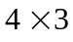 grid of dots? (The diagram below shows two rectangles.)
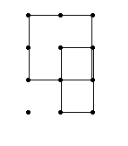
How many rectangles lie within a grid of dots?
Question 5: Utilizing Partitions
- There are six solutions to the equation 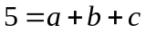 with a, b, c each a positive whole number: . Show that, in general, the number of such solutions to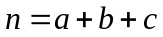, with n greater than two, is 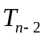.
- What is the coefficient of 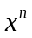 when one expands 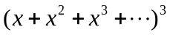?
- Prove that is a repeating decimal. Find its period.
Question 6: Moving Seats
a) Four hundred and two women sit in a circle. Is it possible for each person to stand and move clockwise to a new seat in such a manner that:
- Each person shifts a unique number of seats clockwise
- No person moves more than 402 seats clockwise?
(Note: One person must move precisely 402 places to return to her original seat.)
b) Can the analogous feat be accomplished with 503 people sitting in a circle?
Question 7: Nested Nines
Show that a nested product of the form is always a triangular number.
Question 8: Missing Digits
Prove that no triangular number ends in a 2, 4, 7, or 9.
Question 9: Triangular Factors
The number 360 has seven triangular factors (1, 3, 6, 10, 15, 36, 45, and 120) whereas the number 365 only has one triangular factor (namely, 1). The following is a list of the number of triangular factors possessed by each of the numbers one through 20. The average of the values in this list is 1.6.

1, 1, 2, 1, 1, 2, 1, 1, 2, 2, 1, 3, 1, 1, 2, 1, 1, 3, 1, 2

The average count of triangular factors of the first fifty numbers is 1.74, of the first 100 numbers, 1.8, and of the first 200 numbers, 1.865. If 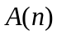 is the average number of triangular factors possessed by the numbers one through n, what’s 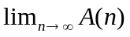?
Question 10: Perfectly Triangular
A number is called perfect if it equals the sum of its factors different from itself. For example, 28 is perfect since its factors 1, 2, 4, 7, and 14 satisfy 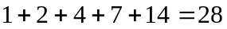. The first four perfect numbers are 6, 28, 496, 8,128, which all happen to be triangular. Prove that every even perfect number is indeed triangular. (Hint: Suppose n is perfect and even. Write n in the form 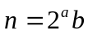 with 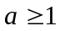 and b odd. Suppose 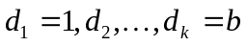 are the factors of b, including b itself. What then are the factors of n?)
Question 11: Weird Piles
Take 15 cards and split them into an arbitrary number of piles of arbitrary size. Now take one card from each pile to make a new pile of cards to add to the group. (Note that any pile composed of a single card disappears in this maneuver.) Repeat this procedure multiple times. What do you notice? Play this game again with a different initial configuration of cards, repeating the same maneuver of taking one card from each pile over and over again. Is the outcome the same? Try playing this game with 21, 28, or any triangular number of cards.
Question 12: Intersecting Types
The numbers “1” and “36” are both triangular and square: 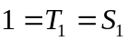 and 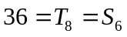. What is the next square triangular number?
Answers, Comments, and Further Questions:
1. Use the following diagrams:
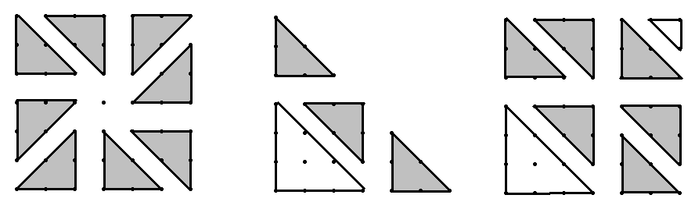
Taking it Further: What other relationships between the square and triangular numbers can you find?
Comment: The relation 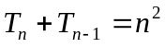gives. This shows that a sum of cubes is a telescoping sum yielding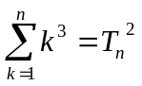.
2. The sum reads: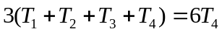. In general, this trick shows that the n^{th} tetrahedral number (the result of layering triangular arrays of dots in three-dimensions to produce a tetrahedron) is given by 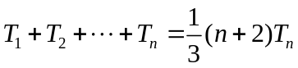.
Taking it Further: Use tetrahedral arrays of numbers to produce a formula for the sum of the first n tetrahedral numbers.
3. Each point of intersection determines a pair of points from the top line and a pair of points from the bottom and, conversely, a choice of two pairs of points, one from the top and one from the bottom, determines an intersection. If there are n points on the top line, m on the bottom, then there are 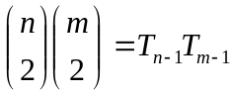 choices of two pairs of points. Thus the product in intersection math corresponds to the (ordinary) product of triangular numbers: 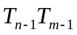. In particular, . Turning pictures upside-down shows that intersection math is commutative.
Taking it Further: Is multiplication in intersection math associative?
4. Each rectangle drawn on a grid of dots determines, and is determined by, a choice of a pair of dots in the left-most column and a pair of dots in the top row. Thus “rectangle math” is precisely the same as “intersection math.”
Taking it Further: How many rectangles of any type are there in an array of dots? For example, there are ten rectangles in a 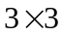 grid of dots: nine with vertical and horizontal edges and one square drawn on a tilt.
Hard Challenge: The formula 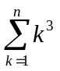 counts the number of cubes in a array of dots, and 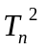counts the number of (non-tilted) rectangles in a array. Is there a geometric way to see that these two counts must be the same? (If there is, let me know! I haven’t yet found one.)
5. a) Place n dots in a row. There are  spaces between the dots and the selection of any two of those spaces corresponds to a solution to the equation (and vice verse). There are thus 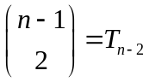 solutions in all.
b) The term is formed in the product by selecting terms 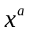, 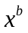, 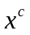, one from each set of parentheses, satisfying . There are ways to accomplish this. Thus we have .
c) Note that the geometric series formula 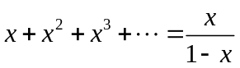 yields 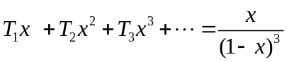. The decimal in question is just this series with the value 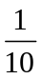 substituted for x. Thus 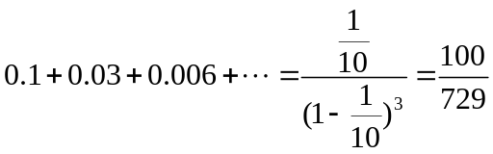, a rational value. The decimal thus repeats (with period 81).
Taking it Further: Use the relation 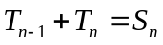 and the formula to find a formula for 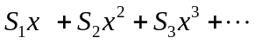. Evaluate 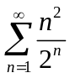.
6. Suppose this feat is accomplished with n women sitting in a circle. Note that one person must shift one place clockwise, one person two places clockwise, and so forth, with one person shifting the full circle n places clockwise. The total number of shifts that occur is thus 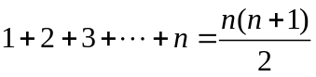. If we keep track of the movement of individual women, then we note that the shifts “decompose” into cycles that wrap around the full circle multiple times. For example, Angela might move to Lashana’s chair, and Lashana to Joi’s, and Joi to Angela’s place. Thus the sum of shifts among these three women is a multiple of n. Consequently, the sum of shifts that occur in all is also a multiple of n and so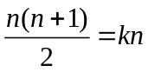 for some integer k. This gives 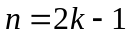 showing that n must be odd if there is any hope for this feat to work. (In particular, the task cannot be accomplished with 402 women in a circle.)
The puzzle can in fact be solved in the case of odd parity. Simply number the seats 0, 1, …, 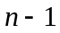 and instruct the person in seat to move places clockwise to seat 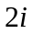, interpreted modulo n. (The person in seat zero may either stay still or move n seats clockwise if she wishes.) Since n is odd we can be sure that no two people will move to the same seat (if 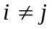, then 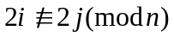) showing that this scheme does solve the challenge.
7: Suppose there are n nines in the product. Then:
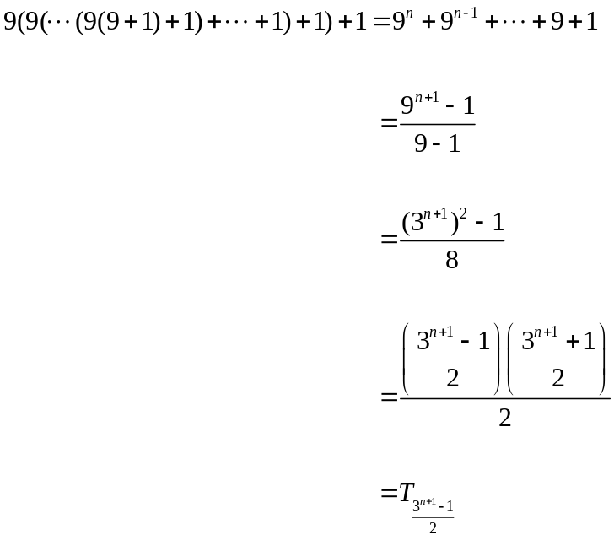
Taking it Further: Show (geometrically?) that 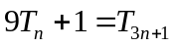. Use it as an alternative means of evaluating the nested product.
8. If n has final digit zero, then 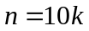 for some integer k and 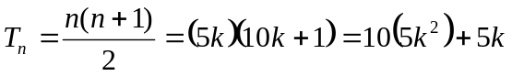 has final digit either 0 or 5. If n has final digit 1, then 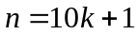 for some integer k and has final digit either 1 or 6. One can check the remaining eight cases to see that the numbers 2, 4, 7, and 9 never appear as possible final digits.
Taking it Further: The “digital root” of a number is the result obtained from adding together the digits of the number, adding the digits of the result, and so forth, until a single digit is obtained. For example, the number 628 has digital root 7 since 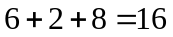 and 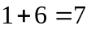.
- Show that the digital root of any number is its remainder upon division by nine (or “9” if the number is a multiple of nine).
- Show that no triangular number has digital root 2, 4, 5, 7, or 8.
9. Given integers n and k, the quantity 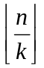 (where the square brackets indicate rounding down to the nearest integer) counts the number of integers from 1 to n which possess k as a factor, or, equivalently, the number of times k appears in a list of all the factors of all the numbers 1 through n. The quantity 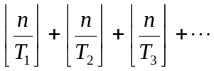 counts the total number of times a triangular number appears in the list of all factors of numbers 1 through n. Consequently, 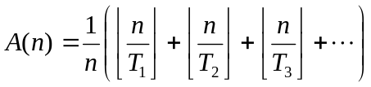.
Note that only a finite number of terms in this sum, the first R of them say, are non-zero. Here R is determined by the largest triangular number 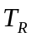 less than or equal to n and it is easy to see that R grows in value for larger and larger values of n but always remains smaller than 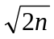. If angle brackets indicate the fraction part of a quantity ( 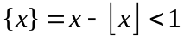), then we have 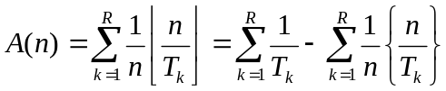. Now 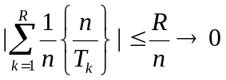 as and 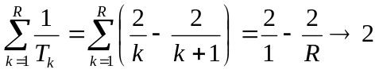 as showing that 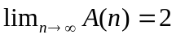.
Taking it Further: Use the series 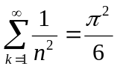 to show that, on average, a number possesses 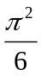 square factors. If you are game, use the alternating harmonic series 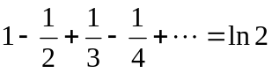 to prove that, on average, a number possesses 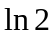 more odd factors than even factors.
Taking it Even Further: Evaluate 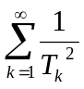 and 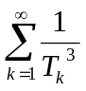.
10. Following the notation of the hint, n has factors 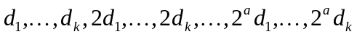, which sum to . Since n is perfect, this sum must equal 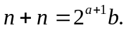 Consequently, 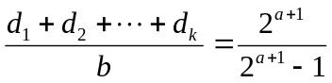. The fraction on the right is in reduced form and so it must be the case that 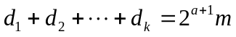 and 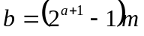 for some integer m. If m is different from 1, then b has at least the three factors 1, m, and b itself. Consequently, , a contradiction. It must be the case then that 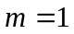 showing that 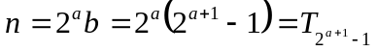, a triangular number.
Taking it Further: Go further and prove that if 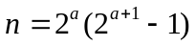 is perfect, then the subscript denoting the triangular number,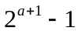, is prime. Show also, that if n is greater than six, then a must be even and is one more than a multiple of three. (The relation 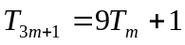 then shows that each even perfect number, other than six, is nine times another triangular number plus one. This also implies that the each even perfect number, other than six, has digital root equal to one.)
Comment: No one to this day has found an example of an odd perfect number, nor demonstrated that one does not exist.
11. No matter the starting configuration, this game always converges to a state of five piles containing, respectively, 1, 2, 3, 4, and 5 cards. In general, any game with a triangular number of cards converges to a “triangular arrangement.” Unfortunately, it takes some work to establish this.
Suppose, as we play the game, we always agree to arrange the piles left to right largest to smallest. Call the first pile abundant/deficient if it has more than/fewer than five cards, the second pile abundant/deficient if it has more than/fewer than four cards, and so forth. (In particular, an empty fifth pile is deemed deficient.) Agree to call a sixth, seventh, or higher numbered pile (if present) abundant. Notice that if one pile is deficient, another pile must be abundant to compensate, and vice versa.
A “move” in this game consists of removing the top card from each pile to form a new stack of cards and placing this stack in the left-most position that respects the non-increasing order of the piles. Call a move “ordinary” if the newly formed pile can legitimately placed as the left-most pile, shifting each pile that remains one place to the right.
Assign each card in the game a “value.” Give the top card of the r-th pile value 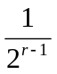 and each card within a pile half the value of the card above it. (Thus, for example, the cards in the first pile have values 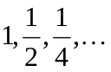, the cards in the second pile values 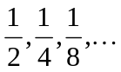 , and so forth.). Let I be the sum of all the card values in a given configuration of piles.
It is straightforward to see that the value of I does not change during an ordinary move. Suppose, on the other hand, in a configuration with k piles the next move made is not ordinary and that the newly formed pile is placed in position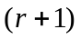from the left for some number 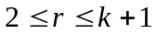. In this move, the cards of the top of each pile change values from 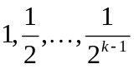to 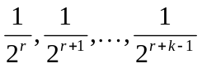 causing a net decrease in the value of I by amount 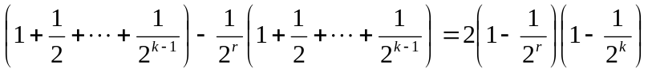. Since the newly formed pile is placed in position 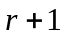 it must be the case that the first r piles each originally contained at least 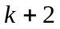 cards. The values of the cards in these piles, excluding the top cards which have already been accounted for, double in value as a result of the maneuver. The net gain in the value of I as a result of this is, at the very least: . No other card in the game changes value. Thus we see that the gain for I is strictly greater than its loss in value showing that the value of I increases in each non-ordinary move of the game. Moreover, the change in I is always at least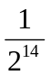, the smallest change in value of single card might incur. Since the value of I cannot increase indefinitely (there is an upper bound on its value given that there are only a finite number of configurations of 15 cards) it must be the case then that the game reaches a state in which every move made thereafter is ordinary.
Notice that if one of the first five piles is deficient, then, after an ordinary move, it remains deficient as it is shifted one place to the right. When this deficient pile occupies the fifth position, an ordinary move then takes it to the first position. Thus deficient piles “cycle” during ordinary play of the game with period five. The same reasoning shows that an abundant pile cycles, however, with period six. (Observe what happens with an abundant pile in the fifth position.) Thus with every six moves of the game a particular pile remains abundant while a deficient pile “shifts” one place further to the right, forcing the two to eventually coincide. This absurdity shows that there cannot be any deficient or abundant piles once the game has reached its steady state of ordinary moves. This steady state must be the “triangular arrangement” of piles.
Taking it Further: Can anything interesting be said about games played with a non-triangular number of cards?
12. The next square triangular number is 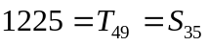, followed by 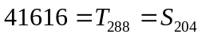, and 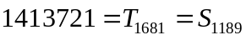.
Taking it Further: Any solution to an equation of the form 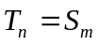 corresponds to a solution of the Pell equation 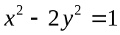. (Set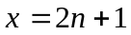 and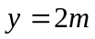.)
- Show that if 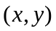 is a solution to the Pell equation, then so is 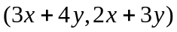.
- Starting with the solution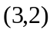(which corresponds to 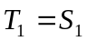), show that the transformation 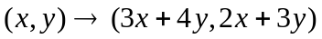 generates all positive integer solutions to the Pell’s equation and hence all numbers that are both square and triangular. (Hint: Work backwards. Show that any solution with positive terms and 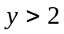is the result of applying this transformation to a “smaller” solution with positive terms. Argue then, that the solution was indeed generated from.)
- List the next few square triangular numbers. What do you notice about the subscripts in the sequence: 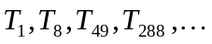?
Taking it Even Further: Explore solutions to equations of the form 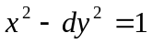 for arbitrary integral values of d. Do they also possess geometric interpretations?

