Asymmetric Chains System
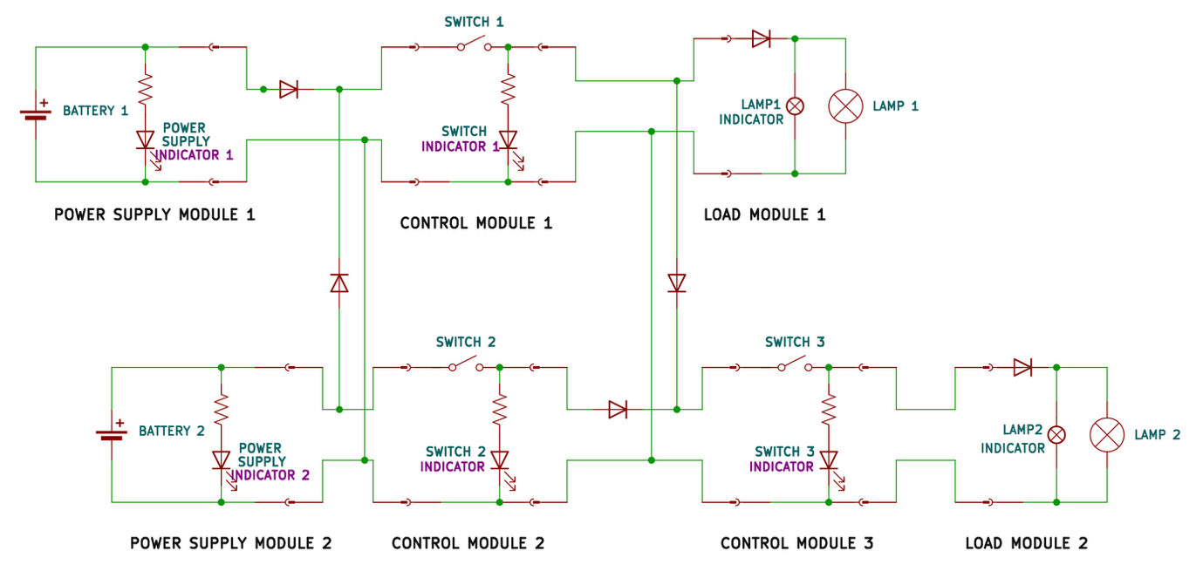

The system has the overall function of operating two loads (lamps).

The system is composed of 7 modules divided into two interconnected chains:
the first chain contains in series the first supply module, the first control module, and the first load module.
The second chain contains in series the second supply module, the second control module, the third control module and the second load module.
The two chains are interconnected: the outputs of supply module 2 are (also) connected to the inputs of control module 1 and the outputs of control module 1 are (also) connected to inputs of control module 3.
Note when a module receives inputs from multiple other modules the inputs are simply merged by connecting positive lines with positive lines and negative lines with negative lines: there is no particular input logic enforced.
Between the modules, a system of diodes (1 on each of the positive lines between supply 1 and control 1, and supply 2 and control 1, and control 1 and control 3, and control 2 and control 1) ensures that current can only flow in the direction from the sources to the loads, possibly crossing, but never reversing direction.
Each module is made of an electrical circuit encased in a plastic box.
The modules are connected by unmarked cables: two cables come out of one face of the power supply 1 box and of the load box, four cables come out of two opposite faces of control module 2 box (two cables per face); four cables come out from control 1 and 3 boxes on the input side and two come out of the output side of both control module 1 and 3 box; four cables come out of power supply box 1; finally 2 cables enter each of the load modules.
The cables are unmarked and have the same color: one cannot distinguish one from the other just by looking at them.
The cables terminate with fast-connection terminals that can be attached and detached together, allowing for connecting and disconnecting the modules together.
The circuit inside each module box can be inspected through a dedicated panel.

Inside each power supply module box, there is a battery case for a 12V lithium battery. On the top face there is a green led, which is inserted in a LED holder (it can be put in and out at will). The LED is in series with a resistor, and the LED and the resistor are connected in parallel with the source, and the LED is oriented so that it will turn on when the 12V source is active and supplied. Of the cables that exit each supply module module, one is connected to the 12V input positive port, the other to the negative port.

All cables coming out of each control module constitute two connected pairs (so during operations one cable -- or cable pair in the case of control 1 and 3 input faces -- per face will have 12V, the other 0V). The 12V line can be opened by a switch, which is encased in the middle of one of the corresponding box faces. Inside each control module, connected between the 12V line and the 0V line there is another resistor in series with a green LED, which is inserted in a LED holder (it can be put in and out at will) on the top face of the box. The LED is oriented in such a way that when the 12V line is energized and the module switch is on, the LED will turn on. This LED is sometimes called control module indicator or control module LED but is generally called switch indicator.
Control module 1 receives the output cables of both supply modules, while control 2 only receives the output cables of supply module 2.
Both the two outputs of control module 1 and the two outputs of control 2 connect to the inputs of control 3 (positive with positive and negative with negative). Control module 1 is connected in series directly before load module 1, while control module 3 is connected in series directly before load module 2.

The cables coming out of each load module are connected to the load ports: the negative lines directly, while the positive lines pass through a polarizing diode, oriented such that it will allow current to flow only if the 12V and 0V lines are actually energized with 12V and 0V respectively (it will block current if the polarity is switched). The lamp itself is encased on the top face of the box. In parallel to the lamp there is a smaller indicator lamp, that is positioned inside the box, and can be seen only by either accessing the box or by opening a small peephole located one of the box faces. Both lamps are not polarized in isolation, but the presence of the polarizing diode makes them so; both lamps are downstream to the diode.

