Current Sensor Sytem
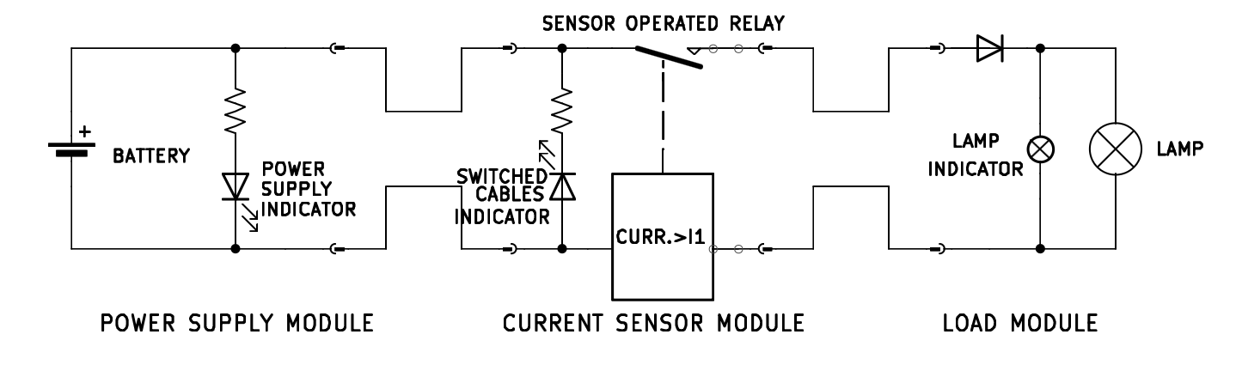

The system has the overall function of operating a load (lightbulb).

The system is composed of three modules connected in series: a power supply module, a control module, a load module.
Each module is made of an electrical circuit encased in a plastic box.
The modules are connected by cables: two cables come out of one face of the power supply box and of the load box, four cables come out of two opposite faces of the control module box (two cables per face).
The cable terminate with fast-connection terminals that can be attached and detached together, allowing for connecting and disconnecting the modules together, and switching the configuration (which cable goes into which port) of the cables of two connected modules.
The circuit inside each module can be inspected through a dedicated panel.

Inside the power supply module box, there is a battery case for a 12V lithium battery. On the top face there is a green LED. The LED is in series with a resistor, and the LED and the resistor are in parallel with the source, and the LED is oriented so that it will turn on when the 12V source is active and connected. Of the cables that exit the module, one is connected to the 12V input positive port, the other to the negative port.

The four cables coming out of the control box constitute two connected pairs (so during nominal operations one cable per face will have 12V, the other 0V). One such pair can be opened by a relay. The relay is controlled by a current sensor present in the module: if the current in the circuit (measured on the 12V line in the control module) is higher than a specific threshold the relay will open the 0V line, and no current will pass through the circuit.

The two cables coming out of the load module are simply connected to the load ports. The lightbulb is mounted on one of the lateral faces of the plastic box. In parallel to the lightbulb there is a smaller lightbulb, that is positioned inside the box, and can be seen only by either accessing the box or by opening a small peephole located on one of the box faces. Both lightbulbs are not polarized by themselves, however there is a diode located on the 12V line, before both lightbulbs, such that it will allow current to flow only if the 12V and 0V lines are actually energized with 12V and 0V respectively (it will block current if the polarity is switched).

