**Label:** Shopping cart functionality

**Name:** By entering any character, symbol or letter in the quantity field at product description page, shopping cart gets updated for one product.

**Environment:**

Operating system: Microsoft Windows 10

Browser/Browser version: Chrome  83.0.4103.116

**Description** User is able to add a product to the cart by entering different symbols, characters or letters in the quantity field at product description page.

**Steps to reproduce**

1.Go to website <https://shop.fitpass.rs/cart>

2. Click on field ‘Proizvodi’ 

3. Select any product

4. Clear value in the quantity field

5. Set new value by entering symbol ‘&’ in the quantity field

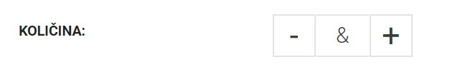

6. Click on ‘Dodaj u korpu’

**Expected result** By enetering different symbols, characters or letters in the quantity field at product description page, and clicking on button ‘Dodaj u korpu’, product should not be added to the cart.

**Actual result** Product is added to the cart when I input any symbol, character or letter in the quantity field, and click on button add to cart, at product description page.

