**Label:** Shopping cart functionality

**Name**: By clicking on button ‘Nastavi sa kupovinom’ at slidedown cart icon, im not redirected to the products page, this button does not working

**Environment:**

Operating system: Microsoft Windows 10

Browser/Browser version: Chrome  83.0.4103.116

**Description** When my shopping cart is empty and I click on the button ‘Nastavi sa kupovinom’ at slidedown menu cart icon I am not redirected to the products page.

**Steps to reproduce**

1. Go to website <https://shop.fitpass.rs/cart>

2. Check that shopping cart is empty



3. Do mouse over cart icon

4. Click on the button ‘Nastavi sa kupovinom’

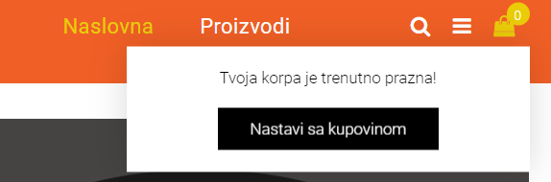

5. It should redirect you to the product page

**Expected result** When shopping cart is empty, and user mouse over the cart icon and if he/she clicks on the button ‘Nastavi sa kupovinom’ at slidedown shopping cart it should be redirecting a user to the product page.

**Actual result** Button ‘Nastavi sa kupovinom’ at slidedown shopping cart menu is not clickable, does not redirects you to the product page.