**Label:** Shopping cart functionality

**Name:** Quantity input field at shopping cart page is not limited, user can enter unlimited quantaties of item

**Environment:**

Operating system: Microsoft Windows 10

Browser/Browser version: Chrome  83.0.4103.116

**Description**

At shopping cart page quantity input field is not limited, user can enter unlimited quantaties of item, and by clicking the button add to cart that quantity will be added to the cart even if that is not available amount of product in the stock.

**Steps to reproduce**

1. Go to website <https://shop.fitpass.rs/cart>

2. Click on field ‘Proizvodi’

3. Select any product

4. Select quantity on 1 at product description page

5. Add product to the cart

6. Go to shopping cart page

7. Edit quantity field by entering amount(1 000 000 000)

8. Quantity field is not limited for input

9. Click on button ‘Kupi’

10. Check behave of the cart, cart should not be updated

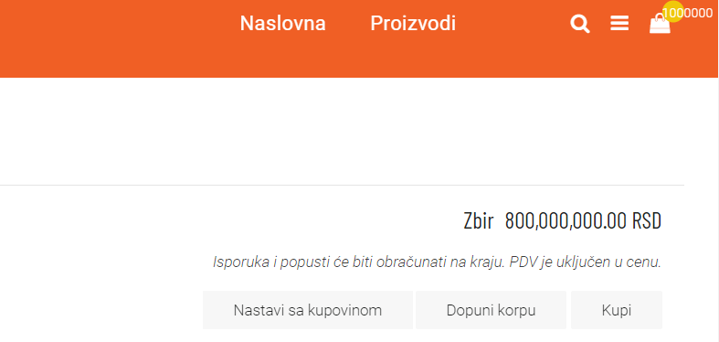

**Expected result**

At shopping cart page, quantity field should be limited for inputs, and user should not be able to add product to the cart if quantities are greater than available amount in the stock, and appropriate message should be displayed to a user that required quantity is not available.

**Actual result** Quantity field at shopping cart page is not limited for inputs, and if entered quantity is greater then available amount in stock user is able to add that amount in the cart and any error message is not displayed.