LAB 02  
BASIC HTML CODING

Cheatsheet: <https://www.wpkube.com/html5-cheat-sheet/>

# Create a Basic Webpage containing Header, Main, Footer

* Create a webpage called index.html
* Page should consist of header, main, and footer elements. Make sure these elements is not empty
* Validate the page.

1. Launch your Text editor, create a new file, and save it as index.html
2. In the index.html, declare the doctype, create the head and body.

<!DOCTYPE html>

<html lang="en">

<head>

<meta charset="utf-8" >

<title> Chew First Page </title>

</head>

<body>

<header><p> This is the header </p></header>

<main><p> This is the main code </p></main>

<footer><p> This is the footer </p></footer>

</body>

</html>

1. Open the index.html with your browser, and make sure that the content is visible. (2%)
2. Validate your code at <https://validator.w3.org/>. If there are any errors found, fixed all the errors, and validate your code again. Make sure there are no errors. (1%)

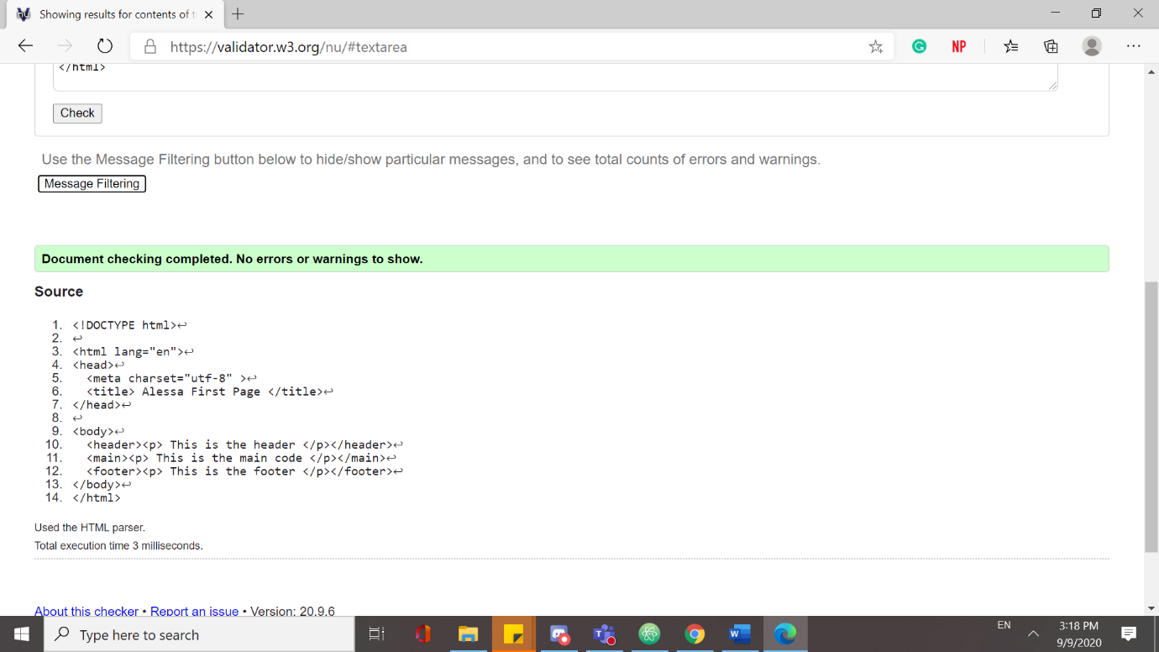

# Starter Sample Template Page

<!DOCTYPE html>

<html lang="en">

<head>

<meta charset="UTF-8">

<title>Document</title>

</head>

<body>

</body>

</html>

# Embedding IMAGE

1. Download an image of the university.
2. Use the starter sample template page provided.
3. On the same directory, create a folder call imgs
4. Paste the image of your university in the imgs folder
5. It is a good practice to include the “alt” attribute.

* In case, the image is not found or not loaded, the alt attribute text will be shown.

1. Using the starting sample page and the image supplied, embed the image into your webpage with different style (size). (2%)

* Default size image
* Width = 500px
* Width = 500px, height = 100px
* Width = 50%
* A sample snippet of code

<figure>

<img src = "imgs/taylors.jpg" alt = "my university">

<figcaption>Default image size </figcaption>

</figure>

1. There are many websites that provide free images and icons, such as [www.flaticon.com](http://www.flaticon.com) . Download any three image from flaticon and embed it into your webpage. (1%)
2. Extra/Optional, <https://fontawesome.com/> allows you to use their icons/images directly from the webpage by connecting to their webpage.

# Favicon [Logo / Image on Browser Tab]

1. The image of your university in the previous section will be use to show in the browser tab.
2. Include the following line of code in your header.

<link rel="icon" type="image/jpg" href="imgs/taylors.jpg" />

1. Refresh your page, and verify whether the logo can be seen on the browser tab. (1%)

# **Hyperlinks**

1. Create four different links (absolute reference) to link to the different school in your university. (2%)

* You may use the following website to obtain school information
* <https://university.taylors.edu.my/en/study/faculties-and-school.html>

1. A sample snippet of the code to create a link.

<a href ="https://university.taylors.edu.my/en/study/undergraduate/architecture.html"> School of Architecture, Building and Design</a>

# Video

1. Embed a simple video into your current webpage.

* The controls attribute adds video controls, like play, pause, and volume.
* It is a good idea to always include width and height attributes. If height and width are not set, the page might flicker while the video loads.
* The <source> element allows you to specify alternative video files which the browser may choose from. The browser will use the first recognized format.
* The text between the <video> and </video> tags will only be displayed in browsers that do not support the <video> element.

Source: <https://www.w3schools.com/html/html5_video.asp>

<video width="320" height="240" controls>

<source src="imgs/taylorsvideo.mp4" type="video/mp4">

Your browser does not support the video tag.

</video>

1. Refresh your webpage and screenshot the video from your webpage. (1%)

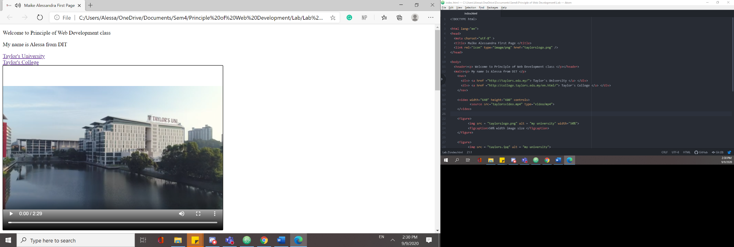

# Table

1. Create the following table using HTML.

|  |  |  |
| --- | --- | --- |
| **Row One** | **Row Two** | **Row Three** |
| One | Two | Three |
| Four | Five | Six |
| Seven | Eight | Nine |

1. Modify the table created to show the following display.

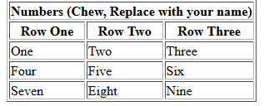

1. Screenshot the modified table from your browser. (2%)

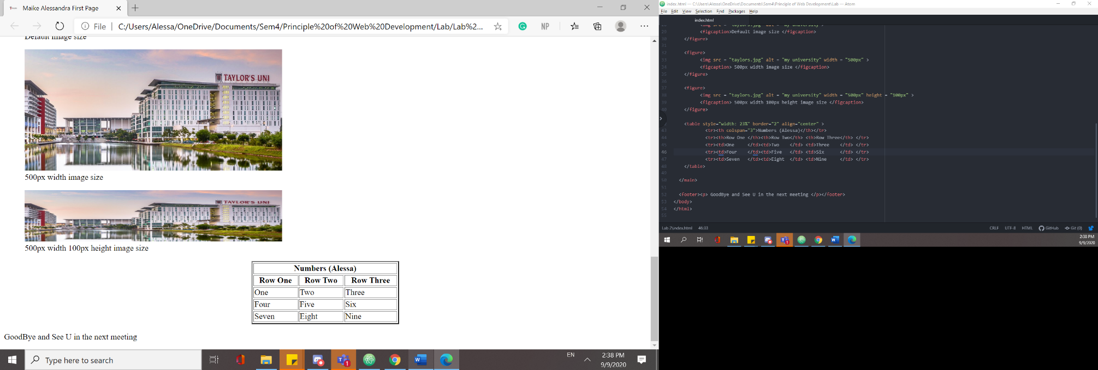

# Extra

* There are too many tags in HTML5. But, you do not need to memorize all the codes.

1. For this part, you are required to try out TWO different tag from each of the categories below, the list below is not the full list of tags, you may use any other tags you found online. (3%)

* e.g,. Block Tags <hr>, <address>, <blockquote>, <details> and <summary>
* e.g,. Inline Tags <span>, <cite>, <abbr>, <time>, <code>, <sub> and <sup>
* e.g,. More tags, <button>, <meter>, <progress>, <iframe>, <bdo>
* Hint: Use w3school.com to find the example of the code.

Gentle Reminder:

***\*MARKS WILL NOT BE GIVEN IF YOUR OWN NAME IS NOT USE*  
(This applied to all subsequent lab)***

Save and submit your Lab documents in **PDF** with the following filename format

**Name_ID_LabX**  || E.g.: ChewYeeJian-113812-LabX.pdf