SmartHire
Resume-to-Job Matching & Career Guidance Engine
Final Project Report — Classical Machine Learning (No LLMs)

1. Project Overview
SmartHire is a portal where a candidate uploads a resume and receives: (a) a predicted job category, (b) a ranked list of matching jobs from a merged job corpus, (c) an optional fit/shortlisting score for each match, and (d) a skill-gap report highlighting what to improve. The entire system is built with classical machine learning — TF-IDF, cosine similarity, K-Means, and standard scikit-learn classifiers — with no LLMs or generative AI anywhere in the pipeline.
The system maps onto six ML tasks spanning both supervised and unsupervised learning:
- Resume category classification (supervised) — Model A
- Content-based job recommendation via cosine similarity (unsupervised) — core engine
- Job / role clustering via K-Means (unsupervised)
- Skill-gap detection built on top of the clustering output (unsupervised)
- Shortlisting / fit prediction (supervised, optional) — Model B
- A Streamlit portal tying all of the above together

2. Data
Three public datasets were merged into the system:
Dataset | Rows | Role
Resume Dataset (Kaggle, Snehaan Bhawal) | 2,483 (cleaned) | Training data for Model A — 24 job categories
Naukri Job Listings | ~30,000 | India-focused postings, merged into the job corpus
LinkedIn Job Postings 2023–2024 | ~40,000 (sampled from 123k) | Global postings incl. skills + salary, merged into the job corpus

The two job sources were cleaned and merged into a single job corpus with common columns: title, company, location, skills, description, experience, source. Neither source had a clean, ready-made skills/experience field — Naukri's fields were regex-extracted from the free-text description, and LinkedIn's skills came from a separate job_skills.csv keyed by job_id, joined against a skill-name mapping table. The merged corpus totals 69,991 postings.

2.1 Exploratory Data Analysis
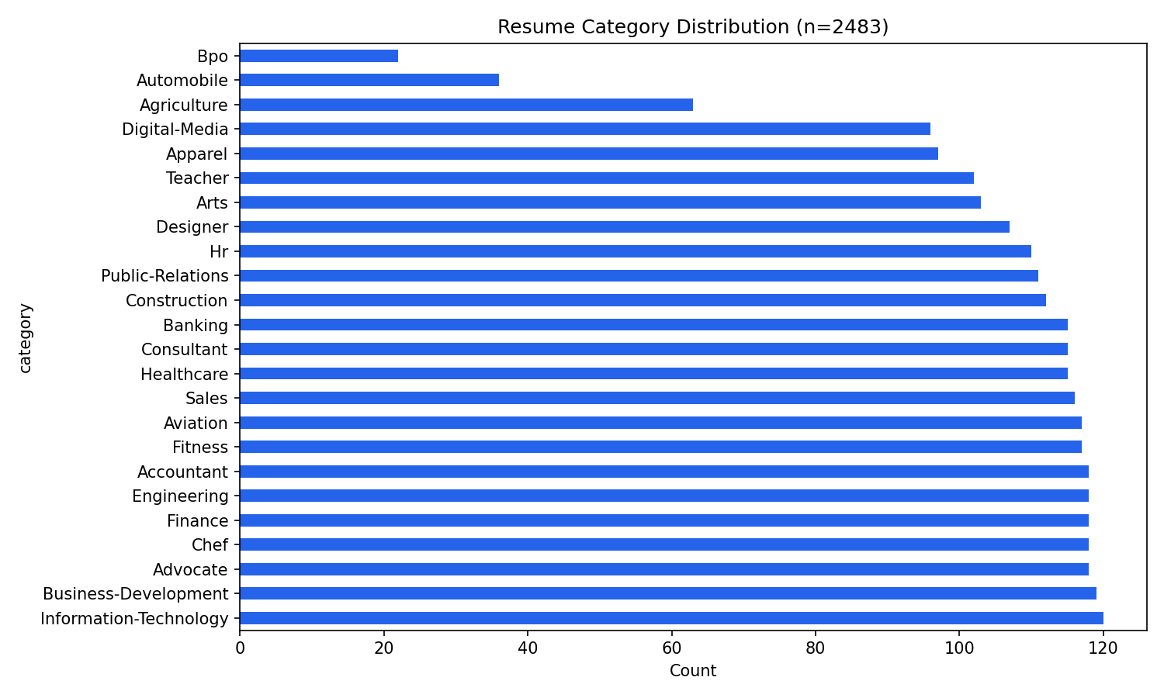
Figure 1. Resume category distribution — fairly balanced (~100–120 per class), except Automobile and Bpo which are noticeably smaller.
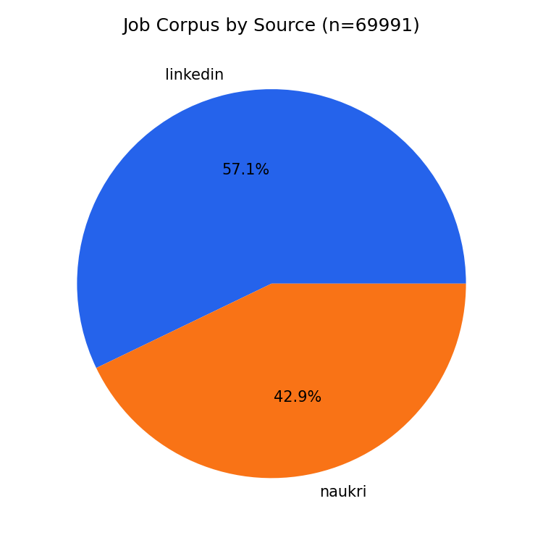
Figure 2. Job corpus composition by source after merging and cleaning.

3. Model A — Resume Category Classifier (Supervised)
Pipeline: clean resume text → TF-IDF (8,000 features, 1–2 grams) → multi-class classifier. Three models were trained and compared with class-balanced weighting to handle the mild class imbalance (Automobile: 36 resumes, Information-Technology: 120 resumes):
Model | Accuracy | Precision (macro) | Recall (macro) | F1 (macro)
Logistic Regression | 0.690 | 0.671 | 0.651 | 0.647
Linear SVM | 0.718 | 0.702 | 0.680 | 0.675
Random Forest (selected) | 0.765 | 0.799 | 0.731 | 0.734

Random Forest was selected as the best model by macro F1. It reaches 76.5% accuracy across 24 classes (random guessing ≈ 4%).
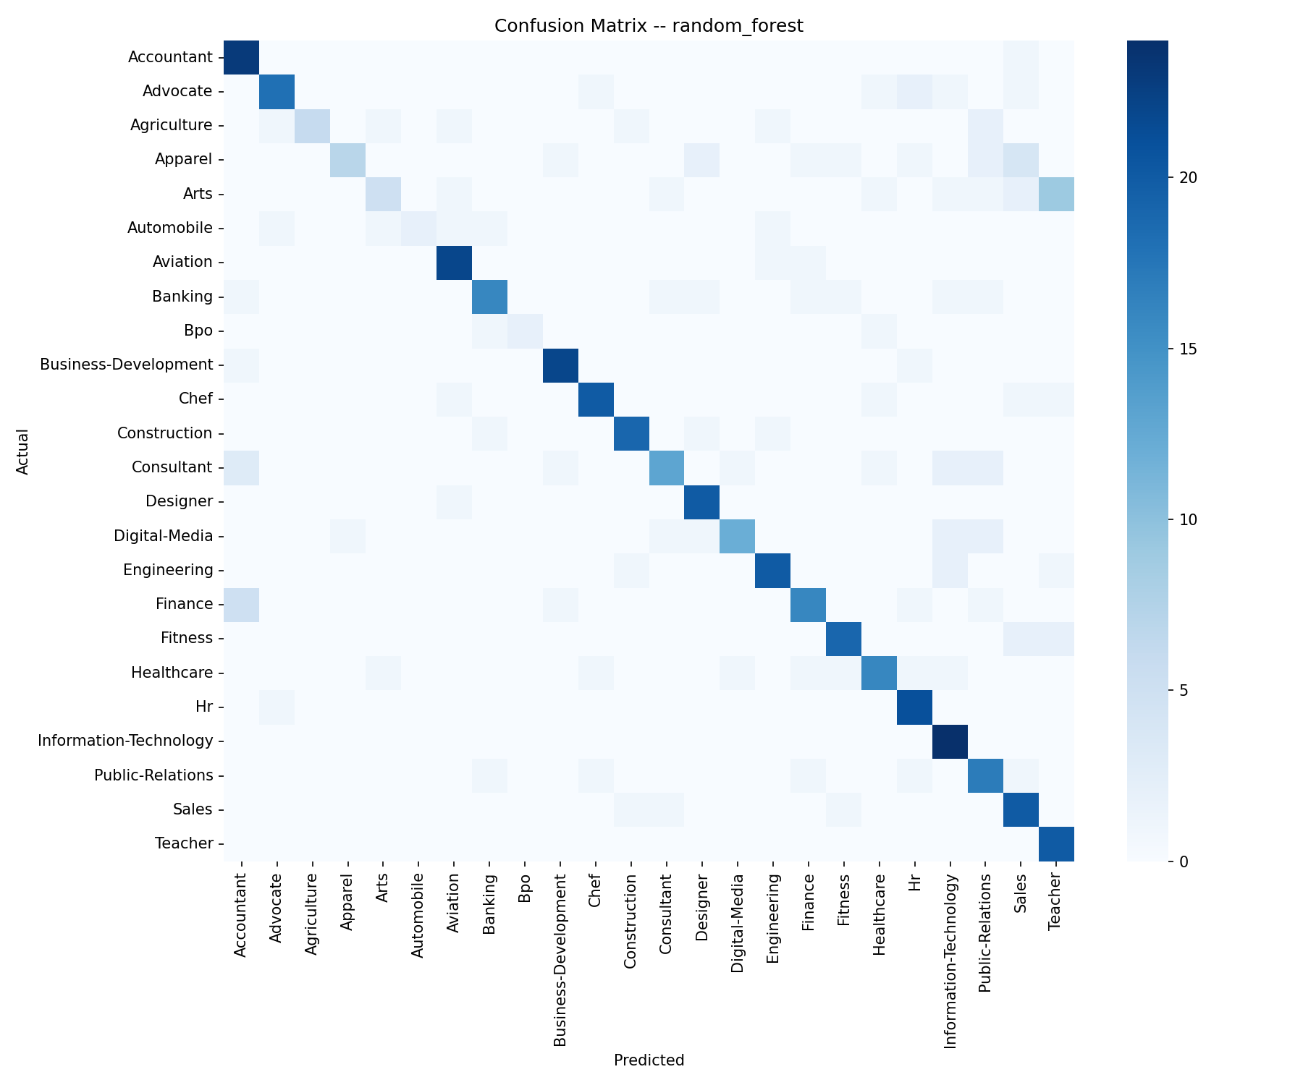
Figure 3. Confusion matrix, Random Forest classifier on the held-out test set. Strong diagonal; most confusion is between semantically adjacent categories (e.g. Arts vs. Digital-Media, Consultant vs. Finance).
Limitations: Automobile and Bpo have the fewest training examples, which shows up as lower recall for those classes. Confusable categories share overlapping vocabulary, which is the main source of remaining misclassification.

4. Job Recommender (Unsupervised Core Engine)
The full job corpus (69,991 postings) is vectorized once with TF-IDF (15,000 features, 1–2 grams). For any resume, the same vectorizer transforms the resume text into the same space, and jobs are ranked by cosine similarity — this is the heart of the portal's 'search' feature.
Qualitatively, recommendations are strong: an HR resume's top-5 matches are all HR/People-Ops management roles; a Python/Django/AWS engineer's top matches are DevOps and Python developer roles. A quantitative Precision@10 check was also run using a keyword-overlap proxy (does the resume's category name share a token with the recommended job's title) since the job corpus has no ground-truth category label. This proxy is intentionally strict and undercounts true matches (e.g. category "Hr" vs. title "Human Resources Manager" share no exact token), so it should be read as a conservative lower bound rather than an absolute score — the qualitative spot-checks give a fuller picture.

5. Job / Role Clustering (Unsupervised)
The job TF-IDF matrix was reduced to 100 dimensions via TruncatedSVD (16.3% explained variance), then K-Means was run for k ∈ {4, 6, ..., 20}. k was selected by silhouette score (computed on an 8,000-row subsample for speed), with k=20 scoring highest.
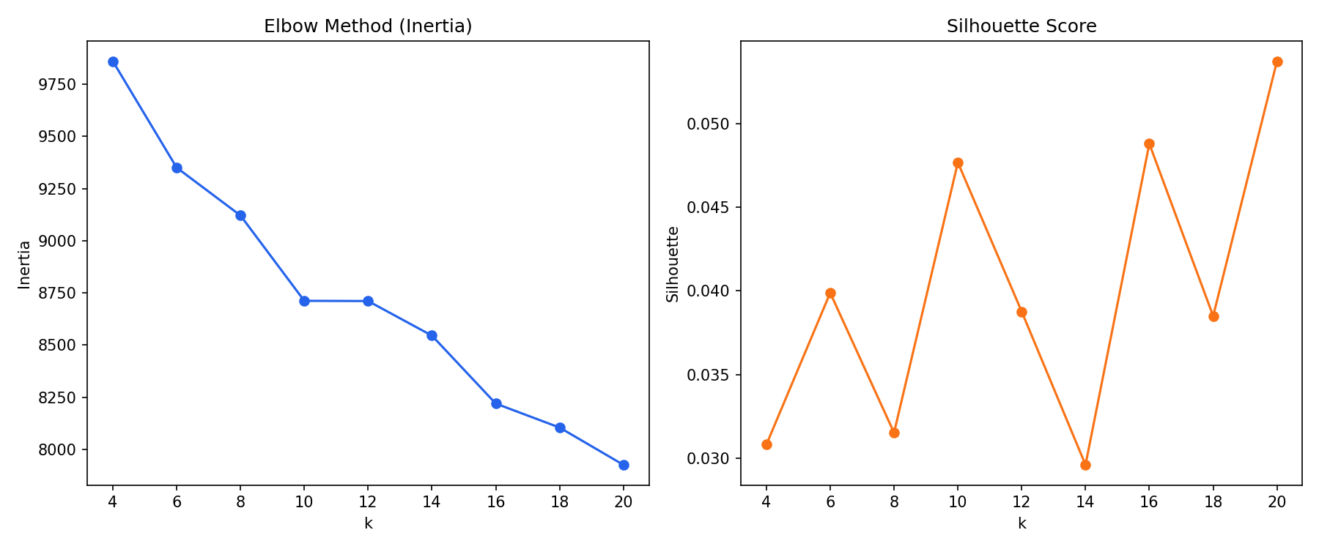
Figure 4. Elbow (inertia) and silhouette score across candidate k values.
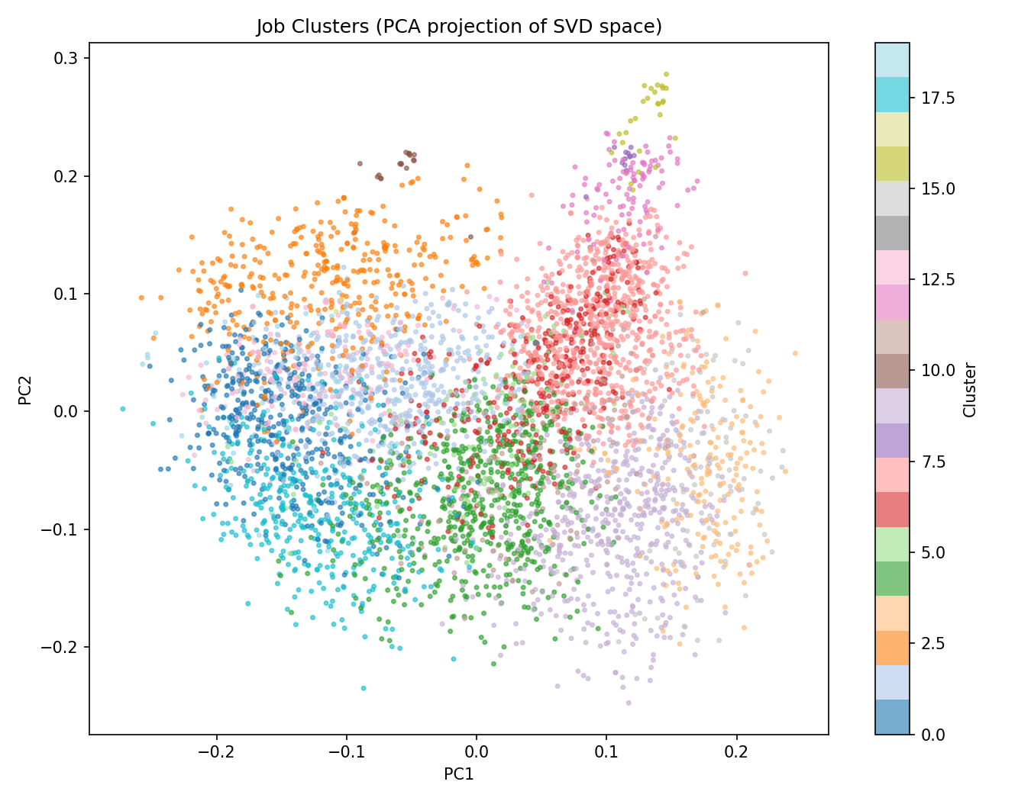
Figure 5. PCA projection of the 20 job clusters. Visible structure with expected overlap from projecting 20 clusters down to 2 dimensions.
The resulting clusters are interpretable role families: nursing/healthcare, Java development, web development, marketing, accounting, BPO/call-center, sales/retail, and several general clusters. Silhouette scores are low overall (~0.03–0.05), typical for sparse, high-dimensional TF-IDF text with generic boilerplate language (EEO clauses, generic "requirements" phrasing) diluting cohesion — a few clusters are dominated by this boilerplate rather than job-specific content, which is a known limitation.

6. Skill-Gap Report (Unsupervised Insight Module)
For a candidate resume, the system predicts its nearest job cluster (via the fitted SVD + K-Means models), extracts that cluster's most common skills from a curated ~100-term skill vocabulary matched against job text, and compares it against the candidate's own extracted skills to report matched vs. missing skills. This directly powers the "CV preparation" feature from the original brief.
This module gives directionally sensible advice — e.g. a Python/Django engineer resume gets shown adjacent missing skills like Java, JavaScript, and Azure. Its main limitation is coverage: skills outside the curated vocabulary are invisible to both candidate-skill extraction and cluster-skill extraction.

7. Model B — Fit / Shortlisting Predictor (Supervised, Optional)
There is no public ground-truth "was this candidate shortlisted" dataset, so training labels are heuristic: a (resume, job) pair is labeled "fit" if the resume's known category shares a keyword with the job title, otherwise "not fit." 1,440 training pairs were generated this way across 180 sampled resumes.
Features: skill overlap (count + Jaccard), resume/job skill counts, an education-keyword match flag, job-side required experience (years), and text similarity (cosine similarity in the job TF-IDF space).
Model | Accuracy | Precision | Recall | F1 | ROC-AUC
Logistic Regression (selected) | 0.689 | 0.707 | 0.644 | 0.674 | 0.768
XGBoost | 0.678 | 0.708 | 0.606 | 0.653 | 0.750

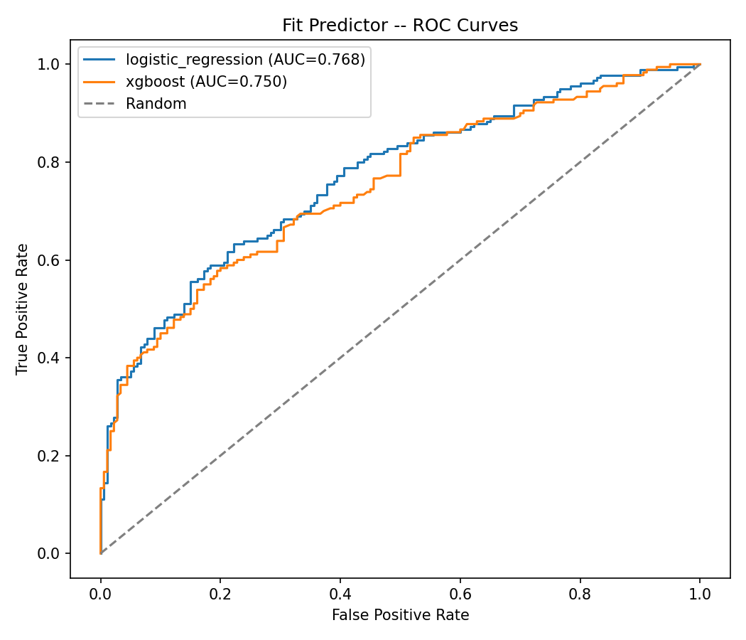
Figure 6. ROC curves, Logistic Regression vs. XGBoost fit predictor.
Logistic Regression slightly outperformed XGBoost — with only 7 engineered features and a noisy heuristic label, a simpler linear model generalizes marginally better than a tree ensemble prone to overfitting small feature sets.
Important caveat: text_similarity is expected to be the single strongest feature, since it's closely related to how the heuristic labels were constructed (title keyword overlap correlates with topical similarity) — this is a known form of label leakage, flagged here rather than hidden. In live testing through the Streamlit app, fit scores for close job matches came out very close to 1.0, suggesting the model is somewhat overconfident / poorly calibrated. This module should be read as a proof-of-concept demonstrating the full supervised workflow (feature engineering, class-balance handling, model comparison, ROC-AUC), not as a production-ready shortlisting tool. A real deployment would need an actual labeled shortlisting dataset, e.g. from ATS decisions.

8. Streamlit Portal
All modules are tied together in app/streamlit_app.py. A user uploads a resume (PDF, DOCX, or TXT) or pastes text; the app extracts and cleans the text, then displays:
- The predicted job category (Model A)
- A ranked table of top-N matching jobs with cosine similarity match scores
- A fit/shortlist probability per matched job (Model B, when available)
- A skill-gap report: detected skills, matched skills, and skills to develop
Model and job-corpus artifacts are cached with @st.cache_resource so the app stays responsive after the first load. The app was smoke-tested end-to-end with real resume text and confirmed to boot and return sensible results for multiple resume categories.

9. Limitations & Future Work
- The job corpus caps each source at 40,000 rows for speed (MAX_JOBS_PER_SOURCE in src/config.py) — raising this, or moving to MiniBatch/approximate methods throughout, would let the full ~150k+ postings be used.
- Several clusters are dominated by boilerplate legal/EEO language rather than job content; more aggressive boilerplate stripping before vectorization would sharpen cluster quality.
- The fit predictor's heuristic labels are a stand-in for real shortlisting outcomes; replacing them with actual ATS decision data (if available) would substantially improve the model's validity and calibration.
- The skill-gap module's vocabulary (~100 curated terms) is a coverage bottleneck — an expanded or learned skill taxonomy would catch more nuanced or emerging skills.
- Stretch goals not attempted in this pass: sentence-embedding-based matching (still classical ML in spirit, but more expensive), a learning-to-rank model for job ordering, and public deployment on Streamlit Community Cloud.

10. Conclusion
SmartHire delivers the full minimum-scope requirement — a resume classifier, a content-based job recommender, and a skill-gap report — plus the optional fit/shortlisting predictor, all using classical ML techniques and real-world datasets. The strongest components are the resume classifier (76.5% accuracy across 24 classes) and the job recommender (qualitatively strong, fast, and interpretable); the fit predictor is the weakest link due to the absence of real shortlisting ground truth, and is presented as a demonstration of the supervised workflow rather than a production-ready feature.

