**Classes and Objects**

**Conditionals**

**Loops**

**Functions**



1. **In java how a program works**

Classes: Think of a class as a blueprint or a template for creating objects. It defines what an object will be made of and what it can do. In our analogy, the "Character" class would define the common characteristics and behaviors shared by all characters.

Objects: An object is an instance of a class. It's like creating an actual character in the game based on the blueprint provided by the class. For example, you might create an object called "warrior" from the "Character" class, which would have its own specific health points, attack power, etc.

class Test{

    public static void main(String args[]){

     System.out.println("Hello Java");

    }

}

Save the above file as Simple.java.

|  |  |
| --- | --- |
| **To compile:** | javac Simple.java |
| **To execute:** | java Simple |

**Output:**

Hello Java

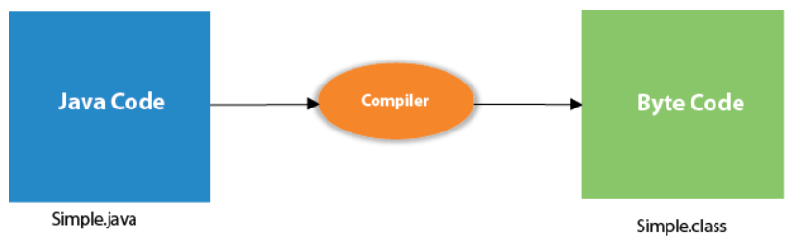

**Java Control Statements | Control Flow in Java**

It is one of the fundamental features of Java, which provides a smooth flow of program.

Java provides three types of control flow statements.

1. Decision Making statements
   * if statements
   * switch statement
2. Loop statements
   * do while loop
   * while loop
   * for loop
   * for-each loop
3. Jump statements
   * break statement
   * continue statement

**If-Else**

public class Student {

    public static void main(String[] args) {

    int x = 10;

    int y = 12;

    if(x+y < 10) {

    System.out.println("x + y is less than      10");

    }   else {

    System.out.println("x + y is greater than 20");

    }

    }

    }

**Output:**



x + y is greater than 20



**Loops in Java**

The Java for loop is used to iterate a part of the program several times. If the number of iteration is fixed, it is recommended to use for loop.

There are three types of for loops in Java.

For Loop

public class ForExample {

    public static void main(String[] args) {

        //Code of Java for loop

        for(int i=1;i<=10;i++){

            System.out.println(i);

        }

    }

    }