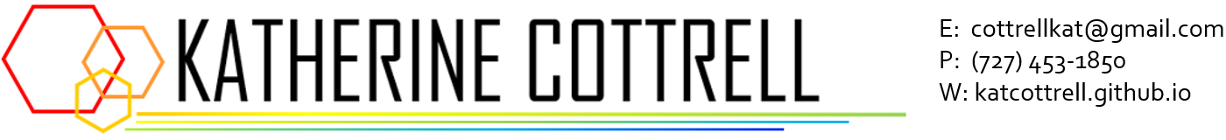

**EDUCATION**

|  |  |
| --- | --- |
| **DUKE UNIVERSITY** | **Durham, NC** |
| *B.S. in Computer Science* | *Expected graduation: May 2022* |

* Coursework: Data Structures, Analysis of Algorithms, Applications in Data Science, Data Visualization, Methods in Machine Learning, Probability and Statistical Inference, Computations with MATLAB, Databases and Applications, Software Design and Implementation, Computational Imaging, 2D Graphics
* Extracurricular: Rhodes iiD Graphic Designer, Nexus (Treasurer), MIT Women's Technology Program

**TECHNICAL SKILLS**

Angular, C, C++, C#, HTML/CSS, Java, JavaScript, Lisp, MATLAB, Python, R, Stata, SQL, TensorFlow, Tableau, Unix/Linux, Git/GitHub/GitLab, Agile/Scrum

**EXPERIENCE**

|  |  |
| --- | --- |
| **NEXTECH SYSTEMS, LLC** | **Tampa, FL** |

*Software intern, Summer 2021*

* Worked with a team of senior developers to develop IntelleChartPRO, a specialized EHR software for intuitive streamlined ophthalmology charting and practice management.
* Used the Angular framework, C#, JavaScript, SQL, and Sass, as well as GitHub and Agile/Scrum practices.

|  |  |
| --- | --- |
| **SHORT BLOCK TECHNOLOGIES, INC.** | **Clearwater, FL** |

*Data and web maintenance, 2021*

* Wrote scripts to automate inventory database management, reducing process from months to minutes.
* Used JavaScript and Miva eCommerce to develop and maintain multiple company websites.

|  |  |
| --- | --- |
| **DATA+ RHODES INFORMATION INITIATIVE AT DUKE UNIVERSITY** | **Durham, NC** |

*Data Scientist, Summer 2020 and 2021*

* Manipulated and sanitized over fifty years of large datasets using R.
* Worked with teams of graduate data scientists to develop interactive RShiny web applications for users to visualize relationships and trends over time; used R and OCR tools.

|  |  |
| --- | --- |
| **DUKE UNDERGRADUATE MACHINE LEARNING** | **Durham, NC** |

*Executive Board Member, 2018 - 2019*

* Planned and hosted two annual Datathon competitions for undergraduates and graduate students.
* Organized panels to promote diversion and inclusivity in data science and machine learning (e.g. “Women in Data Science”) attended by national experts.