CSCI 301- Survey of Scripting Languages

Lab03- Python

This lab Completes the following tasks

* The first task is to take 3 scalar numbers and return the highest
* The second task takes a list of numbers and returns the median. If there are two medians, it returns a tuple
* The third task takes a string and returns true if there are any vowels in the string
* The fourth task takes a string and returns true if every character is a consonant
* The fifth task takes a string and returns if the string is a palindrome

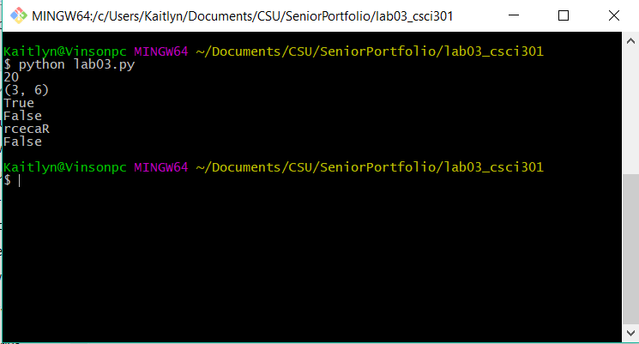

Lab03-key

This lab Completes the following tasks

* The first task is to take 3 scalar numbers and return the highest
* The second task takes a list of numbers and returns the median. If there are two medians, it returns a tuple
* The third task takes a string and returns true if there are any vowels in the string
* The fourth task takes a string and returns true if every character is a consonant
* The fifth task takes a string and returns if the string is a palindrome

