Lab 08: Linked List Stacks and Queues

CSCI 325: Java I

Grade Received: 100

Comments Regarding Design: Run the program using IntelliJ. You must run LinkedListStack and LinkedListQueue separately. These will output the results shown in screenshots of the files running.

* Part 1: implements push, pop, peek, and size for a Linked List Stack

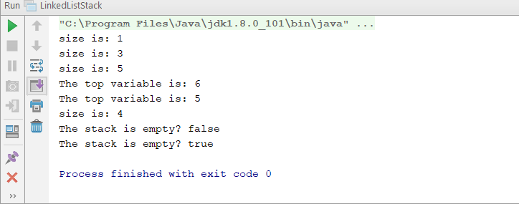

* Part 2: implements enqueue, dequeue, first, and size for a Linked List Queue

