**Student Name**: Kaitlyn Vinson

**Advisor Name:** Dr. Paul West

**Expected Date of Graduation:** May 2019

**Description of Project:**

An application to be used on Android phones or Computers that allows the user to calculate the open and closed rings needed for an entered length of chainmaille. One Section of the app is for the calculations, another is for the users inventory, and a third is an instruction section. The inventory section keeps a rough inventory so that the user knows when they need to order more supplies, or so that they can know if they have enough rings for a certain project. The instruction section gives detailed instructions on different weaves so that the user can remind themselves how to do the weaves they need for their projects. There will be 3D graphic image representation and step by step written instruction.

* May add in a warning label for if the ring size selected will warp the weave due to too large or too small of an aspect ratio. Will need to do testing to see what ratio ranges are acceptable.

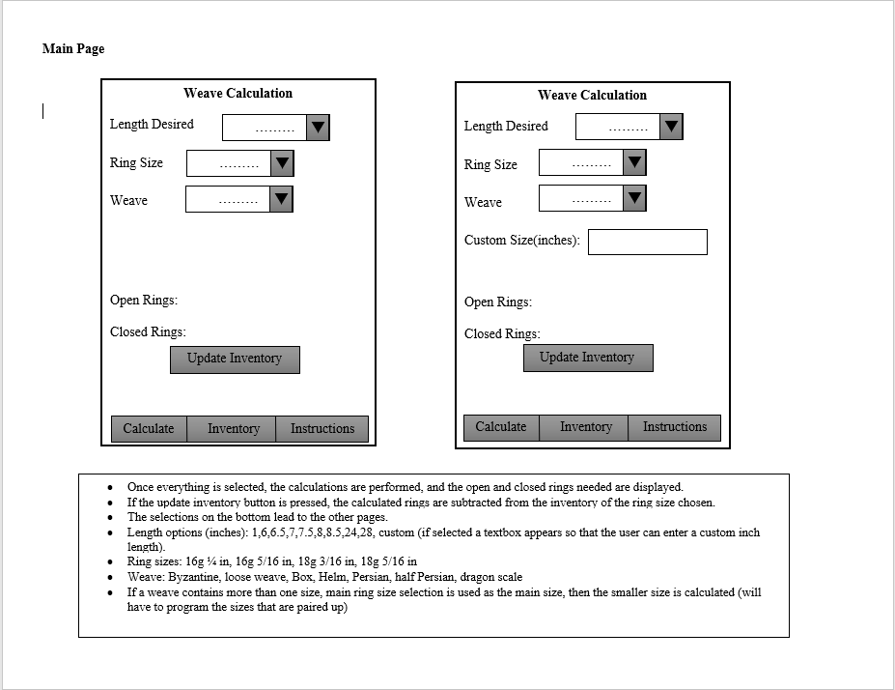

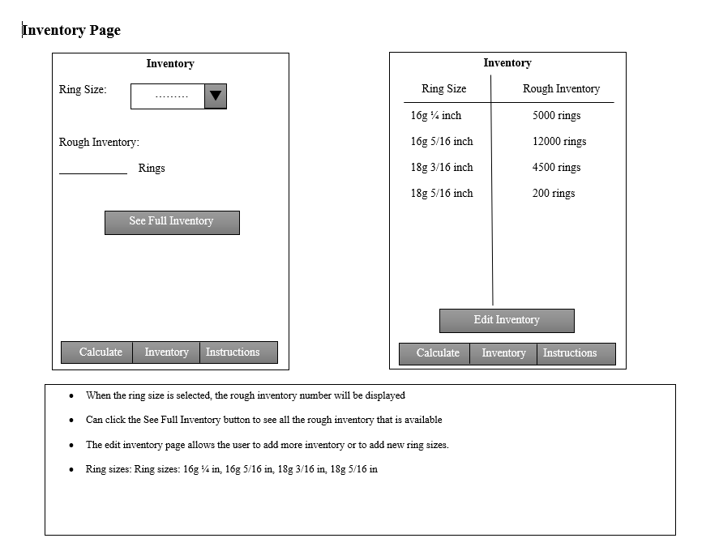

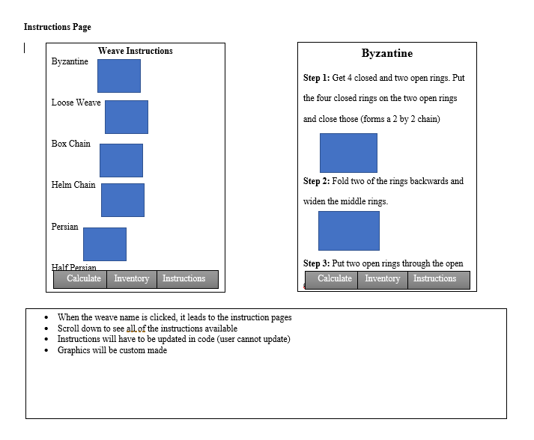

**Proposed Implementation Language(s):**

HTML and Java

**Any software/hardware equipment needed**:

Android Studio, Phone and computer to test on.

Phone Information: Samsung Galaxy S8 SM-G950U

**Motivation and Problem Statement:**

This application is needed for anyone who runs a chainmaille jewelry or cosplay business. It would allow them to keep track of their inventory and calculate how much each item will cost in materials.

**Outline of Future Research Efforts:**

The future additions will include more weaves, as well as a cost calculator for homemade rings, as well as purchased rings. The cost calculator will calculate the rough cost of the project so the user can give an estimated cost to the purchaser (so the user can calculate the profit).

**Testing:**

Personal Testing, Try contacting other chainmaille artists to see if they would be interested in beta testing the application.

Testing of individual modules:

* Testing the calculations of ring open/closed numbers.
* Testing of the adding and subtracting from inventory
* Testing to ensure that all links to instructions are correct
* Testing that the correct aspect ratios are selected for each ring type

**Similar Projects:**

There is only one similar app that contains instruction examples and an Aspect Ratio calculator, but no inventory or ring calculations.

Chainmaille Tutorials:

<https://play.google.com/store/apps/details?id=com.andromo.dev420527.app590846&hl=en>

MailleDroid (Aspect Ratio Calculator):

<https://play.google.com/store/apps/details?id=mailledroid.tomddean.com>

**Schedule:**

August 27 – Outline and Structure of the Application Completed

September 10 – Inventory database completed

September 24 – Inventory search page completed

October 8 – Calculator completed

October 22 – Graphics completed

November 5 – Instruction selection and step pages completed

November 19 – App completion

November 26 – App testing completed on PC and android app