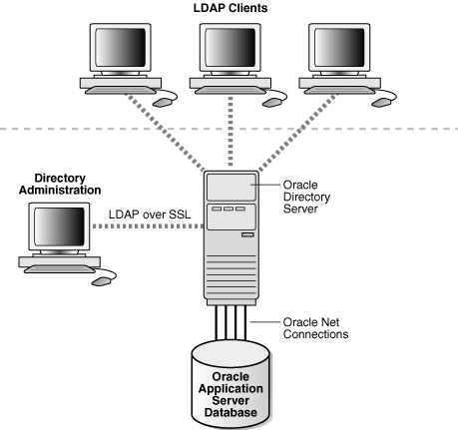

Secure Sockets Layer(SSL)

LDAP is a standard, extensible directory access protocol. It is a common language that LDAP clients and servers use to communicate.

LDAP was conceived as an Internet-ready, lightweight implementation of the International Standardization Organization (ISO) standard for directory services. It requires a minimal amount of networking software on the client side, which makes it particularly attractive for Internet-based, thin client applications.

The LDAP standard simplifies management of directory information in three ways:

* It provides all users and applications in the enterprise with a single, well-defined, standard interface to a single, extensible directory service. This makes it easier to rapidly develop and deploy directory-enabled applications.

Oracle Internet Directory includes:

* Oracle directory server, which responds to client requests for information about people and resources, and to updates of that information, by using a multitiered architecture directly over TCP/IP
* Oracle directory replication server, which replicates LDAP data between Oracle directory servers
* Directory administration tools, which include:
  + Oracle Directory Manager, which simplifies directory administration through a Java-based graphical user interface
  + A variety of command-line administration and data management tools invoked from LDAP clients
  + Directory server management tools within Oracle Enterprise Manager 10*g* Application Server Control Console. These tools enable you to:
    - Monitor real-time events and statistics from a normal browser
    - Start the process of collecting such data into a new repository