Workshop Project Info

Find demo project:

<https://jlord.us/forkngo>

GitHub repository for the project:

<http://www.github.com/jlord/hello>

**Fork the hello repository & clone your fork**

* Fork the project from <http://www.github.com/jlord/hello>.
* GitHub will create a copy of the “hello” project into your GitHub account
* Clone your copy of the “hello” project
  + Copy the ssh url within GitHub

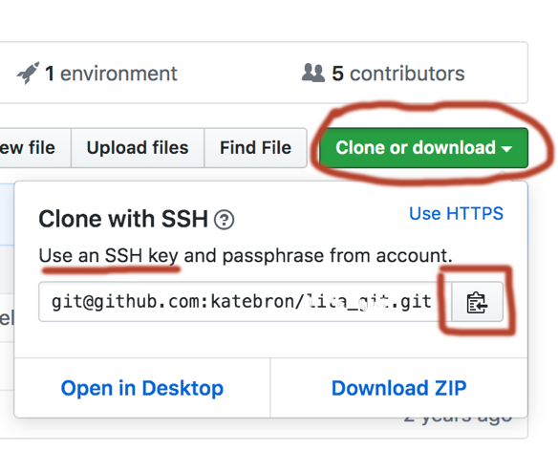

* + Start the command git clone – then paste in the ssh url
    - Example:

**Explore your local repository**

* Run git remote to see your remote alias (the site where you’ll will push back to & pull from)



* Run git log to see previous commits
* Run git branch to see branch info



**Make edits & commit**

* To edit the text, open up index.html
  + Nano index.html
    - If you open up an empty document, make sure you’re in the correct directory.
* Preview your changes
* When you want to make a commit, save to the document, run git add & git commit -m.

**Push back to your GitHub account**

* Run the git push command.



* + In most other cases, you’ll actually push to master (i.e. git push origin master)
* Navigate to your GH pages
  + You’ll find your site at a URL: [https://*github_user_name*.github.io/hello](https://github_user_name.github.io/hello)

**Make more edits and repeat process!**

* To change how the page looks, edit css/style2.css
* Remember to add & commit & push, when you see fit.