# Readme

RecipientListManagement is a tool that currently allows two things:

1. Manage recipient lists: add new lists, import users, delete users from list etc.
2. Limit user rights. Users only see the lists and messages that they have created/sent. Admins see everything.

Sure, everything is customizable and you can go back to standard Sitecore ECM controls easily.

## Installation of the module

Just install a RecipientListManagement-1.0.0.0.zip package from Packages folder, overriding everything.

## Changes and additions

In red frame: new added features

In green frame: changed controls

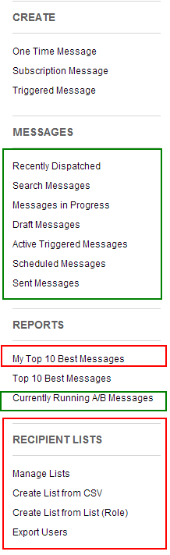

All messages controls (in green) were changed to allow user to see only his own emails. So, if you are logged in under non-admin user Kate, you will see only messages that were created by you.

My Top 10 Best Messages – the title speaks for itself.

A bunch of new controls, related to list management.

## Manage Lists

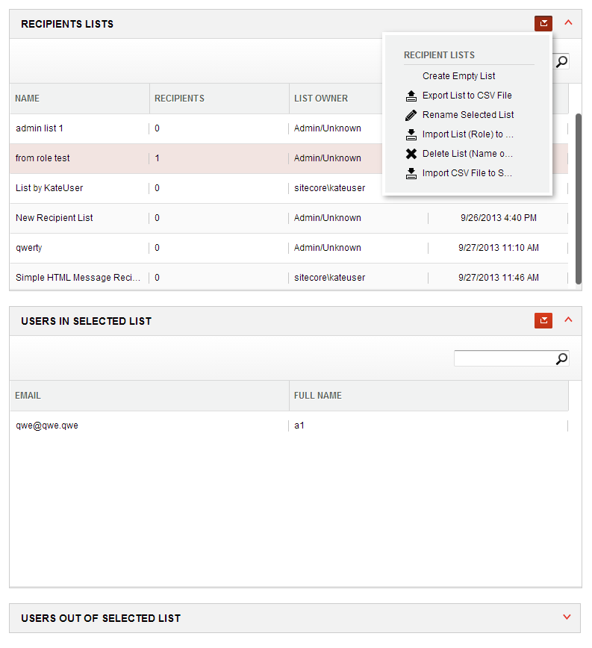

“Manage Lists” option will show you all the lists that you have created. You can perform all options from the context menu:

* Create an Empty list
* Export selected list to CSV file
* Import users from some CSV file to selected list
* Delete list
* Import Sitecore role to selected list

You can also search through the lists.

As soon as you select a list in the top control, you immediately see users that are in this Recipient list and also users that have unsubscribed from this list before. You can also manually unsubscribe user or edit his User profile:

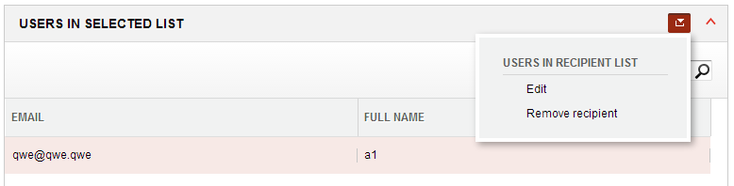

Please report all bugs to <https://github.com/katebutenko/RecipientListManagement/issues>