STAKEHOLDER BRIEFING
Presented by Olena McMurtrey
Choosing the Right Model for Each Task
Response time, compute cost and routing across four vision-language models
Olena McMurtrey | AAI-500 Final Team Project, University of San Diego | October 9, 2026

The research question we set out to answer
How does response time vary across models and request characteristics, and what patterns can guide model selection in a multi-model workflow?

The answer in brief
Part of the question | What the data shows
Across models | Average response time ranges from 11.8 s (Qwen) to 71.8 s (Gemma), a sixfold gap. Confidence intervals and bootstrap estimates both support this ranking, and the slower models also vary more from call to call.
Across request characteristics | Answer length is strongly associated with response time (r = 0.91 across 460 completed calls; 0.82 to 0.98 within each model). The structure search found no direct link from input type, trigger or bot instance to response time.
Patterns for model selection | Qwen is the leading candidate for short, time-sensitive tasks and MiniCPM for longer answers, subject to answer-quality testing. The expected length of an answer is a promising input for routing rules.

Key numbers
- 6x gap in average response time: 11.8 s for the fastest model (Qwen) against 71.8 s for the slowest (Gemma).
- r = 0.91 correlation between answer length and response time, the strongest request-level association we found.
- About 2x faster per 1,000 characters of answer: MiniCPM and Qwen against Pixtral and Gemma.
- 5.07x the estimated processing work (CPU-seconds) for a typical Gemma call compared with a typical Qwen call.
- 19.7 CPU-hours estimated saving for every 1,000 calls moved from Gemma to Qwen.
- 33 s vs 246 s longest observed call for Qwen against Gemma.

What we tested
We benchmarked four locally hosted vision-language models on 600 logged requests sent through our n8n workflow (two bot instances), and analyzed the 460 that completed. Each request was logged with its response time, average CPU and memory during the call, total workflow time, the bot instance that ran it, and the text the model returned. The test was balanced: every model completed exactly 115 runs and received the same mix of input types (text only, image only, text plus image, and mixed).
Model | Developer | Size
qwen2-vl-7b-instruct | Alibaba Qwen team | 7B parameters
minicpm-o-2_6 | OpenBMB | 8B parameters, multimodal
pixtral-12b | Mistral AI | 12B decoder plus 400M vision encoder
gemma-3-12b-it | Google DeepMind | 12B parameters, 128,000-token context

Reliability did not separate the models. Each model had 115 completed calls, 3 logged failures and 32 requests that never executed. The logs do not record why calls failed or did not execute, but the identical counts mean completion rates cannot favor one model over another.

Results at a glance
Model | Typical call (median) | Average call (mean) | Longest observed call | Typical answer length (characters) | Response seconds per 1,000 characters | Median estimated CPU-seconds
Qwen | 7 s | 11.8 s | 33 s | 471 | 15.0 | 9.8
MiniCPM | 17 s | 17.9 s | 59 s | 1,173 | 13.0 | 16.6
Pixtral | 31 s | 42.5 s | 122 s | 1,050 | 28.0 | 34.9
Gemma | 46 s | 71.8 s | 246 s | 1,194 | 32.8 | 49.9
Models are listed fastest to slowest. Every figure comes from the 460 completed runs, 115 per model.

PART 1 Response time across models

1. The models differ sharply in speed
Average response time ranges from 11.8 seconds (Qwen) to 71.8 seconds (Gemma). The spread grows with the average: the standard deviation is 8.2 seconds for Qwen and 56.7 seconds for Gemma. Gemma's middle half of calls alone spans 34 to 113 seconds, which is wider than Qwen's entire range.
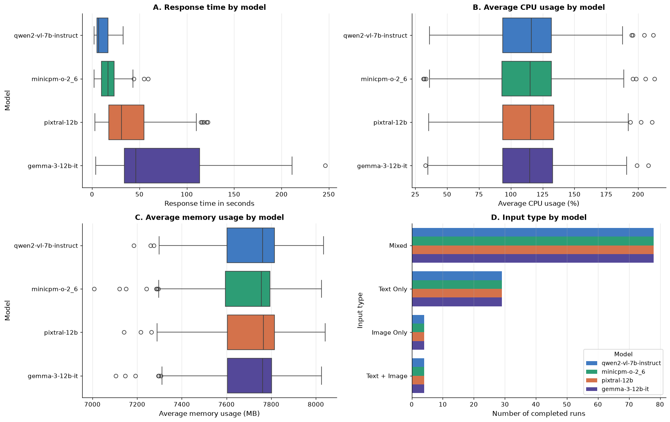
Figure 1. Response time, CPU, memory and input type by model.
How to read it: Each box covers the middle half of a model's calls, the line inside it is the median, and the dots are unusually slow or fast calls. In panel A the boxes barely overlap and stretch further right as the models get slower, which is the speed gap in picture form. Panels B and C tell the opposite story: CPU and memory boxes sit at the same place for every model. Panel D confirms each model received the same mix of input types, so input type cannot explain the speed differences.

2. The ranking is supported by uncertainty estimates
A standard error measures how precisely each average has been estimated. The 95% confidence intervals for the average do not overlap for any pair, and bootstrap estimates, which make no assumption about the shape of the data, give the same ranking.
Model | 95% range for the average call | 95% range for the typical call (median)
Qwen | 10.3 to 13.3 s | 6 to 12 s
MiniCPM | 15.9 to 19.9 s | 15 to 17 s
Pixtral | 36.5 to 48.4 s | 25 to 37 s
Gemma | 61.4 to 82.3 s | 39 to 52 s
Average ranges use the t distribution; median ranges use bootstrap resampling. Bootstrap ranges for the average agree within a few tenths of a second.

3. Plan for the slow tail, not the average
Response times are skewed to the right for every model (skewness 0.89 to 1.16): most calls are quick, with a minority of much slower ones. Three charts show this from different angles.
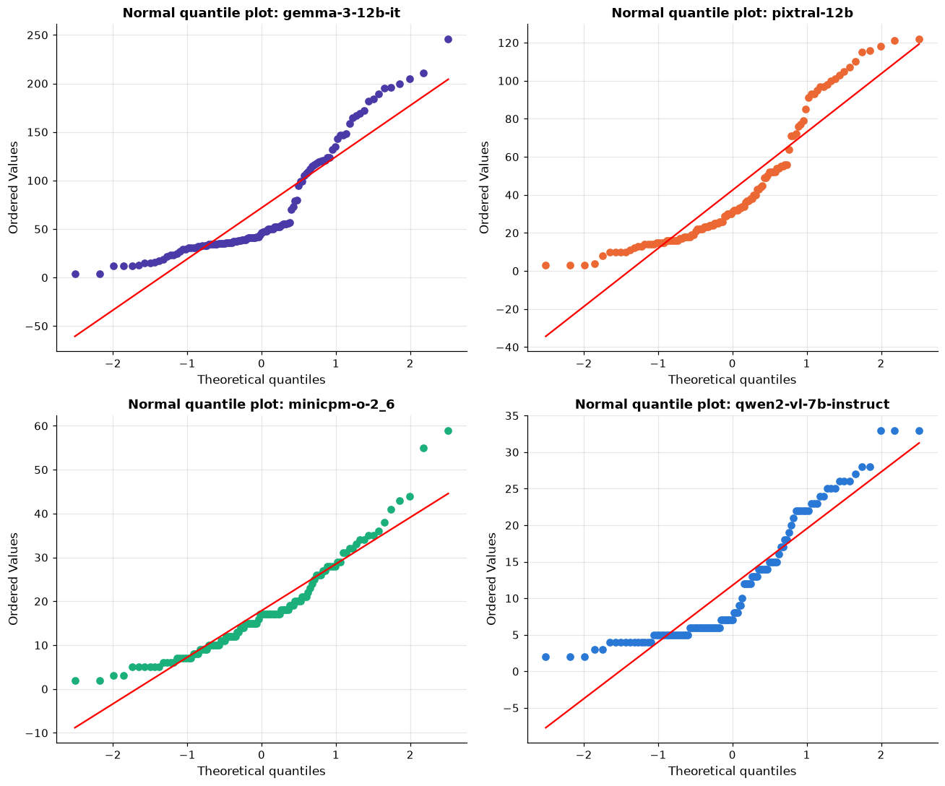
Figure 2. Normal quantile plots, one per model.
How to read it: If response times followed a bell curve, the dots would sit on the red line. Instead, every model's dots bend upward at the top right, which means the slowest calls are much slower than a bell curve would predict. The same bend appears in all four models, so one approach to planning covers all of them.
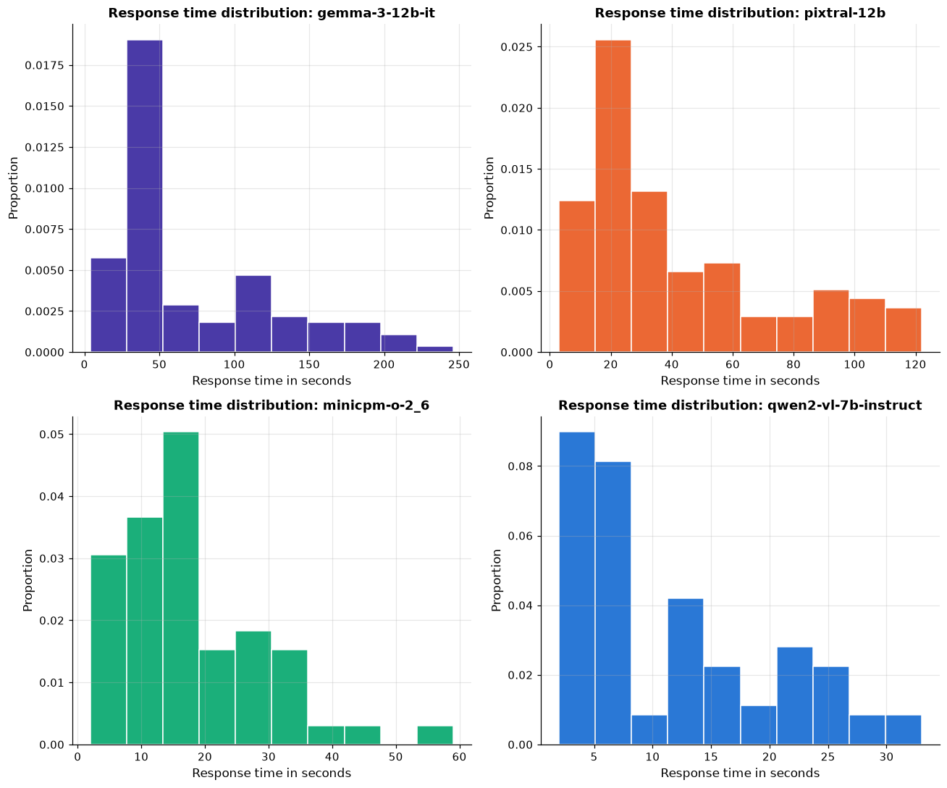
Figure 3. Distribution of response times, one histogram per model.
How to read it: Each bar shows the share of calls that fell in a time range. Every histogram peaks on the left and trails off to the right: most calls finish quickly, and a smaller group takes much longer. Note the different time scales: Qwen's whole chart ends at about 33 seconds, while Gemma's runs to 250.
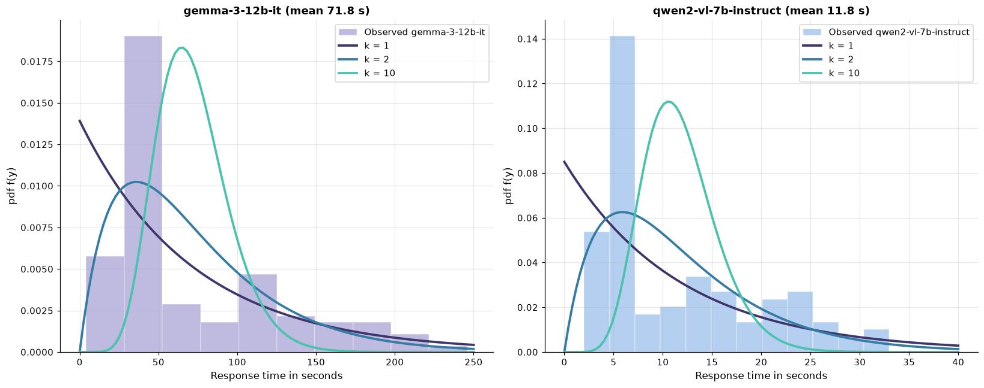
Figure 4. Observed response times against three Gamma curves with the same average, for the slowest model (Gemma) and the fastest (Qwen).
How to read it: A Gamma curve is a standard shape for waiting times, and its shape value (k) sets how lopsided it is. For both models the observed bars follow the strongly lopsided k = 2 curve far better than the near-symmetric k = 10 curve. This supports treating response times as skewed in planning; it is a descriptive fit, not a proven model.
That skew has two practical consequences:
- For user expectations, quote the median. A typical Gemma call takes 46 seconds, not the 72-second average.
- For capacity and timeout planning, use the average and the upper tail, not the average alone. Totals across many calls follow the average, and a timeout set at the average would cut off a large share of legitimate calls. Future tails may also exceed the longest times seen in this benchmark.
A bell-curve assumption gives the wrong answer for the slower models. Asked what share of calls finish within one minute, it misjudges Gemma by 23 percentage points:
Model | Bell curve predicts within 60 s | Actually finished within 60 s
Qwen | 100% | 100%
MiniCPM | 100% | 100%
Pixtral | 71% | 77%
Gemma | 42% | 65%
The 60-second threshold was chosen for this comparison; it is not a recorded service target.
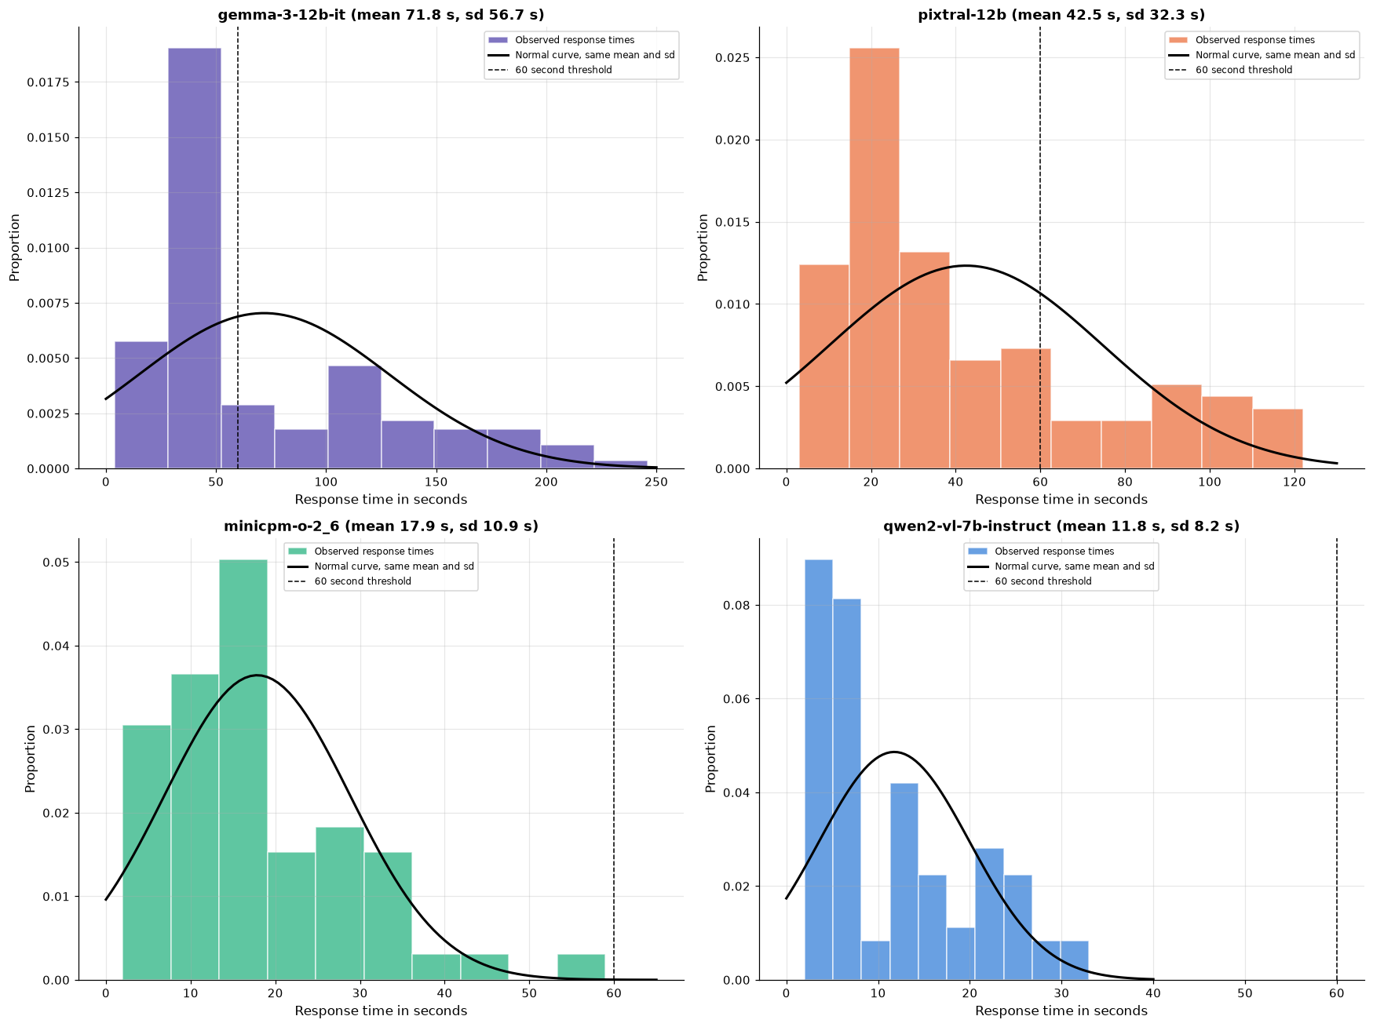
Figure 5. Observed response times against a bell curve with the same average and spread; the dashed line marks 60 seconds.
How to read it: The black curve is what a bell-curve assumption expects; the bars are what actually happened. For Gemma and Pixtral the curve is too flat: it misses the tall peak of quick calls and spreads its weight across times where few calls fell, which is why it underestimates how many calls finish within a minute. For Qwen and MiniCPM the 60-second line sits beyond every observed call.

PART 2 Response time across request characteristics

4. Answer length is strongly associated with response time
A model writes its answer piece by piece, so a longer answer would be expected to take longer. Across 460 completed calls, answer length (in characters) and response time correlate at r = 0.91, where 1.0 would be a perfect straight-line match. The association holds inside every model, so it is not just a side effect of comparing a fast model with a slow one:
Model | Correlation of answer length with response time | Typical answer length (characters)
Qwen | r = 0.95 | 471
MiniCPM | r = 0.82 | 1,173
Pixtral | r = 0.98 | 1,050
Gemma | r = 0.95 | 1,194
All runs together | r = 0.91

The models fall into two pace tiers. Measured as response seconds per 1,000 characters of answer, MiniCPM (13.0 s) and Qwen (15.0 s) take about half as long as Pixtral (28.0 s) and Gemma (32.8 s). This measure uses the full call time, so it is a practical pace figure rather than pure text-generation speed.
This helps explain the speed ranking. Qwen has the lowest response times and also writes the shortest answers. MiniCPM writes answers about as long as Gemma's in well under half the time per character, which makes it the stronger candidate when a task needs a long answer.
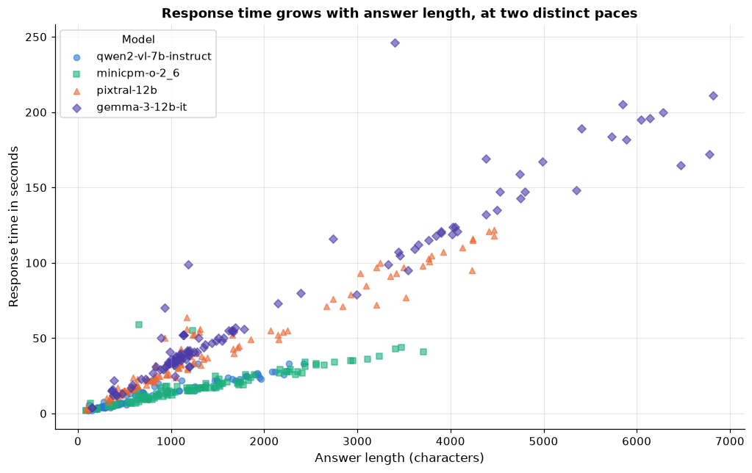
Figure 6. Response time against answer length, all four models.
How to read it: Each point is one call. Points climb from bottom left to top right, so longer answers came with longer waits. They also form two separate bands: a steep band for Pixtral and Gemma (more seconds per character) and a shallow band for MiniCPM and Qwen. Correlation shows the two move together; it does not on its own prove that length is the only cause.
What this means for routing: the actual answer length is known only after a call, but the expected length of an answer (a one-word classification against a full image description) is known in advance. That makes expected length a promising routing input, to be tested before it is relied on.

5. Request setup showed no direct link to response time
The other request characteristics in the log showed no direct link to response time:
- Input type: every model received the same mix (Figure 1, panel D), and the structure search below selected no direct link from Input Type to Response Time.
- Bot instance: median response time is 22.0 s on Bot 1 and 23.5 s on Bot 2. The bots handled uneven numbers of calls (396 for Bot 1 and 64 for Bot 2 completed), so similar medians suggest, rather than prove, equal speed.
- Trigger: no direct link selected. Smaller or conditional effects have not been ruled out.

6. One picture of what drives what
Earlier findings tested variables one pair at a time. As a final step, a structure search looked at every setup variable and every measured outcome together and selected the dependencies best supported by the data. The search (a score-based hill-climbing method using the BIC score) tries many possible diagrams and keeps the simplest one that fits the 460 completed runs well. Response time, CPU and memory were grouped into four equal bands (quartiles) for this step.
Boundaries: the search was not allowed to draw an arrow from a measured outcome (response time, CPU, memory) back to a setup choice (model, input type, trigger, bot), because something measured after a call cannot shape how that call was set up.
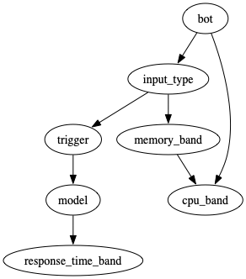
Figure 7. Learned dependency structure (exploratory).
How to read it: Each arrow is a dependency the search found worth keeping. The arrows are statistical links, not proven cause and effect, and a missing arrow means no direct link was found, not that none exists.
- model → response time is the only arrow into response time. Once the model is known, input type, trigger and bot add no direct information. This points to model choice as the main lever.
- No arrow from model to CPU or memory, which agrees with the separate statistical tests in Finding 7.
- bot → CPU and input type → memory link resource readings to the workflow rather than the model (Finding 8).
- bot → input type → trigger → model reflects how the benchmark scenarios were set up, not performance.
How this fits with answer length: the diagram covers settings fixed before a call. Answer length is produced during the call, so it was analyzed separately in Finding 4. Read together, the evidence points to the model, through how much it writes and how fast, as the main factor in the wait.

PART 3 The resource cost of each model

7. The cost difference lies in how long a model holds the processor
CPU use (around 115%, where 100% is one full core) and memory (around 7,700 MB) show no statistically significant differences between models (Tukey pairwise tests, adjusted p of 0.89 or higher), and neither moves with response time (r = 0.05 for CPU, 0.00 for memory). Taken alone, those readings would suggest model choice has no resource cost.
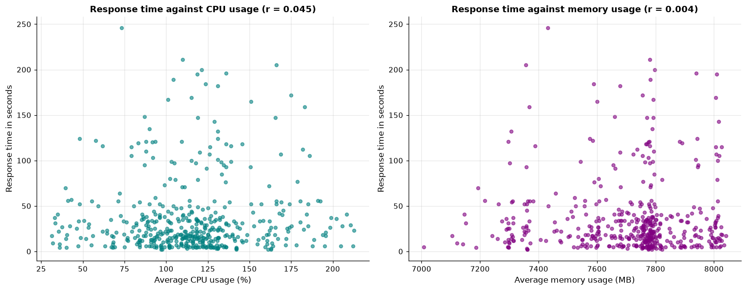
Figure 8. Response time against CPU use (left) and memory (right), all calls.
How to read it: If slow calls drew more CPU or memory, the points would rise from left to right. Instead both panels show a shapeless cloud.
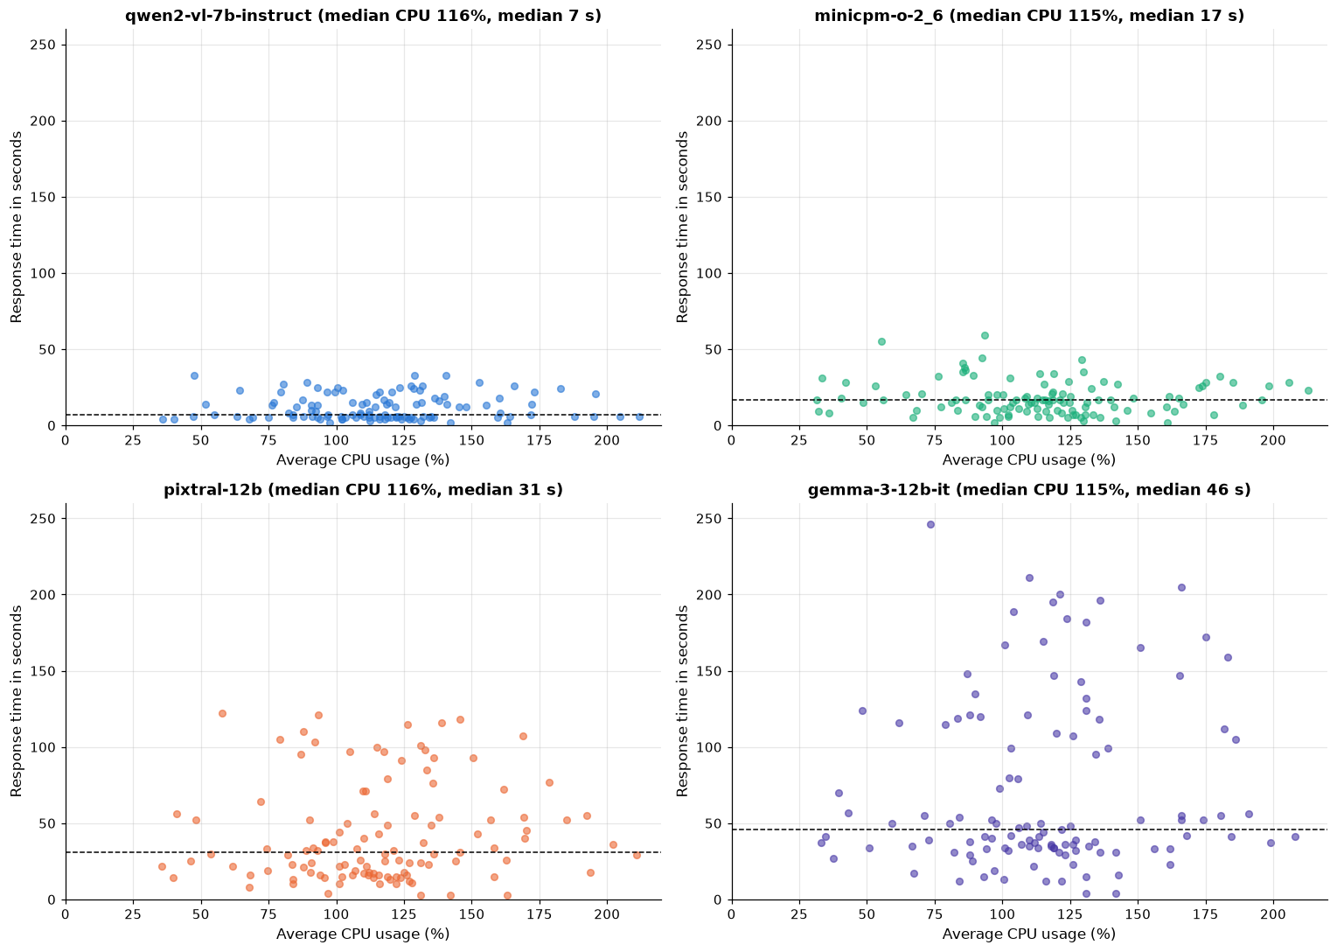
Figure 9. CPU use against response time, one panel per model; the dashed line is each model's median response time.
How to read it: All four panels share the same scales. Every model spreads across the same CPU range (left to right), but the models reach very different heights: Qwen stays below 35 seconds while Gemma reaches 246. The models run the processor at the same intensity; the slower ones simply run it for longer.
That duration is where the cost lies. Multiplying CPU use by call duration gives estimated CPU-seconds, an approximation of the processing work in each call (CPU % / 100 x seconds). It is a planning estimate, not a direct monetary or energy measurement. On this measure the models separate clearly.
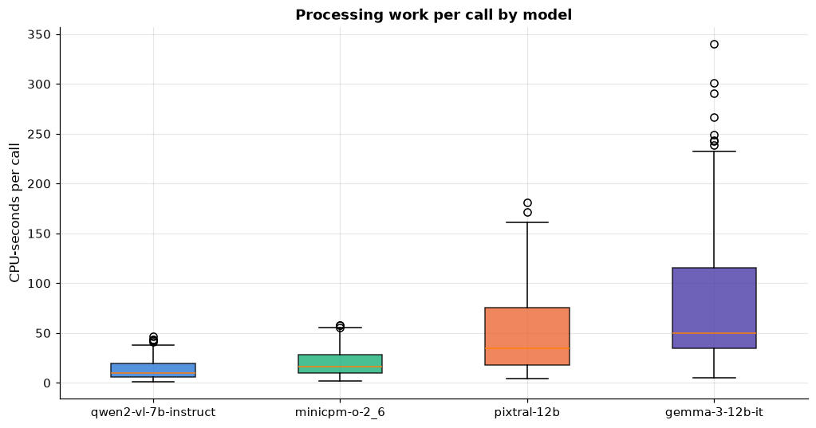
Figure 10. Estimated CPU-seconds per call, by model.
How to read it: Unlike the flat CPU-percentage boxes in Figure 1, these boxes climb steadily from Qwen to Gemma. A typical Gemma call does about 5 times the processing work of a typical Qwen call, and its long upper whisker shows that some Gemma calls cost far more.
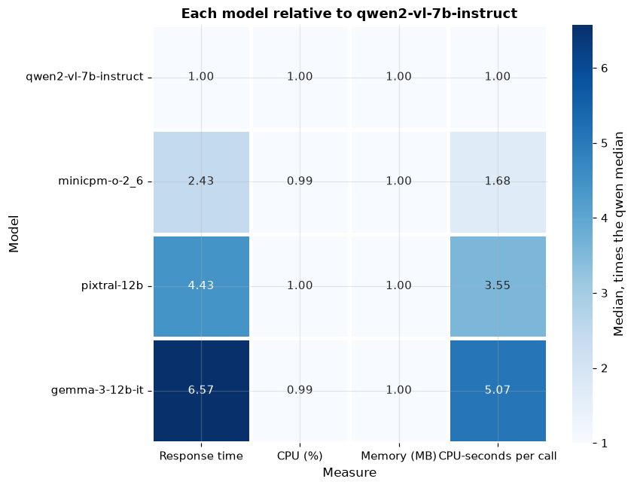
Figure 11. Each model's median relative to Qwen (1.00 = same as Qwen).
How to read it: Darker cells mean a larger multiple of Qwen. The CPU and memory columns stay at 1.00 for every model, while the response time and CPU-seconds columns climb to 6.57 and 5.07 for Gemma. This is the clearest single view of the finding: same intensity, very different duration and total work.
Moving calls from this model to Qwen | Median CPU-seconds vs Qwen | Estimated CPU-hours saved per 1,000 calls
MiniCPM | 1.68x | 1.8
Pixtral | 3.55x | 10.1
Gemma | 5.07x | 19.7
Savings use average CPU-seconds, since totals across many calls follow the average. They assume the substitute model could handle the same work.

8. Memory and CPU load track the workflow, not the model
Memory has a moderate correlation with total workflow duration (r = 0.50) but almost none with the model call (r = 0.00), and the pattern is nearly identical for all four models. Model calls are short relative to the whole workflow: the median model call is 7.6% of the median workflow time.
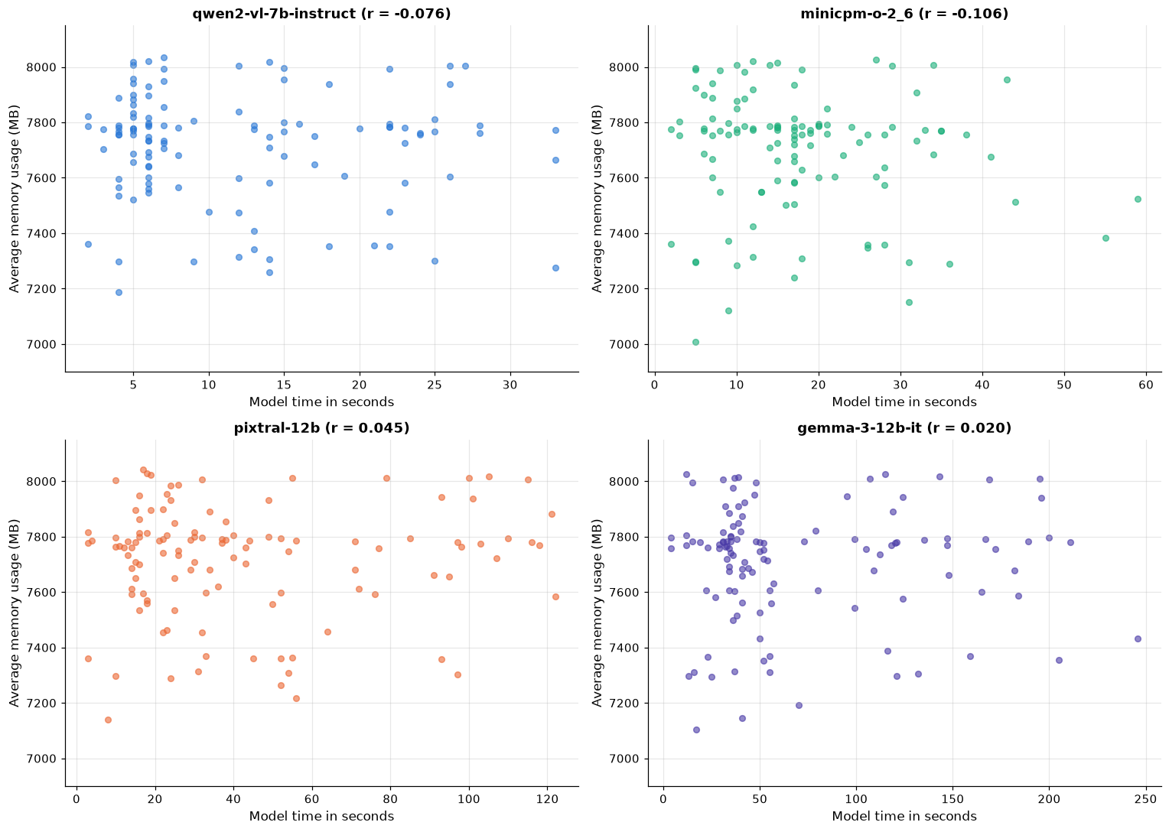
Figure 12. Memory against model response time, one panel per model.
How to read it: Each panel shows a flat cloud with a correlation near zero (from -0.11 to 0.05). However long a model takes, memory stays in the same range, so choosing a different model would not be expected to change memory needs.
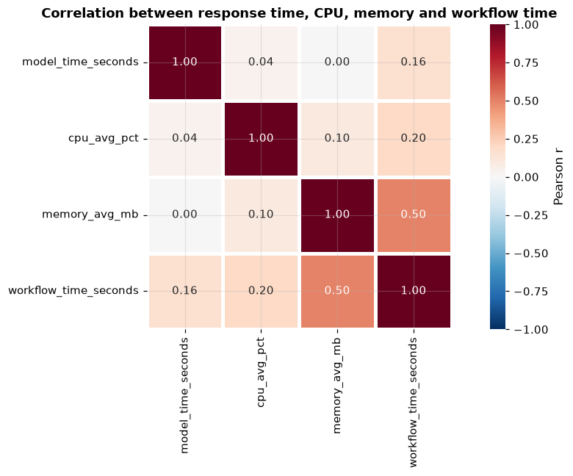
Figure 13. Correlations between response time, CPU, memory and workflow time.
How to read it: Each cell shows how strongly two measures move together, from -1 to 1. The only notable link is memory with workflow time (0.50). Response time is almost unrelated to CPU (0.04) and memory (0.00), and only weakly related to total workflow time (0.16).
CPU load, by contrast, differs by bot instance:
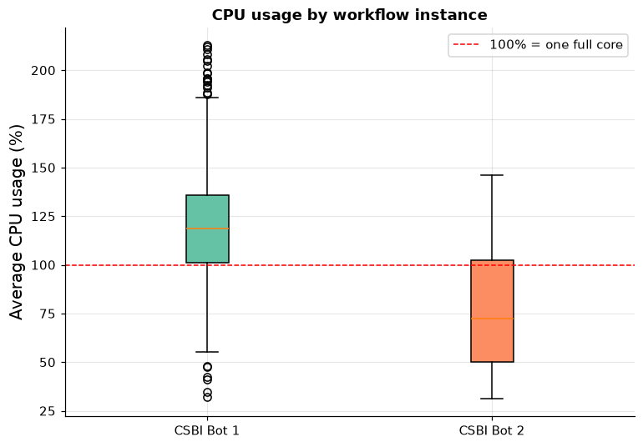
Figure 14. CPU use by workflow instance; the red line marks one full core.
How to read it: Bot 1 runs at a median of 119% CPU, above one full core, while Bot 2 runs at 72%, even though both bots show nearly the same model response times. Bot 2 contributed only 64 completed calls, so this is a strong signal worth confirming with more data.

Patterns for model selection
Finding | Evidence
Models differ in speed | Averages 11.8 to 71.8 s; all 95% intervals separate
Response times are right-skewed | Skewness 0.89 to 1.16; average above median for every model
Slower models vary more | Standard deviation 8.2 s (Qwen) to 56.7 s (Gemma); longest Gemma call 246 s
Answer length is associated with response time | r = 0.91 overall; two pace tiers
No direct setup-to-response-time links found | No edge from input type, trigger or bot to response time
CPU % and memory differences not detected | Tukey adjusted p of 0.89 or higher; r near 0 with response time
Estimated CPU-seconds vary by model | Gemma 5.07x Qwen; about 19.7 CPU-hours per 1,000 calls
Memory relates to the workflow | r about 0.50 with workflow time, near 0 with model time

Recommendations

Routing
Task type | Candidate model | Why
Short, time-sensitive (classification, tagging, quick replies) | Qwen (fastest) | Lowest median and average response time; longest observed call 33 s; lowest estimated compute. Confirm answer quality.
Longer answers (image descriptions, summaries) | MiniCPM (most stable) | Lowest response seconds per 1,000 characters; median and average within 1 s of each other. Validate with matched tasks and quality scoring.
Tasks with specialist quality needs | Pixtral or Gemma | This benchmark measures speed, not accuracy. Use task-based quality tests to justify 2 to 5 times the wait and compute.

Appendix: how the analysis was done
All figures come from the 460 completed runs (115 per model). Methods used:
- Descriptive statistics and box plots per model for response time, CPU and memory.
- Distribution checks (normal quantile plots, histograms, skewness, Gamma shape comparison) showing right-skewed response times; Gamma is used as a descriptive approximation, not a proven fit.
- Standard errors and 95% confidence intervals for mean response time using the t distribution and bootstrap resampling, plus bootstrap intervals for the median.
- Tukey pairwise comparisons for CPU and memory between models.
- Correlation analysis, estimated CPU-seconds (CPU % / 100 x seconds) and response seconds per 1,000 characters of answer.
- An exploratory score-based dependency structure search (BIC, hill climbing) across setup and banded outcome variables.
Full code, tables and figures are in the accompanying notebook Olena_request_characteristics_eda_final.ipynb.

