**Test Result Report**

https://secret.com/ was tested on the 2 most popular browsers for USA

* Google **Chrome** (Version 87.0.4280.88) Windows 10
* **Safari** 14.0.1 (16610.2.11.51.8) MacOs 10.15

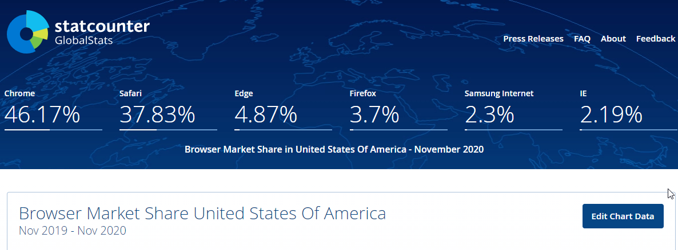

**Following modules were tested:**

* The main Page (30min)
* How It works (30min)
* About (10min)
* Reviews (15 min)
* Contact (20min)
* FAQ (20min)
* Buy secret now (40-50min)

Both functional testing and non-functional testing (usability testing, UI) have been done, as well as smoke testing and critical path testing. As a result, there was created a detailed Bug Report.

**Following bugs were found:**

|  |  |  |
| --- | --- | --- |
| Summary | severity | priority |
| Option to buy sensors disappears if you had chosen weight before | critical | high |
| There is no delete or add/change option on the basket | critical | high |
| Sticky header with phone number and promo code disappears on the pages as “About“, “FAQ”, “Contacts”, “Buy secret now”, “Reviews”. | critical | high |
| Low site’s downloading speed (source https://developers.google.com/speed) It is 9 from 100 | critical | high |
| There is no Menu Panel on the 'Order' page | major | high |
| There is a strange pic under icon 4k on page “how it works” | minor | low |
| A horizontal scroll on the “Order” page | minor | low |
| On click “cart” or “return to cart” it is required to enter password to continue using the website | critical | high |
| There is no phone number on “contact” page | major | high |
| There is no placeholder tip for email field (example@example.com) | minor | low |
| On FAQ page link is for main page, not for list( that text promised) | minor | medium |
| For Subscription the User is asked to enter ‘IP Address’ User Agent’ and other irrelevant data . | critical | high |
| There is 404 error on the mane page in console | major | medium |
| Page refreshing cancels likes and dislikes | major | high |
| There is an old promo code “black friday” on the main page | major | high |
| The FAQ page phone from one part doesn’t work as a “tel” label on code. | minor | low |

**Here is a couple improvements:**

Do the promo-code clickable on the basket.

Mark visited links with another color.

**Conclusion**

Site can be deployed in production on the condition that

1. all the critical bugs are fixed
2. the contact info is checked and placed in the related pages
3. there was added the possibility to edit (as delete/add items) cart items
4. correctly calculated the discount with the promo.