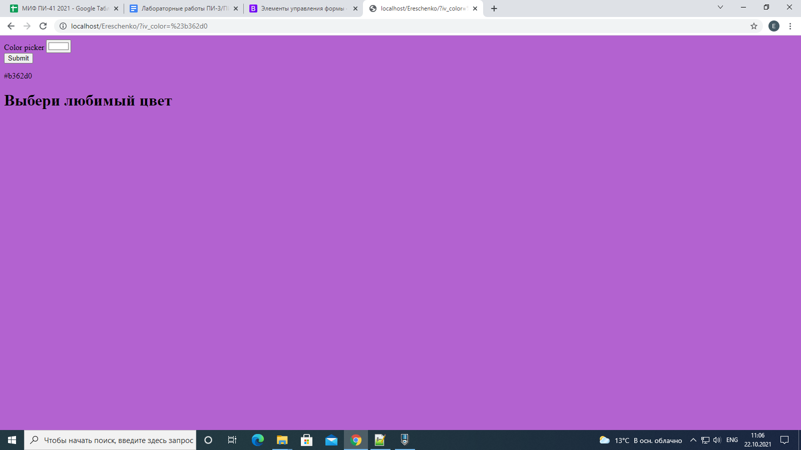

<form action="/Ereschenko/" method="GET">

<div class="mb-3">

<label for="exampleColorInput" class="form-label">Color picker</label>

<input name="iv_color" type="color" class="form-control form-control-color" id="exampleColorInput"

value="#ffffff"" title="Choose your color">

</div>

<button type="submit" class="btn btn-primary">Submit</button>

</form>

<?

if (isset($_GET["iv_color"]))

print_r($_GET["iv_color"]);

$bg_color = "#fff";

if (isset($_GET["iv_color"]))

$bg_color = $_GET["iv_color"];

else

$bg_color = "#fff";

?>

</head>

<body style="background-color:<?=$bg_color?>">

<div class="container">

<h1><?

echo "Выбери любимый цвет"?></h1>

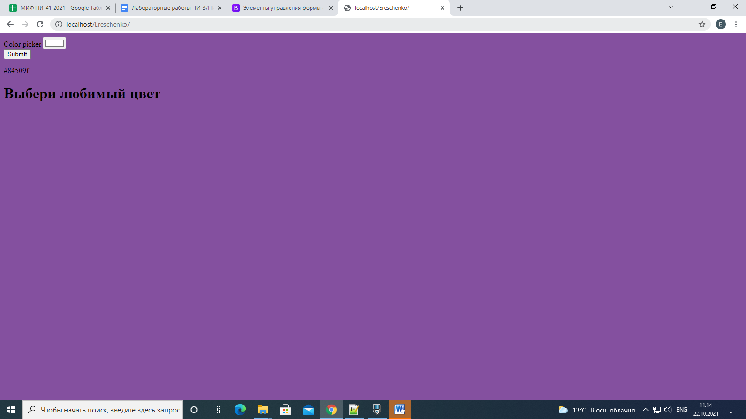

<form action="/Ereschenko/" method="POST">

<div class="mb-3">

<label for="exampleColorInput" class="form-label">Color picker</label>

<input name="iv_color" type="color" class="form-control form-control-color" id="exampleColorInput"

value="#ffffff"" title="Choose your color">

</div>

<button type="submit" class="btn btn-primary">Submit</button>

</form>

<?

if (isset($_POST["iv_color"]))

print_r($_POST["iv_color"]);

$bg_color = "#fff";

if (isset($_POST["iv_color"]))

$bg_color = $_POST["iv_color"];

else

$bg_color = "#fff";

?>

</head>

<body style="background-color:<?=$bg_color?>">

<div class="container">

<h1><?

echo "Выбери любимый цвет"?></h1>