Katherine Brown (Graham)
Milestone 2
2/22/2026
Updated ERD:
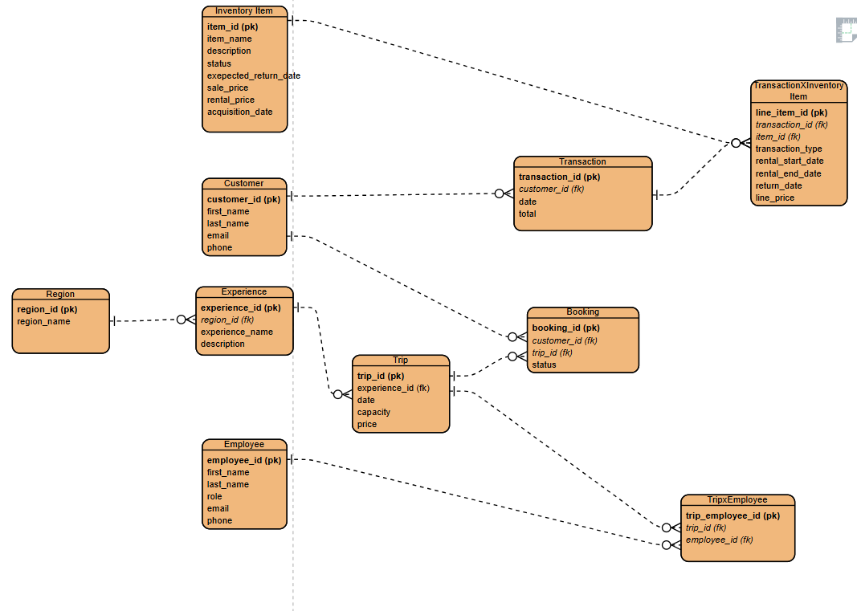

Scripts:
Output: