Katherine Brown (Graham)
Module 2 Assignment 3
12/14/2025
SQL:
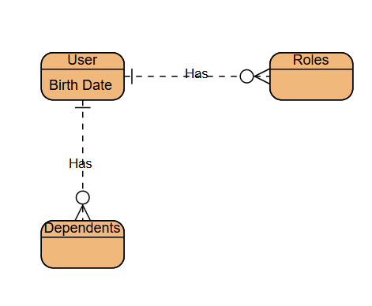

NoSQL:
