Project: Test Plan
Course: CSD380 - DevOps
Description: Todo app testing.
Date: 2026/01/14
To complete the test case plan, fill out the information for Project, Course, Description and Date in the header below.
.
TABLE OF CONTENTS
Allow users to access the website through a standard URL. 2
Create Task 2
Edit Task 3
Delete Task 4
Preventing Empty Submission 5

For each test, the developer should: provide a test description, a test objective, the developer name and date tested. For each step, fill out the actions to be taken and describe the expected results, and indicate yes or no for each step depending upon the result. The peer tester should provide their name, date tested, indicate yes or no for each step depending upon the result, and a screenshot (thumbnail) of the result.

Test 1 | Allow users to access the website through a standard URL.
 | Test Objective: Allow users to access the website with the standard URL: https://buwebdev.github.io/todo | Developer: Brennan Cheatwood  Date tested: <2026/01/14> | Peer tester: Kate Graham  Date tested: 1/18/2026
Step | Action | Expected results: | Developer pass/fail | /Tester pass/fail
1 | Visit https://buwebdev.github.io/todo in a web browser. | The page will display without errors. | Yes | Yes 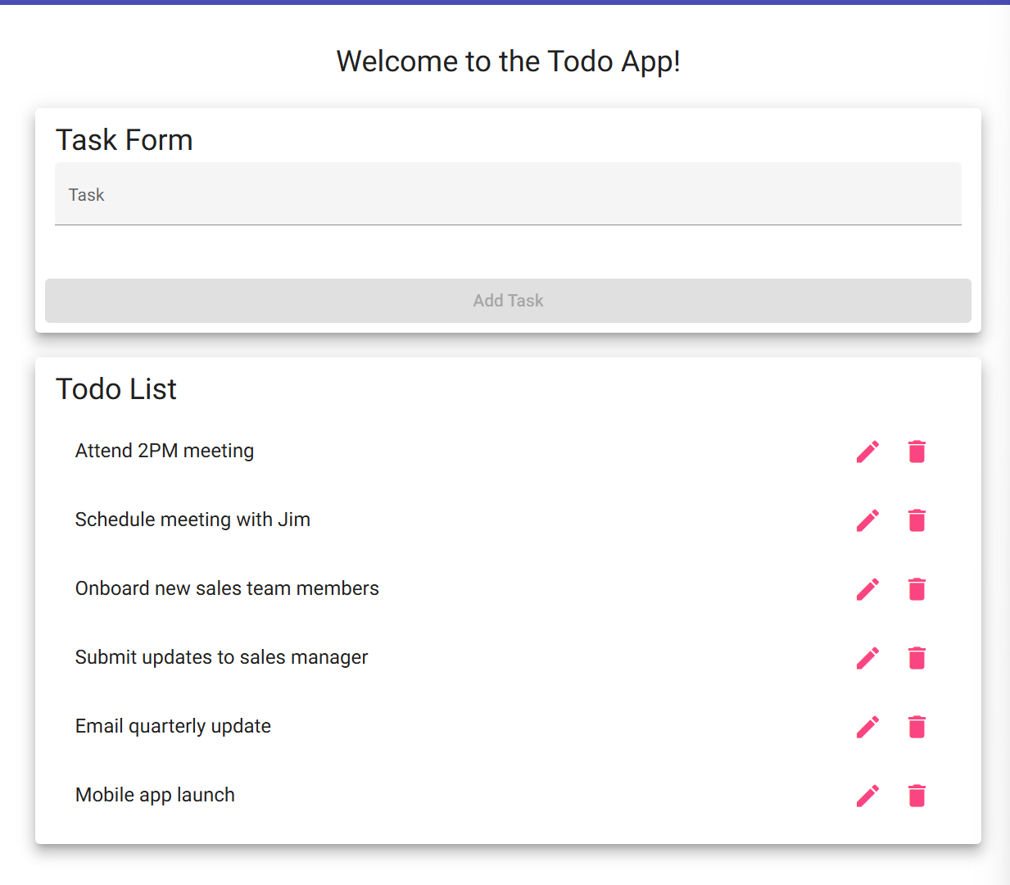
2 | Refresh the browser window | The page will refresh without errors. | Yes | Yes 
Comments | Site loads appropriately and reload works as well.

Test 2 | Create Task
 | Test Objective: Create a new todo task item. | Developer: Brennan Cheatwood  Date tested: 2026/01/14 | Peer tester: Kate Graham  Date tested: 1/18/2026
Step | Action | Expected results: | Developer pass/fail | Tester pass/fail
1 | Click underneath “Task Form” to input text | The Task Form will allow the user to input text | Yes | Yes 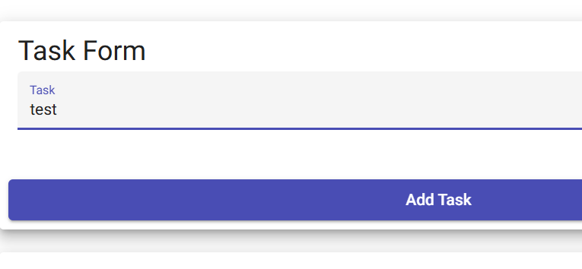
2 | Click “Add Task” once text is entered | The text entered inside the task form will appear in the Todo List section. | Yes | Yes
Comments | Adding new tasks works appropriately however when refreshing, my new tasks disappear. Please consider making them persistent.

Test 3 | Edit Task
 | Test Objective: Edit a todo task item. | Developer: Brennan Cheatwood  Date tested: <2026/01/14> | Peer tester: Kate Graham  Date tested: 1/18/2026
Step | Action | Expected results: | Developer pass/fail | Tester pass/fail
1 | Click the pencil icon on a task | An “Edit Form” dialogue window will appear giving the option to edit the text of the task. | Yes | Yes 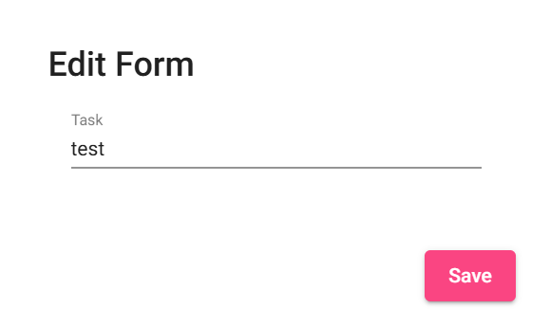
2 | Click “Save” once the text is edited. | The updated text will appear on the Todo List. | Yes | Yes 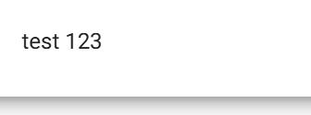
Comments | Editing task works however it allows me to delete all characters and submit an empty Todo task. Please update.

Test 4 | Delete Task
 | Test Objective: Delete a todo task item. | Developer: Brennan Cheatwood  Date tested: <2026/01/14> | Peer tester: Kate Graham  Date tested: 1/18/2026
Step | Action | Expected results: | Developer pass/fail | Tester pass/fail
1 | Click the Trash icon on a desired task | The selected task will be removed from the list immediately. | Yes | Yes 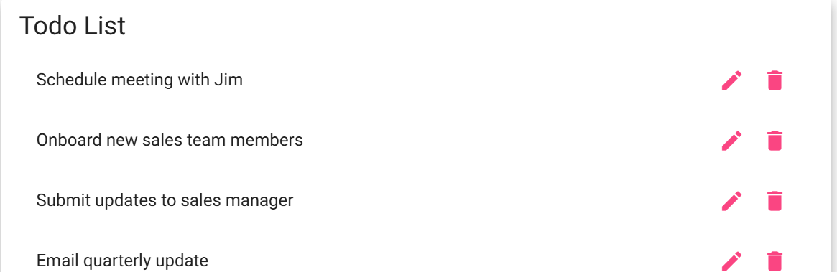
2 | Ensure the Todo List is updated accordingly. | The todo list will be updated and the previously selected task will not appear. | Yes | Yes 
Comments | Deleting a task worked appropriately however when I refreshed the page, the tasks I’ve deleted are back. Please update.

Test 5 | Preventing Empty Submission
 | Test Objective: Prevent users from submitting a task form without entering a todo item | Developer: Brennan Cheatwood  Date tested: <2026/01/14> | Peer tester: Kate Graham  Date tested: 1/18/2026
Step | Action | Expected results: | Developer pass/fail | Tester pass/fail
1 | Leave submission form blank | The “Add Task” button will stay grey | Yes | Yes 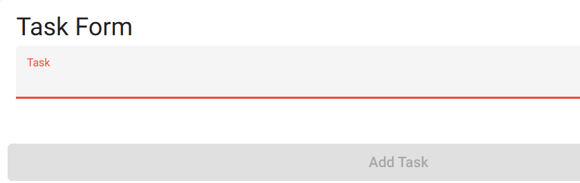
2 | Click the greyed-out “Add Task” button to ensure submission isn’t possible. | Nothing will happen when the button is clicked. | Yes | Yes 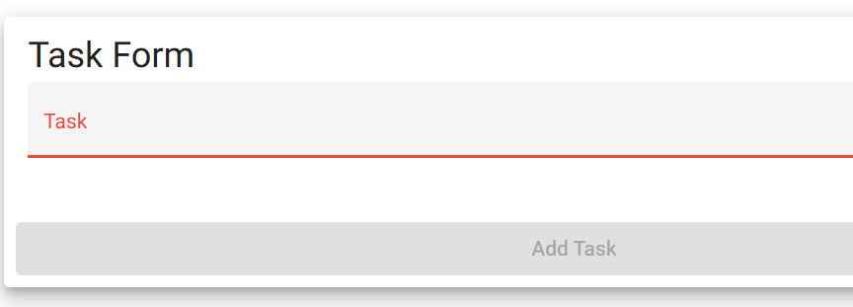
Comments | System does not allow blank submission but please consider dropping the minimum character count to 3 instead of 4.

