Project: <Enter a project name>
Course: <Enter the course number and name>
Description: <Enter a description>
Date: <Enter a date (yyyy/mm/dd)>
To complete the test case plan, fill out the information for Project, Course, Description and Date in the header below.
.
TABLE OF CONTENTS
<DESCRIPTION> 2
<DESCRIPTION> 2
<DESCRIPTION> 3

For each test, the developer should: provide a test description, a test objective, the developer name and date tested. For each step, fill out the actions to be taken and describe the expected results, and indicate yes or no for each step depending upon the result. The peer tester should provide their name, date tested, indicate yes or no for each step depending upon the result, and a screenshot (thumbnail) of the result.

Test 1 | Todo App Visual Test
 | Test Objective: Verifies that the Todo App and list loads without issue | Developer: Hugo Ramirez  Date tested: 2026/01/16 | Peer tester: Kate Graham  Date tested: 1/18/2026
Step | Action | Expected results: | Developer pass/fail | Tester pass/fail  + Screenshot
1 | Visit https://buwebdev.github.io/todo/ | Page displays normal layout without any issues | Yes | Yes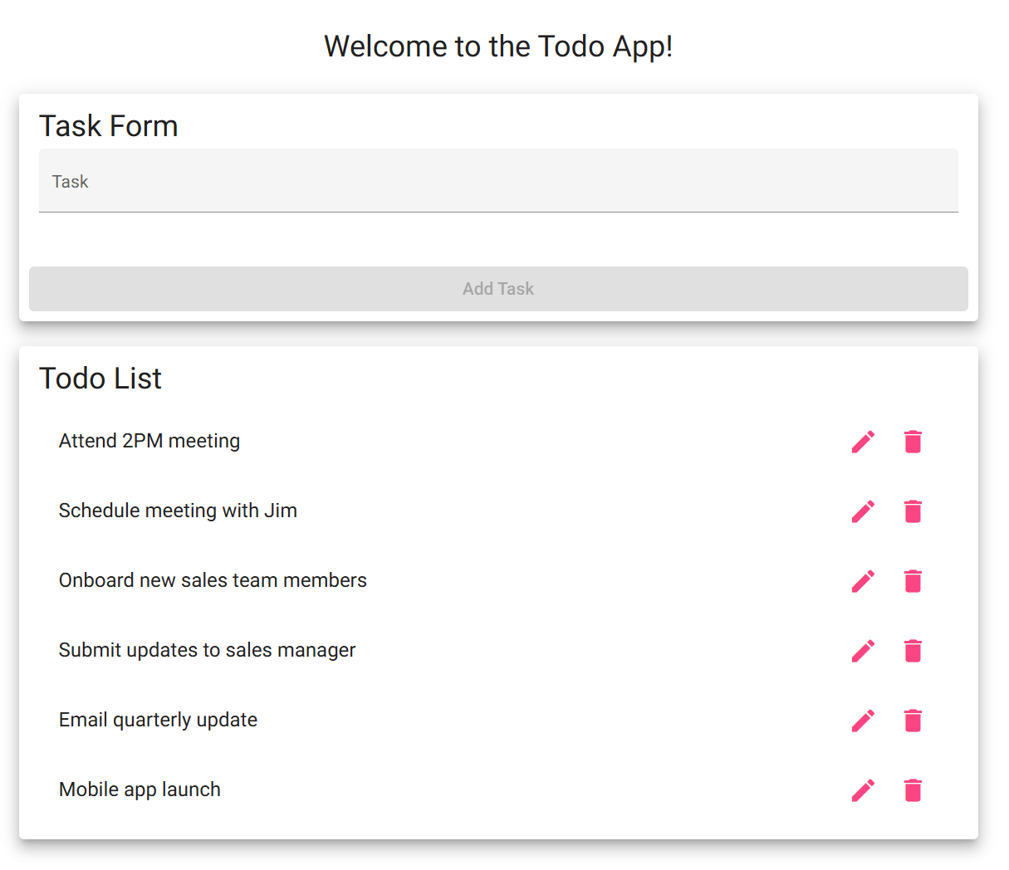
2 | Does the Todo List load correctly | List appears without any visual issues | Yes | Yes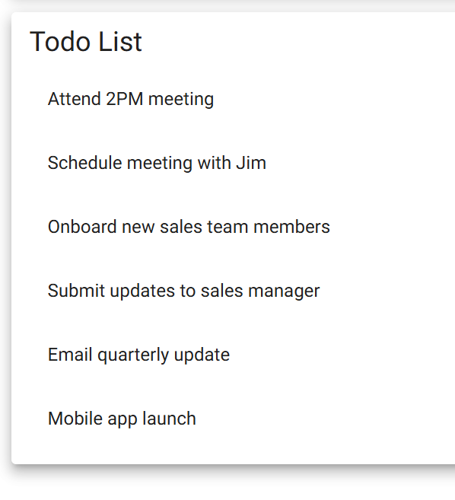
3 | Refresh the page | Page refreshes without errors | Yes | Yes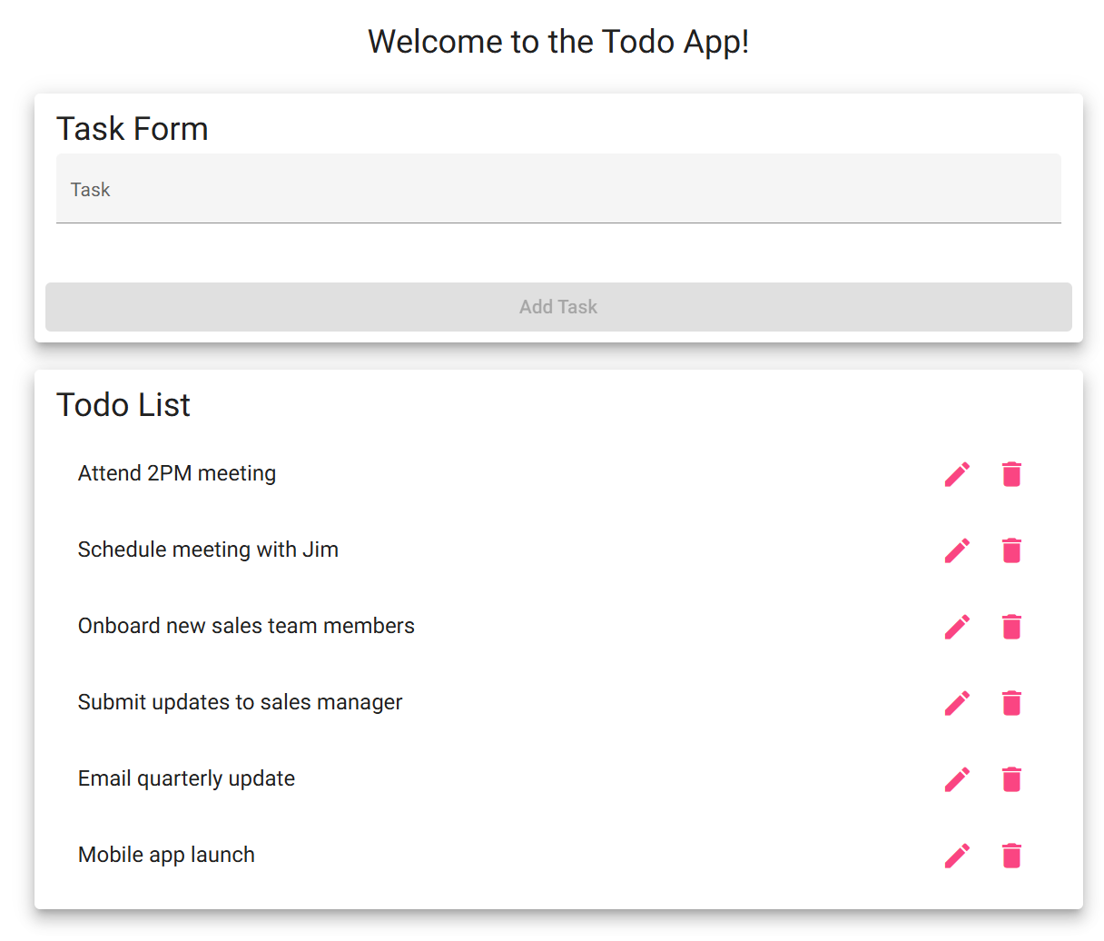
4 | Confirm if the page refreshed correctly | Page displays normal layout without any issues | Yes | Yes
5 | Confirm if the Todo list appears correctly after the refresh | List appears without any visual issues | Yes | Yes 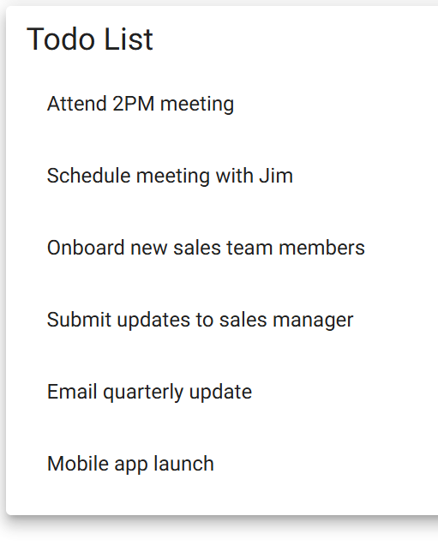
Comments | Page loads appropriately. Refresh works as well. Todo List loads after each refresh.

Test 2 | Creating a Task
 | Test Objective: Checks the Apps ability to create a task | Developer: Hugo Ramirez  Date tested: 2026/01/16 | Peer tester: Kate Graham  Date tested: 1/18/2026
Step | Action | Expected results: | Developer pass/fail | Tester pass/fail
1 | Click on the task input field | A blinking cursor appears blinking | Yes | Yes 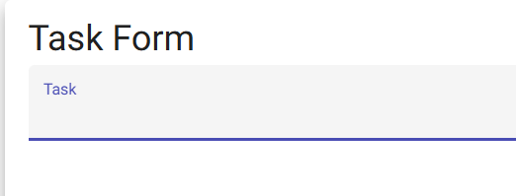
2 | Type “Cat” into the input field | “Add Task” button is still greyed out | Yes | Yes 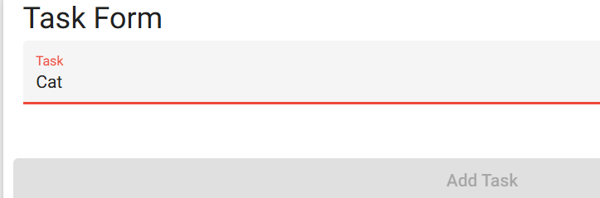
3 | Type “Feed cat” into the input field | “Add Task” button turned blue | Yes | Yes 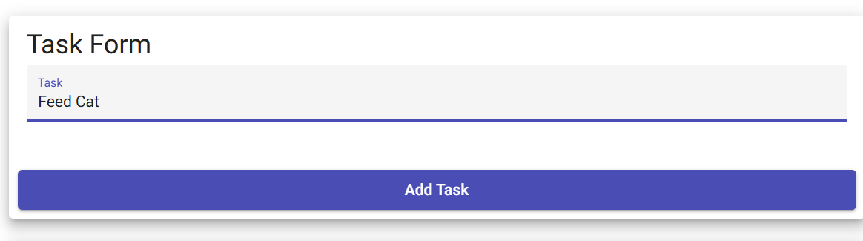
4 | Click “Add Task” button to add “Feed cat” task to the Todo List | “Feed cat” task appears at the bottom of the Todo List | Yes | Yes 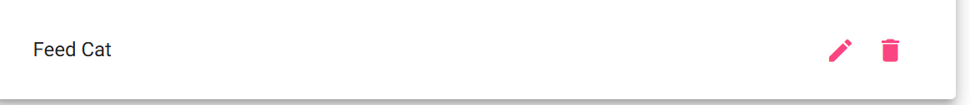
Comments | Adding tasks works appropriately, I have concerns about the minimum length of tasks. For example “Run” as a task in my day will now have to be expanded to “go for a run”. I think a minimum character count of 2 could be more appropriate. Tasks also disappear after reload.

Test 3 | Edit Task
 | Test Objective: Checks if user can edit a task | Developer: Hugo Ramirez  Date tested: 2026/01/16 | Peer tester: Kate Graham  Date tested: 1/18/2026
Step | Action | Expected results: | Developer pass/fail | Tester pass/fail
1 | Click the pencil icon for “Attend 2PM meeting” to edit the task | Edit Form for task “Attend 2PM meeting” appears | Yes | Yes 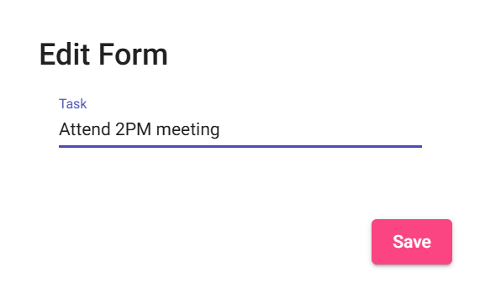
2 | Change the time from 2PM to 3PM and click save | Task “Attend 2PM meeting” changes to “Attend 3PM meeting” | Yes | Yes 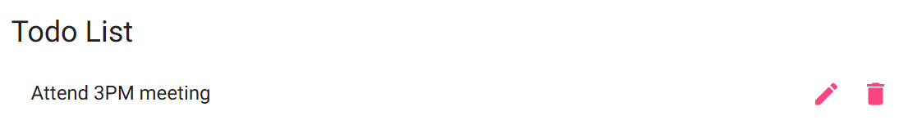
3 | Confirm that there is no visual change besides the task name changing | Task “Attend 3PM meeting” is in the same location that “Attend 2PM meeting” was | Yes | Yes 
4 | Change the created task “Feed cat” to “Feed dog” to edit the task | The created task “Feed cat” changes to “Feed dog” | Yes | Yes 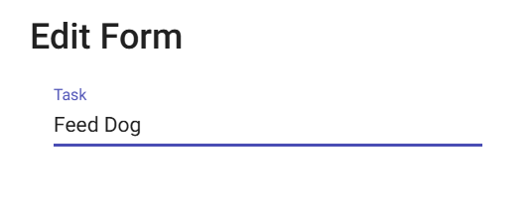
5 | Confirm that there is no visual change besides the task name changing | Task “Feed dog” is in the same location that “Feed cat” was | Yes | Yes
Comments | Edit works appropriately but does allow edit to remove all characters with no validations. Please update.

Test 4 | Delete Task
 | Test Objective: Checks if user can delete a task | Developer: Hugo Ramirez  Date tested: 2026/01/16 | Peer tester: Kate Graham  Date tested: 1/18/2026
Step | Action | Expected results: | Developer pass/fail | Tester pass/fail
1 | Click the trash can icon “Attend 2PM meeting” to delete the icon | The task “Attend 2PM meeting” is deleted from the Todo List | Yes | Yes 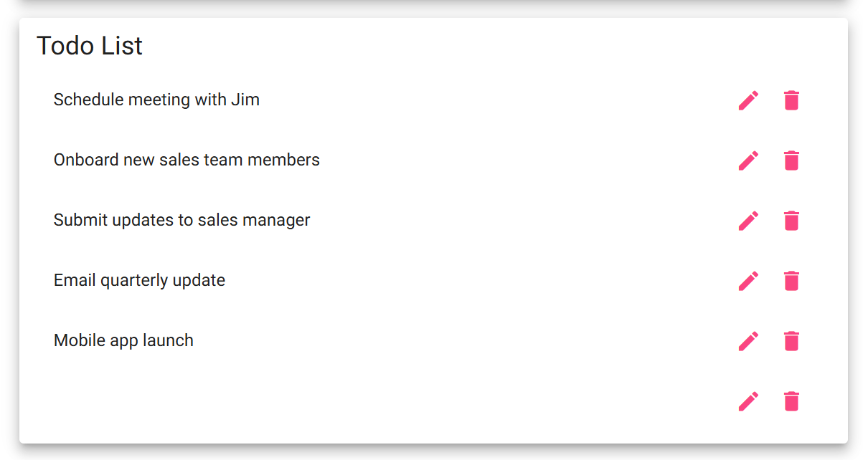
2 | Confirm that there are no visual changes or issues besides the task being deleted | There is one less task | Yes | Yes 
3 | Delete the created task “Feed dog” | The created task “Feed dog” is deleted | Yes | Yes 
4 | Confirm that there are no visual changes or issues besides the task being deleted | Task “Feed dog” is deleted from the Todo List | Yes | Yes 
Comments | Delete function works appropriately but when reloading, deleted tasks are back. Also consider an undo button or “are you sure you’d like to delete this item” for things deleted in error.

Test 5 | Custom 404 error
 | Test Objective: Checks if user can delete a task | Developer: Hugo Ramirez  Date tested: 2026/01/16 | Peer tester: Kate Graham  Date tested: 1/18/2026
Step | Action | Expected results: | Developer pass/fail | Tester pass/fail
1 | Visit https://buwebdev.github.io/todo/not-found | Page displays error message “not-found works!” | Yes | Yes 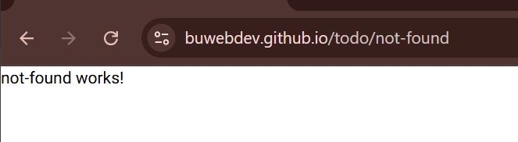
2 | Confirm that entering the wrong URL takes a user to the not-found error page by modifying https://buwebdev.github.io/todo/ by adding an ‘e’ after the last slash | Page displays error message “not-found works!” and the URL is https://buwebdev.github.io/todo/not-found | Yes | Yes 
3 | Refresh the not-found error page | Page displays error message “not-found works!” and the URL is https://buwebdev.github.io/todo/not-found after the refresh | Yes | Yes 
Comments | Page does redirect to not found. Consider adding a link back to appropriate site from ‘not found’ page for ease of user experience.

