Katherine Brown (Graham)
Module 1 – Assignment 2
12/7/2025
Introduction
The term DevOps rose to popularity in 2009 at the O’Reilly Velocity Conference. John Allspaw and Paul Hammond’s presentation, “10+ Deploys per Day: Dev and Ops Cooperation at Flickr” emphasized the importance of collaboration between development and operations teams for the rapid and reliable software delivery (Bunnyshell, 2021). Following this event, it gained traction as a philosophy in technology, although versions of this concept had existed in manufacturing for decades.
DevOps is a philosophy of practices, cultural values, and tools used to integrate development and operations teams. Within DevOps, ideas of cross team communication, collaboration, and automation are explored in differing manners depending on the specific methodology that is utilized (Atlassian, n.d.). Three major influences on DevOps include the Lean Movement, the Agile Manifesto, and the Continuous Delivery Method.
The Lean Movement
Lean Manufacturing was inspired by the Toyota Manufacturing Method in the late 1980s. Centered around the idea of continuous improvement, companies were encouraged to keep inventory at a minimum, minimize order queues, and maximize efficiency. Each step of the process was evaluated for inefficiencies and improved on a small scale knowing that elimination of these individually would benefit the process as a whole (Bunnyshell, 2021). 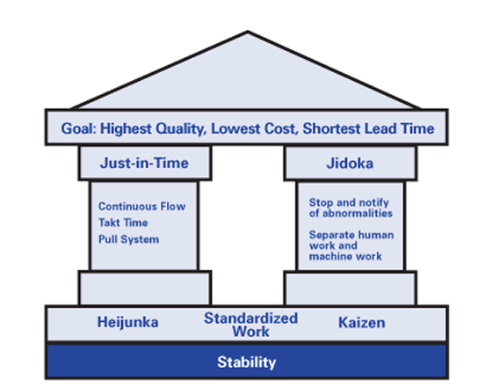
While Toyota inspired this, the term Lean was first introduced in the book The Machine That Changed the World by James P. Womack, Daniel T. Jones and Daniel Roos. Their research condensed Toyota’s practices into the following principles: identifying value, mapping the value stream, creating a flow, establishing pull, seeking perfection and repeating this cycle continuously (The Lean Way, 2017).
The Agile Manifesto
The Agile Manifesto was created in 2001 by 17 people who met to discuss the future of development. Their goal was to identify common values between the methodologies of scrum, extreme programming, crystal clear and other frameworks. The Agile Manifesto emphasizes valuing individuals and interactions over processes and tools, working software over comprehensive documentation, customer collaboration over contract negotiation, and responding to change over following a plan (Drumond, n.d.).
The manifesto succeeds as an amalgamation of these original practices because it incorporates the structure and iterative cadence of scrum, the technical rigor and discipline of extreme programming, and the context related adaptable nature of crystal clear (Hohl, Dingsøyr, & Moe, 2018).
The Continuous Delivery Movement
Continuous Delivery was popularized in the book Continuous Delivery by Jez Humble and David Farley in 2010. The philosophy is to develop in a manner that every change is constantly ready to be deployed. Continuous Delivery also builds on the idea of Continuous Integration which includes automated testing to reduce errors. This enables teams to deploy at any time while reducing manual effort and risk (CircleCI, 2021).
Conclusion
The history of DevOps is full of ideas building upon and aiming to take the best practices from its predecessor similar to the aim of the iterative cycle introduced by the Lean Method. Through this, software development will continue to be more efficient provided companies allow the flexibility needed for developers to work effectively with operations.

Citation
Atlassian. What is DevOps? Retrieved December 7, 2025, from https://www.atlassian.com/devops
Bunnyshell. (2021, April 1). History of DevOps – When did DevOps become a thing? https://www.bunnyshell.com/blog/history-of-devops/
CircleCI. (2021, June 16). A brief history of DevOps, Part IV: Continuous delivery and continuous deployment. https://circleci.com/blog/a-brief-history-of-devops-part-iv-continuous-delivery-and-continuous-deployment/
Drumond, C. (n.d.). Agile Manifesto. Atlassian. https://www.atlassian.com/agile/manifesto
Hohl, P., Dingsøyr, T., & Moe, N. B. (2018). Back to the future: origins and directions of the “Agile Manifesto”. Journal of Software: Evolution and Process, 30(9), e2141. https://doi.org/10.1002/smr.2141
The Lean Way. (2017, August 5). What is Lean? Lean manufacturing & lean enterprise. https://theleanway.net/what-is-lean

