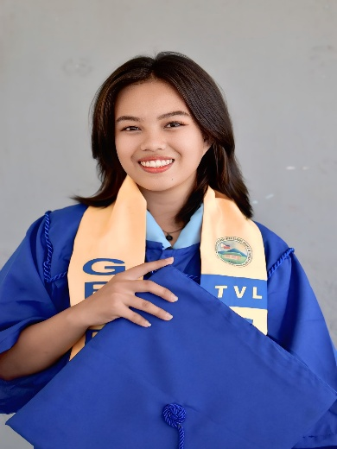




Profile
As an IT student and a graduate of the TVL Electronics strand, I carry with me a strong foundation of both technical skills and practical experience. My journey began with understanding the basics of circuits, troubleshooting, and hands-on problem-solving skills that shaped my discipline and attention to detail. Now in the field of Information Technology, I continue to grow by exploring programming, systems, and digital innovations that drive the modern world.
I believe that every challenge I encounter is an opportunity to learn and improve. From fixing hardware issues to developing solutions through technology, I am committed to becoming someone who not only understands systems but also creates meaningful impact through them. My background in electronics taught me resilience and precision, while my IT journey fuels my creativity and passion for continuous learning. I am not just preparing for a career, I am building a future where I can innovate, adapt, and make a difference.

Work Experience
During my On-the-Job Training as an Electronics student, I discovered my true strengths through hands-on experience and real-world challenges. I proved to be adaptable and quick to learn, especially when working with electronic components, troubleshooting systems, and following technical procedures. My attention to detail and patience helped me complete tasks accurately, even under pressure. I also developed strong teamwork and communication skills by collaborating with supervisors and co-trainees, showing professionalism and responsibility in every task assigned to me.
This experience inspired me to become more confident in my abilities and more determined to grow in my field. Being assessed as competent is not just a recognition of my skills, but a reflection of my dedication, hard work, and willingness to improve. It motivates me to keep learning, embrace challenges, and strive for excellence in everything I do. I believe that this journey is only the beginning, and I am ready to take on greater responsibilities as I continue building my career in electronics and technology.

Technical

Skills
- Programming: Java, C++
- Web Development: HTML, JavaScript
- Database Management: MySQL
- Networking Basics
- Microsoft Office (Word, Excel, PowerPoint)

LANGUAGE

- English
- Tagalog

kate fernandez
IT Student
09071290207
Katef5340@gmail.com
Brgy. Odiong, Moises Padilla

Education
Bachelor of Science in Information Technology

Central Philippines State University - Moises Padilla Campus
2025 – 2026

Electronic Products Assembly and Services (EPAS)

Guinpana-an National High School - Odiong Extension
2023 – 2024

Elementary
Odiong Elementary School
2017 - 2018

