Introduction to Software Development

Spring, 2024

Homework two

Instructor Wei Fang

**READ INSTRUCTIONS AND FOLLOW CAREFULLY!**

**Assignment two of three (5% towards your final course grade)**

Instructions

This assignment is due promptly by 11:59:59 PM on Wednesday March 20. We will go over answers during the lecture on March 21.

Please type your answers clearly and carefully.

You need to submit this file to the course’s page on Canvas. No email or print submission will be accepted.

For question 1, insert snapshots of results of your working programs.

For question 2 and 3, make sure you insert your source codes and snapshots of results.

For question4, write one single program. Insert your source codes and snapshot of result.

**This is a Word document. Insert your answers right below the questions. Submission in other formats will result deduction of one point.**

**Please make sure that you submit correct version. If you submitted wrong version, only the version closes to the deadline will be graded and counted.**

Question 1: Copy and paste screen shots of your program and result screen shots. What would the following program print out? Explain briefly in English about each and every output (1 point)

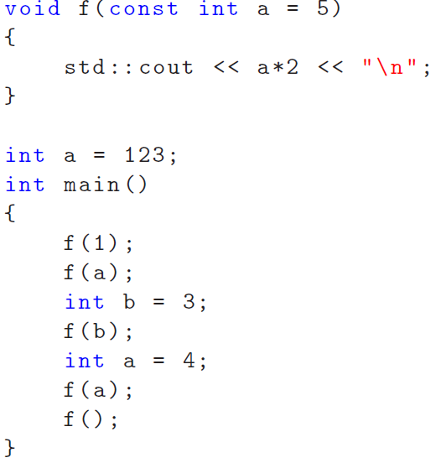

//Answer here:

Declare a void function named f. The function f accepts a constant integer a as its parameter, with a default value of 5.

For f(1), 1 is passed to the function f, resulting in the output 2 (since 1 * 2 = 2).

For f(a), the global variable a, with a value of 123, is passed to f, resulting in the output 246 (123 * 2 = 246).

For f(b), the variable b, which has a value of 3, is used, leading to an output of 6 (3 * 2 = 6).

For the second f(a), a local variable a with a value of 4 is used. Here, the global variable a (value 123) is overshadowed, and the output is 8 (4 * 2 = 8).

For f(), with no argument provided, the function's default parameter of 5 is used, resulting in an output of 10 (5 * 2 = 10)."

Question 2: c/p screen shots of your entire program and results. What does the function below do? **Explain** briefly in English and **finish** the whole program by allowing the user to input in the run time. Draw a flowchart (1 points)

void test (char *test = “\n”, int n = 1 ) {

for ( int i = 0; i < n; ++i ) {

cout << test;

}

}

//your program and working snapshot here:

#include <iostream>

#include <string>

using namespace std;

void test(const char* test = "\n", int n = 1) {

for (int i = 0; i < n; ++i) {

cout << test;

}

}

int main() {

string userInput;

int times;

cout << "Enter a string: ";

getline(cin, userInput);

cout << "Enter the number of times to print: ";

cin >> times;

test(&userInput[0], times);

return 0;

}

// The void function takes two parameters: test and n. The default value for test is "\n", and the default value for n is 1. It uses a for loop to print the string pointed to by test n times.

Question 3: copy and paste screen shots of your entire program and results. Consider the following function, finish the function by allowing it to identify if x is a negative number or a nonnegative number. Write a **full program using this function** to output the result to the user. (1 points)

void setTest (char **setPointer) {

int x;

cin >> x;

// your function code here

cout<<”\n”;

cout<<”Homework 2 q3.”;

}

//your main program and working snapshot here

#include <iostream>

using namespace std;

void setTest(char** setPointer)

{

int x;

cin >> x;

if (x < 0)

{

cout << "negative number";

}

else

{

cout << "nonnegative number";

}

cout << "\n";

cout << "Homework 2 q3.";

}

int main()

{

cout << "Enter a number: ";

setTest(nullptr);

return 0;

}

// The aim of this code is to distinguish between negative and nonnegative numbers, and it prints a corresponding message to the console. The ** symbol denotes a pointer to a pointer. However, I'm not using the char ** setPointer parameter, so I signify this by passing nullptr in the main function.

Question 4: copy and paste screen shots of your entire program and results. Write a program that takes nine integer as its arguments from command line. The first eight arguments are going to be sorted using the bubble sort. The ninth numeric argument is going to be used as the keyword that will be searched for by your program using binary search. Your program should display the original unsorted inputs (note: without the 9th argument, which is the searching keyword), then displays the sorted inputs, and then displays the position of the keyword in the sorted array. Your program should be able to handle basic exceptions as demoed below (2 points):

__________________________

C:\ >ISD-Homework2-Q4.exe

Please type in at least one argument.

C:\ >ISD-Homework2-Q4.exe 23 4 3 5 6

Pleas type in exact 9 arguments.

C:\ >ISD-Homework2-Q4.exe 5 6 9 10 94 2 5 3 10

Your original inputs are:

5

6

9

10

94

2

5

3

Sorted inputs are:

2 in position: 0

3 in position: 1

5 in position: 2

5 in position: 3

6 in position: 4

9 in position: 5

10 in position: 6

94 in position: 7

That number 10 is found at element 6 in the array.

//Your codes and working snapshot below

#include <iostream>

#include <vector>

#include <cstdlib>

#include <algorithm>

using namespace std;

// bubble sort

void bubbleSort(vector<int>& arr) {

int n = arr.size();

for (int i = 0; i < n - 1; i++) {

for (int j = 0; j < n - i - 1; j++) {

// Swap if the element found is greater than the next element

if (arr[j] > arr[j + 1]) {

swap(arr[j], arr[j + 1]);

}

}

}

}

// binary search

int binarySearch(const vector<int>& arr, int x) {

int low = 0, high = arr.size() - 1, mid;

while (low <= high) {

mid = low + (high - low) / 2;

// // If element is present at the middle itself

if (arr[mid] == x) {

return mid;

}

// If element is greater, ignore left half

else if (arr[mid] < x) {

low = mid + 1;

}

// If element is smaller, ignore right half

else {

high = mid - 1;

}

}

return -1;

}

int main(int argc, char* argv[]) {

if (argc < 2) {

cout << "Please type in at least one argument.\n";

return 1;

}

else if (argc != 10) {

cout << "Please type in exact 9 arguments.\n";

return 1;

}

// store numbers

vector<int> numbers;

for (int i = 1; i <= 8; i++) {

numbers.push_back(atoi(argv[i]));

}

int keyword = atoi(argv[9]);

cout << "Your original inputs are:\n";

for (int i = 1; i <= 8; i++) {

cout << atoi(argv[i]) << endl;

}

// sort the numbers

bubbleSort(numbers);

cout << "Sorted inputs are:\n";

for (int i = 0; i < numbers.size(); i++) {

cout << numbers[i] << " in position: " << i << endl;

}

int position = binarySearch(numbers, keyword);

if (position != -1) {

cout << "\nThat number " << keyword << " is found at element " << position << " in the array.\n";

}

else {

cout << "\nThat number " << keyword << " is not found in the array.\n";

}

return 0;

}

