Introduction to Software Development
Spring, 2024 Instructor Wei Fang

Assignment three of three (5% of towards the final course grade)
This assignment is due promptly by 11:59 PM on Wednesday April 10,2024
Please write down your answers clearly and carefully. You need to provide screen shots of your source codes and running results.

Write down your name: Kai-Yin Huang
Write down your email address: kh966@scarletmail.rutgers.edu

Class debug questions (one and half points):
The following code snippets have bugs. Identify them and write down your full codes. Explain briefly in English.
1)
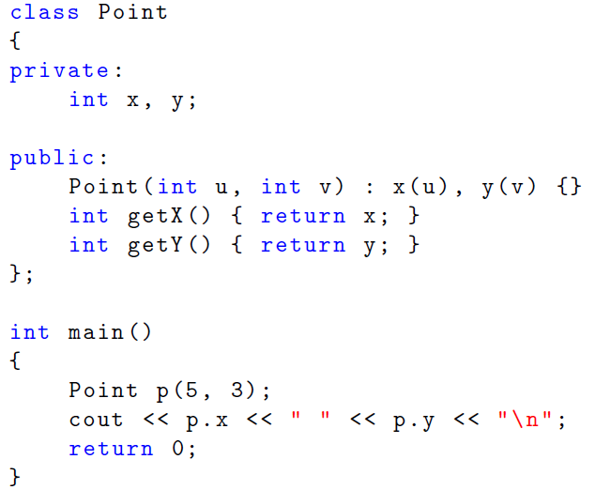
Screen captures of your codes and output file.
#include <iostream>
using namespace std;
class Point {
private:
int x, y;
public:
Point(int u, int v) : x(u), y(v) {}
int getX() { return x; }
int getY() { return y; }
};
int main() {
Point p(5, 3);
cout << p.getX() << " " << p.getY() << "\n";

return 0;
}
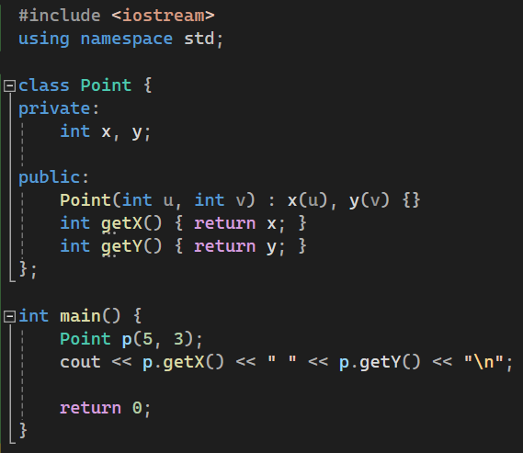


Private members are accessible only within their class, not from external locations such as the main function or other classes. Therefore, to access p.x and p.y, one must use p.getX() and p.getY() instead.

2)
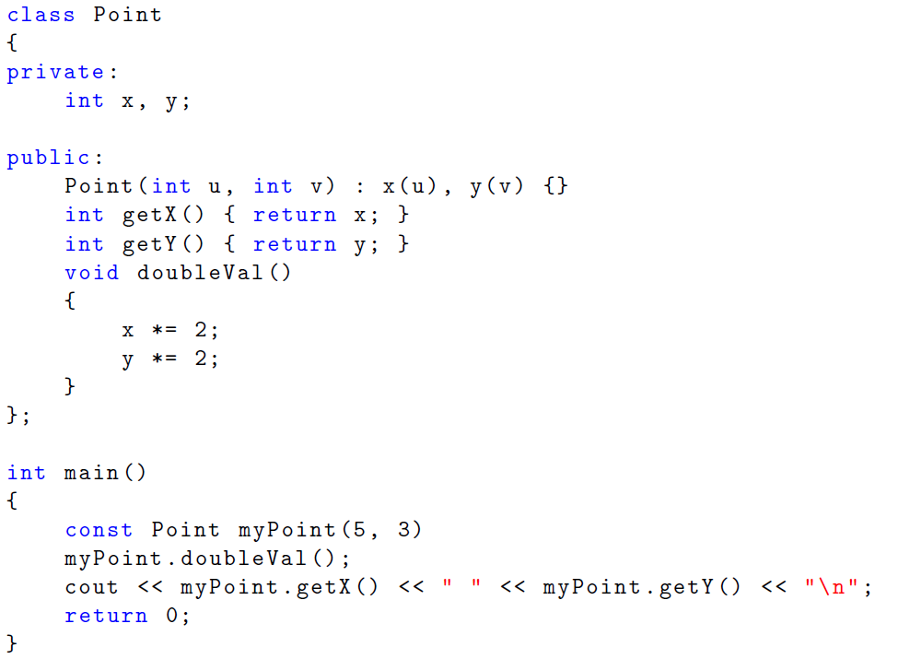
Screen captures of your codes and output file.
#include <iostream>
using namespace std;

class Point {
private:
int x, y;
public:
Point(int u, int v) : x(u), y(v) {}
int getX() const { return x; }
int getY() const { return y; }
void doubleVal()
{
x *= 2;
y *= 2;
}
};

int main() {
Point myPoint(5, 3);
myPoint.doubleVal();
cout << myPoint.getX() << " " << myPoint.getY() << "\n";

return 0;
}
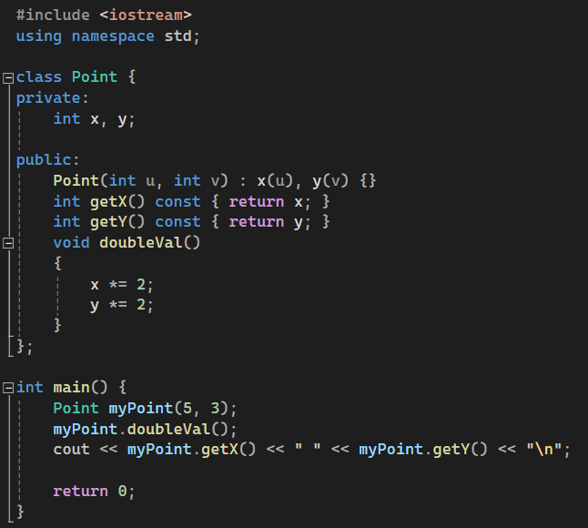


The program shows a Point class for creating points, doubling their coordinates, and accessing their values. It was revised by removing the const qualifier from myPoint to allow modifications and by marking getX() and getY() as const to designate them as non-modifying accessors, thus resolving issues related to state modification and method use on const instances.

3) In addition to debugging and writing descriptions of bugs, separate the class’s declaration into a header a file named Point.h. Separate the implementation into another file named Point.cpp. Use the newly established header file Point.h into main program in your project’s source.cpp .
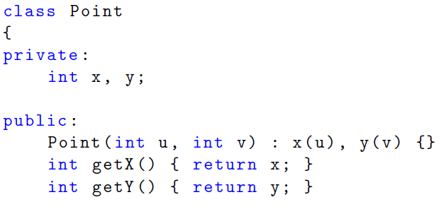
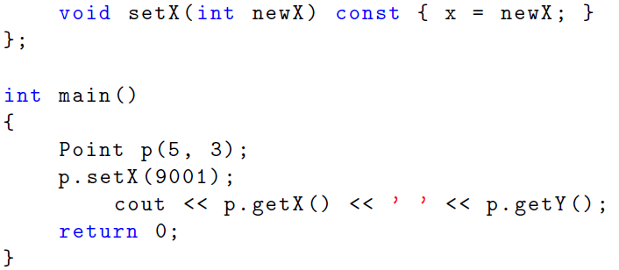
Screen captures of your codes and output file.

The code had two problems. First, when making a new Point, it mixed up setting the y value, using an incorrect way that didn't work. Second, the setX method was not supposed to be const because it changes the value of x, but it was marked as const, making it confusing.

// Point.h
class Point {
private:
int x, y;

public:
Point(int u, int v);
int getX();
int getY();
void setX(int newX);
};
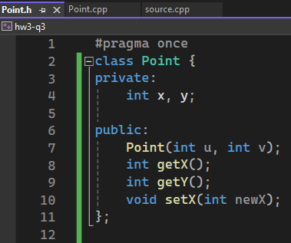
// Point.cpp
#include "Point.h"

Point::Point(int u, int v) : x(u), y(v) {}

int Point::getX() { return x; }

int Point::getY() { return y; }

void Point::setX(int newX) { x = newX; }
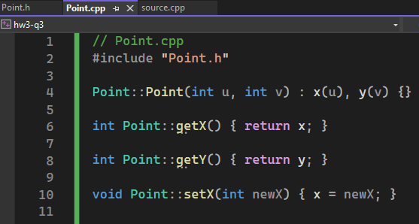

// source.cpp
#include <iostream>
#include "Point.h"

using namespace std;

int main() {
Point p(5, 3);
p.setX(9001);
cout << p.getX() << ' ' << p.getY();
return 0;
}
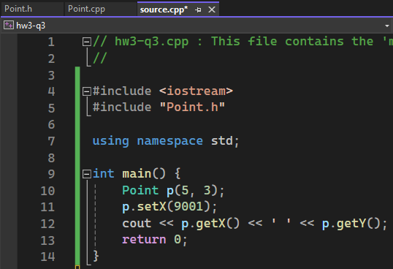
Class interface (three and half points):
Part one - Implement a class representing a point, appropriately named Point. Put your class definitions and function prototypes in a header file called ISD24.h, and your function definitions in a file called ISD24.cpp. If your functions are one-liners, you may choose to include them in the header file.
1 Foundation
Create the class with two private integers. Name them x and y.
2 Constructors
Implement constructors that, if called with 0 arguments, initializes a point to the origin – (0, 0) – but if called with two arguments x and y, creates a point located at (x,y). (Hint: You will need to use default arguments.)
Implement a destructor.
3 Member Functions
Support the following operations using the given function signatures:
•Get the x coordinate
int Point::getX() const
• Get the y coordinate
int Point::getY() const
• Set the x coordinate
void Point::setX(const int new x)
• Set the y coordinate
void Point::setY(const int new y)

Write down your implementation for part one here:

// ISD24.h
class Point {
private:
int x, y;
public:
Point(int x = 0, int y = 0);
~Point();

int getX() const;
int getY() const;
void setX(const int newX);
void setY(const int newY);
};

// ISD24.cpp
#include "ISD24.h"

Point::Point(int x, int y) : x(x), y(y) {}

Point::~Point() {}

int Point::getX() const { return x; }
int Point::getY() const { return y; }
void Point::setX(const int newX) { x = newX; }
void Point::setY(const int newY) { y = newY; }

Part two – write a program and save it as part of the source.cpp, that 1) uses the class you defined above. 2) declare a Point type named “pointerISD24”. 3) display initial values. 4) ask user to type in values for x and y. 5) display the updated x and y values. 6) ask inputs for six more records 7) save the input into a structured file using your own structure.

Screen captures of your header file, its cpp file, main program cpp file and output file.
// head file
class Point {
private:
int x, y;
public:
Point(int x = 0, int y = 0);
~Point();

int getX() const;
int getY() const;
void setX(const int newX);
void setY(const int newY);
};
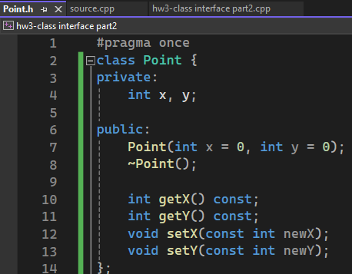

// source file
#include <iostream>
#include <vector>
#include <fstream>
#include "Point.h"

using namespace std;

int main() {
vector<Point> points;
int x, y;

Point pointerISD24;
cout << "Initial values of pointerISD24: x = " << pointerISD24.getX() << ", y = " << pointerISD24.getY() << endl;

cout << "Please enter new values for x and y: ";
cin >> x >> y;

pointerISD24.setX(x);
pointerISD24.setY(y);
cout << "Updated values of pointerISD24: x = " << pointerISD24.getX() << ", y = " << pointerISD24.getY() << endl;

points.push_back(pointerISD24);

for (int i = 0; i < 6; ++i) {
cout << "Enter values for x and y for Point " << i + 1 << ": ";
cin >> x >> y;
points.push_back(Point(x, y));
}

ofstream outFile("points.txt");
for (const auto& point : points) {
outFile << "x: " << point.getX() << ", y: " << point.getY() << endl;
}
outFile.close();

cout << "All points have been saved to points.txt." << endl;

return 0;
}
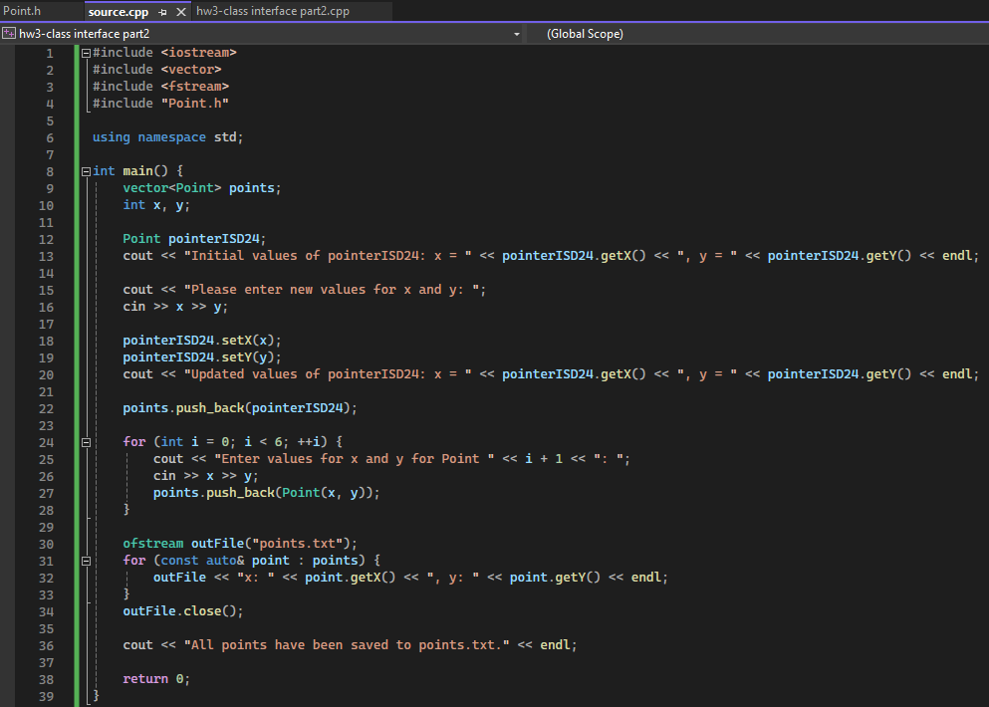
// main program file
#include "Point.h"

Point::Point(int x, int y) : x(x), y(y) {}

Point::~Point() {}

int Point::getX() const { return x; }
int Point::getY() const { return y; }
void Point::setX(const int newX) { x = newX; }
void Point::setY(const int newY) { y = newY; }
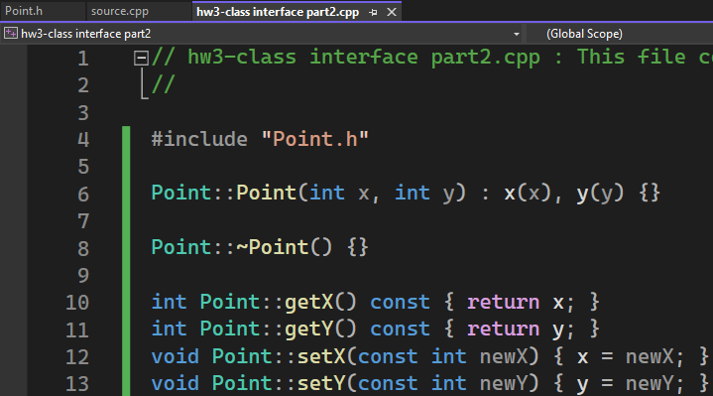

// ouput
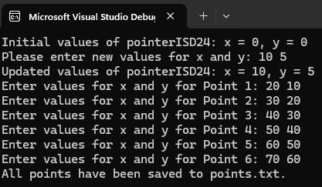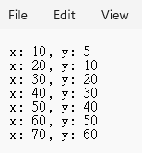
GUI: What happens when you draw a Shape that doesn’t fit inside its window? What happens when you draw a Window that does not fit on your screen? Explain and write two programs that illustrate these two phenomena. Screen captures of your codes and windows.

1.
#include <FL/Fl.H>
#include <FL/Fl_Window.H>
#include <FL/Fl_Box.H>

int main(int argc, char **argv) {
Fl_Window *window = new Fl_Window(300, 180);
Fl_Box *box = new Fl_Box(FL_UP_BOX, 20, 40, 400, 200, "Hello, World!");
box->labelfont(FL_BOLD + FL_ITALIC);
box->labelsize(36);
box->labeltype(FL_SHADOW_LABEL);
window->end();
window->show(argc, argv);
return Fl::run();
}
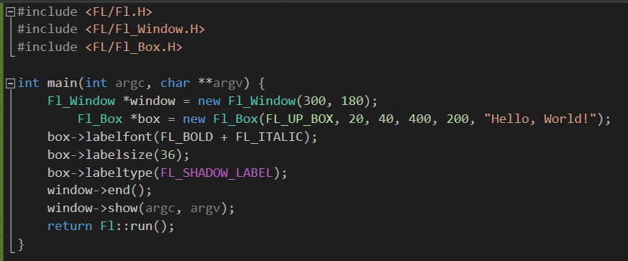
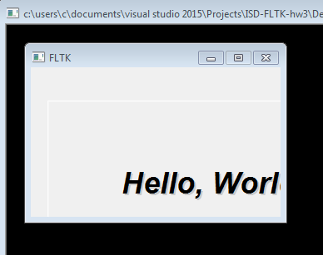

The size of the Fl_Box is larger than the Fl_Window. When I run the application, I will see only the part of the Fl_Box that is inside the window boundaries. The rest that goes beyond the edges will be clipped and not shown.

2.
#include <FL/Fl.H>
#include <FL/Fl_Window.H>

int main() {
int screen_w = Fl::w();
int screen_h = Fl::h();

printf("Screen size: %dx%d\n", screen_w, screen_h);

Fl_Window* window = new Fl_Window(screen_w + 50, screen_h + 50);
window->label("Slightly Oversized Window");

window->show();

return Fl::run();
}
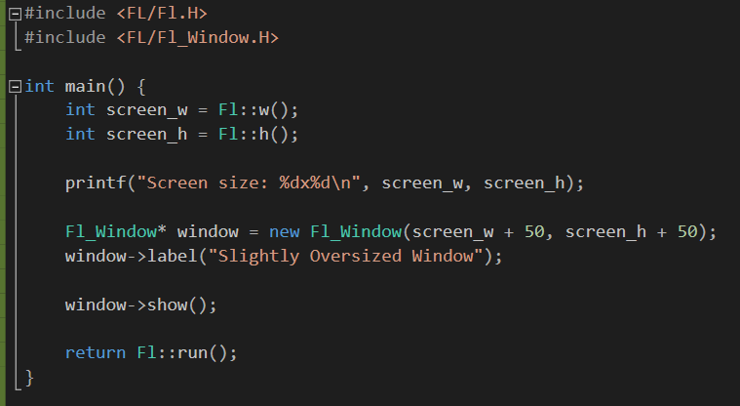


This program uses Fl::w() and Fl::h() to get the width and height of the screen. Then, it creates a window that is 50 pixels wider and 50 pixels taller than the screen. When I run this program, I see the window just appear maximized instead of its specified size.

