# **Contrast and focus**

## **Contrast**

### Links

1. Links must have at least 4.5:1 contrast with the page background and if a link is in a paragraph it must also have at least 4.5:1 contrast with the paragraph text colour, unless item #2 is true.
2. If a link in a paragraph has no other cue that it’s a link other than the colour, then it must have a 3:1 contrast with the paragraph text colour AND provide another visual cue (not just a color change) that appears on hover and focus. The most common way to do this is to underline the link on hover and focus. This isn’t necessary if there is another way of identifying links (like an underline or background colour). Here’s a tool to [test non-underlined link contrast](https://webaim.org/resources/linkcontrastchecker/).

### Buttons

* Text or icons on a button must have at least 4.5:1 contrast with the background of the button or the page (if the button background is transparent or otherwise invisible).
* The button must have at least 3:1 contrast with the page background.

### Input fields

* Input field borders must have at least 3:1 contrast with the background of the page.
* If an input field has no border, then the background of an input field must have at least 3:1 contrast with the background of the page.

A label with a text input shown by a complete border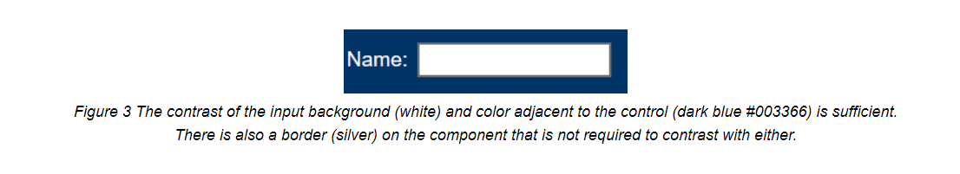

## **Focus**

Links, buttons and input fields can all be focused on with the keyboard and you have to be able to see when they are focused. Using the default browser focus is acceptable. However, accessibility can be improved by using custom focus styles.

The image below shows the default focus states on a variety of browsers. Some are quite faint. You can see how there’s room for improvement!

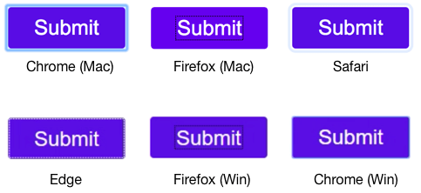

### Links

Ways to show what has link has focus include:

* Changing the background colour
* Underlining
* Changing the font style
* Inverting the colours
* Adding a border
* Adding an icon

Here’s an example of a custom focus style for links. The same styles can be used for hover and keyboard focus. It’s also fine to use different styles for hover and focus. An example would be if an image is used as a link – you may want to outline the image on focus and chose a different style for hover.

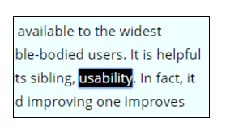

### Buttons and input fields

The same techniques for showing focus apply to buttons and input fields.

Focused button examples:

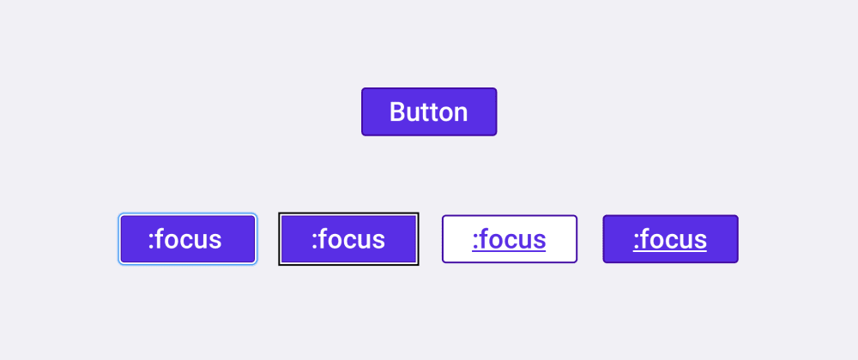

Focused input examples:

A label with a text input shown by a complete border and blue outlineThe same label and input with a yellow outline