Homework 4

Katie Miller

2023-05-25

# Set Up

# loading in the necessary packages  
library(tidyverse)  
library(here)  
library(naniar)  
library(dplyr)  
library(performance)  
library(broom)  
library(flextable)  
library(ggeffects)  
library(car)

# reading in the data using here package  
fish <- read_csv(here("data", "ntl6_v12.csv"))

# filtering data frame to extract relevant info  
trout <- fish %>%   
 filter(spname %in% "TROUTPERCH") %>%   
 reframe(year = case_when(spname == "TROUTPERCH" ~ year4),  
 species = case_when(spname == "TROUTPERCH" ~ spname),  
 length = case_when(spname == "TROUTPERCH" ~ length),  
 weight = case_when(spname == "TROUTPERCH" ~ weight))

# Problem 1

## 1.

Biological:

Null: The length of a trout perch is not a significant predictor of its weight.

Alternative: The length of a trout perch significantly predicts its weight.

Mathematical:

Null: the predicted and predictor variable have no significant correlation.

Alternative: the predicted variable is significantly correlated with the predictor variable.

Null:

Alternative:

## 2.

# visualizing missing data in the filtered perch trout dataset  
gg_miss_var(trout) +   
 labs(caption = "Plot 1: Missing data in the observations of perch trout. There are 199 missing\nmeasurements for trout perch weight, of the 489 observations, this is about 40%.\nThis missingness in our predicted variable lowers the sample size of our dataset.")

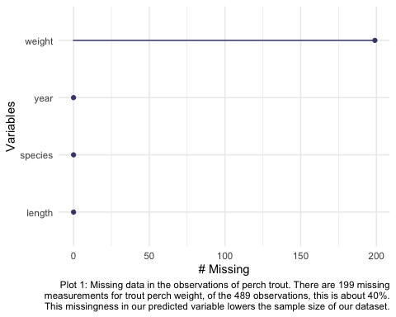

## 3.

# creating a linear model for the trout perch dataset   
trout_model <- lm(weight ~ length, data = trout)

## 4.

par(mfrow = c(2, 2))  
plot(trout_model)

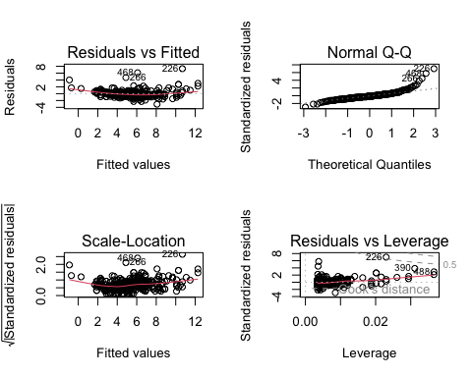

dev.off()

## null device   
## 1

## 5.

Plot 1: Plot 2: Plot 3: Plot 4:

## 6.

# creating a summary of the trout perch model  
model_summary <- summary(trout_model)  
  
model_summary

##   
## Call:  
## lm(formula = weight ~ length, data = trout)  
##   
## Residuals:  
## Min 1Q Median 3Q Max   
## -3.0828 -0.4862 -0.1830 0.4128 7.3191   
##   
## Coefficients:  
## Estimate Std. Error t value Pr(>|t|)   
## (Intercept) -11.702476 0.481564 -24.30 <2e-16 ***  
## length 0.199852 0.005584 35.79 <2e-16 ***  
## ---  
## Signif. codes: 0 '***' 0.001 '**' 0.01 '*' 0.05 '.' 0.1 ' ' 1  
##   
## Residual standard error: 1.057 on 288 degrees of freedom  
## (199 observations deleted due to missingness)  
## Multiple R-squared: 0.8164, Adjusted R-squared: 0.8158   
## F-statistic: 1281 on 1 and 288 DF, p-value: < 2.2e-16

## 7.

# setting up the initial ANOVA table  
model_anova <- anova(trout_model)

# creating a summary table  
model_anova_table <- tidy(model_anova) %>%   
 mutate(across(sumsq:meansq, ~ round(.x, digits = 2))) %>%   
 mutate(statistic = round(statistic, digits = 1)) %>%   
 mutate(p.value = case_when(p.value < 0.001 ~ "< 0.001")) %>%   
 mutate(term = case_when(term == "length" ~ "Trout Perch Length",   
 TRUE ~ term)) %>%  
 flextable() %>%   
 set_header_labels(df = "Degrees of Freedom",   
 sumsq = "Sum of squares",  
 meansq = "Mean squares",  
 statistic = "F-statistic",  
 p.value = "p-value")  
   
model_anova_table

| term | Degrees of Freedom | Sum of squares | Mean squares | F-statistic | p-value |
| --- | --- | --- | --- | --- | --- |
| Trout Perch Length | 1 | 1,432.29 | 1,432.29 | 1,280.8 | < 0.001 |
| Residuals | 288 | 322.05 | 1.12 |  |  |

## 8.

## 9.

## 10.

# creating the initial predictions object  
predictions <- ggpredict(trout_model, terms = "length")

predict_plot <- ggplot(data = trout,  
 aes(x = length, y = weight)) +  
 geom_point() +  
 geom_line(data = predictions,   
 aes(x = x, y = predicted),   
 color = "purple", linewidth = 1) +  
 geom_ribbon(data = predictions,   
 aes(x = x, y = predicted, ymin = conf.low,   
 ymax = conf.high), alpha = 0.3) +  
 theme_bw() +  
 labs(x = "Trout perch length", y = "Trout perch mass")  
  
  
predict_plot

