Midterm

Katie Miller

2023-05-10

## Problem 1

1. Ho = the mean phosphorus content in the burned and unburned sites is not significantly different. Ha = there is a significant difference between mean phosphorus content in the soil of the burned and unburned sites.
2. t-test to determine if the mean of the two areas is significantly different.
3. To perform a successful student’s t-test, we assume that the data sets are evenly distributed and have an equal variance.
4. if the data sets had an unequal variance we could perform a Welch’s t-test.
5. Because the p-value is less than 0.05, we can reject the null hypothesis that there is no difference in phosphorus content between the burned and unburned sites.
6. Ho = the mean phosphorus content of the soil before and after the fire is not significantly different. Ha = the mean phosphorus content of the soil is unchanged before and after the fires.
7. I would preform a t-test to compare the mean phosphorus content of the soil before and after the fire in each survey site.

## Problem 2

## Warning in read.table(file = file, header = header, sep = sep, quote = quote, :  
## not all columns named in 'colClasses' exist

## Warning: Using `size` aesthetic for lines was deprecated in ggplot2 3.4.0.  
## ℹ Please use `linewidth` instead.  
## This warning is displayed once every 8 hours.  
## Call `lifecycle::last_lifecycle_warnings()` to see where this warning was  
## generated.

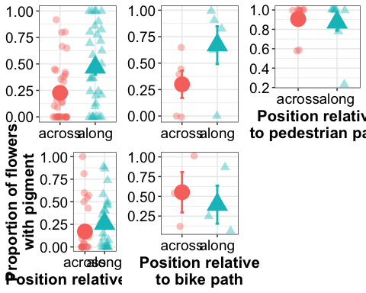

## Problem 3

## Warning: Removed 406 rows containing missing values (`geom_point()`).

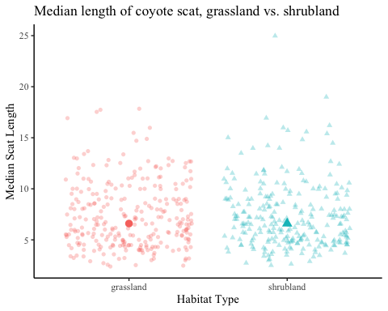

1. 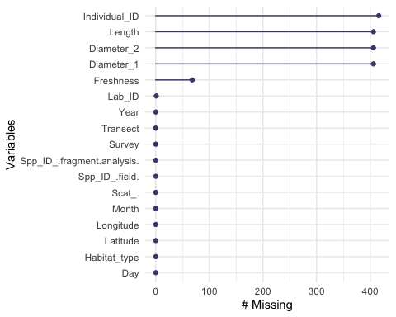

## Problem 4

1. 