class05.R

katybrown

2022-02-03

library(ggplot2)

## Warning in register(): Can't find generic `scale_type` in package ggplot2 to  
## register S3 method.

ggplot(cars)



ggplot(cars) + aes(x = speed, y = dist) + geom_point()

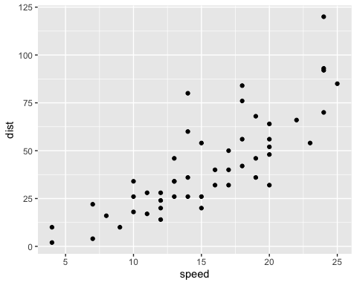

url <- "https://bioboot.github.io/bimm143_S20/class-material/up_down_expression.txt"  
genes <- read.delim(url)  
head(genes)

## Gene Condition1 Condition2 State  
## 1 A4GNT -3.6808610 -3.4401355 unchanging  
## 2 AAAS 4.5479580 4.3864126 unchanging  
## 3 AASDH 3.7190695 3.4787276 unchanging  
## 4 AATF 5.0784720 5.0151916 unchanging  
## 5 AATK 0.4711421 0.5598642 unchanging  
## 6 AB015752.4 -3.6808610 -3.5921390 unchanging

nrow(genes)

## [1] 5196

ncol(genes)

## [1] 4

colnames(genes)

## [1] "Gene" "Condition1" "Condition2" "State"

table(genes$State)

##   
## down unchanging up   
## 72 4997 127

ggplot(genes) + aes(x = Condition1, y = Condition2) + geom_point()

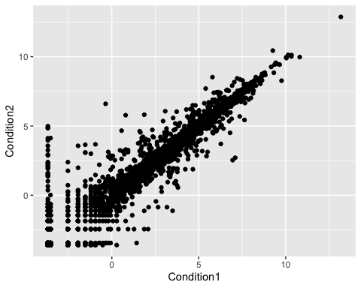

ggplot(genes) + aes(x = Condition1, y = Condition2, col = State) + geom_point()

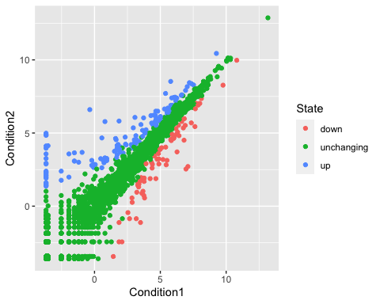

p <- ggplot(genes) + aes(x = Condition1, y = Condition2, col = State) + geom_point()  
p + scale_colour_manual(values = c("blue", "gray", "red"))

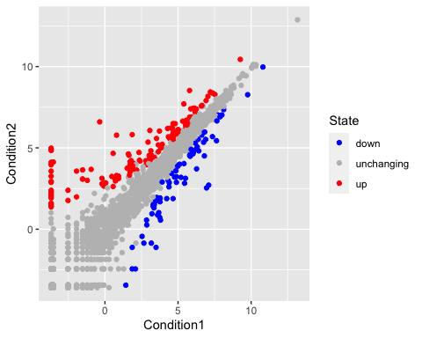

p + scale_colour_manual(values = c("blue", "gray", "red")) + labs(title = "Gene Expression Changes Upon Drug Treatment", x = "Control (no drug)", y = "Drug Treatment")

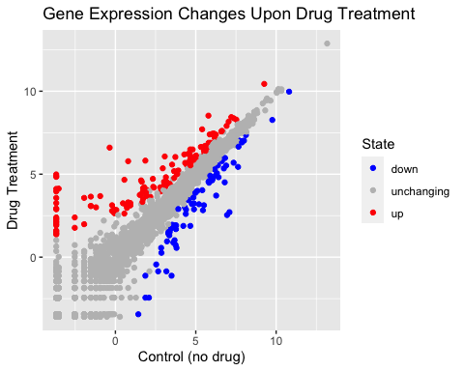

library(gapminder)  
library(dplyr)

##   
## Attaching package: 'dplyr'

## The following objects are masked from 'package:stats':  
##   
## filter, lag

## The following objects are masked from 'package:base':  
##   
## intersect, setdiff, setequal, union

gapminder_2007 <- gapminder %>% filter(year==2007)  
ggplot(gapminder_2007) + aes(x = gdpPercap, y = lifeExp) + geom_point()

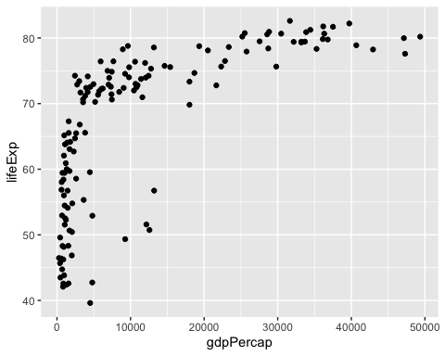

ggplot(gapminder_2007) + aes(x = gdpPercap, y = lifeExp) + geom_point(alpha = 0.5)

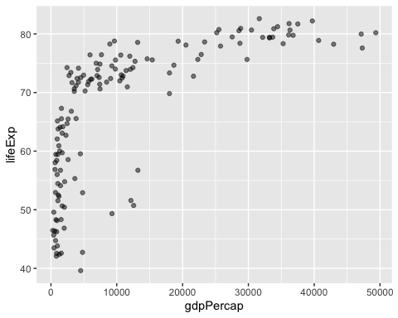

ggplot(gapminder_2007) + aes(x = gdpPercap, y = lifeExp, color = continent, size = pop) + geom_point(alpha = 0.5)

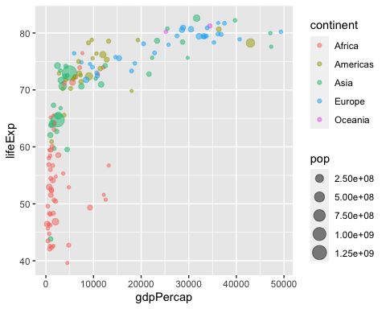

ggplot(gapminder_2007) + aes(x = gdpPercap, y = lifeExp, color = pop) + geom_point(alpha = 0.8)

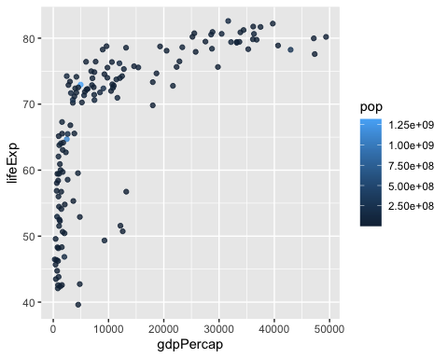

ggplot(gapminder_2007) + aes(x = gdpPercap, y = lifeExp, size = pop) + geom_point(alpha = 0.5)

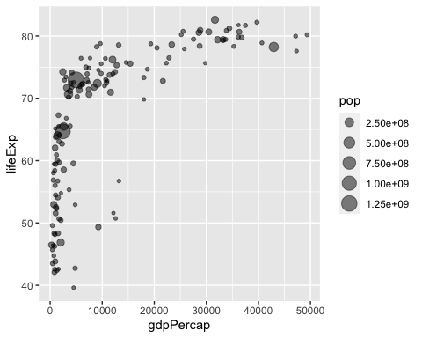

ggplot(gapminder_2007) + aes(x = gdpPercap, y = lifeExp, size = pop) + geom_point(alpha = 0.5) + scale_size_area(max_size = 10)

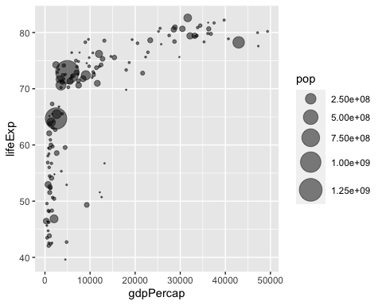

gapminder_1957 <- gapminder %>% filter(year == 1957)  
gm1957 <- ggplot(gapminder_1957) + aes(x = gdpPercap, y = lifeExp) + geom_point()  
gm1957 + aes(color = continent, size = pop) + scale_size_area(max_size = 15) + geom_point(alpha = 0.7)

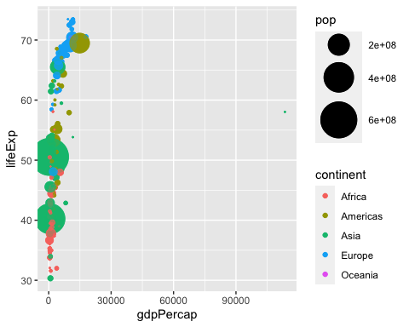

gapminder_1957 <- gapminder %>% filter(year == 1957 | year == 2007)  
ggplot(gapminder_1957) + geom_point(aes(x = gdpPercap, y = lifeExp, color = continent, size = pop), alpha = 0.7) + scale_size_area(max_size = 10) + facet_wrap(~year)

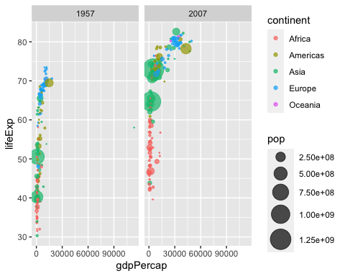

gapminder_top5 <- gapminder %>% filter(year == 2007) %>% arrange(desc(pop)) %>% top_n(5, pop)  
gapminder_top5

## # A tibble: 5 × 6  
## country continent year lifeExp pop gdpPercap  
## <fct> <fct> <int> <dbl> <int> <dbl>  
## 1 China Asia 2007 73.0 1318683096 4959.  
## 2 India Asia 2007 64.7 1110396331 2452.  
## 3 United States Americas 2007 78.2 301139947 42952.  
## 4 Indonesia Asia 2007 70.6 223547000 3541.  
## 5 Brazil Americas 2007 72.4 190010647 9066.

ggplot(gapminder_top5) + geom_col(aes(x = country, y = pop))

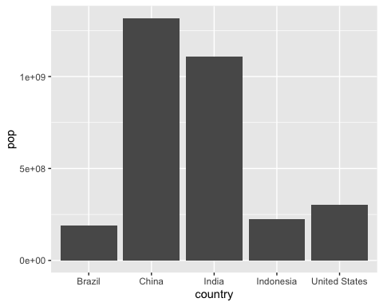

ggplot(gapminder_top5) + geom_col(aes(x = country, y = pop, fill = continent))

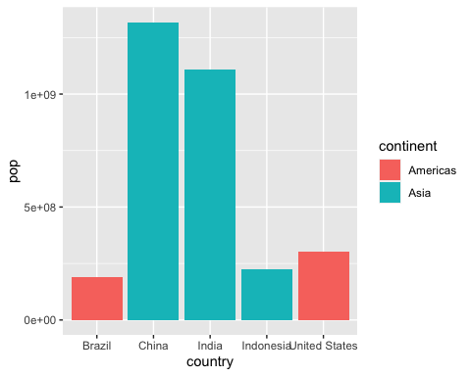

ggplot(gapminder_top5) + geom_col(aes(x = country, y = pop, fill = lifeExp))

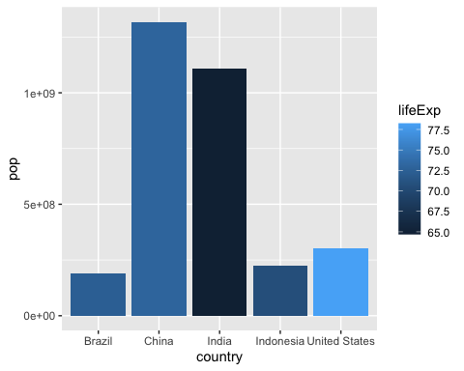

ggplot(gapminder_top5) + aes(x = reorder(country, -pop), y = pop, fill = country) + geom_col(col = "gray30") + guides(scale = "none")

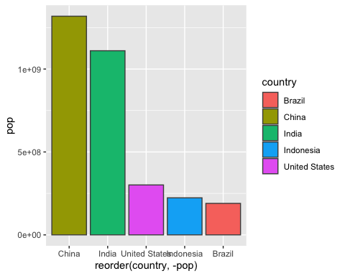

head(USArrests)

## Murder Assault UrbanPop Rape  
## Alabama 13.2 236 58 21.2  
## Alaska 10.0 263 48 44.5  
## Arizona 8.1 294 80 31.0  
## Arkansas 8.8 190 50 19.5  
## California 9.0 276 91 40.6  
## Colorado 7.9 204 78 38.7

USArrests$State <- rownames(USArrests)  
ggplot(USArrests) + aes(x = reorder(State, Murder), y = Murder) + geom_col() + coord_flip()

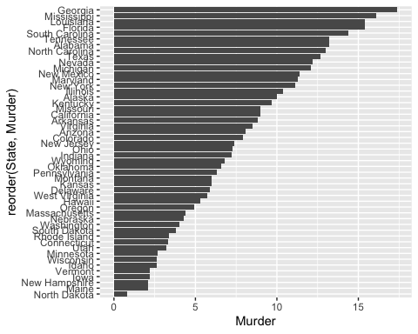

ggplot(USArrests) + aes(x = reorder(State, Murder), y = Murder) + geom_point() + geom_segment(aes(x = State, xend = State, y = 0, yend = Murder), color = "blue") + coord_flip()

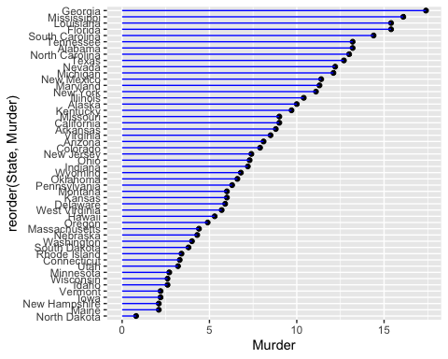

library(gapminder)  
library(gganimate)  
ggplot(gapminder, aes(gdpPercap, lifeExp, size = pop, colour = country)) + geom_point(alpha = 0.7, show.legend = FALSE) +  
 scale_colour_manual(values = country_colors) +   
 scale_size(range = c(2, 12)) + scale_x_log10() +  
 facet_wrap(~continent) +   
 labs(title = "Year: {frame_time}", x = "GDP per capita", y = "life expectancy") +  
 transition_time(year) +   
 shadow_wake(wake_length = 0.1, alpha = FALSE)



library(patchwork)  
p1 <- ggplot(mtcars) + geom_point(aes(mpg, disp))  
p2 <- ggplot(mtcars) + geom_boxplot(aes(gear, disp, group = gear))  
p3 <- ggplot(mtcars) + geom_smooth(aes(disp, qsec))  
p4 <- ggplot(mtcars) + geom_bar(aes(carb))  
  
(p1 | p2 | p3) / p4

## `geom_smooth()` using method = 'loess' and formula 'y ~ x'

