ClimateWMA

KateMarkham

04/26/2022

library(knitr)  
library(tidyverse)  
library(data.table)  
library(readr)  
library(ggplot2)  
library(gridExtra)  
library(car)  
library(stargazer)  
library(tmap)  
#library(lmtest)  
library(sf)  
library(Hmisc)  
#library(rcompanion)  
library(FSA)

Import all of the communal lands data and make Year and Month factors rather than numeric.

#Import data  
WMA_LST <- read_csv("WMA_LST.csv")  
WMA_LST$Year<-factor(WMA_LST$Year)  
WMA_LST$Month<-factor(WMA_LST$Month)  
LST<-WMA_LST  
  
WMA_NDVI <- read_csv("WMA_NDVI.csv")  
WMA_NDVI$Year<-factor(WMA_NDVI$Year)  
WMA_NDVI$Month<-factor(WMA_NDVI$Month)  
NDVI<-WMA_NDVI   
  
WMA_Precip <- read_csv("WMA_Precip.csv")  
WMA_Precip$Year<-factor(WMA_Precip$Year)  
WMA_Precip$Month<-factor(WMA_Precip$Month)  
Precip<-WMA_Precip  
   
WMA_Soil <- read_delim("WMA_Soil.csv", delim = "\t",   
 escape_double = FALSE, trim_ws = TRUE)  
WMA_Soil$Year<-factor(WMA_Soil$Year)  
WMA_Soil$Month<-factor(WMA_Soil$Month)  
Soil<-WMA_Soil

Plot LST

ggplot(LST,aes(x=Month,y=MEDIAN))+  
 geom_boxplot() + ggtitle("Median LST in communal lands")+   
 xlab("Month") + ylab("LST (K)") +  
 facet_wrap(~Year)

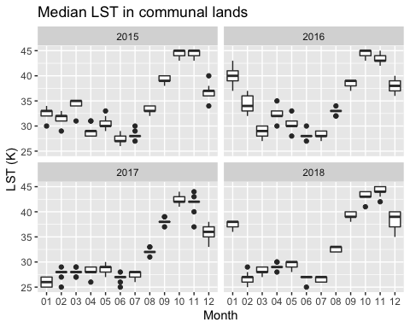

Plot precip by year in all communal lands

ggplot(Precip,aes(x=Month,y=MEDIAN))+  
 geom_boxplot() + ggtitle("Median precipitation in communal lands")+   
 xlab("Month") + ylab("Precipitation (mm/month)") +  
 facet_wrap(~Year)

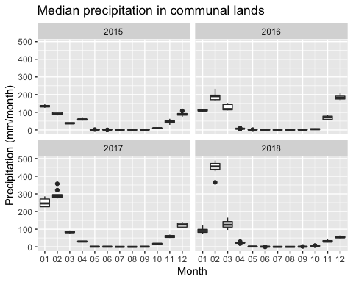

Soil moisture 10 to 40 cm by year in all communal lands

ggplot(Soil,aes(x=Month,y=MEDIAN))+  
 geom_boxplot() + ggtitle("Median soil moisture (10 to 40 cm depth) in communal lands")+   
 xlab("Month") + ylab("Soil moisture (m3/m3)") +  
 facet_wrap(~Year)

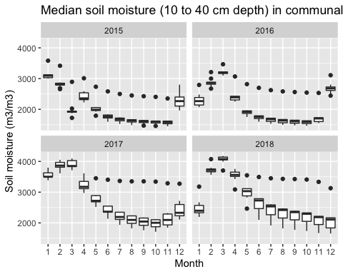

ggplot(Soil,aes(x=Month,y=RANGE))+  
 geom_boxplot() + ggtitle("Soil moisture (10 to 40 cm depth) range in communal lands")+   
 xlab("Month") + ylab("Soil moisture (m3/m3)") +  
 facet_wrap(~Year)

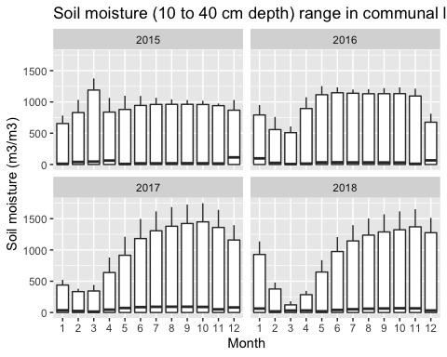

ggplot(Soil,aes(x=Month,y=MAX))+  
 geom_boxplot() + ggtitle("Maximum soil moisture (10 to 40 cm depth) in communal lands")+   
 xlab("Month") + ylab("Soil moisture (m3/m3)") +  
 facet_wrap(~Year)

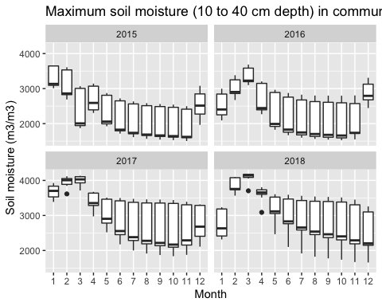

NDVI by year in all communal lands

ggplot(NDVI,aes(x=Month,y=MEDIAN))+  
 geom_boxplot() + ggtitle("Median NDVI in communal lands")+   
 xlab("Month") + ylab("Median NDVI (1-200)") +  
 facet_wrap(~Year)

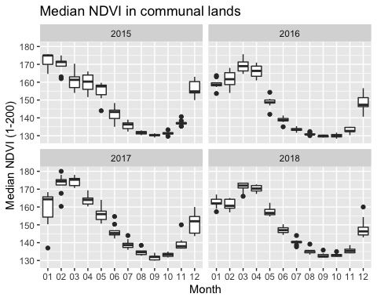

ggplot(NDVI,aes(x=Month,y=RANGE))+  
 geom_boxplot() + ggtitle("NDVI Range in communal lands")+   
 xlab("Month") + ylab("NDVI Range (1-200)") +  
 facet_wrap(~Year)

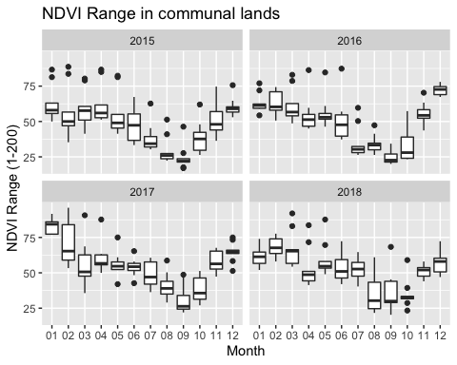

Test for normality Shapiro test: if p<0.01, data is not normally distributed.

shapiro.test(NDVI$MEDIAN)

##   
## Shapiro-Wilk normality test  
##   
## data: NDVI$MEDIAN  
## W = 0.90963, p-value = 2.263e-15

qqnorm(NDVI$MEDIAN); qqline(NDVI$MEDIAN)

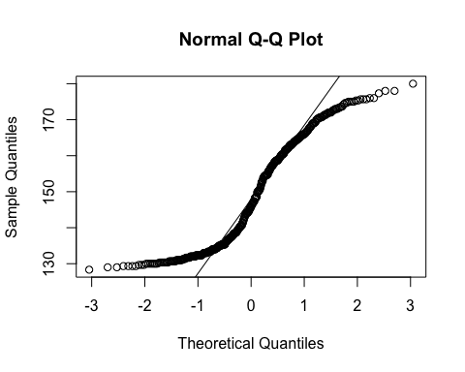

Land Cover Analysis Data import

LC_LST <- read_csv("LC_LST.csv")  
LC_LST$Year<-factor(LC_LST$Year)  
LC_LST$Month<-factor(LC_LST$Month)  
LC_LST<-LC_LST %>%   
 filter(LC %in% c("ag", "forest", "grassland","shrubland"))  
  
LC_Precip <- read_csv("LC_Precip.csv")  
LC_Precip$Year<-factor(LC_Precip$Year)  
LC_Precip$Month<-factor(LC_Precip$Month)  
LC_Precip <-LC_Precip %>%   
 filter(LC %in% c("ag", "forest", "grassland","shrubland"))  
  
LC_Soil<-LC_Soil <- read_csv("LC_Soil.csv")  
LC_Soil$Year<-factor(LC_Soil$Year)  
LC_Soil$Month<-factor(LC_Soil$Month)  
LC_Soil<-LC_Soil %>%   
 filter(LC %in% c("ag", "forest", "grassland","shrubland"))  
  
LC_NDVI <- read_csv("LC_NDVI.csv")  
LC_NDVI$Year<-factor(LC_NDVI$Year)  
LC_NDVI$Month<-factor(LC_NDVI$Month)  
LC_NDVI<-LC_NDVI %>%   
 filter(LC %in% c("ag", "forest", "grassland","shrubland"))

LST all land cover types

ggplot(LC_LST,aes(x=Month,y=MEDIAN))+  
 geom_boxplot() + ggtitle("Median LST in different land cover types")+   
 xlab("Month") + ylab("LST (K)") +  
 facet_wrap(~Year)

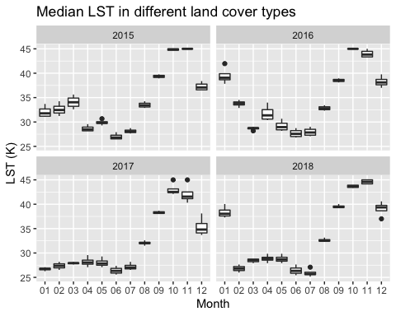

LST_LC_Plot<-ggplot(LC_LST,aes(x=Month,y=MEDIAN, color=LC))+  
 geom_point() + ggtitle("Median LST by Land Cover")+   
 xlab("Month") + ylab("LST (K)") +  
 facet_wrap(~Year)  
LST_LC_Plot1<-LST_LC_Plot + scale_color_discrete(name="LC")  
LST_LC_Plot1

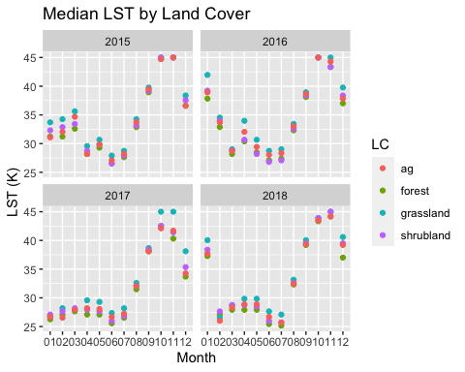

Precip all land cover types

ggplot(LC_Precip,aes(x=Month,y=MEDIAN))+  
 geom_boxplot() + ggtitle("Median Precip in different land cover types")+   
 xlab("Month") + ylab("Precipitation (mm)") +  
 facet_wrap(~Year)

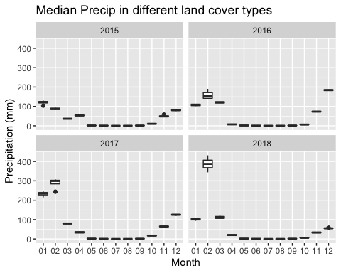

Precip_LC_Plot<-ggplot(LC_Precip,aes(x=Month,y=MEDIAN, color=LC))+  
 geom_point() + ggtitle("Median Precipitation by Land Cover")+   
 xlab("Month") + ylab("Precipitation (mm)") +  
 facet_wrap(~Year)  
Precip_LC_Plot1<-Precip_LC_Plot + scale_color_discrete(name="LC")  
Precip_LC_Plot1

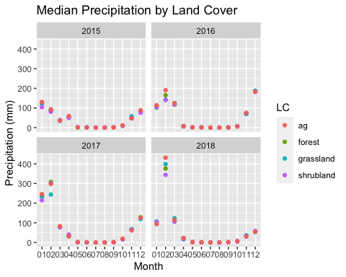 NDVI for all land cover types

NDVI all land cover types

ggplot(LC_NDVI,aes(x=Month,y=MEDIAN))+  
 geom_boxplot() + ggtitle("Median NDVI in different land cover types")+   
 xlab("Month") + ylab("NDVI") +  
 facet_wrap(~Year)

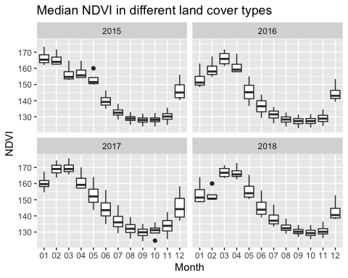

LC_NDVI_Plot<-ggplot(LC_NDVI,aes(x=Month,y=MEDIAN, color=LC))+  
 geom_point() + ggtitle("Median NDVI by Land Cover")+   
 xlab("Month") + ylab("NDVI (0-200)") +  
 facet_wrap(~Year)  
LC_NDVI_Plot1<-LC_NDVI_Plot + scale_color_discrete(name="LC")  
LC_NDVI_Plot1

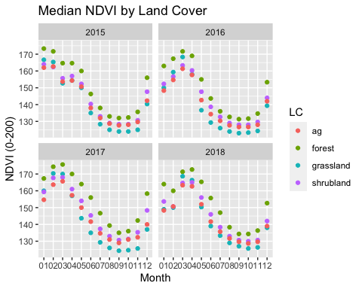

Soil moisture

ggplot(LC_Soil,aes(x=Month,y=MEDIAN))+  
 geom_boxplot() + ggtitle("Median Soil Moisture in different land cover types")+   
 xlab("Month") + ylab("Soil Moisture (m3/m3)") +  
 facet_wrap(~Year)

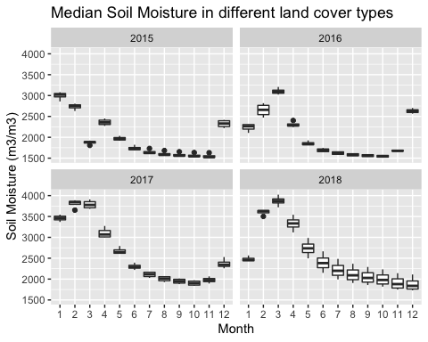

LC_Soil_Plot<-ggplot(LC_Soil,aes(x=Month,y=MEDIAN, color=LC))+  
 geom_point() + ggtitle("Median Soil Moisture by Land Cover")+   
 xlab("Month") + ylab("Soil Moisture (m3/m3)") +  
 facet_wrap(~Year)  
LC_Soil_Plot1<-LC_Soil_Plot + scale_color_discrete(name="LC")  
LC_Soil_Plot1

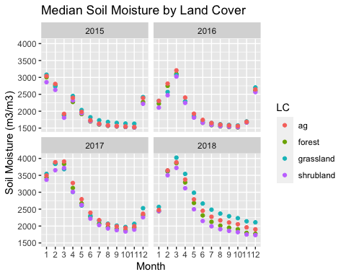

Test for normality Shapiro test: if p<0.01, data is not normally distributed.

shapiro.test(LC_NDVI$MEDIAN)

##   
## Shapiro-Wilk normality test  
##   
## data: LC_NDVI$MEDIAN  
## W = 0.93155, p-value = 7.455e-08

qqnorm(LC_NDVI$MEDIAN); qqline(LC_NDVI$MEDIAN)

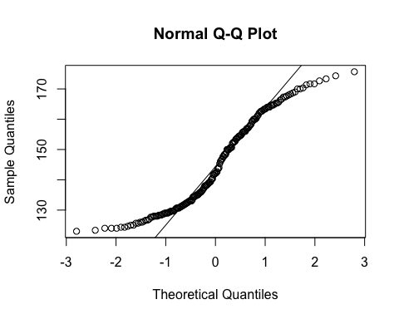

shapiro.test(LC_Precip$MEDIAN)

##   
## Shapiro-Wilk normality test  
##   
## data: LC_Precip$MEDIAN  
## W = 0.71056, p-value < 2.2e-16

qqnorm(LC_Precip$MEDIAN); qqline(LC_Precip$MEDIAN)

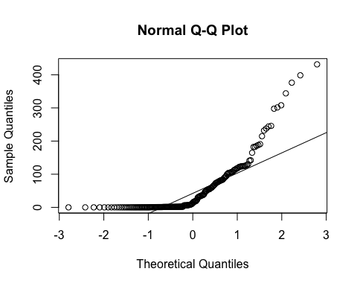

shapiro.test(LC_Soil$MEDIAN)

##   
## Shapiro-Wilk normality test  
##   
## data: LC_Soil$MEDIAN  
## W = 0.89811, p-value = 3.481e-10

qqnorm(LC_Soil$MEDIAN); qqline(LC_Soil$MEDIAN)

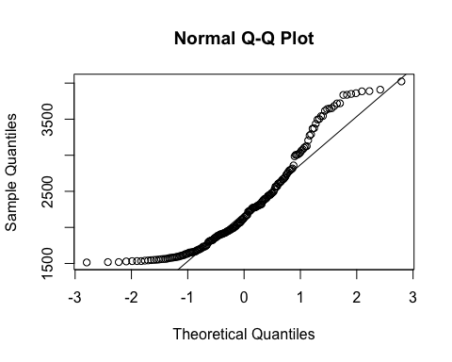

shapiro.test(LC_LST$MEDIAN)

##   
## Shapiro-Wilk normality test  
##   
## data: LC_LST$MEDIAN  
## W = 0.89432, p-value = 2.043e-10

qqnorm(LC_LST$MEDIAN); qqline(LC_LST$MEDIAN)

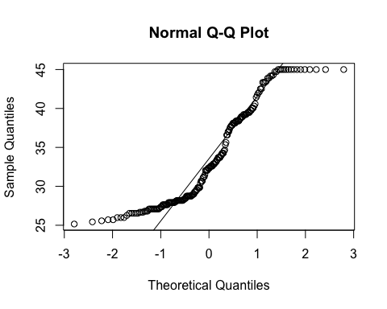 Data is not normally distributed.

Test for normality Shapiro test: if p<0.01, data is not normally distributed.

shapiro.test(LC_NDVI$PCT90)

##   
## Shapiro-Wilk normality test  
##   
## data: LC_NDVI$PCT90  
## W = 0.93163, p-value = 7.564e-08

qqnorm(LC_NDVI$PCT90); qqline(LC_NDVI$PCT90)

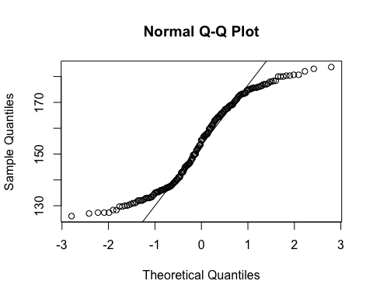

shapiro.test(LC_Precip$PCT90)

##   
## Shapiro-Wilk normality test  
##   
## data: LC_Precip$PCT90  
## W = 0.71022, p-value < 2.2e-16

qqnorm(LC_Precip$PCT90); qqline(LC_Precip$PCT90)

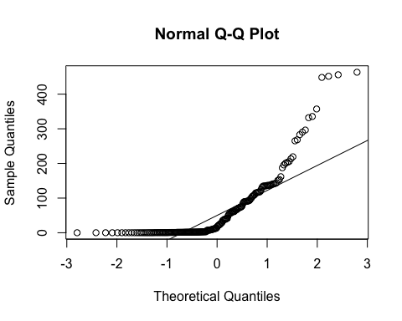

shapiro.test(LC_Soil$PCT90)

##   
## Shapiro-Wilk normality test  
##   
## data: LC_Soil$PCT90  
## W = 0.97184, p-value = 0.0006549

qqnorm(LC_Soil$PCT90); qqline(LC_Soil$PCT90)

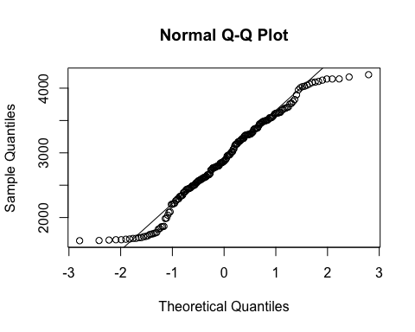

shapiro.test(LC_LST$PCT90)

##   
## Shapiro-Wilk normality test  
##   
## data: LC_LST$PCT90  
## W = 0.87452, p-value = 1.516e-11

qqnorm(LC_LST$PCT90); qqline(LC_LST$PCT90)

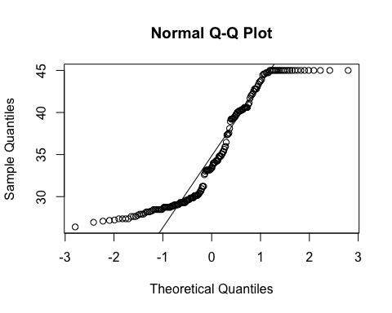 Test for normality Shapiro test: if p<0.01, data is not normally distributed.

shapiro.test(LC_NDVI$RANGE)

##   
## Shapiro-Wilk normality test  
##   
## data: LC_NDVI$RANGE  
## W = 0.98655, p-value = 0.06448

qqnorm(LC_NDVI$RANGE); qqline(LC_NDVI$RANGE)

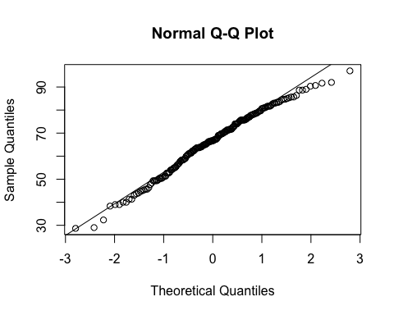

shapiro.test(LC_Precip$RANGE)

##   
## Shapiro-Wilk normality test  
##   
## data: LC_Precip$RANGE  
## W = 0.70618, p-value < 2.2e-16

qqnorm(LC_Precip$RANGE); qqline(LC_Precip$RANGE)

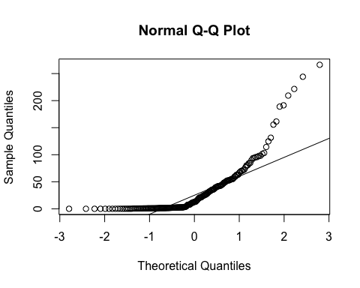

shapiro.test(LC_Soil$RANGE)

##   
## Shapiro-Wilk normality test  
##   
## data: LC_Soil$RANGE  
## W = 0.95094, p-value = 3.579e-06

qqnorm(LC_Soil$RANGE); qqline(LC_Soil$RANGE)

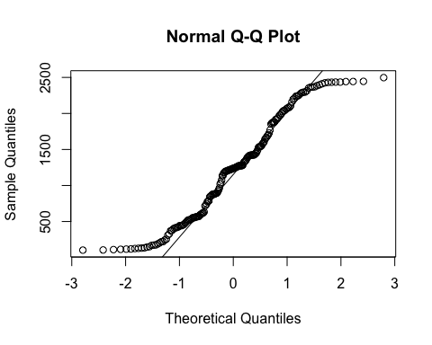

shapiro.test(LC_LST$RANGE)

##   
## Shapiro-Wilk normality test  
##   
## data: LC_LST$RANGE  
## W = 0.045618, p-value < 2.2e-16

qqnorm(LC_LST$RANGE); qqline(LC_LST$RANGE)

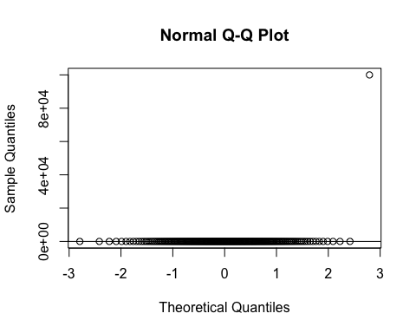 Test for correlation with variables of interest and area to check that there is nothing weird happening with large pixel size

cor(LC_Soil$MEDIAN, LC_Soil$AREA)

## [1] -0.08194229

cor(LC_NDVI$MEDIAN,LC_NDVI$AREA)

## [1] 0.2687659

cor(LC_Precip$MEDIAN,LC_Precip$AREA)

## [1] -0.005598103

cor(LC_LST$MEDIAN,LC_LST$AREA)

## [1] -0.07130262

cor(LC_Soil$MAX, LC_Soil$AREA)

## [1] 0.4422545

cor(LC_NDVI$MAX,LC_NDVI$AREA)

## [1] 0.3446239

cor(LC_Precip$MAX,LC_Precip$AREA)

## [1] 0.04054734

cor(LC_LST$MAX,LC_LST$AREA)

## [1] 0.09509555

cor(LC_Soil$RANGE, LC_Soil$AREA)

## [1] 0.6184476

cor(LC_NDVI$RANGE,LC_NDVI$AREA)

## [1] 0.2101668

cor(LC_Precip$RANGE,LC_Precip$AREA)

## [1] 0.1405772

cor(LC_LST$RANGE,LC_LST$AREA)

## [1] 0.09521212

Test and plots for differences in WMA

kruskal.test(MEDIAN ~ NAME, data = WMA_NDVI)

##   
## Kruskal-Wallis rank sum test  
##   
## data: MEDIAN by NAME  
## Kruskal-Wallis chi-squared = 3.675, df = 8, p-value = 0.8852

kruskal.test(RANGE ~ NAME, data = WMA_NDVI)

##   
## Kruskal-Wallis rank sum test  
##   
## data: RANGE by NAME  
## Kruskal-Wallis chi-squared = 76.364, df = 8, p-value = 2.628e-13

dunnTestNDVI<-dunnTest(RANGE ~ NAME, data = WMA_NDVI, method = "bh",list=TRUE)  
dunnTestNDVI

## Dunn (1964) Kruskal-Wallis multiple comparison

## p-values adjusted with the Benjamini-Hochberg method.

## Comparison Z P.unadj P.adj  
## 1 Chidobe - Jambezi 0.4214089 6.734565e-01 7.820785e-01  
## 2 Chidobe - Kachecheti -0.4733187 6.359858e-01 7.631830e-01  
## 3 Jambezi - Kachecheti -0.8947276 3.709327e-01 5.805903e-01  
## 4 Chidobe - Mabale 1.0872433 2.769293e-01 4.984728e-01  
## 5 Jambezi - Mabale 0.6658343 5.055170e-01 6.740227e-01  
## 6 Kachecheti - Mabale 1.5605619 1.186271e-01 2.512104e-01  
## 7 Chidobe - Nekatambe -5.3005153 1.154763e-07 1.039287e-06  
## 8 Jambezi - Nekatambe -5.7219242 1.053243e-08 1.895837e-07  
## 9 Kachecheti - Nekatambe -4.8271966 1.384684e-06 7.121233e-06  
## 10 Mabale - Nekatambe -6.3877585 1.683349e-10 6.060055e-09  
## 11 Chidobe - Nemananga -1.0512743 2.931326e-01 4.796716e-01  
## 12 Jambezi - Nemananga -1.4726833 1.408365e-01 2.816729e-01  
## 13 Kachecheti - Nemananga -0.5779556 5.632941e-01 6.992616e-01  
## 14 Mabale - Nemananga -2.1385176 3.247476e-02 7.793942e-02  
## 15 Nekatambe - Nemananga 4.2492410 2.144961e-05 7.721859e-05  
## 16 Chidobe - Sidinda -0.3278079 7.430569e-01 8.106075e-01  
## 17 Jambezi - Sidinda -0.7492169 4.537265e-01 6.533662e-01  
## 18 Kachecheti - Sidinda 0.1455108 8.843076e-01 8.843076e-01  
## 19 Mabale - Sidinda -1.4150512 1.570535e-01 2.975750e-01  
## 20 Nekatambe - Sidinda 4.9727073 6.602430e-07 4.753749e-06  
## 21 Nemananga - Sidinda 0.7234664 4.693934e-01 6.499293e-01  
## 22 Chidobe - Simangani -0.6368139 5.242461e-01 6.740307e-01  
## 23 Jambezi - Simangani -1.0582229 2.899539e-01 4.970637e-01  
## 24 Kachecheti - Simangani -0.1634952 8.701285e-01 8.949893e-01  
## 25 Mabale - Simangani -1.7240572 8.469752e-02 1.905694e-01  
## 26 Nekatambe - Simangani 4.6637014 3.105720e-06 1.397574e-05  
## 27 Nemananga - Simangani 0.4144604 6.785370e-01 7.633541e-01  
## 28 Sidinda - Simangani -0.3090060 7.573170e-01 8.018650e-01  
## 29 Chidobe - Unknown 16 -4.4311294 9.374081e-06 3.749633e-05  
## 30 Jambezi - Unknown 16 -4.8525383 1.218912e-06 7.313472e-06  
## 31 Kachecheti - Unknown 16 -3.9578107 7.563986e-05 2.269196e-04  
## 32 Mabale - Unknown 16 -5.5183727 3.421533e-08 4.105839e-07  
## 33 Nekatambe - Unknown 16 0.8693859 3.846361e-01 5.769542e-01  
## 34 Nemananga - Unknown 16 -3.3798551 7.252406e-04 1.864904e-03  
## 35 Sidinda - Unknown 16 -4.1033215 4.072607e-05 1.332853e-04  
## 36 Simangani - Unknown 16 -3.7943155 1.480513e-04 4.099883e-04

kruskal.test(MAX ~ NAME, data = WMA_NDVI)

##   
## Kruskal-Wallis rank sum test  
##   
## data: MAX by NAME  
## Kruskal-Wallis chi-squared = 5.301, df = 8, p-value = 0.725

ggplot(WMA_NDVI,aes(x=NAME,y=RANGE))+  
 geom_boxplot() + ggtitle("NDVI (0-200) range in communal lands")+   
 xlab("Communal land") + ylab("NDVI") +  
 facet_wrap(~Year) + theme(axis.text.x = element_text(angle = 45, hjust = 1))

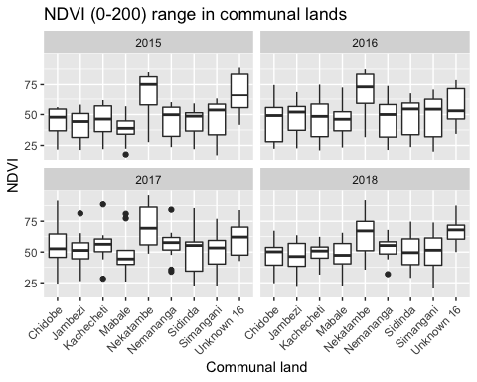

Tests and plots for precip and LST by communal land

kruskal.test(MEDIAN ~ NAME, data = WMA_Precip)

##   
## Kruskal-Wallis rank sum test  
##   
## data: MEDIAN by NAME  
## Kruskal-Wallis chi-squared = 1.0401, df = 8, p-value = 0.998

kruskal.test(RANGE ~ NAME, data = WMA_Precip)

##   
## Kruskal-Wallis rank sum test  
##   
## data: RANGE by NAME  
## Kruskal-Wallis chi-squared = 11.349, df = 8, p-value = 0.1827

kruskal.test(MAX ~ NAME, data = WMA_Precip)

##   
## Kruskal-Wallis rank sum test  
##   
## data: MAX by NAME  
## Kruskal-Wallis chi-squared = 0.71413, df = 8, p-value = 0.9995

kruskal.test(MEDIAN ~ NAME, data = WMA_LST)

##   
## Kruskal-Wallis rank sum test  
##   
## data: MEDIAN by NAME  
## Kruskal-Wallis chi-squared = 7.694, df = 8, p-value = 0.4639

kruskal.test(RANGE ~ NAME, data = WMA_LST)

##   
## Kruskal-Wallis rank sum test  
##   
## data: RANGE by NAME  
## Kruskal-Wallis chi-squared = 294.24, df = 8, p-value < 2.2e-16

kruskal.test(MAX ~ NAME, data = WMA_LST)

##   
## Kruskal-Wallis rank sum test  
##   
## data: MAX by NAME  
## Kruskal-Wallis chi-squared = 14.002, df = 8, p-value = 0.08172

Tests and plots for soil distribution by communal land

kruskal.test(MEDIAN ~ NAME, data = WMA_Soil)

##   
## Kruskal-Wallis rank sum test  
##   
## data: MEDIAN by NAME  
## Kruskal-Wallis chi-squared = 63.467, df = 8, p-value = 9.689e-11

dunnTestNDVI<-dunnTest(MEDIAN ~ NAME, data = WMA_Soil, method = "bh",list=TRUE)

## Warning: NAME was coerced to a factor.

dunnTestNDVI

## Dunn (1964) Kruskal-Wallis multiple comparison

## p-values adjusted with the Benjamini-Hochberg method.

## Comparison Z P.unadj P.adj  
## 1 Chidobe - Jambezi 0.55301590 5.802525e-01 7.203135e-01  
## 2 Chidobe - Kachecheti -0.01471439 9.882600e-01 9.882600e-01  
## 3 Jambezi - Kachecheti -0.56773029 5.702181e-01 7.331376e-01  
## 4 Chidobe - Mabale 1.73588952 8.258337e-02 2.123572e-01  
## 5 Jambezi - Mabale 1.18287362 2.368592e-01 4.263466e-01  
## 6 Kachecheti - Mabale 1.75060391 8.001416e-02 2.215777e-01  
## 7 Chidobe - Nekatambe 1.27729097 2.014995e-01 4.029991e-01  
## 8 Jambezi - Nekatambe 0.72427507 4.688969e-01 7.033453e-01  
## 9 Kachecheti - Nekatambe 1.29200536 1.963553e-01 4.158112e-01  
## 10 Mabale - Nekatambe -0.45859855 6.465225e-01 7.508003e-01  
## 11 Chidobe - Nemananga 2.17486888 2.963994e-02 1.067038e-01  
## 12 Jambezi - Nemananga 1.62185298 1.048348e-01 2.516036e-01  
## 13 Kachecheti - Nemananga 2.18958327 2.855447e-02 1.142179e-01  
## 14 Mabale - Nemananga 0.43897936 6.606765e-01 7.432611e-01  
## 15 Nekatambe - Nemananga 0.89757791 3.694106e-01 5.782079e-01  
## 16 Chidobe - Sidinda 0.60901233 5.425163e-01 7.233550e-01  
## 17 Jambezi - Sidinda 0.05599644 9.553446e-01 1.000000e+00  
## 18 Kachecheti - Sidinda 0.62372673 5.328071e-01 7.377329e-01  
## 19 Mabale - Sidinda -1.12687718 2.597944e-01 4.251181e-01  
## 20 Nekatambe - Sidinda -0.66827863 5.039557e-01 7.256963e-01  
## 21 Nemananga - Sidinda -1.56585654 1.173822e-01 2.641100e-01  
## 22 Chidobe - Simangani -4.46827036 7.885461e-06 4.055380e-05  
## 23 Jambezi - Simangani -5.02128625 5.132660e-07 3.079596e-06  
## 24 Kachecheti - Simangani -4.45355596 8.445968e-06 3.800686e-05  
## 25 Mabale - Simangani -6.20415987 5.498986e-10 6.598784e-09  
## 26 Nekatambe - Simangani -5.74556132 9.161655e-09 8.245489e-08  
## 27 Nemananga - Simangani -6.64313923 3.070715e-11 1.105457e-09  
## 28 Sidinda - Simangani -5.07728269 3.828710e-07 2.756671e-06  
## 29 Chidobe - Unknown 16 1.78943355 7.354502e-02 2.206351e-01  
## 30 Jambezi - Unknown 16 1.23641766 2.163034e-01 4.098379e-01  
## 31 Kachecheti - Unknown 16 1.80414795 7.120812e-02 2.330447e-01  
## 32 Mabale - Unknown 16 0.05354404 9.572984e-01 9.846498e-01  
## 33 Nekatambe - Unknown 16 0.51214259 6.085512e-01 7.302615e-01  
## 34 Nemananga - Unknown 16 -0.38543532 6.999149e-01 7.635435e-01  
## 35 Sidinda - Unknown 16 1.18042122 2.378327e-01 4.077132e-01  
## 36 Simangani - Unknown 16 6.25770391 3.906867e-10 7.032360e-09

kruskal.test(RANGE ~ NAME, data = WMA_Soil)

##   
## Kruskal-Wallis rank sum test  
##   
## data: RANGE by NAME  
## Kruskal-Wallis chi-squared = 401.24, df = 8, p-value < 2.2e-16

kruskal.test(MAX ~ NAME, data = WMA_Soil)

##   
## Kruskal-Wallis rank sum test  
##   
## data: MAX by NAME  
## Kruskal-Wallis chi-squared = 134.18, df = 8, p-value < 2.2e-16

ggplot(WMA_Soil,aes(x=NAME,y=MEDIAN))+  
 geom_boxplot() + ggtitle("Median soil moisture (10 to 40 cm depth) in communal lands")+   
 xlab("Communal land") + ylab("Soil moisture (m3/m3)") +  
 facet_wrap(~Year) + theme(axis.text.x = element_text(angle = 45, hjust = 1))

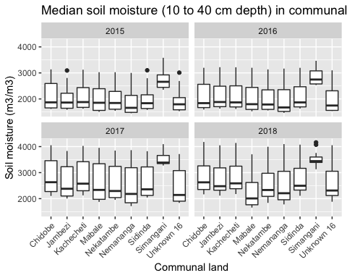

ggplot(WMA_Soil,aes(x=NAME,y=RANGE))+  
 geom_boxplot() + ggtitle("Soil moisture (10 to 40 cm depth) range in communal lands")+   
 xlab("Communal land") + ylab("Soil moisture (m3/m3)") +  
 facet_wrap(~Year) + theme(axis.text.x = element_text(angle = 45, hjust = 1))

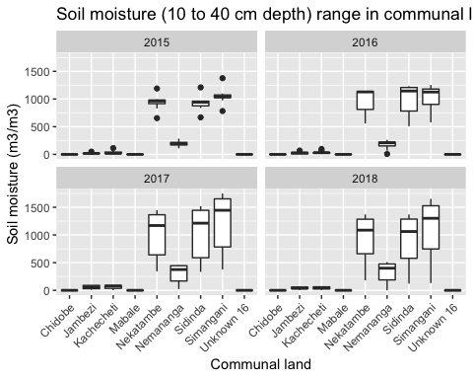

ggplot(WMA_Soil,aes(x=NAME,y=MAX))+  
 geom_boxplot() + ggtitle("Maximum soil moisture (10 to 40 cm depth) in communal lands")+   
 xlab("Communal land") + ylab("Soil moisture (m3/m3)") +  
 facet_wrap(~Year) + theme(axis.text.x = element_text(angle = 45, hjust = 1))

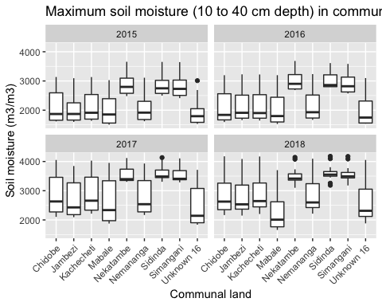

***LC TYPE***

kruskal.test(MEDIAN ~ LC, data = LC_NDVI)

##   
## Kruskal-Wallis rank sum test  
##   
## data: MEDIAN by LC  
## Kruskal-Wallis chi-squared = 18.27, df = 3, p-value = 0.0003869

dunnTestNDVIMEDIAN<-dunnTest(MEDIAN ~ LC, data = LC_NDVI, method = "bh",list=TRUE)  
dunnTestNDVIMEDIAN

## Dunn (1964) Kruskal-Wallis multiple comparison

## p-values adjusted with the Benjamini-Hochberg method.

## Comparison Z P.unadj P.adj  
## 1 ag - forest -3.2180023 1.290868e-03 0.0038726036  
## 2 ag - grassland 0.8265417 4.084969e-01 0.4084968821  
## 3 forest - grassland 4.0445440 5.242507e-05 0.0003145504  
## 4 ag - shrubland -0.8559298 3.920366e-01 0.4704439104  
## 5 forest - shrubland 2.3620725 1.817309e-02 0.0363461797  
## 6 grassland - shrubland -1.6824715 9.247744e-02 0.1387161651

kruskal.test(RANGE ~ LC, data = LC_NDVI)

##   
## Kruskal-Wallis rank sum test  
##   
## data: RANGE by LC  
## Kruskal-Wallis chi-squared = 14.375, df = 3, p-value = 0.002436

dunnTestNDVIRANGE<-dunnTest(RANGE ~ LC, data = LC_NDVI, method = "bh",list=TRUE)  
dunnTestNDVIRANGE

## Dunn (1964) Kruskal-Wallis multiple comparison  
## p-values adjusted with the Benjamini-Hochberg method.

## Comparison Z P.unadj P.adj  
## 1 ag - forest -3.0663631 0.0021668004 0.006500401  
## 2 ag - grassland -2.6824937 0.0073075526 0.014615105  
## 3 forest - grassland 0.3838693 0.7010752844 0.841290341  
## 4 ag - shrubland -3.3795196 0.0007261262 0.004356757  
## 5 forest - shrubland -0.3131566 0.7541617085 0.754161708  
## 6 grassland - shrubland -0.6970259 0.4857865697 0.728679855

kruskal.test(MAX ~ LC, data = LC_NDVI)

##   
## Kruskal-Wallis rank sum test  
##   
## data: MAX by LC  
## Kruskal-Wallis chi-squared = 29.049, df = 3, p-value = 2.186e-06

dunnTestNDVIMAX <-dunnTest(MAX ~ LC, data = LC_NDVI, method = "bh",list=TRUE)  
dunnTestNDVIMAX

## Dunn (1964) Kruskal-Wallis multiple comparison  
## p-values adjusted with the Benjamini-Hochberg method.

## Comparison Z P.unadj P.adj  
## 1 ag - forest -4.7192874 2.366723e-06 1.420034e-05  
## 2 ag - grassland -0.2924836 7.699169e-01 7.699169e-01  
## 3 forest - grassland 4.4268038 9.563966e-06 2.869190e-05  
## 4 ag - shrubland -2.5192220 1.176145e-02 2.352289e-02  
## 5 forest - shrubland 2.2000654 2.780226e-02 3.336271e-02  
## 6 grassland - shrubland -2.2267384 2.596476e-02 3.894714e-02

ggplot(LC_NDVI,aes(x=LC,y=MEDIAN))+  
 geom_boxplot() + ggtitle("Median NDVI (0-200) by land cover type")+   
 xlab("Land cover") + ylab("NDVI") +  
 facet_wrap(~Year) + theme(axis.text.x = element_text(angle = 45, hjust = 1))

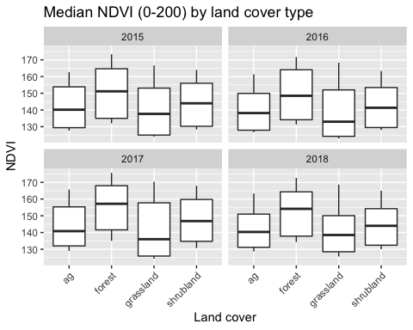

ggplot(LC_NDVI,aes(x=LC,y=RANGE))+  
 geom_boxplot() + ggtitle("Range in NDVI (0-200) by land cover type")+   
 xlab("Land cover") + ylab("NDVI") +  
 facet_wrap(~Year) + theme(axis.text.x = element_text(angle = 45, hjust = 1))

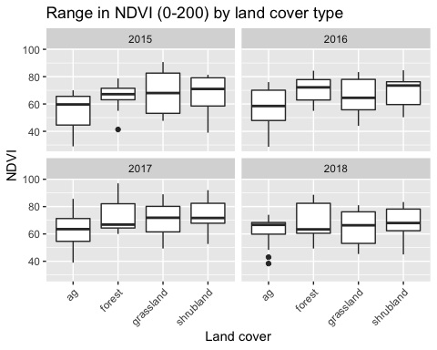 Precipitation

kruskal.test(MEDIAN ~ LC, data = LC_Precip)

##   
## Kruskal-Wallis rank sum test  
##   
## data: MEDIAN by LC  
## Kruskal-Wallis chi-squared = 0.2167, df = 3, p-value = 0.9748

dunnTestPrecip<-dunnTest(MEDIAN ~ LC, data = LC_Precip, method = "bh",list=TRUE)  
dunnTestPrecip

## Dunn (1964) Kruskal-Wallis multiple comparison

## p-values adjusted with the Benjamini-Hochberg method.

## Comparison Z P.unadj P.adj  
## 1 ag - forest -0.36365614 0.7161148 1.0000000  
## 2 ag - grassland -0.02571306 0.9794862 0.9794862  
## 3 forest - grassland 0.33794308 0.7354061 1.0000000  
## 4 ag - shrubland -0.31590332 0.7520759 1.0000000  
## 5 forest - shrubland 0.04775283 0.9619132 1.0000000  
## 6 grassland - shrubland -0.29019026 0.7716707 1.0000000

kruskal.test(RANGE ~ LC, data = LC_Precip)

##   
## Kruskal-Wallis rank sum test  
##   
## data: RANGE by LC  
## Kruskal-Wallis chi-squared = 5.2773, df = 3, p-value = 0.1526

dunnTestPrecip<-dunnTest(RANGE ~ LC, data = LC_Precip, method = "bh",list=TRUE)  
dunnTestPrecip

## Dunn (1964) Kruskal-Wallis multiple comparison  
## p-values adjusted with the Benjamini-Hochberg method.

## Comparison Z P.unadj P.adj  
## 1 ag - forest -1.6805322 0.09285382 0.2785615  
## 2 ag - grassland 0.2699871 0.78717015 0.7871702  
## 3 forest - grassland 1.9505193 0.05111425 0.3066855  
## 4 ag - shrubland -1.2048406 0.22826486 0.3423973  
## 5 forest - shrubland 0.4756916 0.63429409 0.7611529  
## 6 grassland - shrubland -1.4748277 0.14025887 0.2805177

kruskal.test(MAX ~ LC, data = LC_Precip)

##   
## Kruskal-Wallis rank sum test  
##   
## data: MAX by LC  
## Kruskal-Wallis chi-squared = 1.5326, df = 3, p-value = 0.6748

dunnTestPrecip<-dunnTest(MAX ~ LC, data = LC_Precip, method = "bh",list=TRUE)  
dunnTestPrecip

## Dunn (1964) Kruskal-Wallis multiple comparison  
## p-values adjusted with the Benjamini-Hochberg method.

## Comparison Z P.unadj P.adj  
## 1 ag - forest -0.9587298 0.3376949 1.0000000  
## 2 ag - grassland 0.1524417 0.8788386 0.8788386  
## 3 forest - grassland 1.1111715 0.2664945 1.0000000  
## 4 ag - shrubland -0.5014047 0.6160863 0.9241295  
## 5 forest - shrubland 0.4573251 0.6474374 0.7769248  
## 6 grassland - shrubland -0.6538464 0.5132108 1.0000000

ggplot(LC_Precip,aes(x=LC,y=MEDIAN))+  
 geom_boxplot() + ggtitle("Precipitation by land cover type")+   
 xlab("Land cover") + ylab("Precipitation (mm)") +  
 facet_wrap(~Year) + theme(axis.text.x = element_text(angle = 45, hjust = 1))

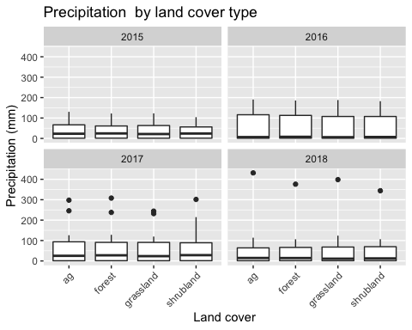

ggplot(LC_Precip,aes(x=LC,y=RANGE))+  
 geom_boxplot() + ggtitle("Range in Precipitation by land cover type")+   
 xlab("Land cover") + ylab("Precipitation (mm)") +  
 facet_wrap(~Year) + theme(axis.text.x = element_text(angle = 45, hjust = 1))

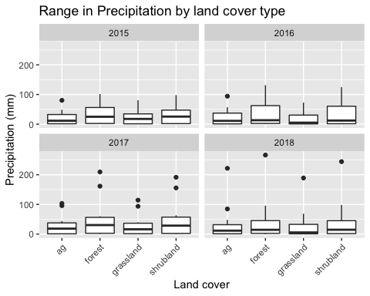 Soil moisture

kruskal.test(MEDIAN ~ LC, data = LC_Soil)

##   
## Kruskal-Wallis rank sum test  
##   
## data: MEDIAN by LC  
## Kruskal-Wallis chi-squared = 3.2081, df = 3, p-value = 0.3606

kruskal.test(RANGE ~ LC, data = LC_Soil)

##   
## Kruskal-Wallis rank sum test  
##   
## data: RANGE by LC  
## Kruskal-Wallis chi-squared = 136.8, df = 3, p-value < 2.2e-16

dunnTestNDVI<-dunnTest(RANGE ~ LC, data = LC_Soil, method = "bh",list=TRUE)  
dunnTestNDVI

## Dunn (1964) Kruskal-Wallis multiple comparison

## p-values adjusted with the Benjamini-Hochberg method.

## Comparison Z P.unadj P.adj  
## 1 ag - forest -7.942631 1.979367e-15 5.938102e-15  
## 2 ag - grassland -5.712927 1.110491e-08 2.220981e-08  
## 3 forest - grassland 2.229704 2.576711e-02 2.576711e-02  
## 4 ag - shrubland -11.367082 6.099285e-30 3.659571e-29  
## 5 forest - shrubland -3.424450 6.160442e-04 7.392530e-04  
## 6 grassland - shrubland -5.654154 1.566155e-08 2.349232e-08

kruskal.test(MAX ~ LC, data = LC_Soil)

##   
## Kruskal-Wallis rank sum test  
##   
## data: MAX by LC  
## Kruskal-Wallis chi-squared = 105.44, df = 3, p-value < 2.2e-16

dunnTestNDVI<-dunnTest(MAX ~ LC, data = LC_Soil, method = "bh",list=TRUE)  
dunnTestNDVI

## Dunn (1964) Kruskal-Wallis multiple comparison  
## p-values adjusted with the Benjamini-Hochberg method.

## Comparison Z P.unadj P.adj  
## 1 ag - forest -4.40429115 1.061303e-05 1.273564e-05  
## 2 ag - grassland -4.48694049 7.225325e-06 1.083799e-05  
## 3 forest - grassland -0.08264933 9.341304e-01 9.341304e-01  
## 4 ag - shrubland -10.22464089 1.537969e-24 9.227816e-24  
## 5 forest - shrubland -5.82034973 5.872462e-09 1.761739e-08  
## 6 grassland - shrubland -5.73770040 9.597069e-09 1.919414e-08

ggplot(LC_Soil,aes(x=LC,y=MAX))+  
 geom_boxplot() + ggtitle("Maximum soil moisture at 10-40 cm by land cover type")+   
 xlab("Land cover") + ylab("Soil moisture (m3/m3)") +  
 facet_wrap(~Year) + theme(axis.text.x = element_text(angle = 45, hjust = 1))

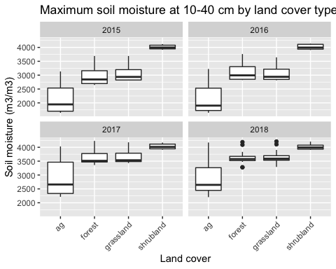

ggplot(LC_Soil,aes(x=LC,y=RANGE))+  
 geom_boxplot() + ggtitle("Range in soil moisture at 10-40 cm by land cover type")+   
 xlab("Land cover") + ylab("Soil moisture (m3/m3)") +  
 facet_wrap(~Year) + theme(axis.text.x = element_text(angle = 45, hjust = 1))

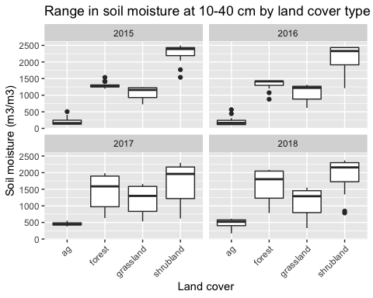 LST

kruskal.test(MEDIAN ~ LC, data = LC_LST)

##   
## Kruskal-Wallis rank sum test  
##   
## data: MEDIAN by LC  
## Kruskal-Wallis chi-squared = 3.7673, df = 3, p-value = 0.2877

kruskal.test(RANGE ~ LC, data = LC_LST)

##   
## Kruskal-Wallis rank sum test  
##   
## data: RANGE by LC  
## Kruskal-Wallis chi-squared = 72.763, df = 3, p-value = 1.093e-15

dunnTestLST<-dunnTest(RANGE ~ LC, data = LC_LST, method = "bh",list=TRUE)  
dunnTestLST

## Dunn (1964) Kruskal-Wallis multiple comparison

## p-values adjusted with the Benjamini-Hochberg method.

## Comparison Z P.unadj P.adj  
## 1 ag - forest -6.1724169 6.725388e-10 2.017616e-09  
## 2 ag - grassland 0.5870181 5.571916e-01 5.571916e-01  
## 3 forest - grassland 6.7594350 1.385309e-11 8.311855e-11  
## 4 ag - shrubland -5.1958908 2.037419e-07 3.056128e-07  
## 5 forest - shrubland 0.9765261 3.288038e-01 3.945646e-01  
## 6 grassland - shrubland -5.7829088 7.341986e-09 1.468397e-08

kruskal.test(MAX ~ LC, data = LC_LST)

##   
## Kruskal-Wallis rank sum test  
##   
## data: MAX by LC  
## Kruskal-Wallis chi-squared = 4.8044, df = 3, p-value = 0.1867

ggplot(LC_LST,aes(x=LC,y=RANGE))+  
 geom_boxplot() + ggtitle("Range in LST by land cover type")+   
 xlab("Land cover") + ylab("LST (K)") +  
 facet_wrap(~Year) + theme(axis.text.x = element_text(angle = 45, hjust = 1))

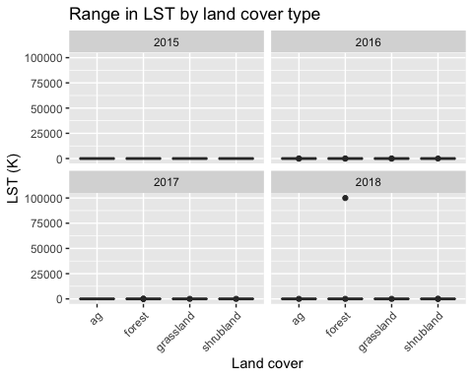

***Analyses for crop raiding period only***

Crop raiding months only LST WMA

WMA_LST_CR<-WMA_LST%>%   
 filter(Month%in% c("03", "04", "05"))  
  
WMA_CR_LST_Plot<-ggplot(WMA_LST_CR,aes(x=Month,y=MEDIAN, color=NAME))+  
 geom_point() + ggtitle("Median LST in communal lands during crop raiding season")+   
 xlab("Month") + ylab("LST (K)") +  
 facet_wrap(~Year)  
WMA_CR_LST_Plot1<-WMA_CR_LST_Plot + scale_color_discrete(name="Communal land")  
WMA_CR_LST_Plot

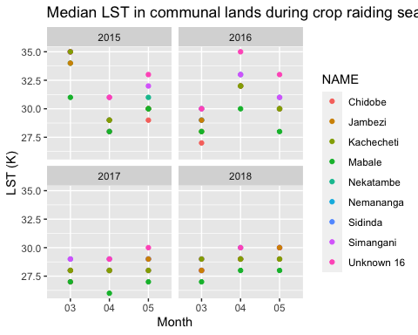

Precipitation three months prior to CR period due to assumed lag WMA

WMA_Precip_CR<-WMA_Precip %>%   
 filter(Month%in% c("12", "01", "02"))  
  
WMA_CR_Precip<-ggplot(WMA_Precip_CR,aes(x=Month,y=MEDIAN, color=NAME))+  
 geom_point() + ggtitle("Median precipitation in communal lands during crop raiding season")+   
 xlab("Month") + ylab("Precipitation (mm/month)") +  
 facet_wrap(~Year)  
WMA_CR_Precip1<-WMA_CR_Precip + scale_color_discrete(name="Communal land")  
WMA_CR_Precip1

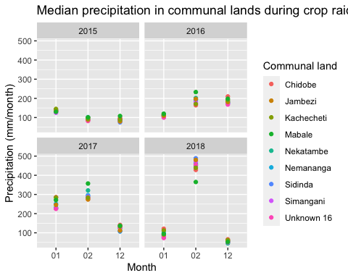

Soil moisture WMA crop raiding period

#Soil Moisture Plots for crop raiding period   
#Median NDVI  
WMA_Soil_CR<-WMA_Soil %>%   
 filter(Month %in% c(3, 4, 5))  
p1<-ggplot(WMA_Soil_CR,aes(x=Month,y=MEDIAN,color=NAME))+  
 geom_point()+  
 xlab("Month") + ylab("Median Soil Moisture (m3/m3)") +ggtitle("Median soil mosture in communal lands during crop raiding season") +  
 facet_wrap(~Year)  
p1<-p1 + scale_color_discrete(name="Communal land")  
p1

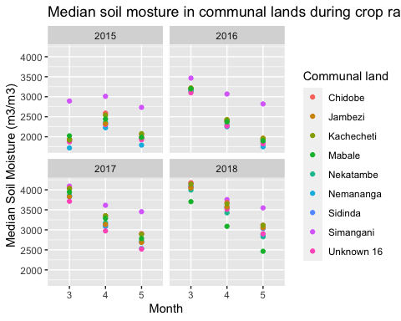

NDVI WMA CROP RAIDING PERIOD

#NDVI Plots for crop raiding period   
#Maximum NDVI  
WMA_NDVI_CR<-WMA_NDVI %>%   
 filter(Month%in% c("03", "04", "05"))  
p1<-ggplot(WMA_NDVI_CR,aes(x=Month,y=MEDIAN,color=NAME))+  
 geom_point()+  
 xlab("Month") + ylab("Median NDVI (0-200)") +ggtitle("Median NDVI in communal lands during crop raiding season") +  
 facet_wrap(~Year)  
p1<-p1 + scale_color_discrete(name="Communal land")  
p1

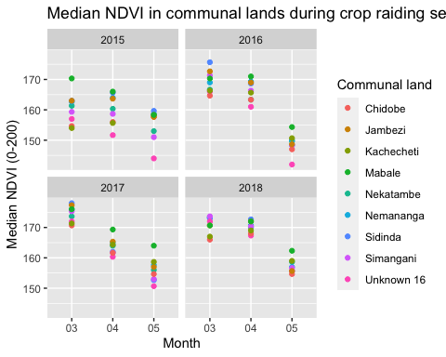

Land cover types crop raiding season only

#NDVI Plots for crop raiding period   
#Range NDVI  
LC_NDVI_CR<-LC_NDVI %>%   
 filter(Month%in% c("03", "04", "05"))  
p1<-ggplot(LC_NDVI_CR,aes(x=Month,y=RANGE,color=LC))+  
 geom_point()+  
 xlab("Month") + ylab("Range NDVI (0-200)") +ggtitle("Range in NDVI values by land cover during crop raiding season") +  
 facet_wrap(~Year)  
p1<-p1 + scale_color_discrete(name="Land cover")  
p1

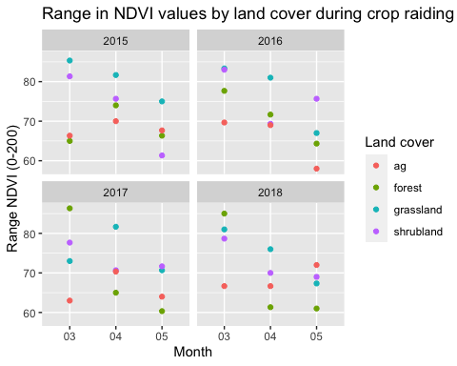

Maximum NDVI CR by LC

#NDVI Plots for crop raiding period   
#Maximum NDVI  
LCNDVI_CR<-LC_NDVI %>%   
 filter(Month%in% c("03", "04", "05"))  
p1<-ggplot(LCNDVI_CR,aes(x=Month,y=MEDIAN,color=LC))+  
 geom_point()+  
 xlab("Month") + ylab("Maximum NDVI (0-200)") +ggtitle("Maximum NDVI during crop raiding season by land cover") +  
 facet_wrap(~Year)  
p1<-p1 + scale_color_discrete(name="Land cover type")  
p1

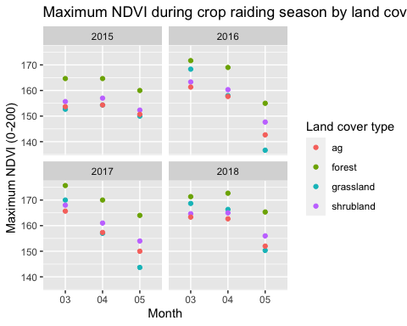

Statistics CR period only-NDVI

kruskal.test(MEDIAN ~ LC, data = LCNDVI_CR)

##   
## Kruskal-Wallis rank sum test  
##   
## data: MEDIAN by LC  
## Kruskal-Wallis chi-squared = 13.462, df = 3, p-value = 0.003737

dunnTestNDVI<-dunnTest(MEDIAN ~ LC, data = LCNDVI_CR, method = "bh",list=TRUE)

## Warning: LC was coerced to a factor.

dunnTestNDVI

## Dunn (1964) Kruskal-Wallis multiple comparison

## p-values adjusted with the Benjamini-Hochberg method.

## Comparison Z P.unadj P.adj  
## 1 ag - forest -3.3397036 0.0008386784 0.005032071  
## 2 ag - grassland -0.4593915 0.6459530186 0.775143622  
## 3 forest - grassland 2.8803121 0.0039728172 0.011918452  
## 4 ag - shrubland -0.7802364 0.4352517205 0.652877581  
## 5 forest - shrubland 2.5594672 0.0104832754 0.020966551  
## 6 grassland - shrubland -0.3208449 0.7483279399 0.748327940

kruskal.test(RANGE ~ LC, data = LCNDVI_CR)

##   
## Kruskal-Wallis rank sum test  
##   
## data: RANGE by LC  
## Kruskal-Wallis chi-squared = 13.266, df = 3, p-value = 0.004095

dunnTestNDVI<-dunnTest(RANGE ~ LC, data = LCNDVI_CR, method = "bh",list=TRUE)

## Warning: LC was coerced to a factor.

dunnTestNDVI

## Dunn (1964) Kruskal-Wallis multiple comparison  
## p-values adjusted with the Benjamini-Hochberg method.

## Comparison Z P.unadj P.adj  
## 1 ag - forest -0.7509872 0.452660384 0.452660384  
## 2 ag - grassland -3.2810119 0.001034354 0.006206124  
## 3 forest - grassland -2.5300247 0.011405450 0.034216349  
## 4 ag - shrubland -2.3258729 0.020025335 0.040050670  
## 5 forest - shrubland -1.5748857 0.115282832 0.172924248  
## 6 grassland - shrubland 0.9551390 0.339507405 0.407408886

kruskal.test(MAX ~ LC, data = LCNDVI_CR)

##   
## Kruskal-Wallis rank sum test  
##   
## data: MAX by LC  
## Kruskal-Wallis chi-squared = 25.127, df = 3, p-value = 1.453e-05

dunnTestNDVI<-dunnTest(MAX ~ LC, data = LCNDVI_CR, method = "bh",list=TRUE)

## Warning: LC was coerced to a factor.

dunnTestNDVI

## Dunn (1964) Kruskal-Wallis multiple comparison  
## p-values adjusted with the Benjamini-Hochberg method.

## Comparison Z P.unadj P.adj  
## 1 ag - forest -4.0254869 5.685755e-05 1.705727e-04  
## 2 ag - grassland 0.4187094 6.754285e-01 6.754285e-01  
## 3 forest - grassland 4.4441963 8.822104e-06 5.293262e-05  
## 4 ag - shrubland -2.0347808 4.187294e-02 6.280940e-02  
## 5 forest - shrubland 1.9907061 4.651321e-02 5.581585e-02  
## 6 grassland - shrubland -2.4534902 1.414774e-02 2.829548e-02

Statistics CR period only-

#NDVI Plots for crop raiding period   
#Range NDVI  
LC_Precip_CR<-LC_Precip %>%   
 filter(Month%in% c("10","11","12", "01", "02", "03"))  
p1<-ggplot(LC_Precip_CR,aes(x=Month,y=RANGE,color=LC))+  
 geom_point()+  
 xlab("Month") + ylab("Precipitation Range (mm)") +ggtitle("Precipitation by land cover prior to crop raiding season") +  
 facet_wrap(~Year)  
p1<-p1 + scale_color_discrete(name="Land cover")  
p1

