EmoClips Preprocessing Pipeline

**Preprocessing**

1. Type ‘PrePro’ into command window
2. Press ‘open data file’ and start selecting .RAW files from the window gui.
   1. Press ‘cancel’ when you are done selecting files.
   2. Instead of selecting individual files. You can select a batch files which are made in R script 001b.
3. After selecting files, select the HC1 257 net in top right of gui as shown in screenshot. This is necessary for eyeblink and eyemovement correction.

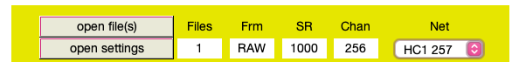

1. Enable low pass filter and high pass filter
   1. Select ‘Apply’
   2. Emegs filters are finicky, so you will need to click ‘Configure’ again, then press ‘Apply’ to apply the filter

|  |  |
| --- | --- |
| Low pass filter parameters | High pass filter parameters |
| Order: 17  Filter type: BUTTER  FPass: 35  FStop: 55  Rpass: 3  RStop: 45 | Order: 4  Filter type: BUTTER  FPass: 0.1  FStop: 0.05  Rpass: 1  RStop: 18 |

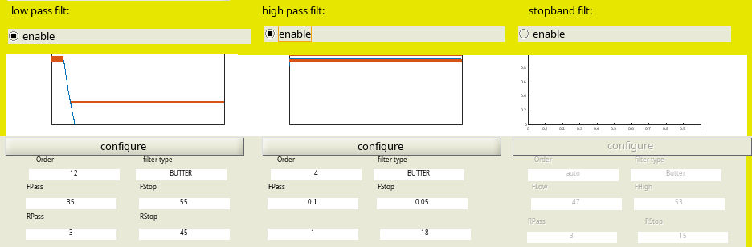

1. Select the ‘autosearch GAIN & ZERO -files’ circle
2. For “PreTrig” insert 2000 (equates to -2 seconds)
3. For “PostTrig” insert 10000 (equates to 10 seconds)
4. Enable biosig eye corrections as show in screenshot
5. Leave the “Artifact detection” parameters as default
6. Change “all trials” to “only:” and input 5:94 because the first four triggers are not videos (eyes closed – eyes open task)
7. In “Miscellaneous” do the following:
   1. Keep all default settings + check “Trigger from RAW file”
8. Press ‘Run’
9. “.RAW” file is transformed into “.TAW” file with filtering parameters in filename
10. Double check the “PrePro.log” file to make sure the parameters were correctly entered

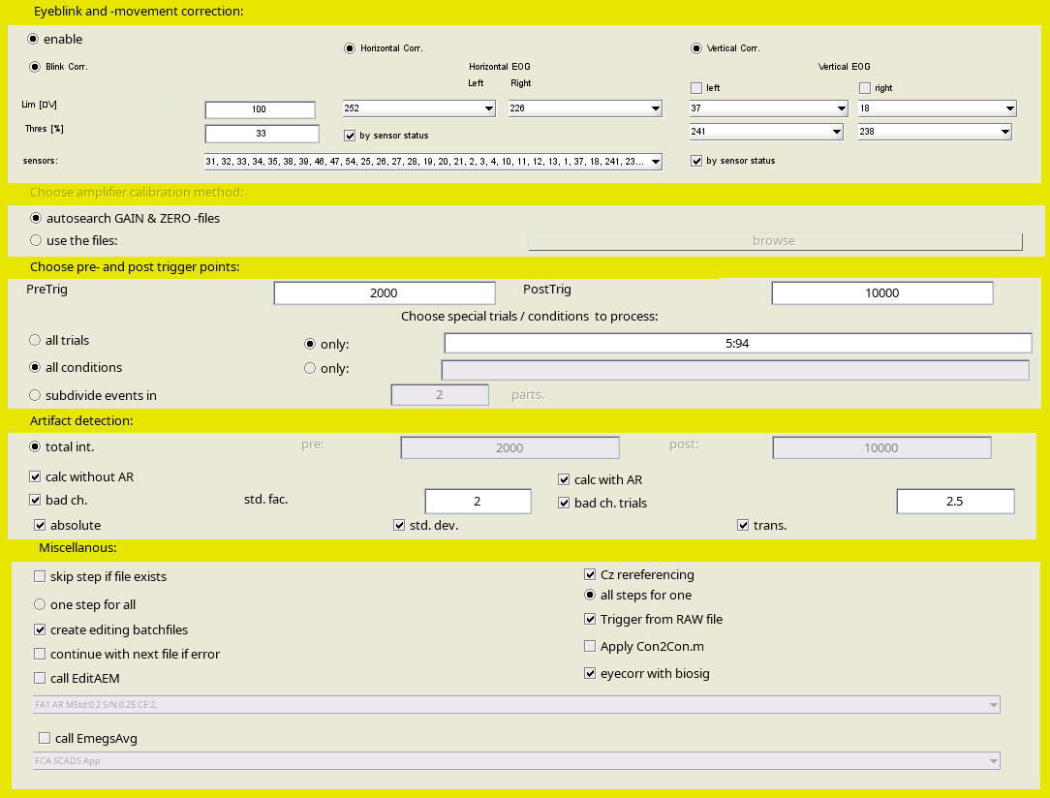

**eye-correction may not be used because of how it may cause unpleasant filter sideeffects. If preprocessing without eye-blink correction, this is how the window should look.**

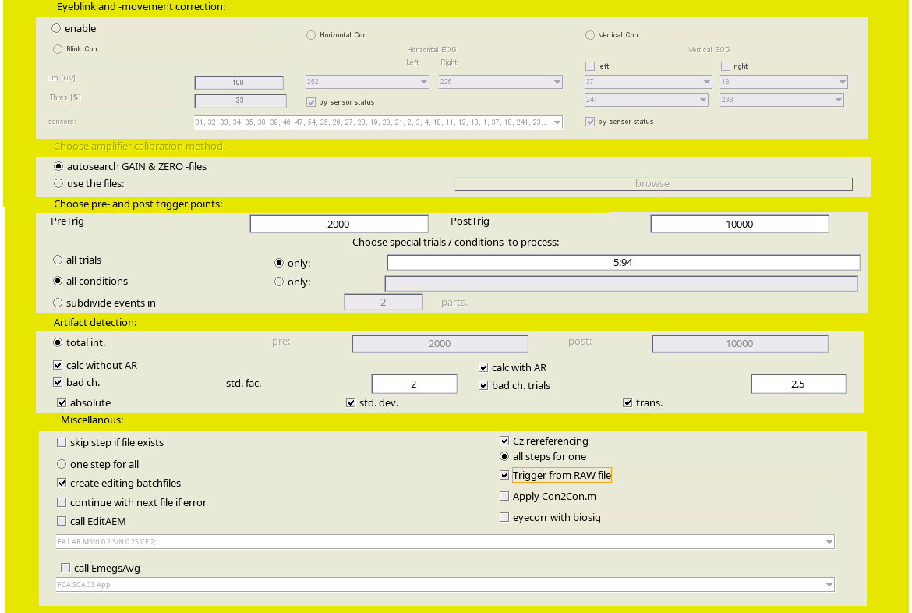

**Artifact Rejection**

1. Close all boxes except for the “Preprocessing Menu”

2. In this GUI, select the ‘Edit processed files’ button

1. Can also access this using the ‘EditAEM’ command
2. Press the ‘Abs MaxStd Grad’ button’
   1. A box will pop up, just press ‘Yes”
3. You should see a top graph showing number of trials (y-axis) against the maximum standard deviation of approximation (x-axis) and the bottom graph showing the Abs, Std, Gradient, and Flat parameter values for all channels of one trial
   1. Drag the dotted red line in the top graph to .25 and press accept
4. Press ‘close all except main’
5. Open the subject’s “PrePro.log” file in the respective subject folder using text editor
   1. Write down the total number of bad sensors, and which channels these are in the excel spreadsheet
6. Open the subject’s “EditAEM.log” file in the text editor
   1. Write down the following in the excel spreadsheet: Mean Std of approximation, Std threshold, number of good trials, number of bad trials, number of globally extracted channels, min number of extracted channels per trial, and max number of extracted channels per trial
7. At the bottom in the “Close and continue” section, press ‘All and EmegsAvg’
   1. You can also simply close this window and type ‘EmegsAvg’ in the command window
8. Press ‘close all and EmegsAvg’ button

File types:

1. “.CON” file contains trigger information for each trial
2. Statistical parameters for artifact correction are saved into the “.AEM” file, and the “.AEM.AR” file contains this along with the average referenced data
3. “.AEM.AWE” and “.TVM.AR” contain good/bad trials and sensors, and are used to interpolate bad sensors in trials during averaging
4. The “.129/128est” contains corrupted sensors